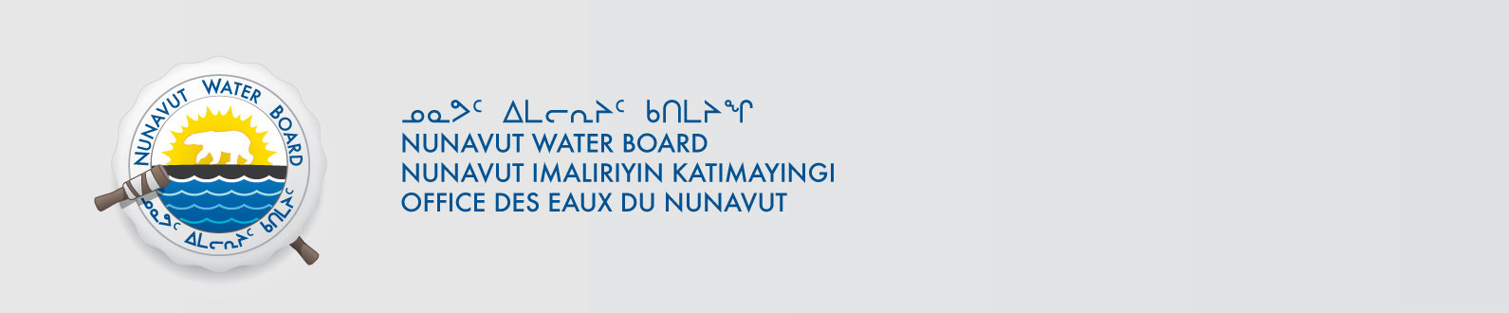

January 23, 2020 NWB File No: 2BE-TIM0813

Deborah Chadwick
Diamondex Resources Ltd.
P.O. Box 11584
650 West Georgia Street, Suite 1410
Vancouver, BC V6B 4N8
Email: dchadwick@ingold.ca

Subject: Final Inspection – Cancellation of Licence and Closure of 2BE-TIM0813

Dear Ms. Chadwick:

On July 20, 2014 the Nunavut Water Board (NWB) received a final water inspection report from Crown Indigenous Relations and Northern Affairs Canada (CIRNAC) covering the above noted file. The report indicates there are no outstanding reclamation issues associated with the project. Further, there are no outstanding NWB administrative matters that require attention.

In accordance with section 43.(i)(c) of the Nunavut Waters and Nunavut Surface Rights Tribunal Act (NWNSRTA), the Board may cancel a licence in certain specific cases.

The NWB hereby notifies all parties that the aforementioned licence is now cancelled and that the corresponding NWB file is now considered closed. Any future relevant activities on this site will require a new Water Licence or Approval Without a Licence.

Sincerely,

Richard Dwyer
Manager Licensing

Cc: Kitikmeot Distribution List
CIRNAC Enforcement

