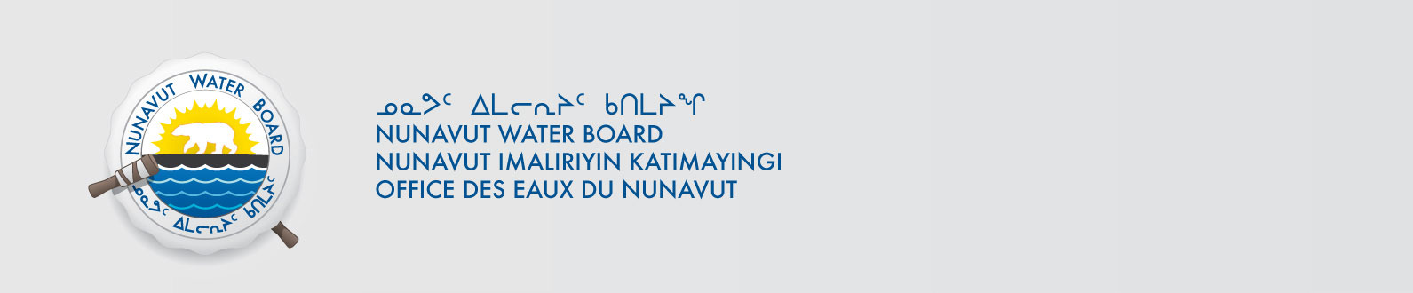

May 25, 2017 NWB File No: 2BE-PBP1520

David Smith
Exploration Manager, Canada
NORDGOLD Norquest Ltd.
Suite 101-50 Richmond Steet East
Toronto, ON M5C 1N7
E-mail: david.smith@nordgold.com

Subject: Application Amendment Acknowledgement for the Pistol Bay Project

Dear Mr. Smith:

The Nunavut Water Board (“NWB”) acknowledges receipt on May 15, 2017 of your amendment water licence application, for the Pistol Bay Project. This application has been assigned file number 2BE-PBP1520. Please refer to this number on future submissions. Application documents received are as follows:

- Property Configuration Claims dated March 12, 2013 Received May 16, 2017
- Water Source Map dated March 12, 2013 Received May 16, 2017
- A & R Plan Received May 15, 2017
- Executive Summary (English) Received May 15, 2017
- Executive Summary (Inuktitut) Received May 15, 2017
- IK Authorization for DL dated February 3, 2017 Received May 15, 2017
- Land Use Permit Inspection Form July 6, 2015 Received May 15, 2017
- Letter of Support HTO Received May 15, 2017
- Norquest Amendment Application Received May 15, 2017
- Norquest Pistol Bay Project Consultation Log March 24, 2017 Received May 15, 2017
- NWB MM1 Mineral Exploration Remote Camp SIG di edits May 15, 2017
- SmartAsh Description BIN 056 Receivbed May 15, 2017
- Spill Contingency Plan dated April 10, 2017 Received May 15, 2017

Please be advised that under the Agreement Between the Inuit of the Nunavut Settlement Area and Her Majesty the Queen in Right of Canada (Nunavut Agreement) Article 11, Section 11.5.9 and s. 76 (1) of Nunavut Planning and Project Assessment Act (NuPPAA), the proponent of a project governed by NuPPAA is also required to submit a project proposal document (which may include the water licence application) directly to the Nunavut Planning Commission (NPC or Commission) for the NPC’s determination regarding the applicable land use planning requirements and/or directions regarding whether the project is subject to screening by the Nunavut Impact Review Board. In particular, please note that as established under Articles 11, 12 and 13 of the Nunavut Agreement, NuPPAA and Part 3 of the Nunavut Waters and Nunavut Surface Rights Tribunal Act, until the project has completed the applicable land use planning and assessment process required by the NPC and the NIRB, the NWB cannot issue a water licence.

The NWB confirms receipt of NPC conformity under NuPPAA on May 12, 2017. This application is now ready for review and comments. Deadline for submissions is June 26, 2017

Please call the undersigned at (867) 360-6338 or email to licensing@nwb-oen.ca if you have any questions.

Sincerely,

Licence Administrator

Cc: Technical Advisor Sean Joseph

NPC

NIRB

