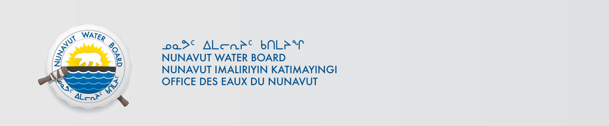

June 24, 2024 NWB File No: 2WLC-NUT----

Russel Starr
Greenridge Exploration Inc.
250-997 Seymour Street,
Vancouver, BC
V6B 3M1
Ph: 1-(778) 897-3388
russell@greenridge-exploration.com
Allyson Ullrich
Dahrouge Geological Consulting Ltd.
Suite 103, 10183 112 Street,
Edmonton, AB
T5K 1M1
Ph: 1-(780) 996-0873
Email: allyson.ullrich@dahrouge.com

Re: Acknowledgement and Receipt of Application Fee for Application for an Approval for the use of Waters and deposit of Waste Without a Licence – Nut Lake Project - Kivalliq

Dear Mr. Starr, Ms. Ullrich:

The Nunavut Water Board acknowledges receipt on June 24, 2024 of your Credit card information for an application fee for the above project. Your information for payment has been forwarded to Crown Indigenous Relations and Northern Affairs Canada in Iqaluit for processing. A receipt will be issued through their office for fees totaling $30.00.

Please call the undersigned at (867) 360-6338 or e-mail licensing@nwb-oen.ca if you have any questions.

Sincerely,

Original signed by:

Robert Hunter
Licensing Administrator

Cc: Andrew Keim, CIRNAC

Margaret Mike, CIRNAC

