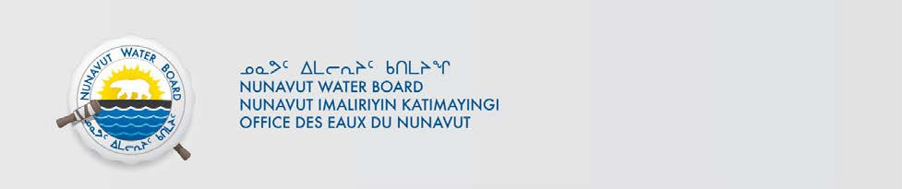

PUBLIC NOTICE OF NEW APPLICATION
Hamlet of Chesterfield Inlet

Pursuant to Section 55(1) of the Nunavut Waters and Nunavut Surface Rights Tribunal Act (“Act”), notice is given that Hamlet of Chesterfield Inlet filed an application to the Nunavut Water Board (“NWB”) for an amendment of existing Type "B" water licence to a Type “A” water licence to use water or deposit of waste into water for the following:

File #: 3AM-CHE----
Project: Municipal Water Use
Location: Latitude : 63°20'47.43" N Lognitude : 90°44'12.60" W
Purpose: Municpal Water Licence Amendment
Type: “A”

Interested persons are invited to submit comments on or before June 16, 2023 to:

Manager of Licensing
Nunavut Water Board
P.O. Box 119, Gjoa Haven, Nunavut X0B 1J0
Phone: (867) 360-6338; Fax: (867) 360-6369; E-mail: licensing@nwb-oen.ca

Copies of all application documents may be obtained by affected parties, free of charge, through the internet on our ftp site at the following link:

ftp://ftp.nwb-oen.ca/registry/3%20MUNICIPAL/3A/3AM%20-%20Municipality/3AM-CHE----/1%20APPLICATION/2023%20Amend%20Renew

or by contacting:
John Ivey, SAO Hamlet of Chesterfield
Phone: (867) 898-9951
E-mail: SAO@chesterfield-inlet.ca

Failure to respond to this Notice of Application within the specified period shall result in the loss of the right to be compensated, pursuant to Sections 58 to 61 of the Act.

CURRENT DATE: May 23, 2023

