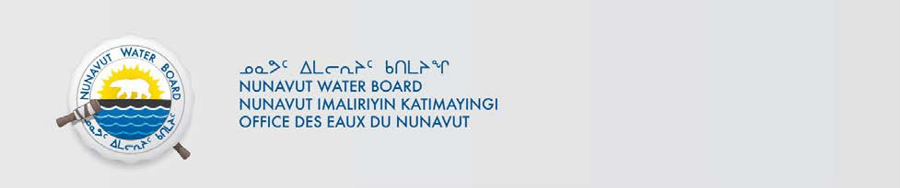

ᐃᓄᖕᓂᒃ ᖃᐅᔨᒃᑲᐃᔾᔪᑎ ᓄᑖᖑᕆᐊᕐᑎᑦᑎᔪᒪᔪᑦ ᐱᓇᓱᒍᑎ
ᕼᐊᒻᓚᒃᑯᑦ ᓴᓪᓖᑦ

ᒪᓕᒃᓗᒍ ᑎᑎᕋᕐᓯᒪᔪᖅ ᐃᓚᖓᓂ 55(1) ᓄᓇᕗᑦ ᐃᒥᖏᑦ ᐊᒻᒪᓗ ᓄᓇᕗᑦ ᓄᓇᖓᓂ ᖄᖓᓂ ᐱᔪᓐᓇᐅᑎᓕᕆᓂᕐᒧᑦ ᑲᑎᒪᔨᐅᔪᑦ ᐱᖁᔭᐃᑦ (ᐱᖁᔭᐃᑦ), ᖃᐅᔨᒃᑲᐃᕗᑦ ᐅᑯᐊ ᕼᐊᒻᓚᒃᑯᑦ ᓴᓪᓖᑦ ᑎᑎᕋᕐᓯᒪᒃᒪᑕ ᐱᓇᓲᑎᒥᒃ ᑕᕙᓂ ᐅᓪᓗᖓᓂ ᓄᑕᖑᕆᐊᕐᑎᑦᑎᔪᒪᓪᓗᑎᒃ ᓄᓇᕗᑦ ᐃᒥᓕᕆᓂᕐᒧᑦ ᑲᑎᒪᔨᖏᓐᓄᑦ ᐊᑐᕈᒪᓪᓗᑎᒃ ᐃᒥᕐᒥᒃ ᐅᕙᓘᓐᓂᑦ ᑯᕕᓯᖃᑦᑕᕐᓗᑎᒃ ᐅᑯᓂᖓ ᐱᓕᕆᐊᒃᓴᖃᕐᑎᓪᓗᒋᑦ:

ᑎᑎᕋᖓ #: 3BM-COR1521
ᐱᓕᕆᐊᖓ: ᕼᐊᒻᓚᒃᑯᑦ ᓴᓪᓕᓂ
ᓄᓇᖓᓂ: Latitude: 64°09'36.98" N; Longitude: 83°08'51.95" W
ᐱᔾᔪᑎᖓ: ᓄᓇᓕᖕᓄᑦ
ᐃᒪᐃᑦᑐᖅ: “B”
ᑭᓇᑐᐃᓐᓇᖅ ᐱᔪᒪᒍᓂ ᑐᖓᓱᒃᑎᑕᐅᔪᖅ ᐅᖃᐅᓯᒃᓴᖃᕈᓂ ᑕᕙᓂ ᑐᖓᓃᓘᓐᓃᑦ ᔪᓚᐃ 29. 2021 ᐅᕗᖓ:
ᐊᐅᓚᑦᑎᔨ ᐱᔪᓐᓇᐅᑎᓕᕆᓂᕐᒧᑦ
ᓄᓇᕗᑦ ᐃᒥᓕᕆᓂᕐᒧᑦ ᑲᑎᒪᔨᖏᑦ
ᑎᑎᕋᒃᑯᕕᐊᐅ 119, ᐅᕐᓱᕐᑐᖅ, ᓄᓇᕗᑦ X0B 1J0
ᐅᖄᓚᐅᑖ: (867) 360-6338; ᓱᒃᑲᔪᒃᑯᑦ: (867) 360-6369; ᖃᕋᓴᐅᔭᒃᑯᑦ:
licensing@nwb-oen.ca

ᑎᑎᕋᕐᓯᒪᔪᒥᒃ ᐊᔾᔨᖏᓐᓂᒃ ᐱᔭᒃᓴᐅᔪᑦ ᐃᒃᐱᒃᓂᕐᑎᑕᐅᔪᓄᑦ, ᐊᑭᖃᖏᓪᓗᓂ, ᖃᕋᓴᐅᔭᒃᑯᑦ ᑕᑯᒋᐊᕐᕕᖓᓂ ᐅᕗᖓᕐᓗᓂ:
ftp://ftp.nwb-oen.ca/registry/3%20MUNICIPAL/3B/3BM%20-%20Municipality/3BM-COR1521/1%20APPLICATION/2021%20Renewal/

ᐅᕙᓘᓐᓂᑦ ᖃᐅᔨᒋᐊᕐᕕᒋᓗᒍ ᐅᓇ:
ᓕᐅᓂ ᐸᒥᐅᓕᒃ, ᑎᑎᕋᕐᑎ ᕼᐊᒻᒪᒃᑯᑦ ᓴᓪᓖᑦ
ᐅᖄᓚᐅᑕ: (867) 925-8867; Fax: (867) 925-8867
ᖃᕋᓴᐅᔭᒃᑯᑦ: munch@qiniq,com

ᑭᐅᔭᐅᖏᒃᑯᓂ ᖃᐅᔨᒃᑲᐃᔾᔪᑎ ᑐᒃᓯᖃᐅᑎᖓ ᐃᓗᐊᓂ ᐅᓪᓗᖏᑕ ᐊᓯᐅᔨᓂᐊᕐᑐᖅ ᐊᑭᓕᕐᑕᐅᔭᕆᐊᖃᕐᓂᕈᓂ, ᒪᓕᒃᓗᒍ ᑎᑎᕋᕐᓯᒪᔪᖅ ᐃᓚᖓᓂ 58 ᑎᑭᓪᓗᒍ 61 ᐱᖁᔭᓂ.
CURRENT DATE: JUNE 29, 2021

