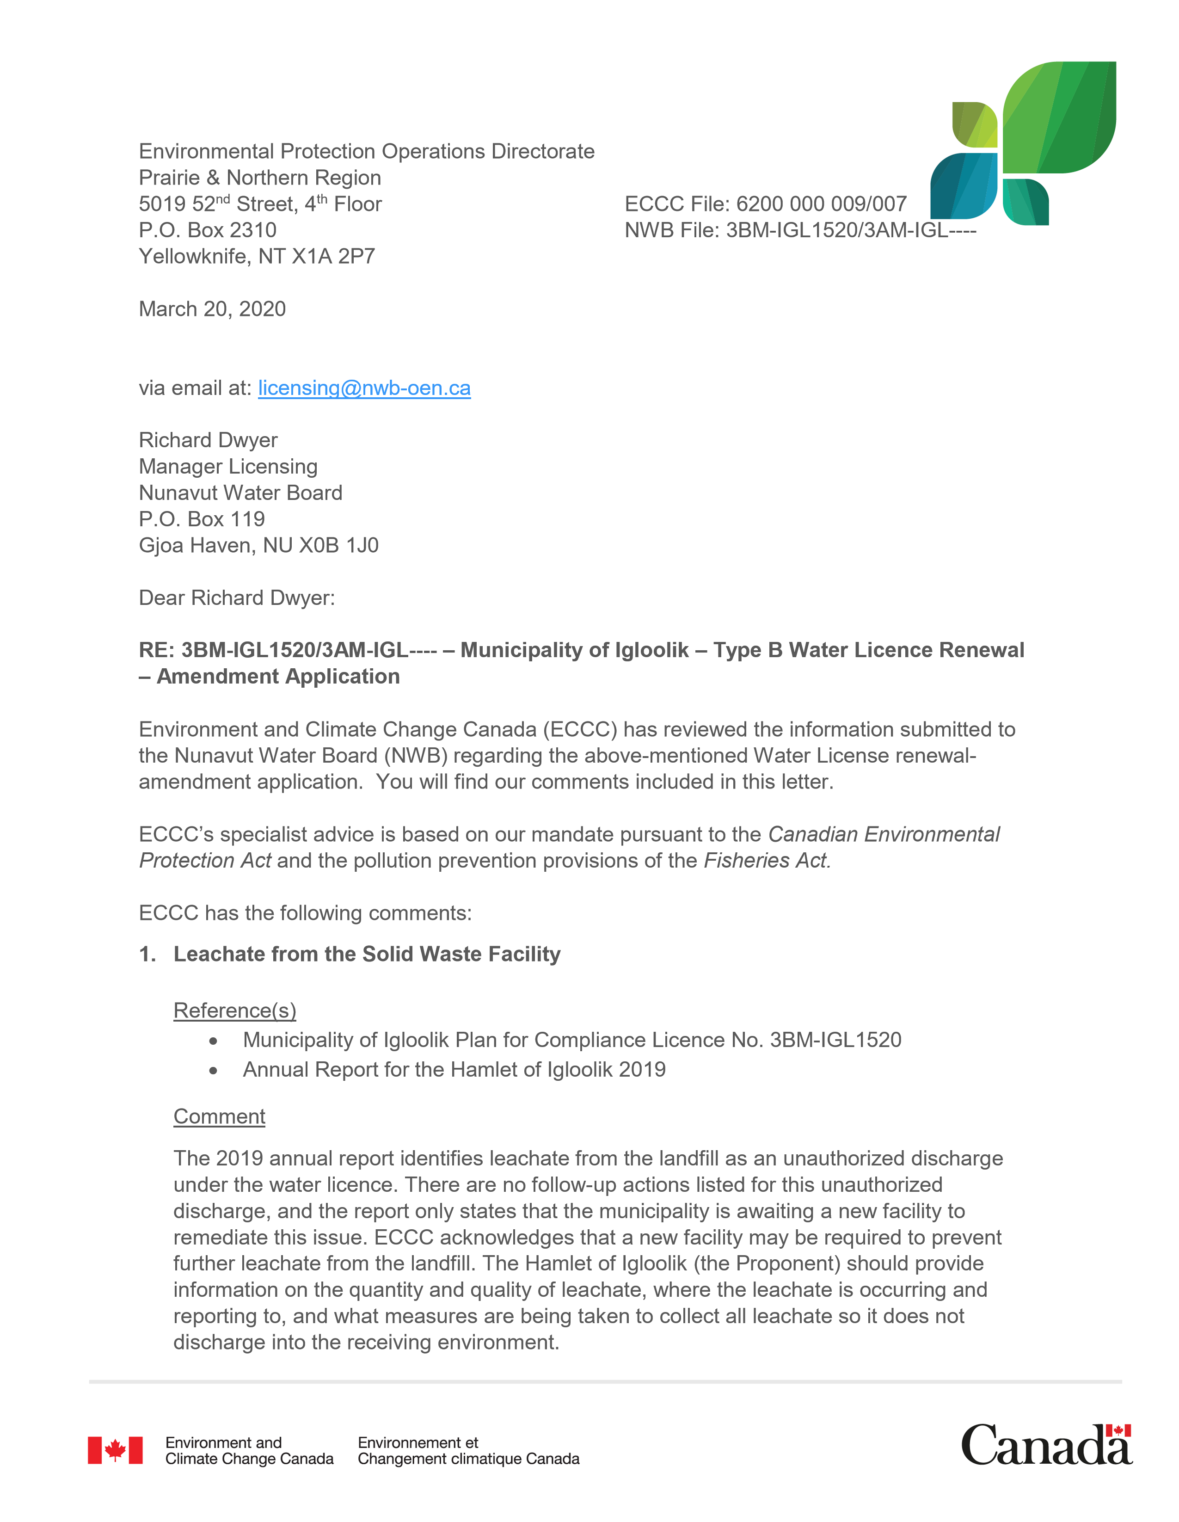
ECCC Recommendation(s)
ECCC recommends that the Proponent take measures to capture all leachate from the landfill site for appropriate management so that it does not get discharged into the receiving environment. In addition, information on the quality, quantity, and locations of leaching should be provided
Ans. The existing Land fill is a non engineering facility and leachate is uncontrolled. Leachate is suggested to get tested following the licence condition as long as the flow is seen.
Hamlet will be using GPS coordinates for this summer Leachate sampling locations and will be presented in 2020 annual reporting.
Leachate is naturally treated in the natural ponds/ wetland and absorbed mostly in the soil. Very less chance to reach to the receiving body which is almost 3km away.
However, the new facility will be an Engineered facility and leachate control measures will be there. The Feasibility study is at the final stage and the new facility is anticipated to be built and operational in next 2 to 3 yrs.

- Monitoring Results

Reference(s)
  - Operations and Maintenance Manual Volume 1, Igloolik Wastewater Facility. Exp Services Inc. August 2014, revised February 2020.
Comment
Section 4.4 of the Wastewater Facility Operations and Maintenance Manual outlines the parameters to be analyzed at all monitoring stations for the lagoon system. ECCC notes that carbonaceous biochemical oxygen demand (cBOD) is on this list, but is not analyzed in the August 21, 2019 sample results provided with the renewal application.
ECCC Recommendation(s)
ECCC recommends that the Proponent include all parameters listed in Section 4.4 in the analysis of effluent and water quality associated with the lagoon, including cBOD.
Ans. The Lab will be advised to include cBOD testing for wastewater effluent this summer and will be presented in the 2020 annual reporting.
- Treatment Capabilities

Reference(s)
  - Operations and Maintenance Manual Volume 1, Igloolik Wastewater Facility. Exp Services Inc. August 2014, revised February 2020.
Comment
The operations and maintenance manual indicates that the wastewater treatment system uses the sewage lagoons as the main method of treatment, with the filter strip wetlands providing additional treatment prior to the release into the environment. However, the laboratory results provided as part of the water licence application only include data for the three cells of the lagoon and provide no information of the final quality after the filter strip wetlands (IGL-5). Based on the lagoon effluent quality results, the concentration of total ammonia as nitrogen in effluent should be monitored. Understanding that the filter strip wetland strip provides additional treatment, the total ammonia concentrations at the end of this wetland should be provided to ensure that concentrations would not cause effects to aquatic life.
ECCC Recommendation(s)
ECCC recommends the Proponent provide monitoring data of effluent quality for the three individual sewage lagoons (IGL-4) as well as at the end of the filter strip wetland, to quantify final quality prior to release to the environment (IGL-5).
Ans. Agreed. The Hamlet has been advised to conduct summer sampling at Monitoring stations IGL-4 and IGL-5 as advised above with the GPS coordinates. The summer test results will be the part of 2020 annual reporting.

If you need more information, please contact Eva Walker at (867) 669-4744 or Eva.Walker@Canada.ca.

Sincerely,

[original signed by]

Eva Walker
Environmental Assessment Coordinator

Attachment(s):

cc: John Olyslager, Acting Head, Environmental Assessment North (NT and NU)

