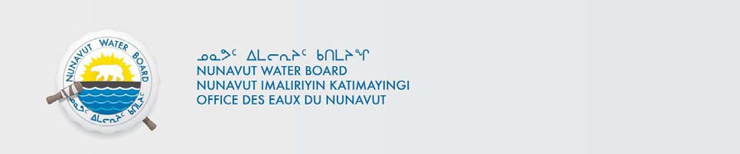

File No.: 3BM-PAN1417 /
Renewal – Amendment / PTR

May 04, 2017

Bhabesh Roy, M.A.Sc., P.Eng. Municipal Planning Engineer GN – CG&S, Baffin Region
  - Box 379
Pond Inlet, X0A 0S0 broy@gov.nu.ca

Subject: Licence No. 3BM-PAN1417 – Submission of Renewal – Amendment Application for Hamlet of Pangnirtung Municipal Licence

Dear Mr. Roy:
The Nunavut Water Board (NWB or Board) received on April 4, 2017, from the Government of Nunavut – Community and Government Services (GN-CG&S), on Behalf of the Hamlet of Pangnirtung, an application to renew and amend Licence No. 3BM-PAN1417, which included the following documents:

- Authorization Letter from the Hamlet of Pangnirtung, March 16, 2017;
- NIRB Screening Decision Report, March 17, 2017;
- NIRB Screening Decision Cover Letter, March 17, 2017;
- NIRB Notice of Assessment, March 17, 2017;
- Application Cover Letter, March 20, 2017;
- Project Summary (English);
- Project Summary (Inuktitut);
- Nunavut Planning Commission, Land Use Conformity Determination, November 22, 2016;
- Completed Type “A” Water Licence Application Form;
- Mechanical & Electrical Operation & Maintenance Manual, Pangnirtung Truck Fill Station, Pangnirtung, Nunavut, September 2016;
- Spill Contingency Plan, Hamlet of Pangnirtung, Pangnirtung, Nunavut, October 31, 2016;

- WWTP Bypass Contingency Plan; Hamlet of Pangnirtung, Pangnirtung, Nunavut, October 31, 2016;
- Application Cover Letter, March 20, 2017 and Accompanying Water Licence Application Form, March 20, 2017;
- Fish Process Plant Waste Management Plan, Hamlet of Pangnirtung, Pangnirtung, Nunavut, April 2017; and
- Solid Waste Operation and Maintenance Plan, June 2014;
- Water Treatment Plant Operation and Maintenance Manuals:
  - Pangnirtung Waste Water Treatment Plant Documentation O&M;
  - Electrical Instruction Manual;
  - GE MBR O& M Manual, October 2014;
  - Pangnirtung WWTP Process Operation Manual, February 2015; and
- Application Cover Letter, March 20, 2017.

Following receipt, the NWB conducted an internal preliminary review of the Application in which the following issues have been identified:

    - Water Source
Absence of hydrological information to confirm whether or not the water source, the Duval River, is cable of satisfying the increased water withdrawal rate(s) and volume(s) proposed in the renewal-amendment application;
Answer: We have not recently done any recent hydrology study on Duval River. However,
McMaster University did a study on Water Resource Development for High Arctic Communities in
August 1975. This study shows that the drainage area of Duval River is 39 square miles
(100.96 Km²), length is 11 miles (17.70KM) and net discharge volume in 1974 is 923million
cubic feet ( 26 million cubic meters). We feel that discharge volume might not change that
much. The capacity of the Storage Reservoir is only 120,000 cubic meters. We are more than
sufficient in terms of Water requirements.
However, we are planning to conduct a Hydrology study on Duval River in 2017-18.

    - Management Plans
The following management plans submitted in support of the application should be redeveloped, modified or revised to better reflect or address water licensing requirements:

      - Solid Waste Operation and Maintenance Plan, dated June 2014, should be updated to address:
        - Removal of information that is no longer applicable to the facility;
        - Outdated information for contact persons of relevant government agencies or organizations.

Answer: This document has been revised and attached.

      - Mechanical and Electrical Operation and Maintenance Manual, Pangnirtung Truck Fill Station, dated September 2016, should be revised or redeveloped to ensure that the document is compatible with the water licence requirements:

        - While this manual is very detailed in terms of the information it contains for troubleshooting and repairing mechanical and electrical issues associated with the facility, it is not a manual that is functional in the context of the water licence requirements. It is recommended that a different manual be created to reflect the contextual format of the Guidelines for the Preparation of an Operation and Maintenance Manual for the Sewage and Solid Waste Disposal Facility in the Northwest Territories.

Answer: The New Water Treatment Plant was commissioned and is being calibrated right now. The plant is required to be updated and is planned to be completed within three months. After that the O&M document will be updated accordingly in the formatted requested by the Board.

    - Abandonment/Closure:
Details on the eventual fate of infrastructure or facilities associated with the Hamlet’s water licence that are no longer in use by the Hamlet of Pangnirtung should be provided for at least the following:

      - Old Sewage Lagoon Facility; and
Answer: The so called “old lagoon” used to receive fish Plant effluent and also used for emergency dumping of truck sewage in case of emergency.

The Wastewater Treatment Plant was optimized using membrane treatment technology and fish plant effluent is currently being treated there along with municipal sewage.

The Plant has an overflow pipe which is used for automatic bypassing through a single outlet as and when required. Therefore the old lagoon is not in use any more. However, a decommissioning design (attached) has been prepared and waiting at least a year or two to see the performance of the optimized Wastewater Treatment Plant.

      - Old Truck Fill Station.

It is recommended that details be provided regarding the status and plans for the facilities or structure that are no longer in use by the Hamlet.
Answer: The New Truck Filling station was commissioned and is planned to be in full production within three months. It is necessary to keep the old truck filling station as the backup for at least a year.
This old plant is planned to be decommission on or before 2019.
    - Redundant Documents
Confirmation is required from the Applicant on how the NWB should address redundant documents included as part of the application.


Answer: Any redundant documents (if any) included with the application package are recommended to be deleted or removed as and when required.

The NWB request that the above-mentioned issues be addressed before the NWB could proceed to the next stage(s) of the Licensing Process for the Application.

If you have any questions regarding the above, please contact the NWB’s Licensing Department at licensing@nwb-oen.ca or the undersigned at your earliest convenience.

