OPERATION AND MAINTENANCE PLAN
FOR
SOLID WASTE FACILITIES

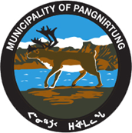

AUGUST 2017

(Revised)

HAMLET OF PANGNIRTUNG BAFFIN REGION
NUNAVUT

Table on Contents: Page No.

- Introduction ----3
2.0 Waste production -----10
  - Population Projection ------10
  - Waste Generation -------10
    - Sludge Handling and Disposal ------11
    - Solid waste Generation ---------------17
2.2.3 Transportation of Waste --------- -18
3.0 Site Personnel ------18
4.0 Health and Safety----------------------------------------------------------------------------------------------------------------------------------------------------------------------------------------- 19
5.0 Municipal Solid Waste Area --------------------------------------------------------------------------------------------------------------------------------------------------------------------------------19
    - Waste segregation------------------------------------------------------------------------------------------------------------------------------------------------------------------------------19
    - Burning ---20
    - Operational Procedure-----------------------------------------------------------------------------------------------------------------------------------------------------------------------21
6.0 Bulk Metal/Hazardous Waste Storage areas--------------------------------------------------------------------------------------------------------------------------------------------------------24
  - Bulk Metal Management ----24
  - Hazardous Waste Management-----------------------------------------------------------------------------------------------------------------------------------------------------------------24
    - Operations ----- 27
    - Maintenance --- 29
  - Solid waste Disposal Facility Maintenance---------------------------------------------------------------------------------------------------------------------------------------------------- 30
  - Inspection and Audit ----30
  - Maintenance Activities ---- 30
  - Fence and signs - 31
  - Monitoring and sampling ----- 33 8.1 Monitoring Requirement --- --33
  - Sampling procedure - 34
8.3 Record Keeping -- 34
9.0 Emergency Response---------------------------------------------------------------------------------------------------------------------------------------------------------------------------------- 35
- Spill Contingency Plan -- -36
  - Site descriptions --36
  - Regulations ------ -36
  - Contacts and Regulatory Authorities -37
  - Potential Contaminants ----38
  - Spill Response procedure -38
  - Hydrocarbon Spills ----39
  - Spill Kit and Training Equipment --41
  - Spill kit contents ------41
  - Spill kit locations ---------42
  - Required Training ---------42
  - Off-site Resources -----43
11.0 Record Keeping ------43
Fig.: -1: Location Map of Hamlet of Pangnirtung --4
Fig.: -2: Site locations of existing Waste Facilities--------------------------------------------------------------------------------------------------------------------------------------------------5
Fig:- 3: Plan of Land fiill site---------------------------------------------------------------------------------------------------------------------------------------------------------------------------------------------------6
Fig.: 4:Cross section of the existing Landfill site-----------------------------------------------------------------------------------------------------------------------------------------------------7
Fig:- 5: Plan of Metal Dump-----------------------------------------------------------------------------------------------------------------------------------------------------------------------------8
Fig.: 6: Cross section of the metal dump--------------------------------------------------------------------------------------------------------------------------------------------------------------9
Fig:- 7: Sludge Disposal Hooper----------------------------------------------------------------------------------------------------------------------------------------------------------------------- 13
Fig.:-6: Geo-Tube on the Hooper----------------------------------------------------------------------------------------------------------------------------------------------------------------------14
Fig.:-6: Geo-tube disposal to Land fill-----------------------------------------------------------------------------------------------------------------------------------------------------------------15
Fig:-7: Sludge Management in Winter -------16
Fig:-8: Open burning Garbage ---------23
Fig:-9: Identification of Hazardous wastes -----25
Fig:-10: Typical Monitoring Sign-----------------------------------------------------------------------------------------------------------------------------------------------------------------------32
Table-1: Population of Pangnirtung ---- 10
Table-2: Waste Categories ---------11
Table-3: Projected sludge generation rate-------------------------------------------------------------------------------------------------------------------------------------------------------------12
Table-4: Annual Solid generation rate summary------------------------------------------------------------------------------------------------------------------------------------------------ 17
Table-5: Summary of yearly waste generation volume --- -18
Table-6: Burn and non-burn wastes--------------------------------------------------------------------------------------------------------------------------------------------------------------------20
Table-7: Monitoring Station -------------33

1.0 Introduction:

The Hamlet of Pangnirtung has a population of approximately 1,592 people in 2017 and is located at the coordinates of 62°10’N latitude and 92°36’W longitude, on the eastern shore of Baffin Island within the Qikiqtani Region of Nunavut. Solid waste from the Hamlet is currently disposed of in a landfill located approximately 800 meters from the edge of the Hamlet. The existing solid waste site has been determined to be inappropriately sited due to ecological concerns, odour and windblown litter, poorly operated and maintained, and is nearing its life capacity.

During the inspection in 2006 of the solid waste facility in Pangnirtung, INAC Inspector stated that”
“This is of great concern as the buildup of sludge from years of use is now being exposed and flowing directly out into the environment”.

CGS hired Dillon Consulting ltd in 2007 to conduct a complete comprehensive performance evaluation for the existing Solid waste site. They evaluated the existing solid waste site and also identified a new solid waste site... The recommended new solid waste site is more than three km away from the community and the proposed access road crosses two water courses where bridges are required to cross. During the planning process, Hamlet approached in 2008 to implementing short- term measures to improve overall waste management practices.

exp Services Inc. was retained in 2012 to conduct a research on the best practice of solid waste management for the Hamlet of Pangnirtung. By this time, CGS has accepted new guidelines for solid waste management for Nunavut and put this project on hold. Practically no physical work was carried out since 2006 for the improvement of waste management facility for this community. This project is still on hold for the future direction.

Fish plant adopted a different strategy since 2010 in managing their fish wastes explained in the letter attached in Appendix-F. They are exporting Fish wastes to Asian Market for producing multi products for different uses.
The liquid wastes of the Fish plant is being now treated in the Community WWTP along with the Municipal
Sewage.

The current landfill site is (200m long and 65 m wide), a rectangular land area, are enclosed with 3m high steel fence all around. About 30% of the land area is designated for fish and sludge waste management as shown in the Fig.-2.

The Community is managing an independent metal dump site located just opposite to the land fill site and this site is not fenced.

Design, drawing and O&M plan do not exist for these facilities. Hamlet is expecting for a new facility soon (tentatively in 2023) to manage the Community wastes satisfying the requirements of NWB. As soon as the new waste management facility is built and commissioned, the existing facilities will be decommissioned.

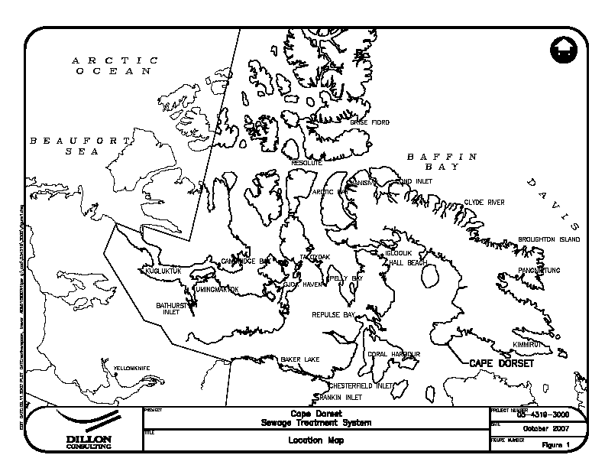
Hamlet of Pangnirtung

Fig:-1: Location Map of Hamlet of Pangnirtung

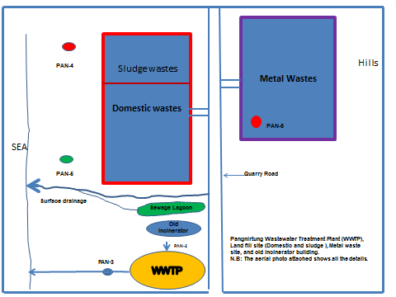

Fig.-2: Location Plan of the wastes facilities
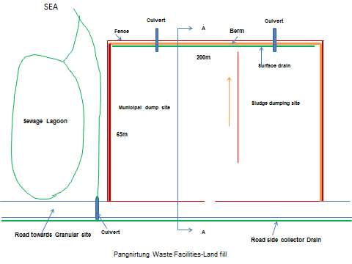

Fig.: 3: Site plan details of the existing Landfill Facility

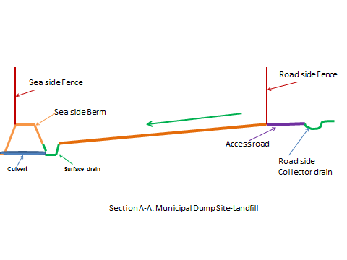

Fig.4: Cross section of the existing Landfill Facility

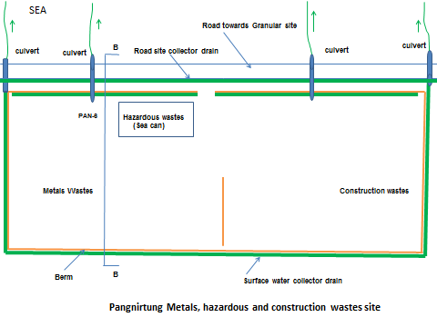

Fig.:5: Site Plan of the metal dump facility

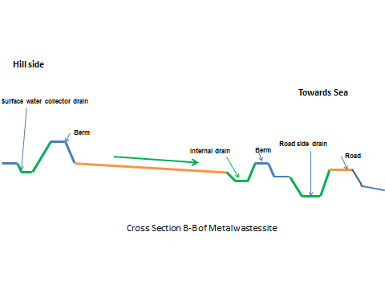

Fig. 6: Cross section of the Metal Dump site

Monitoring Stations:

Monitoring Program Station Numbers | Descriptions | Status
PAN-2 | Raw Sewage from Pump –out truck | Volume, Daily
PAN-3 | Effluent from Wastewater Treatment Facility | Quality, Monthly
PAN-4 | Run-off from Sludge Disposal Area | Quality, 3 times, annually
PAN-5 | Run-off from the Solid waste Disposal Facility | Quality, 3 times, annually
PAN-6 | Run-off from Metal Storage Area | Quality,3 times, annually

The licensee shall sample at monitoring Program Stations PAN-4, PAN-5 and PAN-6 once at the beginning, middle and near the end of discharge/run-off observed. Samples shall be analyzed for the parameters as follows;

Biochemical oxygen Demand (BOD); pH, Total Suspended Solids(TSS);Nitrate-Nitrite, Chloride, Sodium, Magnesium, Total Hardness, Total Phenols, Total Arsenic, total Cadmium, total Copper, Faecal Coliforms, Conductivity, Oil and Grease (visual), Ammonia Nitrogen, Sulphate, Potassium, Calcium, Total Alkalinity, Total Manganese, Total Aluminum, Total Cobalt, Total Chromium, Total Iron, Total Mercury, Total Zinc, Total Lead, Total Nickel and Total Organic Carbon-TOC.

2.0 Waste production:

2.1 Population projection:

Population estimates were generated using values provided in the Nunavut Bureau of Statistics report Nunavut: Community Population Projections, 2017-2032

Table -1: Pangnirtung Population Estimates

Year | Population
2017 | 1592
2022 | 1695
2027 | 1805
2032 | 1922

Waste Generation
Solid waste generated in Pangnirtung includes: municipal solid waste generated in the community, sewage sludge generated in the waste water treatment plant (WWTP) and fish waste generated at the fish plant.
Below are Dillon’s projections of the sludge waste and solid waste (garbage) generation rates for the 15 year planning horizons. 2007 was used as the initial year for planning purposes. Actual waste generation measurements for the community are limited. Where possible, waste generation projections have been derived based on actual measurements. Standard reference information was used when site specific information was not available. Population projections were acquired from the Nunavut Bureau of Statistics.

.

Table ‐2: Pangnirtung Waste Categories

Waste Type | Source | Delivery Method
General Waste | Residential, Commercial, Institutional, | Waste Collection Public drop off
Scrap metal | Residential, construction | Waste Collection Public drop off
White goods (appliances etc.) | Residential, construction | Public drop off
Fish processing offal | Fish Processing Plant | Delivered by the fish plant (approximately 1.5 to 2 m3 per day during plant operation; total approx. 230 m3/yr.)
Sludge bags | Wastewater treatment Plant | Delivered by the Hamlet
Note: The fish wastes management was dealt as above until 2010. After that all fish wastes were exported to the
International market. Very recently the plant authority missed that international market. Currently the fishermen
clean Turbot fish at the point of fishing and the wastes of Turbot are thrown into the Ocean. At present, only during
the month of August, they process Arctic Char in the plant and dump about 3000 pounds of char wastes in the land
fill site. This O&M manual will be updated in 2018 accommodating the mode of future operation of the Fish plant.

Sludge handling and Disposal
The municipal wastewater is treated along with the process water from the fish plant in a mechanical treatment plant. The sludge produced in the plant is stored in the filter bags and dump at the designated area of the Municipal land fill site.

The Pangnirtung WWTP has been upgraded with a passive sludge dewatering system known as a Geotube™. The Geotube™ is essentially a large filter bag that retains the waste solids and allows water to pass through. A polymer injection system is used to add polymer to the waste sludge before it enters the Geotube™ and promote better solids separation. Waste sludge is pumped into the Geotube™ unit and the filtrate water is allowed to passively leach out of the bag into the filtrate collection sump. Water collected in the filtrate sump is returned to the pre-anoxic tank inlet using a submersible filtrate pump.

The Geotube™ dewatering bags for the Pangnirtung WWTP have been selected to fit into the bed of a dump trailer which is normally housed in the dewatering room. A capacitive sensor (tag 70-LS-04) suspended over the dewatering trailer will detect when the Geotube™ bag is full. When the very first Geotube™ bag is being filled, some calibration of the height of the sensor will be required. The operator will have to carefully observe the filling of the first bag and when it is full, the sensor should be adjusted to the proper height. The sensor must be adjusted so that it is in contact with the center of the Geotube™ bag when the bag is full. Filtrate from the Geotube™ bag drains from the trailer to a nearby in-ground trench and sump (the trailer tailgate has to be propped open to allow the filtrate to drain). A submersible filtrate pump (tag 70-FRP-01) is used to pump filtrate from the sump back into the treatment process via the anoxic tank feed piping.

Once a Geotube™ bag has been completely filled and allowed to drain thoroughly, it must be removed from the treatment facility. The system has been designed so that the bags are filled in the bed of a hydraulic-actuated dump trailer which is normally parked in the dewatering room. When a bag is ready to be removed,

the trailer can be hauled to an approved disposal site where the bag can be dumped. The trailer is then returned to the treatment facility and a new bag is placed. Prior to removing the trailer and full Geotube™ bag from the dewatering room, the following steps must be taken:

1. Visually inspect the trailer and bag to ensure that all excess filtrate has drained from the bag and trailer.

2. Disconnect the feed hose on the top of the Geotube™ bag. Cap the bag fitting with the PVC cap provided with each bag. Further details can be found in the manufacturer’s operation and maintenance manual.

3. Raise the full bag detection sensor out of the way to avoid obstruction with the trailer as it is removed from the dewatering room.

4. Follow any additional recommendations from the manufacturer for disposal of full Geotube™ bag. After a full bag has been disposed, the trailer is to be returned to the dewatering room. The following steps must be taken prior to resuming dewatering operations after disposal of a full bag:

1. Place liner material and new Geotube™ in the dewatering trailer. Consult the manufacturer’s operation and maintenance manual for additional details.

2. Reconnect waste sludge feed hose to Geotube™ bag. Consult the manufacturer’s operation and maintenance manual for additional details.

3. Return full bag sensor to calibrated position.

4. Follow any additional recommendations from the manufacturer for placement of a new Geotube™ bag and resuming dewatering operations.

Table 3: summarizes the sludge generation rate estimates for the next 15 years in Pangnirtung.

Table 3: Projected Sludge Generation Rate

Year | Population | Current sludge generation rate | Current sludge generation rate | Future sludge generation rate | Future sludge generation rate
 |  | m3/day | m3/year | m3/day | m3/year
2017 | 1592 | 0.67 | 245 | 0.86 | 314
2022 | 1695 | 0.72 | 263 | 0.98 | 358
2027 | 1805 | 0.76 | 278 | 1.04 | 380
2032 | 1922 | 0.81 | 296 | 1.15 | 420

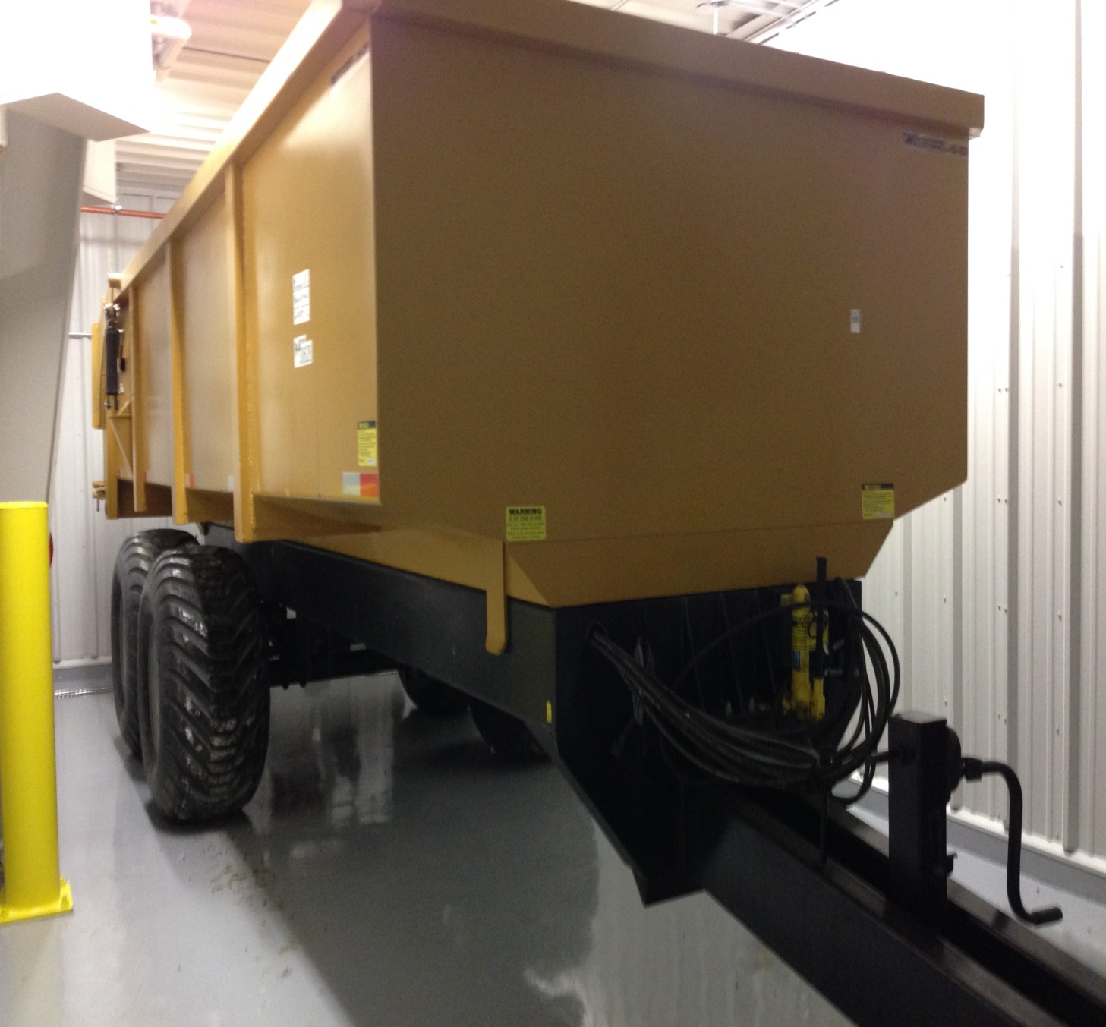

Fig: 7: Hooper for Sludge Disposal

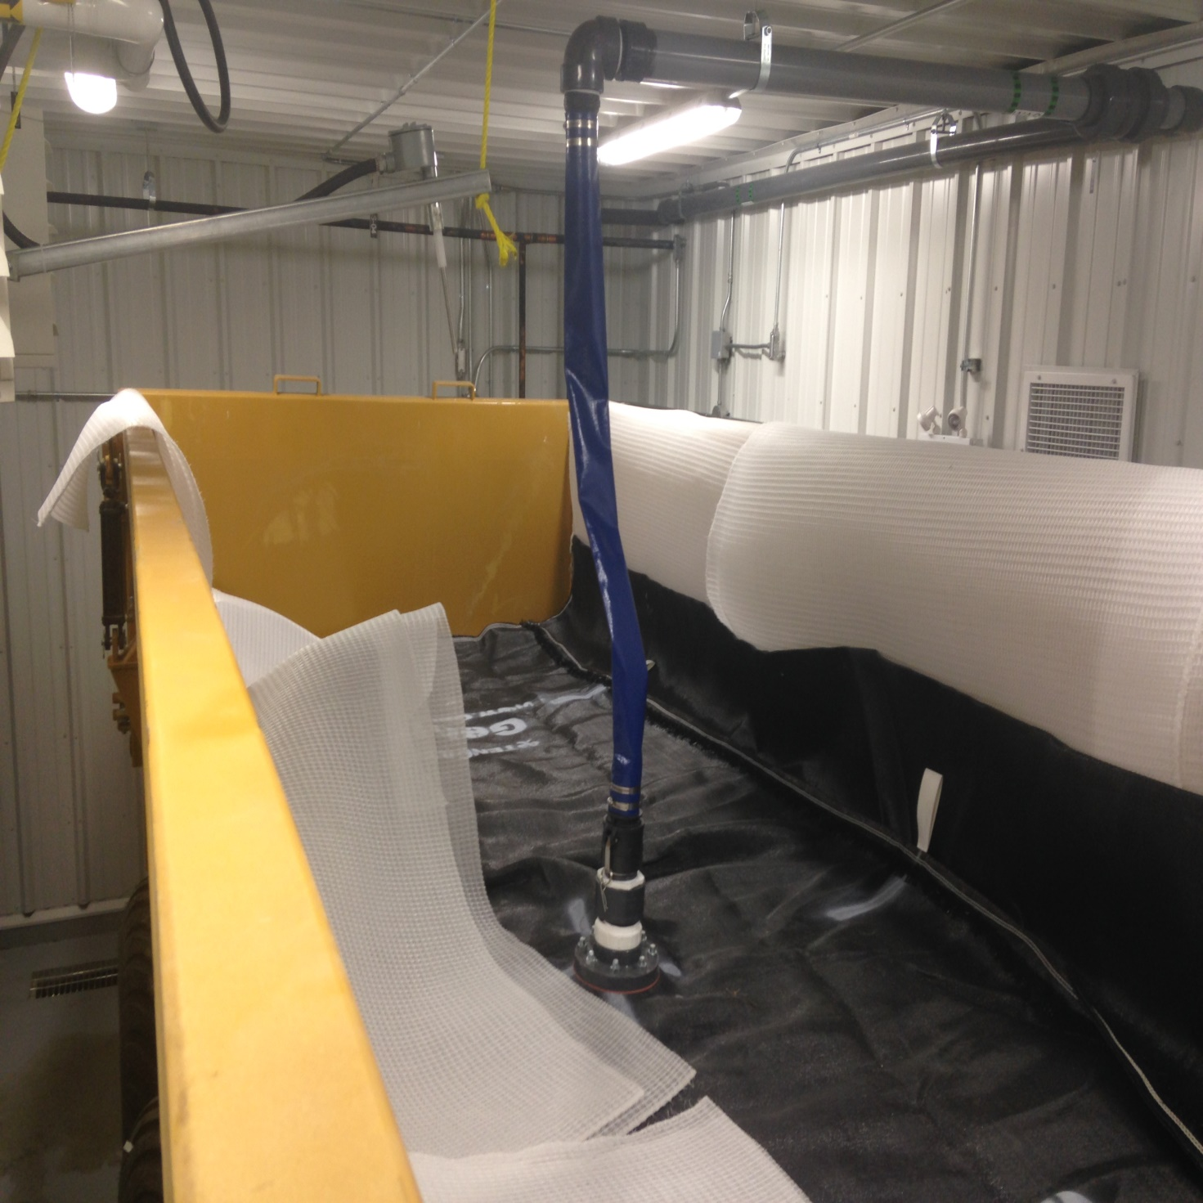

Fig. 8: Geo-tube in the Hooper ready to receive sludge

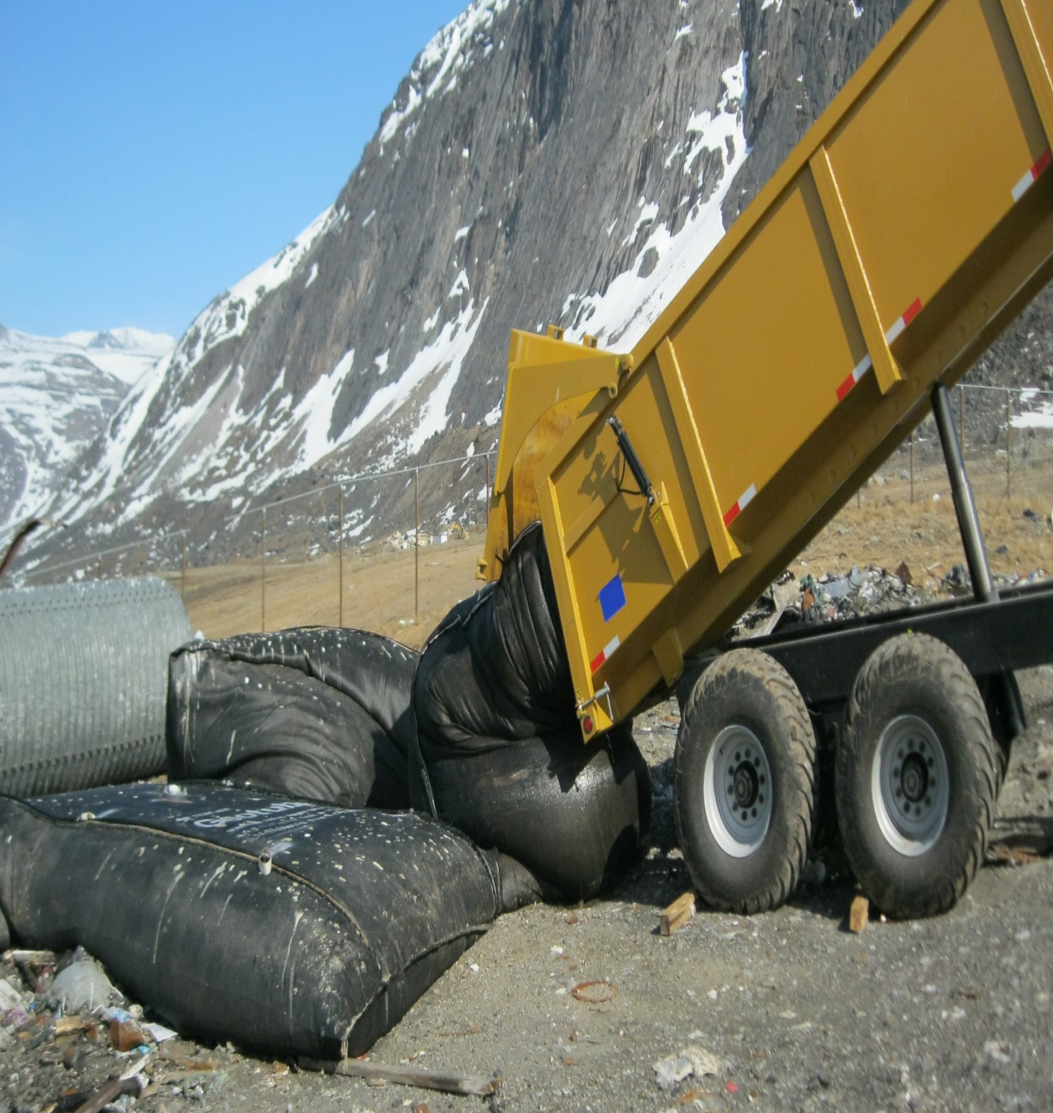

Fig: 9: Geo-tube with sludge dumping at the Land Fill site

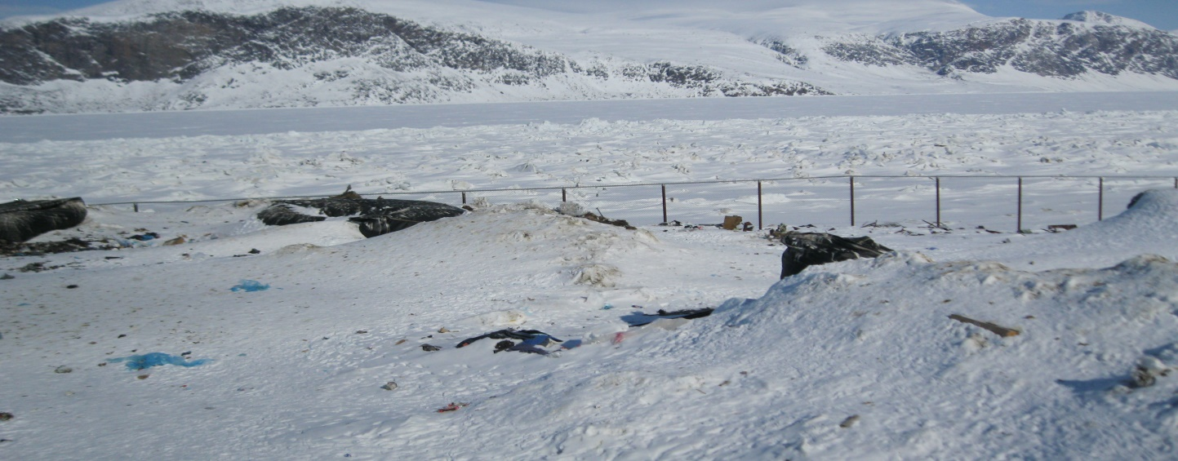

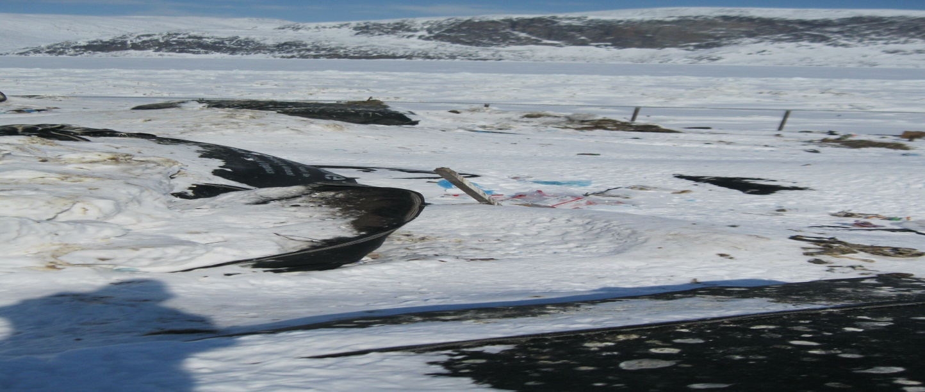

Fig. - 10: Sludge Management in Pangnirtung in Winter

Solid Waste Generation

Solid waste generation information is required to estimate the solid waste disposal facility volume requirements. Detailed solid waste generation information for the Hamlet is not available. Waste generation was, therefore, estimated using average values documented in the Guidelines for the Planning, Design, Operations and Maintenance of Modified Landfill Sites in the NWT, April, 2003 (NWT Landfill Guidelines). According to the
3

NWT Landfill Guidelines the average un-compacted residential solid waste volume is 0.015 m /person/day and
3

the estimated compaction rate is 3:1 in a landfill. This gives an estimate of 0.005 m /person/day of landfill space
required. Table-4: summarizes the un-compacted and compacted annual solid waste generation volume estimates for Pangnirtung.

Table-4: Annual Solid Waste Generation Summary

Year | Population | Uncompact Municipal Solid waste generation rate | Uncompact Municipal Solid waste generation rate | Compacted Solid waste Generation rate | Compacted Solid waste Generation rate
 |  | M3/DAY | M3/YEAR | M3/DAY | M3/YEAR
2017 | 1,592 | 23.88 | 8,176 | 7.96 | 2,905
2022 | 1,695 | 25.43 | 9,282 | 8.48 | 3,095
2027 | 1,805 | 27.10 | 9,882 | 9.03 | 3,296
2032 | 1,922 | 28.84 | 10,526 | 9.61 | 3,508

In addition, offal from the fish processing plant was disposed of at the solid waste disposal facility until 2010.
3

Fish plant management estimated that the plant operated for approximately 115 days/year and that 1.5 to 2 m of
3

Fish waste was generated per day, or 230 m per year. The GN and the fish plant were investigating alternative
Disposal methods for the fish waste (e.g. ocean dumping), which would remove the waste from the Hamlet’s solid waste disposal stream. However alternative disposal arrangements are currently in place as described in the letter dated June 12, 2014 by the production Manager of Pangnirtung fish plant attached in Appendix-F, so no fish waste disposal has been dumped at the landfill since 2010. They have been exporting fish wastes to Asian Market for producing multi products for different uses.
Note: (All fish wastes were exported to the international market since 2010. Very recently the plant authority missed that international market. Currently the fishermen clean Turbot fish at the point of fishing and the wastes of Turbot are thrown into the Ocean. At present, only during the month of August, they process Arctic Char in the plant and dump about 3000 pounds of char wastes in the land fill site. This O&M manual will be updated in 2018 accommodating the mode of future operation of the Fish plant.)

A summary of the total solid waste accumulation (compacted municipal solid waste and proposed sewage sludge volume) is provided in Table -5.

Table -5: Summary of Yearly Solid Waste Generation Volumes

Year | Population | Yearly Solid waste generation Volume m³/year excluding Fish wastes
2017 | 1592 | 34,403
2022 | 1695 | 50,378
2027 | 1805 | 53,662
2032 | 1922 | 57,155

The landfill site has a capacity issue and incapable to accommodate such a huge volume of wastes on annual basis using the current practices of treatment.

2.2.3 Transportation of Wastes
The Hamlet of Pangnirtung operates one ordinary garbage truck for collection of MSW within the community and transfer to the solid waste facility. Front end loader is used to haul metal objects such as old automobiles/fridges etc. to the metal dump. Fish wastes were not dumped into the land fill site since 2010. Sludge bags are transported by Front end loader three times in a month into the landfill site. The access road from the Community connects both the Landfill site and Bulky metal site including the Wastewater Mechanical Treatment Plant. This access is maintained well for all types of vehicular traffics throughout the year.

3.0 Site Personnel
The Hamlet Foreman has overall responsibility of the solid waste disposal facility to ensure proper operation and maintenance is carried out, including compacting, burning, covering, inspections, sampling, and annual reporting to the NWB.
The Foreman is responsible for day-to-day operation and maintenance of the solid waste facility. Day-to-day activities include managing waste collection, proper segregation of waste, compacting and burning of waste, sampling leachate from the facility, completing inspections and other maintenance activities.
The Hamlet typically has one individual hired to operate the Garbage truck and collect waste from community buildings five days a week. This Waste Truck Driver is also responsible for ensuring collected waste is properly segregated, and refusing the collection of hazardous waste if present. If properly trained, this individual may also be required to operate heavy equipment within the solid waste disposal facility.

The WWTP has its own operators: One skilled operator and two helpers. They are responsible for day to day operation of the plant, sludge bagging and disposal of the sludge bags to the land fill site in timely manner. This Operator is also responsible for effluent sampling in the pant and also leachate sampling at the land fill site.

Health and Safety
The public and all personnel working within the solid waste disposal facility should be made aware of potential health and safety hazards associated with working around municipal solid wastes and hazardous wastes. This is imperative so individuals make a conscious effort to perform all necessary safety procedures to protect themselves, their co- workers and family members at home. The requirements of the Nunavut Safety Act will be followed at all times. A site-specific safety plan should be developed by the Hamlet for the solid waste disposal facility and followed once developed. The site-specific safety plans should outline all potential hazards, safe work practices, training requirements, equipment requirements (e.g., fire extinguishers, spill response kits, etc.), and emergency procedures. Public access to the solid waste disposal facility should be restricted to specific areas and/or times to minimize potential hazards to the public. Public access to any hazardous waste storage areas should always be restricted. Additional health and safety precautions for the public and site personnel will be taken during burning of MSW and accidental spills.
See Section 9 of this O&M Manual for emergency response procedures in the event of a fire or spill at the solid waste disposal facility.

5.0 Municipal Solid waste Disposal Area

  - Operations

    - Waste segregation
The MSW disposal area is fully fenced and the Hamlet presently does not limit who disposes of waste and where. Proper waste segregation is imperative to the long-term operation of the facility as it helps ensure potential human health and environmental hazards are minimized, un-compactable wastes (e.g., bulky metal wastes) are kept out of the landfill, hazardous wastes are not properly managed.
The MSW disposal area at Pangnirtung is used as a natural attenuation landfill. This means that the landfill is not lined and small amounts of contaminants can enter the surrounding environment to be naturally broken down. In this type of landfill, the rate that contaminants enter the environment is expected to occur at a rate such that contaminants can easily be broken down and the surrounding environment is not overwhelmed. Natural attenuation landfills also rely on permafrost aggrading into the covered waste cells of the landfill and eventually freezing them. However, as contaminants are able to freely enter the environment in this type of landfill, proper waste segregation is important to ensure harmful contaminants are kept out of the landfill.
Initial waste segregation should begin at the community’s residences and other buildings, ensuring residents and business are familiar with acceptable wastes for the MSW disposal area. Household hazardous or bulky wastes are kept out of the landfill and Burn Area.
The Waste Truck Driver should be familiar with operational procedures for the MSW disposal area, acceptable wastes for burning and landfilling and proper waste segregation practices. Ultimately the Foreman is responsible to ensure proper waste segregation occurs.
The Waste Truck Driver should monitor the waste they collect from community buildings every day, collecting only that which is acceptable for disposal at the MSW disposal area. The Hamlet could provide a ‘grace’ day once or twice per year to collect residents’ household hazardous and/or bulky metal waste. The Hamlet could also provide help to residents who have larger items to dispose of and have no means of transporting them to the correct disposal area. The MSW disposal area needs to be properly signed to inform operators and residents of the correct location to dispose of or store certain wastes. At a minimum, the MSW disposal area should have disposal/storage areas for:

    - Domestic burnable waste (for burning and landfilling) – a selected Burn Area
    - Domestic non-burnable waste (for landfilling)
    - Treated wood and wood products
    - Building/construction materials
    - Bulk metal waste – a separate bulk metal waste disposal area
    - Re-usable/recyclable material (i.e., salvage area)
    - Household hazardous waste (i.e., drop-off hazardous waste disposal area).

Sea cans or constructed drum shelters can be used to store specific household hazardous wastes in a designated area before being shipped out of the community. Hazardous waste management is described in Section 6.2.

    - Burning
Once waste has been properly segregated, burnable waste should be burned at least once per week to keep the volume of waste manageable. Burning should only occur when winds are light and blowing away from the community. Table 6 outlines wastes acceptable for burning.

Table-6: Burnable and non-burnable wastes

Burnable Wastes | Non-Burnable Wastes
Domestic Waste (e.g. paper products, paper board/cardboard packaging, etc.) | Non-wood building /construction materials (e.g. roofing materials, electrical wire, insulation, plastics, asbestos, etc.)
Non-treated wood | Treated wood 9e.g. telephone poles, pilings, cribbing, foundation wood)
(this may also be recyclable / salvageable) | Asphalt and asphalt products
 | Tires
 | Hazardous wastes
 | Waste Paint
 | Fuel and lubricant containers
 | Aerosol cans and other compressed gas containers (e.g. propane tanks.)

The Hamlet presently burns garbage during summer almost every day. Hamlet personnel (e.g., Foreman and crew) typically carry out and control burning of waste at the MSW disposal area. Controlling the open burn is extremely important to reduce the risk of uncontrolled fire and hazards to the public, employees and the surrounding environment. Burning practices at the MSW disposal area should include:

    - Confirmation of weather forecasts prior to any burning. If heavy rain is or will be present, burning should be

Postponed (burning during heavy rain events may result in poor or incomplete combustion and the potential to generate harmful contaminants).

- Confirmation of wind speed and direction prior to any burning. If loose debris can be carried by the wind, burning should be postponed.
- Obtaining a Permit to Burn through the Pangnirtung Fire Department.
- Burning in the selected Burn Area only and ensuring burning does not occur in landfill piles.
- Presence of an attendant during initial stages of the burn and periodic inspection of the burn once it has been established.
- Maintaining a minimum of 5 m buffer zone around the burning area and all ensuring attendants or personnel remain upwind of the burn area.
- Closing the MSW disposal facility to the public during burn events.
- Confirmation the MSW is no longer hot or burning prior to the addition of more waste, or covering with granular material. This can be accomplished by moving around the ash and remaining materials to ensure the Fire is out and material can cool.

    - Operational Procedure
The MSW disposal area requires daily, weekly and monthly operational procedures to ensure it continues to optimally function as the Hamlet’s primary MSW disposal site, and potential public health and environmental hazards are minimized.
Specific information regarding waste segregation and burning were provided in the preceding section. Further information on hazardous waste management at the MSW disposal area is provided in Section 6.2. The following general procedure should be followed to ensure proper operation of the MSW disposal area:

      - The Waste Truck Driver collects MSW from community buildings five times per week using the garbage truck. The MSW is then transported to the MSW disposal area.

      - The number of trips and estimated weight of every load transported to the MSW disposal area should be recorded in a log book or on a record form kept in the garbage truck (a Solid Waste Quantity Form is included in Appendix C). If waste is present at the MSW disposal area that has been brought by others, the Waste Truck Driver should make an estimate of the quantity and record this as well. Trip records should be filed at the Hamlet Office daily. The SAO will include results in the Hamlet’s Annual Report to the NWB.
5, 1.3.3 At the MSW disposal area, waste from the garbage truck will be tipped into the cold Burn Area. Waste should not be tipped onto the Burn Area if a burn is occurring. An alternate tipping/burning area should be designated.

The Waste Truck Driver should then complete an initial inspection of the waste pile to ensure it does not contain any non-burnable wastes (see Table 6). If it does, that specific wastes should be diverted to the appropriate disposal areas:
- Household waste is dumped out of the compactor truck in the selected Burn Area of the MSW disposal area. Waste is properly segregated into burnable and non-burnable waste.
- Any non-burnable, non-hazardous waste should be moved to the edge of the covered portion of the MSW
Disposal area landfill (tipping face).

  - Any materials requiring disposal in the bulk metal/hazardous waste disposal area should be transported there.
  - Hazardous waste materials need to be transported to their appropriate storage areas and properly stored.
  - Reusable/recyclable materials (e.g., wood) should be transported to a Salvage Area of the MSW disposal area. Salvaging of materials will only be supported in the designated Salvage Area due to public health and safety concerns.

      - Burning of combustible waste should only occur in the designated Burn Area(s). Burning should occur at least weekly to ensure materials are burned in manageable volumes. However conditions for open burning depends on weather and burning should only occur when winds are light and blowing away from the community. A permit to burn must be obtained from the Pangnirtung Fire Department before any burning occurs. The guideline for Municipal Solid Wastes Suitable for Open Burning from the GN Department of Environment (GN-DOE) can be found at their website (http://www.gov.nu.ca/env/environment.shtml).
      - After every burn, once the operator confirms the MSW to be cold and no longer burning, the CAT D6 bulldozer should be used to push the ash and remaining material to the landfill tipping face (presumably downslope, if the depression method for landfilling is used).
      - At least twice per month, the CAT D6 bulldozer should push the collected MSW pile over the edge of the landfill tipping face and spread out the MSW. The waste should be worked upslope gradually, to a maximum 3:1 grade (e.g., 3 m wide by 1 m tall). The CAT D6 bulldozer should drive over the waste pile at least three to five times to ensure it is packed down and the 3:1 grade is achieved.
      - The act of burning (waste reduction) and compaction should result in a manageable waste mound on the landfill tipping face that can be covered annually, or when waste volume requires covering. The waste mound should only be allowed to reach two meters high. Annually, or once the waste mound is approximately three metres wide, the waste mound should be covered with 0.3 m (12 in.) of granular material and packed down to form a covered waste cell.

        - Cover material can be limited and hard to find in Pangnirtung. Though dry, sandy material is the preferred cover material for landfilling, sand, gravel and cobbles are also appropriate cover
material. Landfilling operations can be made easier by stock piling cover materials close to the MSW disposal area.
5.1.3.8 Landfilling can continue beside and behind the covered waste cell until the landfilling area is full. Once the landfill site is full, the MSW disposal area must be closed out. To close out the site, cover with 0.6 m (24 in.) of granular material and pack. Water must run off waste piles.

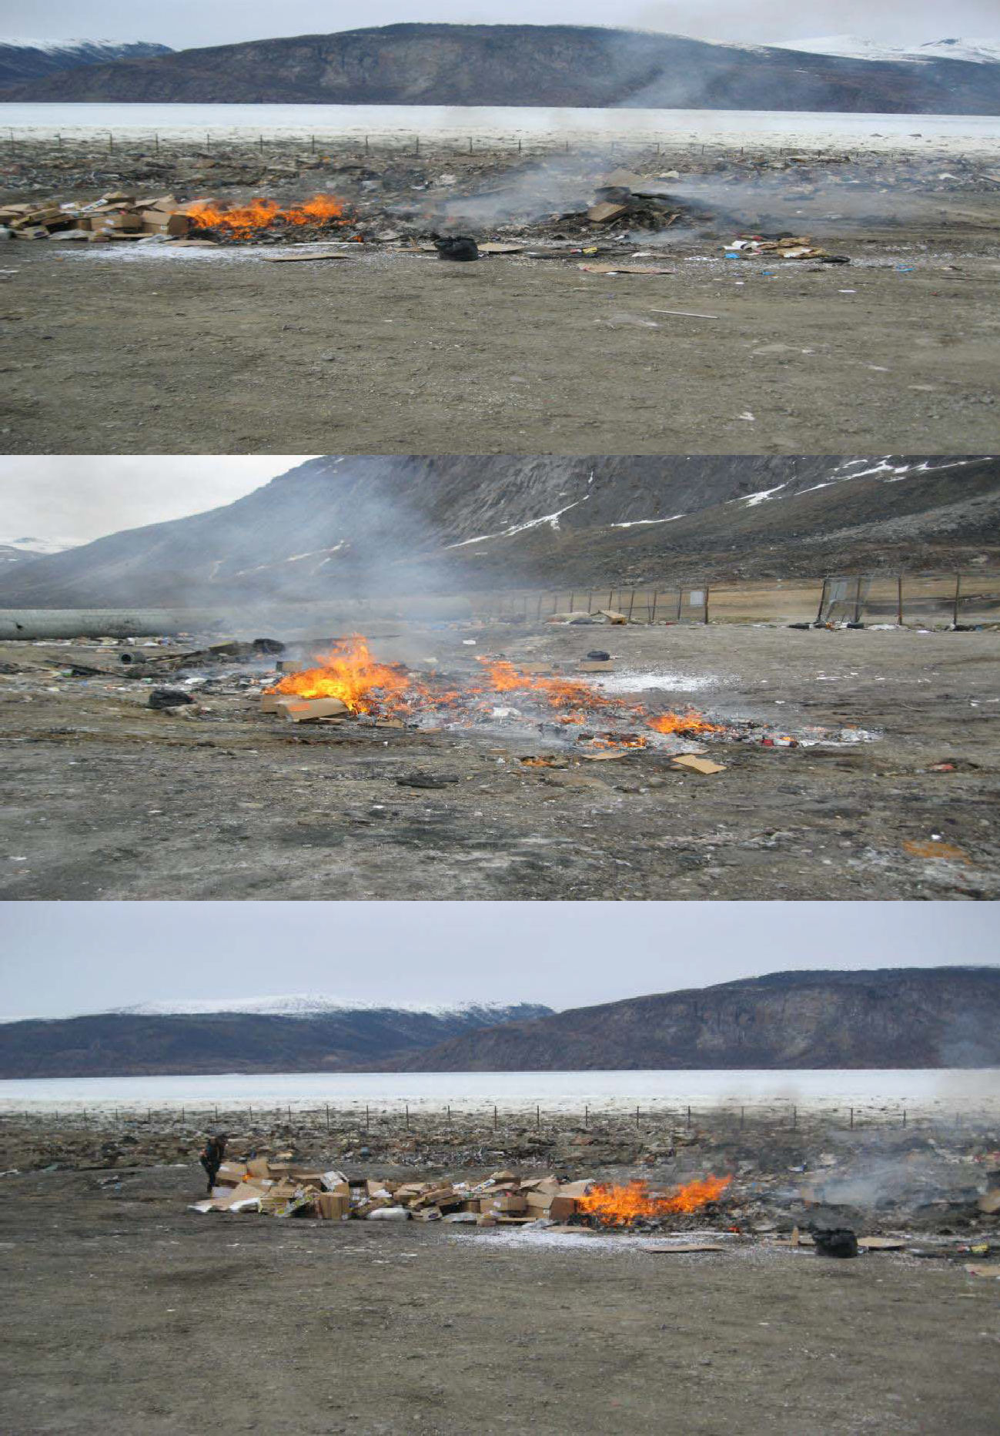

Fig.-11: Open garbage burning in Pangnirtung Land fill site

6.0 Bulk Metal / Hazardous Waste Storage Area

  - Bulk Metal Waste Management
Any bulk metal waste from the community should be disposed of within the bulk metal/hazardous waste disposal area. Handling of bulk metal waste requires less operational activity than MSW (e.g., will not be burned or covered) however proper waste segregation is still required and only specific bulk metal materials should be disposed of. The following is a list of bulk metal materials acceptable for disposal within the bulk metal/hazardous waste disposal area:
- Large metal wastes (i.e., decommissioned fuel tanks, drums, towers, poles/posts, culverts, etc.)
- Tires
- Appliances

- Properly abandoned vehicles, snowmobiles, and all-terrain vehicles (ATVs):

- Properly abandoned implies all vehicles have had their batteries removed and have been drained of fuel, oil, Antifreeze, transmission fluid, and other fluids; these wastes should be properly stored in the hazardous waste storage area.
- Vehicles can also contain ozone-depleting substances (ODS’) in their air conditioning systems. These systems should be properly decommissioned by a qualified technician/Operator.
- Once vehicles have been properly abandoned, they should be tagged to indicate they have been inspected and meet these criteria.

All bulk metal waste should be segregated into separate disposal areas for the above listed items (e.g., a vehicle disposal area, an appliance disposal area, etc.). Eventually all bulk metal waste should be removed from the community through a back haul program and properly disposed of at appropriate receivers. The Hamlet could work with other communities, the GN and a transportation company to establish a backhaul program to remove and dispose of bulk metal waste materials.

  - Hazardous Waste Management

Hazardous waste means any material no longer of use to the possessor whose chemical or biological properties have the potential to endanger personnel, material, or the environment if handled improperly. Such wastes contain one or more hazardous properties. Hazardous wastes come from a wide range of sources, including households, businesses of all types, and public services, such as health service, schools etc.

The Hazardous wastes include waste such as paint, waste fuel, mercury thermometers and switches from household appliances, capacitors and batteries, antifreeze, propane tanks, small flammable or explosive containers, etc. These items should be stored within a marked and separate area located at the solid waste site, until the wastes can be

Manage in open landfill Management process
Waste Type
General Waste

properly crated and shipped to an appropriate disposal facility. It is imperative that these wastes be kept separate from each other and that no mixing of these materials is to occur.
Is the material
Potentially harmful to people, Equipment or the Environment?
Maybe
No

Refer to the specific procedures for these wastes
Fig. 12: Identification of Hazardous Wastes
Is the waste a biological waste, used fluorescent lamp, used battery, used oil, used oil filter or radioactive material?
Managed as a hazardous waste

Hazardous wastes are those that are known to be dangerous due to their chemical, physical or biological properties, are no longer used for their original purpose, and are intended for recycling, treatment, disposal or storage (GNWT 1998, GN-DOE 2002). All hazardous wastes require special handling, storage and disposal methods to prevent human health and environmental exposure.
The Environmental Guideline for the General Management of Hazardous Waste (GN-DOE 2002) provides information regarding the proper management of hazardous waste in Nunavut, and has the intent to establish a monitoring system for hazardous wastes, from generation to final disposal. From the Guide, the generator of any hazardous waste is ultimately responsible for ensuring it will be properly managed from is creation to its disposal (GN-DOE 2002). Generators typically use carriers to transport the hazardous waste to appropriate receivers for disposal. Both carriers and receivers need to be registered with GN Environmental Protection Service and follow specific regulations and training.

The bulk metal/hazardous waste storage area is currently used to store hazardous wastes from the community. This

area is filled but not bermed or lined and runoff from the facility presently flows into the sewage treatment wetland. If use of this area is to continue for storage of hazardous wastes, it is recommended that an engineered berm and liner system be installed as this will limit the amount of potentially hazardous leachate entering the surrounding environment.

Generally, any household items which have the following symbols are considered HHW:



Corrosive Explosive Flammable Poison

Pangnitung solid waste disposal facility is only licensed to accept municipal wastes for disposal and shall only accept household hazardous wastes for storage. Industrial hazardous was sets shall not be accepted for storage or disposal at the Pangnirtung solid waste disposal facility. Industrial sources (generators) are responsible to manage their own hazardous wastes.

The following hazardous waste operations and maintenance procedures deal with household hazardous wastes (HHW) only. Typical HHW which may be found in Pangnirtung include:
- Pesticides and herbicide as
- Oil filters
- Paint
- Antifreeze
- Solvents (e.g., paint cleaners)
- Propane tanks and cylinders
- Flammable liquids
- Aerosol cans (not empty )
- Empty contaminant containers (e.g., 205 L fuel drums)
- Fluorescent light tubes and compact fluorescent light bulbs
- Batteries (wet and dry cell)
- Fire extinguisher
- Used and waste fuel and oil

- Corrosive cleaners

There are certain items considered HHW that cannot be stored within the solid waste facility. These include:

- Ammunition, flares and explosives (including fireworks) – contact the Pangnirtung RCMP for proper disposal
- Prescriptions, medications and bio-hazardous wastes (includes syringes) – dispose of these at the Health Care Centre
- Reactive chemicals (e.g.., ammonium nitrate) – contact the GN-DOE Environmental Protection Services for disposal options.

Contaminated soil or snow from the Hamlet’s own spill clean-up is the only non-HHW that should be accepted by the Hamlet for storage at the Hazardous Waste Storage Area. Contaminated soil or snow should be stored in 205 L steel drums and shipped out of the community every year. Industry, businesses or individuals wishing to store contaminated soil at the Hazardous Waste Storage Area must contact the Operations Manager or WSSW Foreman to discuss storage options and fees for any contaminated soil or snow. The decision to accept contaminated soil or snow for storage from industrial, commercial or private sources rests with the Hamlet.

6.2.1 Operations
As the current bulk metal/hazardous waste storage area is used for HHW storage, this area needs to be properly signed as the “Hazardous Waste Storage Area”. This area should also be fenced with a lockable gate and have appropriate storage options for expected HHW. Proper signage helps operators of the area properly store the wastes. Fencing around the area will allow only trained personnel access to the bulk metal/hazardous waste storage area and help minimize health and safety risks to the public from hazardous wastes and reduce the potential for vandalism.
The bulk metal/hazardous waste storage area is intended for storage only, not disposal. It is expected that hazardous wastes will be stored for up to five years. This should be sufficient time for the community to build up enough waste to make it economical for a back haul out of the community to a licensed waste receiver.

Additionally, the Hamlet should create a site map of the solid waste disposal facility, detailing disposal and storage locations for various wastes. This site map should be posted at the solid waste disposal facility, the Hamlet Garage and contained within the Spill Contingency Plan. All site personnel should be familiar with the layout and disposal/storage areas.

Collection
Since the entire solid waste disposal facility is generally accessible to the public, residents can come and drop off HHW throughout the year. However the general public should not have direct access to the bulk metal/hazardous waste storage area for health and safety reasons. If the Hamlet does not restrict access to the bulk metal/hazardous waste storage area (i.e., through a fence and locked gate), the public should be discouraged from entering the bulk metal/hazardous waste storage area and a designated public drop-off area for HHW should be used. The public drop-off area could be located within the MSW disposal area and tended to on a daily basis by the Foreman, Waste Truck Driver, or other designated and trained site personnel, to remove and properly store any deposited HHW into the bulk metal/hazardous waste storage area.

The Hamlet should also hold a ‘grace’ day for residents, helping them collect and drop off their HHW or bulky metal

wastes. This grace day can be held once or twice per year (e.g., in spring and/or fall) and should be advertised in the community up to 30 days before the event. This grace day will encourage residents to drop off their HHW and bulky metals wastes, and provide information pamphlets on HHW, waste disposal, segregation, and recycling. Like many community-based management programs, successful implementation comes from informed and concerned residents.
Providing facts and figures supporting proper disposal, segregation and minimization of hazardous wastes will help sustain hazardous waste management in the community.

Storage

All HHW collected needs to be properly stored in sea cans to ensure any environmental and human health hazards are minimized. The GN-DOE provides information on proper storage of specific HHW; these include:

- Antifreeze – use original containers where possible, or bulk-store waste antifreeze into good condition 16 gauge or lower gauge steel or plastic 205 L drums.

- Batteries – bulk-store waste batteries into good condition 16 gauge or lower gauge steel or plastic 205 L drums, or other form of containment away from weather; wooden pallets should be used to keep batteries and containers off the ground during storage and transport.

- Fluorescent light tubes/compact fluorescent light bulbs – use original containers where possible and prevent breakage of light tubes/bulbs; keep away from weather.

- Ozone Depleting Substances (ODS’) – do not landfill; wastes with ODS’ (i.e., refrigerators and refrigeration equipment, vehicle air conditioners, ODS-containing fire extinguishers (typically purchased before 1997) should be diverted to the bulk metal waste disposal area. The Hamlet can hire technicians to remove ODS’ from stored equipment.

- Paint – use original containers where possible, or bulk-store compatible paints into good condition 16 gauge or lower gauge steel or plastic 205 L drums; do not mix different types of paint (i.e., alkyd and latex).

- Solvent – use original containers where possible, or bulk-store compatible waste solvents into good condition 16 gauge or lower gauge steel or plastic 205 L drums.

See the GN-DOE website (http://www.gov.nu.ca/env/environment.shtml) for further information on guidelines for storage and disposal of HHW.
As the Hamlet currently stores waste oil in drums at the bulk metal/hazardous waste storage area (if not burned within BLCS’ waste oil burners), it is recommended they register the site as a hazardous waste storage facility with the GN-DOE Environmental Protection Services (R. Eno, pers. comm.). Registering the facility will help the GN- DOE monitor and track hazardous wastes, and eventually improve handling and disposal in the territory. When developing and operating the bulk metal/hazardous waste storage area in Resolute Bay, several factors also need to be considered. From Phifer and McTigue Jr. (1988) and GN-DOE (2002), these are:

- Regulatory Compliance

The GN-DOE Environmental Guideline for the General Management of Hazardous Waste and hazardous waste minimum storage volumes should be considered when planning and operating the bulk metal/hazardous waste storage area.

- Compatibility

Compatibility of wastes and their storage containers, and wastes and nearby materials should be considered. For example, some wastes need to be stored in specific containers to minimize the potential for corrosion and leaks (e.g., acids cannot be stored in steel drums due to corrosion; waste fuel should not be stored long-term in plastic drums). Additionally, not all wastes can be stored in the same area (e.g., flammable wastes near ignition sources).

- Packaging

Storage of HHW in original containers is acceptable. Bulk storage of compatible HHW in 205 L 16 gauge or lower gauge steel or plastic drums is generally acceptable though may depend on the type of waste. All containers need to be in good condition and sealable. Contact the GN-DOE or a licensed waste carrier or receiver for advice on specific wastes. All storage containers also need to be properly labeled, following requirements of WHMIS or Transportation of Dangerous Goods regulations, if transport is planned.

- Segregation

If some HHW can be recovered or recycled at a later time, the HHW should be segregated and stored in a manner to allow this. Final destination of the HHW should be considered during storage.

- Ventilation

All HHW should be properly ventilated to reduce buildup of potentially poisonous or noxious fumes. Most wastes should be stored outside in sheds or under roofs providing free air movement.

- Climate
Not all HHW can be stored directly outside. Waste containers should be stored with some overhead cover (e.g., roof or tarp) and on an impermeable base to prevent contact with rain, snow and direct sunlight. This also makes cleanup of spills and leaks easier and cheaper. Some communities utilize old sea cans for storage of some HHW.

  - Handling
All handlers of HHW will have proper training. At a minimum, all handlers should have WHMIS (Workplace Hazardous Materials Information System) training.

    - Security
Certain security precautions may need to be taken to prevent theft, accidental discharge or harm to the public from collected HHW. Only persons authorized and trained to handle HHW should have access to the bulk Metal/hazardous waste storage area.

6.2.2 Maintenance

General maintenance procedures for the bulk metal/hazardous waste storage area should occur during daily operations at the solid waste disposal facility. These maintenance procedures involve ensuring proper segregation and storage of wastes, prompt cleaning and reporting of any leaks or spills, and general site tidiness.
Inspections of the bulk metal/hazardous waste storage area should occur with the weekly inspections of the entire solid waste disposal facility by the Foreman or other trained personnel (see Appendix-D).

6.2.3: Current steps

Currently the Hamlet is planning to segregate wastes and retain hazardous wastes in the designated area. The initial attempt is to bring a second sea can to store all the batteries. The next step is to retain all the propane and waste oil drums on the wooden platform and isolate the area. This process is expected to be completed in 2018 and this O&M manual will be upgraded accordingly to submit to NWB along with the Hamlet’s Annual Report of 2018.

7.0 Solid Waste Disposal Facility Maintenance

7.1 Inspections and Audits
Regular inspections of the solid waste disposal facility will provide the Foreman, SAO and other personnel with information on the effectiveness of waste segregation, burning, landfilling, signage, and any remedial activities. Inspections are an integral part of the maintenance procedures at the solid waste disposal facility as they identify any concerns and deficiencies, and recognize areas or items which need improvement, correction, repair, and/or replacement.
The Foreman, or trained personnel appointed by the Foreman, should complete weekly inspections of the MSW disposal facility and bulk metal/hazardous waste storage area; monthly or bi-monthly inspections by the Foreman could also be performed. Site Inspection Forms will be used to document the findings of the inspections and ensure basic items requiring weekly inspection and/or maintenance are examined. Site Inspection Forms will also document other relevant information, such as weather conditions, health and safety concerns, and follow-up on any incidents which may have occurred (e.g., accident, fires, flooding, spills, etc.) or deficiencies noted in previous inspections. The following factors will be inspected:
- Site equipment (including heavy equipment, signage, and any storage containers)
- Site infrastructure (including access road, truck pads, drainage systems, fencing, berms, landfill cover and erosion)

- Waste segregation
- Burn completion and proper burn practices
- Proper landfilling practices
- Health and safety concerns (public and personnel)
- Hazardous waste storage area.

The Site Inspection Forms should be filed at the Hamlet Office and results reported to the SAO monthly. The SAO is required to include inspection results and maintenance activities in the Hamlet’s Annual Report to the NWB. A Solid Waste Disposal Facility Inspection Form has been included in Appendix D.
Following year end, the Hamlet will undertake a review of the past year’s inspection results and follow-ups to determine where improvements to the solid waste disposal facility operations and maintenance are required. These improvements should be documented and the O&M Manual is updated accordingly.

  - Maintenance Activities
Specific maintenance activities may need to be completed on portions of the solid waste disposal facility. This will help ensure the facility, including the MSW disposal area and bulk metal/hazardous waste storage area, remain in good condition, appropriate practices are followed, and human health, safety, and environmental hazards are minimized. The following maintenance activities may be required periodically:
- Grading (in summer) or clearing snow (in winter) of all access roads and truck pads used for the solid waste disposal facilities
- Repair of drainage ditches from erosion

- Fence repair
- Repair or replacement of signage
- Litter which has been wind carried to the surrounding area outside the MSW disposal area fence should be removed and deposited back in the MSW disposal area
- Litter which has accumulated against the fence of the MSW disposal area should be removed and deposited
- back in the MSW disposal area
- Repair of the MSW disposal area landfill cover from erosion or settling.

  - Fence and Signs
The landfill site is fully fenced. The metal dump is unfenced. This high fence prevents the migration of windblown debris out of the MSW disposal area. Maintenance activities should be performed on the fence around the solid waste disposal facility and on signage within the solid waste disposal facility to ensure they remain in good condition. Signage is posted on the fence and additional signage should be considered. Maintenance activities of the fence and signs include:

- Weekly inspection of the fence around the solid waste disposal facility to remove any windblown material which has accumulated; this can be performed by the Waste Truck Driver(s) and/or Foreman to
reduce loading on the fence and improve site aesthetics.

- Monthly inspection of the fence around the solid waste disposal facility to ensure the chain-link is in good condition, fence posts are stable (e.g., no evidence of frost heave), gates are in good working condition, and snow drifts are removed.

- Two metallic signs were installed at stations PAN-4 and PAN-5 of the land fill site for leachate sampling

- Monthly inspection of signage to ensure it is still present and readable.

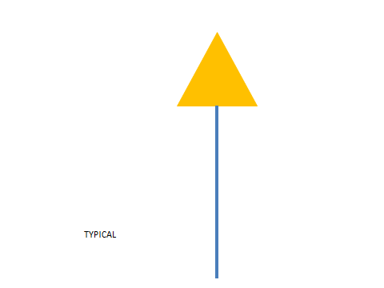
TYPICAL MONITORIG SIGN
PAN-

Fig. 13: Typical Monitoring Sign

8.0 Quality Control and Quality Assurance (QA/QC): Monitoring and Sampling

  - Monitoring Requirement

Table-7: Monitoring Station

Monitoring Station | description | Frequency
PAN-3 | First point of pipe effluent discharge from the WWTP | Monthly
PAN-4 | Leachate sampling from sludge dumping area of the land fill site | Three times: at the beginning, at the middle and near the end of the season when flow is observed.
PAN-5 | Leachate sampling from domestic waste dumping area | Three times: at the beginning, at the middle and near the end of the season when flow is observed.
PAN-6 | Run-off from the metal storage area | Three times: at the beginning, at the middle and near the end of the season when flow is observed.

Monitoring programs are carried out to help ensure all systems are functioning correctly as they provide important Feedback to the operators, helping them track progress of the system and providing warning or notice when issues arise. Monitoring programs also ensure any requirements or guidelines for water quantity and/or quality are being met; these requirements are typically provided in the community’s water license. Monitoring programs form an integral part of the O&M process for all facilities and it is important to ensure they are being completed successfully. The Monitoring Program outlined in the Hamlet’s Water License requires that one station is monitored downstream of the solid waste disposal facility. The solid waste disposal facility monitoring station will provide water quality information to operators and regulators and help assess the leachate quality leaving the solid waste disposal facility and entering the sewage treatment. Leachate quality data will also help assess leachate treatment performance of the sewage treatment wetland and provide an indication of waste segregation success. A description and the location of this station are provided in Table 7.

The leachate at the PAN-4, PAN-5 and PAN-6 sampling stations should be sampled annually when flow is present. All samples taken from these stations will be analyzed for:
  - Biochemical Oxygen Demand (BOD5)
  - Carbonaceous Biochemical Oxygen Demand (cBOD)
  - Total Metals (including aluminum, arsenic, cadmium, cobalt, chromium, copper, iron, lead, nickel, Manganese, mercury and zinc)
  - Total Alkalinity
  - Total Suspended Solids (TSS)
  - Conductivity
  - Total Organic Carbon (TOC)

- Fecal Coliforms
- Polycyclic Aromatic Hydrocarbons (PAHs)

- Ammonia Nitrogen
- Nitrate-Nitrite
- Anions and Cations (including calcium, chloride, magnesium, potassium, sodium and sulphate)
- Total Hardness
- pH
- Total Phenols
- Oil and Grease (visual)
- Total Petroleum Hydrocarbons (TPHs)
- Benzene, Toluene, Ethyl benzene and Xylene (BTEX)

  - Sampling Procedures

As mentioned above, the leachate at stations PAN-4 and PAN-5 should be three times annually during periods of flow. Water samples will be taken by the Foreman, or other trained personnel appointed by the WSSW Foreman, and sent to Caduceon Environmental Lab in Ottawa, ON for analyses. The parameters listed above will be examined in water samples of leachate from the solid waste disposal facility.
Guidelines for the collection of leachate samples from downstream of the solid waste disposal facility are found in Appendix A. The sample collection procedures should be carried out for all sampling within or downstream of the solid waste facilities to ensure the correct sample bottles are obtained, proper sampling procedures are completed, and contamination of the samples is minimized.

Hamlet is following QA/QC protocol for sampling, shipping and testing of Caduceon lab in Ottawa.

  - Record Keeping
Records of activities, inspections, and sampling at the solid waste disposal facility should be kept. These records should be stored at the Hamlet office and kept by the Foreman and SAO. These records will assist with the planning of annual operations and maintenance of the solid waste disposal facility, as well as assess how successful facility practices (e.g., waste segregation, HHW storage, etc.) are operating.
st

Every year by March 31
, the Hamlet is required to submit an Annual Report to the NWB. The Annual Report

provides the NWB with information pertaining to the results of the Monitoring Program, quantities of solid waste disposed, and summaries of any modifications, major maintenance work, and spills. Therefore, at a minimum, the following records should be kept:

- Number of trips the garbage truck makes per day;
- Quantity (weight) of MSW disposed of per day (tallied for monthly and annual quantities);
- Quantity (weight and/or volume) and types of HHW stored at the bulk metal/hazardous waste storage area;
- Dates any leachate sampling has been completed;
- Results from any leachate sampling;
- Dates and description of any maintenance activities (including inspections) carried out on the disposal

Facilities by Hamlet personnel or other Inspectors;
- Dates and descriptions of any modifications and/or major maintenance work, and abandonment and restoration work carried out on the disposal facilities, including on associated structures, facilities and equipment (e.g., old waste oil pit, compactor truck, CAT bulldozer, grader, etc.); and,
- Dates, description and clean-up activities of any spills (fuel, oil, hazardous waste, etc.) related to the MSW disposal area, or bulk metal/hazardous waste storage area.

9.00: Emergency Response

Surface Fires
If site personnel discover a surface fire in the solid waste disposal facility, the Hamlet of Pangnirtung Fire Department will be called immediately and informed of the situation.

Pangnirtung FIRE DEPARTMENT: (867) -473-4422
In the event of an uncontrolled fire during routine burning of MSW, the Fire Department will be contacted and should assess the danger of the burn. Depending on the burn severity, the Fire Department may assume control of the MSW disposal area. The MSW disposal area should normally be closed to the public during any controlled open burn of MSW and will remain closed if a burn becomes uncontrolled, until the Fire Department has deemed the site safe. If site personnel discover a small surface fire, fire extinguishers located at the solid waste disposal facility or in site vehicles can be used to manage small fires. Covering a fire with soil by hand or using the CAT D6 bulldozer may also be used. However, site personnel should not attempt to fight a fire if it cannot be done safely.
The cause of any surface fires will be investigated and necessary steps taken to prevent an uncontrolled surface fire from recurring. The fire incident and all response measures should be documented on the weekly Solid Waste Disposal Facility Inspection Form (Appendix D), and reported to the Hamlet Foreman and Hamlet SAO.

Subsurface Fires
If a subsurface fire is suspected within the MSW disposal area, the Pangnirtung Fire Department will be called and informed of the situation. The solid waste disposal facility should be closed to the public whenever a subsurface fire is suspected.
The Fire Department should be called to site to determine if a subsurface fire is present and to assess the danger of the fire. The Fire Department may assume control of the solid waste disposal facility if the subsurface fire is deemed an emergency. Hamlet personnel should not excavate a suspected subsurface as the fire may quickly get worse when exposed to more oxygen, may release toxic or poisonous fumes, or may have caused underground voids causing an unstable surface prone to collapse. The Fire Department should manage the suppression of any subsurface fires.
The cause of any subsurface fires will be investigated and necessary steps taken to prevent a subsurface fire from recurring. The fire incident and all response measures should be documented on the weekly Solid Waste Disposal Facility Inspection Form (Appendix D), and reported to the Hamlet Foreman and Hamlet SAO.

10.0 Spill Contingency Plan
The intent of this Spill Contingency Plan (SCP) is to provide a guide to operators and other Hamlet personnel in the event of an accidental release of fuel and solid waste facilities in Pangnirtung. The SCP is planned to be protective of the local environment and public and personnel health and safety.
This SCP has been developed for implementation at the solid waste disposal facility in Pangnirtung. At these sites, there may be situations that arise that are beyond the scope of this SCP. In these situations, all activities at the site should stop until a revised procedure or SCP is prepared, reflecting the changing conditions at the site (e.g., operation of a new hazardous waste storage area [if developed] should not continue until this SCP is updated to reflect the new conditions).
All persons involved with operations at the solid waste facilities should read and be familiar with this SCP. To be effective, it is important that all personnel are familiar with their responsibilities and steps to take in the event of a spill. Personnel should not be reading the SCP for the first time during an emergency.

  - Site Descriptions
The solid waste facilities have been described in the preceding sections of this O&M Manual. The sites are shown on Figure- 2.

  - Regulations
Under Section 34 of the Environmental Protection Act, the Nunavut Consolidation of Spill Contingency Planning and Reporting Regulations was enabled by the Commissioner in 1998. In the Spill Contingency Planning and Reporting Regulations, a SCP is required to include the following:
- The name and address of the owner or person in charge, management or control of the site(s).
- The name, job title and 24-hour telephone number for the person(s) responsible for activating the Contingency plan.
- A description of the facility (ies) including location, size, type and amount of contaminants normally stored on the site(s), and site map(s).
- The steps to be taken to report, contain, clean up and dispose of a contaminant in the case of a spill.
- The means by which the contingency plan is activated.
- An inventory and location of the response and clean-up equipment available to implement the plan.
- A description of the training required and provided to employees who respond to a spill.
- The date the plan was prepared.

  - Contacts and Regulatory Authorities
The SAO has overall responsibility of Hamlet solid waste facilities. The Foreman manages the facilities and is responsible for initiating the Spill Contingency Plan. The Foreman should be contacted when a spill occurs at the solid waste facilities. Contact information as follows.

Distribution List:

This plan and most recent revisions will be distributed to:

Ralph Ruediger Director, Community Development, GN-CGS
Ph.: 867 645 8156
Bhabesh Roy Municipal Planning Engineer, GN- CGS
Ph.: 867 899 7314
Ron Ladd Senior Administrative Officer
Ph.: 867 473 8953
Justin Hack Inspector, AANDC
Ph.: 867-975 4517
Karen Kharatyan Manager of Licensing, Nunavut Water Board
Ph.: 867 360 6338
Every time a spill is identified at the solid waste facilities, the Foreman should be contacted as soon as possible. The 24-hour Emergency Spills Report Line should also be contacted in the event any quantity of contaminant is spilled.

24-HOUR EMERGENCY SPILL REPORT LINE: (867) 920-8130
Any person reporting a spill is required to give as much information as possible, however reporting of a spill should not be delayed if all of the necessary information is not known. Additional information can be provided later. From the Consolidation of Spill Contingency Planning and Reporting Regulations (1998), as much of the following information should be reported during the initial spill report:
- Date and time of spill
- Location of spill
- Direction spill is moving
- Name and phone number of a contact person close to the location of the spill
- Type of contaminant spilled and quantity
- Cause of spill
- Whether spill is continuing or has stopped
- Description of existing contaminant
- Action taken to contain, recover, clean up, and dispose of spilled contaminant
- Name, address and phone number of person reporting the spill
- Name of owner or person in charge, management or control of contaminants at the time of the spill.

Other regulatory agencies which have a legislated (vested) interest in the event of a spill are summarized in Table 6-2 below. These authorities do not need to be immediately contacted if a spill occurs, however may be involved in follow-up or additional clean-up activities.

  - Potential Contaminants

At the date of this SCP, the Hamlet of Pangnirtung had not completed a waste inventory and exact types and quantities of contaminants are unknown. However the following contaminants are anticipated to be used at the facilities, and may be involved in a spill:

- Gasoline
- Other lubricating oil
- Diesel
- Antifreeze and other coolants
- Hydraulic oil
- Sewage
- Motor oil

- Batteries

At the solid waste facilities, spills may result from any of the following occurrences:
- Leaks or ruptures of fuel storage tanks
- Valve or line failure in systems, vehicles or heavy equipment
- Heat expansion due to overfilling or improper storage
- Improper storage of contaminants
- Vehicular accidents
- Spill during transfer of contaminant
- Vandalism.

  - Spill Response Procedures
The following steps outline the general spill response procedures for reporting, containing, cleaning up and disposing of materials in the event of hydrocarbon (e.g., fuel, oil, etc.) and other waste spill, or sewage spill.

  - Hydrocarbon Spills
Three procedures for hydrocarbon spills have been developed depending on the media on which the spill has occurred. The following sections outline procedures for hydrocarbon or other waste spills occurring on land (soil, gravel, sand, rock and vegetation), water, or snow/ice.

Spills on Land

- Once a spill is identified, all sources of ignition turned off (e.g., no smoking, shut off engines).
- The spilled material (e.g., gasoline, diesel, antifreeze, etc.) should be identified, if possible.
- The affected area should be secured, ensuring the area is safe for entry and does not represent a threat to human health and safety of the spill responders. Public access of the area should be restricted.
- If possible, identify where the spill is coming from (the source). Determine if the spill is still occurring (i.e., still leaking) or if the spill has stopped. If the spill has not stopped, determine if it is safe to stop or control the spill (e.g. plug hole, close valve, upright container), or contain the spill (e.g., place a container or tarp with built up edges under the spill source to contain the spill).
- If the spill is too large to be controlled with the spill materials at hand, contact the Foreman and report the spill immediately.

- If the spill is small enough to be controlled with the materials at hand, prevent spilled contaminants from spreading or entering waterways by using sorbent (oil-absorbing) materials or a soil dyke down slope from the spill. This is especially the case with liquid contaminants (e.g., gasoline, diesel). If some contaminant has entered a waterway, follow procedures in the next section (Spills on Water) to contain and clean-up the contaminant in the water.
- Once the spill has been controlled and further spreading prevented, contact the Foreman and report the spill.
- If possible with spill response materials at hand, clean up the remaining spilled contaminant and store contaminated materials in a secure container for disposal. Do not flush the affected area with water.
- If possible, remove any contained liquid by pumping into secure drums.

- If needed, assist the Foreman by providing details to complete the Nunavut Spill Report Form with as much information as possible. This form is included in Appendix B.
- The Foreman will contact the 24-Hour Emergency Spill Report Line (Phone: (867) 920-8130) to report the spill as soon as possible and obtain additional advice.
- The Foreman will fax the completed Nunavut Spill Report Form to the 24-Hour Emergency Spill Report Line: Fax: (867) 873-6924.

Spills in Water

- Once a spill is identified, all sources of ignition turned off (e.g., no smoking, shut off engines).
- The spilled material (e.g., gasoline, diesel, antifreeze, etc.) should be identified, if possible.
- The affected area should be secured, ensuring the area is safe for entry and does not represent a threat to Human health and safety of the spill responders. Public access of the area should be restricted.
- If possible, identify where the spill is coming from (the source). Determine if the spill is still occurring (i.e., still leaking) or if the spillage has stopped. If the spill has not stopped, determine if it is safe to stop or control the Spill (e.g., plug hole, close valve, upright container).
- If the spill is too large to be controlled with the spill materials at hand, contact the Foreman and report the Spill immediately).
- If the spill is small enough to be controlled with the materials at hand, use sorbent (oil absorbing) booms to contain the spill for recovery. Place sorbent sheets on the water within the boomed area to help contain the

Spill. For narrow waterways, place one or more sorbent booms across the waterway, downstream of the spill
location, and anchor the booms on the each bank.

- Once the spill has been controlled and further spreading prevented, contact the Foreman and report the spill.
- If possible with the spill response materials at hand, clean up the remaining spilled contaminant within the boomed area. Store contaminated materials in a secure container for disposal.
- If needed, assist the Foreman by providing details to complete the Nunavut Spill Report Form with as much information as possible. This form is included in Appendix B of this O&M Manual.

- The Foreman will contact the 24-Hour Emergency Spill Report Line (Phone: (867) 920-8130) to report the Spill as soon as possible and obtain additional advice.
- The Foreman will fax the completed Nunavut Spill Report Form to the 24-Hour Emergency Spill Report Line (Fax: (867) 873-6924).

Spills on Snow/Ice

- Once a spill is identified, all sources of ignition turned off (e.g., no smoking, shut off engines).
- The spilled material (e.g., gasoline, diesel, antifreeze, etc.) should be identified, if possible.
- The affected area should be secured, ensuring the area is safe for entry and does not represent a threat to human Health and safety of the spill responders. Public access of the area should be restricted.
- If possible, identify where the spill is coming from (the source). Determine if the spill is still occurring (i.e., still leaking) or if the spillage has stopped. If the spill has not stopped, determine if it is safe to stop or control the spill (e.g., plug hole, close valve, upright container).
- If the spill is too large to be controlled with the spill materials at hand, contact the Foreman and report the spill immediately (see Section 6.2.3 above for contact information), particularly
since a spill occurring on snow or ice presents the potential for immediate access of contaminants into waterways.

- If the spill is small enough to be controlled with the spill response materials at hand, prevent spilled contaminants from spreading or entering waterways by using sorbent materials or a snow/soil dyke down slope from the spill. This is especially the case with liquid contaminants (e.g. gasoline, diesel).
- Once the spill has been controlled and further spreading prevented, the Foreman will provide a report.
- If possible with the spill response materials at hand, clean up the remaining spilled contaminant and store contaminated materials in a secure container for disposal. Impacted snow should also be stored in drums for disposal.
- If needed, assist the Foreman by providing details to complete the Nunavut Spill Report Form with as much information as possible. This form is included in Appendix - of this O&M Manual.
- The Foreman will contact the 24-Hour Emergency Spill Report Line (Phone: (867) 920-8130) to report the spill as soon as possible and obtain additional advice.

- The Foreman will fax the completed Nunavut Spill Report Form to the 24-Hour Emergency Spill Report Line (Fax: (867) 873-6924).

Additional Spill Delineation or Monitoring
In the event of a large spill or a spill in which not all of the spilled contaminant can be readily cleaned up with materials at hand (as described above), delineation of the affected area may be required. This would include subsurface investigation of the area (i.e., digging of test pits, soil sampling, installation of monitoring wells) to determine how large and how deep the contaminant affected the subsurface soil and/or groundwater (horizontal and vertical extent of the spill). The delineation would result in the development of an appropriate remediation plan for the affected area. In this case, a qualified environmental consultant should be retained to provide advice on how to proceed with delineation and remediation of a large spill.

  - Spill Kit and Training Requirements
The following sections outline the recommended minimum requirements for contents and number of spill kits that should be present at the water, sewage and solid waste facilities. Personnel training requirements are also provided.

  - Spill Kit Contents
Each spill kit should be regularly inspected to ensure it always contains the following, at a minimum (in part from INAC [2007]):
- 1 – 205 L open top steel drum with lid, bolting ring and gasket (spill kit container)
- 4 – 12.5 cm x 3 m (5 in. X 10 ft.) sorbent booms
- 10 kg bag of sorbent particulate
- 1 roll duct tape
- 1 field notebook and pencil
- 1 pick-axe
- 4 Tyveks® splash suits
- 4 pairs of splash protective goggles

- 10 disposable large 5 mil polyethylene bags (dimensions 65 cm x 100 cm) with ties
- 100 sheets (1 bail) of 50 cm x 50 cm sorbent sheets
- 2 large (5 m x 5 m) plastic tarps
- 1 utility knife
- 1 rake
- 3 spark-proof shovels
- 4 pairs chemical resistant gloves
- Instruction binder, including Spill Contingency Plan

The entire spill kit contents, with the exception of the spark-proof shovels, can be stored within the 205 L steel drum. The drum should be sealed securely to protect the spill kit contents though should always be accessible without the use of tools (i.e., finger tight bolt ring). The drum’s bolt ring should be inspected regularly during facility inspections to ensure it turns freely and is lubricated.
Extra spill response materials should also be available for use, in addition to the spill kit contents. These include:

- 10 – 205 L open top steel drum with lid, bolting ring and gasket
- 2 spark-proof shovels
- 50 disposable large 5 mil polyéthylène bags (dimensions 65 cm x 100 cm)
- 10 – 12.5 cm x 3 m (5 in. X 10 ft.) sorbent booms
- 5 – 10 kg bags of sorbent particulate
- 500 sheets (5 bales) of 50 cm x 50 cm sorbent sheets
- 2 Tiveks ® splash suits
- 2 pairs of chemical resistant gloves
- 2 pairs of splash protective goggles

  - Spill Kit Locations
At least one spill kit should be clearly marked and present at the solid waste disposal facility (within the facility). One spill kit should also be present within the water distribution facility, located at the pump house.

  - Required Training
To ensure the SCP is carried out effectively, the following actions should occur:
- The SCP should be reviewed annually to ensure it is still up-to-date for current conditions.
- When required, the SCP should be revised to reflect current conditions.
- The SCP should be distributed to and read by all personnel who work at the Hamlet’s Solid waste facilities.
- Personnel at these facilities should be familiar with the location of all HHW and other potentially hazardous materials, and their associated Material Safety Data Sheets (MSDS).
- Personnel at these facilities should be trained to read and use MSDS, and have their WHMIS training, at a minimum.

- Personnel should receive proper spill response training to learn and understand the techniques and Materials used to contain, clean up and remediate spills. Trained personnel will be aware of the importance of first response in reducing the impact of spills with respect to protecting human health and safety, the Environment and property.

10.11: Off-site Resources

The following resources are available for assistance if needed:

Territorial 24-Hour Spill Line | (867) 920-8130
Aboriginal and Northern Affair Canada (AANDC) | (867) 669-2761
GN – Emergency Measures Officer | (888) 624-4043
Pangnirtung Health Centre | (867) 473-8977
RCMP (Pangnirtung) | (867) 473-1111
Environment Canada (Emergency) Yellowknife | (867) 669-4725
GN Environmental Health Office | (867) 975-4817
First Air Cargo | 1-800-267-1247 or (867) -473-8960

11.0: Record Keeping

Records of any spills, spill response activities, follow-up inspections, monitoring, and any additional remedial work must be kept. These records should be stored at the Hamlet office and kept by the SAO. These records will assist with the annual review of the SCP, operations and maintenance practices at all facilities, and spill response
requirements.

Every year by March 31
st
, the Hamlet is required to submit an Annual Report to the NWB. The Hamlet is required to

provide a list of all spills and a summary of follow-up action taken for each spill. Therefore, at a minimum, the following records should be kept:

- Reports of all spills and spill reports submitted to the 24-Hour Emergency Spill Report Line;
- Types and quantities of spill contaminants;
- All spill follow-up activities;
- Inspections of spill kit contents and replacement records for any items; and,
- Records of spill response training for all Hamlet spill responder personnel.

References:

- Operation and Maintenance Manual for Water, Sewage and Solid waste Facilities of Baker Lake Nunavut prepared by Stantec, 2011

- Comprehensive Feasibility Study of Waste Management of the Hamlet of Pangnirtung by Dillon Consulting ltd, 2007.

- “Guidelines for the Preparation of an Operations and Maintenance Manual for Sewage and Solid Waste Disposal Facilities in the Northwest Territories, Duong and Kent, 1996”

Appendices:

Appendix-A: Guidelines for Sampling Program Appendix-B: Spill Reporting Form for Pangnirtung
Appendix-C: Monthly Municipal Solid waste Quantity Form Appendix-D: Monthly Solid waste Disposal Facility Inspection Form
Appendix-E: Cumulative wastes Production: Domestic, Sludge and Fish wastes Appendix-F: A letter from Fish Plant on Fish waste Management

APPENDIX-A

GUIDELINES FOR WATER, WASTEWATER AND LEACHATE SAMPLING AND TESTING

Guide Lines for Water, Wastewater and Leachate sampling
Baffin Communities
Drinking water:

Monthly Sampling: (Bacteria analysis)

Collect five samples (200 ml each) from five different locations and send to Iqaluit Health Lab though your local health center. One of the five samples should be raw water sample.
Once in month if population is less than 1000.

Twice in a month if population is in between 1000 to 2000

Iqaluit Lab for all Baffin Communities.

Environmental Health Department Health and Social Services, Baffin P.O.Box 1000, Station 1046 Iqaluit, NU, X0A 0HO
Annual Sampling: (Chemical Analysis)
    - Send samples to Ottawa Lab (All Baffin Communities) once a year for Chemical Analysis.
Caduceon Environmental Laboratories Gord Murphy
2378 Holly Lane
Ottawa Ontario K1V 7P1 Tel: 613-526-0123
Fax: 613 526 1244

Precautions of Sampling:

Be careful not to let the mouth of the bottle or lid touch anything including sampler’s fingers.
- Do not overfill the bottle or rinse out
- Fill the bottle to the 200ml line from water tap, valve or water truck delivery hose nozzle. When sampling from a water tap, remove screen, aerator or other attachment from tap and allow the cold water to run for 2‐3 minutes before collecting. Do not dip into the filled water truck tank to take a sample.
- Ensure each bottle label information is filled for:
‐ Date and time sample was taken
‐ Sample point location
‐ Sampler’s name
- Persons’ name and contact address where to send sample Test results and invoice.
- Samples must arrive at the Labs either Iqaluit or Ottawa within 24 hrs. from the time of sampling.

Wastewater:

- Collect five treated samples from the first point of discharge of Sewage (end of pipe).
- Collect Five raw samples directly from the truck discharge
Leachate:

- Collect five leachate samples from the land fill site
Sample bottles specifications for Wastewater and leachate:
Five samples should be taken from a point in five different bottles: Bottle 1: 500 ml
Bottle 2: 100 ml Bottle3: 1000 ml Bottle 4: 250 ml

All the wastewater and Leachate samples will be sent to Ottawa Lab.
Gord Murphy
Caduceon Environmental Laboratories Gord Murphy
2378 Holly Lane
Ottawa Ontario K1V 7P1 Tel: 613-526-0123
Fax: 613 526 1244

Precautions of sampling:

Use hand gloves
  - Ensure each bottle level information is filled:
    - ‐Date and time sample taken
    - ‐Location with GPS coordinates
    - ‐Sampler’s name
  - Person’s name and contact information where to send sample Test Results and invoice.

  - Samples must be arrived Ottawa Lab within 24 hours from the time of sampling.

APPENAIX-B SPILL REPORTING FORM

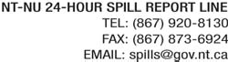

REPORT LINE USE ONLY
A | REPORT DATE: MONTH – DAY – YEAR |  |  |  | REPORT TIME |  |  | ORIGINAL SPILL REPORT, OR UPDATE #  TO THE ORIGINAL SPILL REPORT |  |  |  |  |  | REPORT NUMBER  -
B | OCCURRENCE DATE: MONTH – DAY – YEAR |  |  |  | OCCURRENCE TIME
C | LAND USE PERMIT NUMBER (IF APPLICABLE) |  |  |  |  |  | WATER LICENCE NUMBER (IF APPLICABLE)
D | GEOGRAPHIC PLACE NAME OR DISTANCE AND DIRECTION FROM THE NAMED LOCATION |  |  |  |  |  |  |  |  | REGION  NWT NUNAVUT ADJACENT JURISDICTION OR
E | LATITUDE  DEGREES MINUTES SECONDS |  |  |  |  |  | LONGITUDE  DEGREES MINUTES SECONDS
F | RESPONSIBLE PARTY OR VESSEL NAME |  |  | RESPONSIBLE PARTY ADDRESS OR OFFICE LOCATION
G | ANY CONTRACTOR INVOLVED |  |  | CONTRACTOR ADDRESS OR OFFICE LOCATION
H | PRODUCT SPILLED |  |  | QUANTITY IN LITRES, KILOGRAMS OR CUBIC METRES |  |  |  |  |  |  |  | U.N. NUMBER
H | SECOND PRODUCT SPILLED (IF APPLICABLE) |  |  | QUANTITY IN LITRES, KILOGRAMS OR CUBIC METRES |  |  |  |  |  |  |  | U.N. NUMBER
I | SPILL SOURCE |  |  | SPILL CAUSE |  |  |  |  |  |  | AREA OF CONTAMINATION IN SQUARE METRES
J | FACTORS AFFECTING SPILL OR RECOVERY |  |  | DESCRIBE ANY ASSISTANCE REQUIRED |  |  |  |  |  |  | HAZARDS TO PERSONS, PROPERTY OR ENVIRONMENT
K | ADDITIONAL INFORMATION, COMMENTS, ACTIONS PROPOSED OR TAKEN TO CONTAIN, RECOVER OR DISPOSE OF SPILLED PRODUCT AND CONTAMINATED MATERIALS
L | REPORTED TO SPILL LINE BY |  | POSITION |  |  | EMPLOYER |  |  | LOCATION CALLING FROM |  |  |  |  |  | TELEPHONE
M | ANY ALTERNATE CONTACT |  | POSITION |  |  | EMPLOYER |  |  | ALTERNATE CONTACT LOCATION |  |  |  |  |  | ALTERNATE TELEPHONE
REPORT LINE USE ONLY
N | RECEIVED AT SPILL LINE BY |  | POSITION  Station operator |  |  | EMPLOYER |  |  | LOCATION CALLED  Yellowknife, NT |  |  |  |  |  | REPORT LINE NUMBER  (867) 920-8130
LEAD AGENCY EC CCG GNWT GN ILA INAC NEB TC |  |  |  |  |  | SIGNIFICANCE MINOR MAJOR UNKNOWN |  |  |  |  |  |  | FILE STATUS OPEN CLOSED
AGENCY |  | CONTACT NAME |  |  |  | CONTACT TIME |  |  | REMARKS
LEAD AGENCY
FIRST SUPPORT AGENCY
SECOND SUPPORT AGENCY
THIRD SUPPORT AGENCY

Page 1 of

APPENDIX-C

MONTHLY MUNICIPAL SOLIDWASTE QUANTITY FORM

Hamlet of Pangnirtung

Monthly Municipal Solid waste Quantity Form

Date: Month: Year:

Date | Monthly Loads by Hamlet | Estimated Quantity for Hamlet (m3) | Estimated quantity by others (m3) | Total (m3) | Activities completed | Staffs initial

APPENDIX-D

MONTHLY SOLIDWASTE DISPOSAL FACILITY INSPECTION FORM

Hamlet of Pangnirtung

Monthly Municipal Solid waste Disposal Facility Inspection Form Date: Inspector: Air Temperature:

Issues | Yes | No | Description | Action taken | Refer to: Yes | Refer to: NO
Health and safety
Access Road
Signs
Litter
Fence
Waste Segregation
Burning
Wilde life
Odour
Equipment

APPENDIX- E:

CUMULATIVE WASTE PRODUCTION: DOMESTIC, SLUDGE AND FISH WASTES

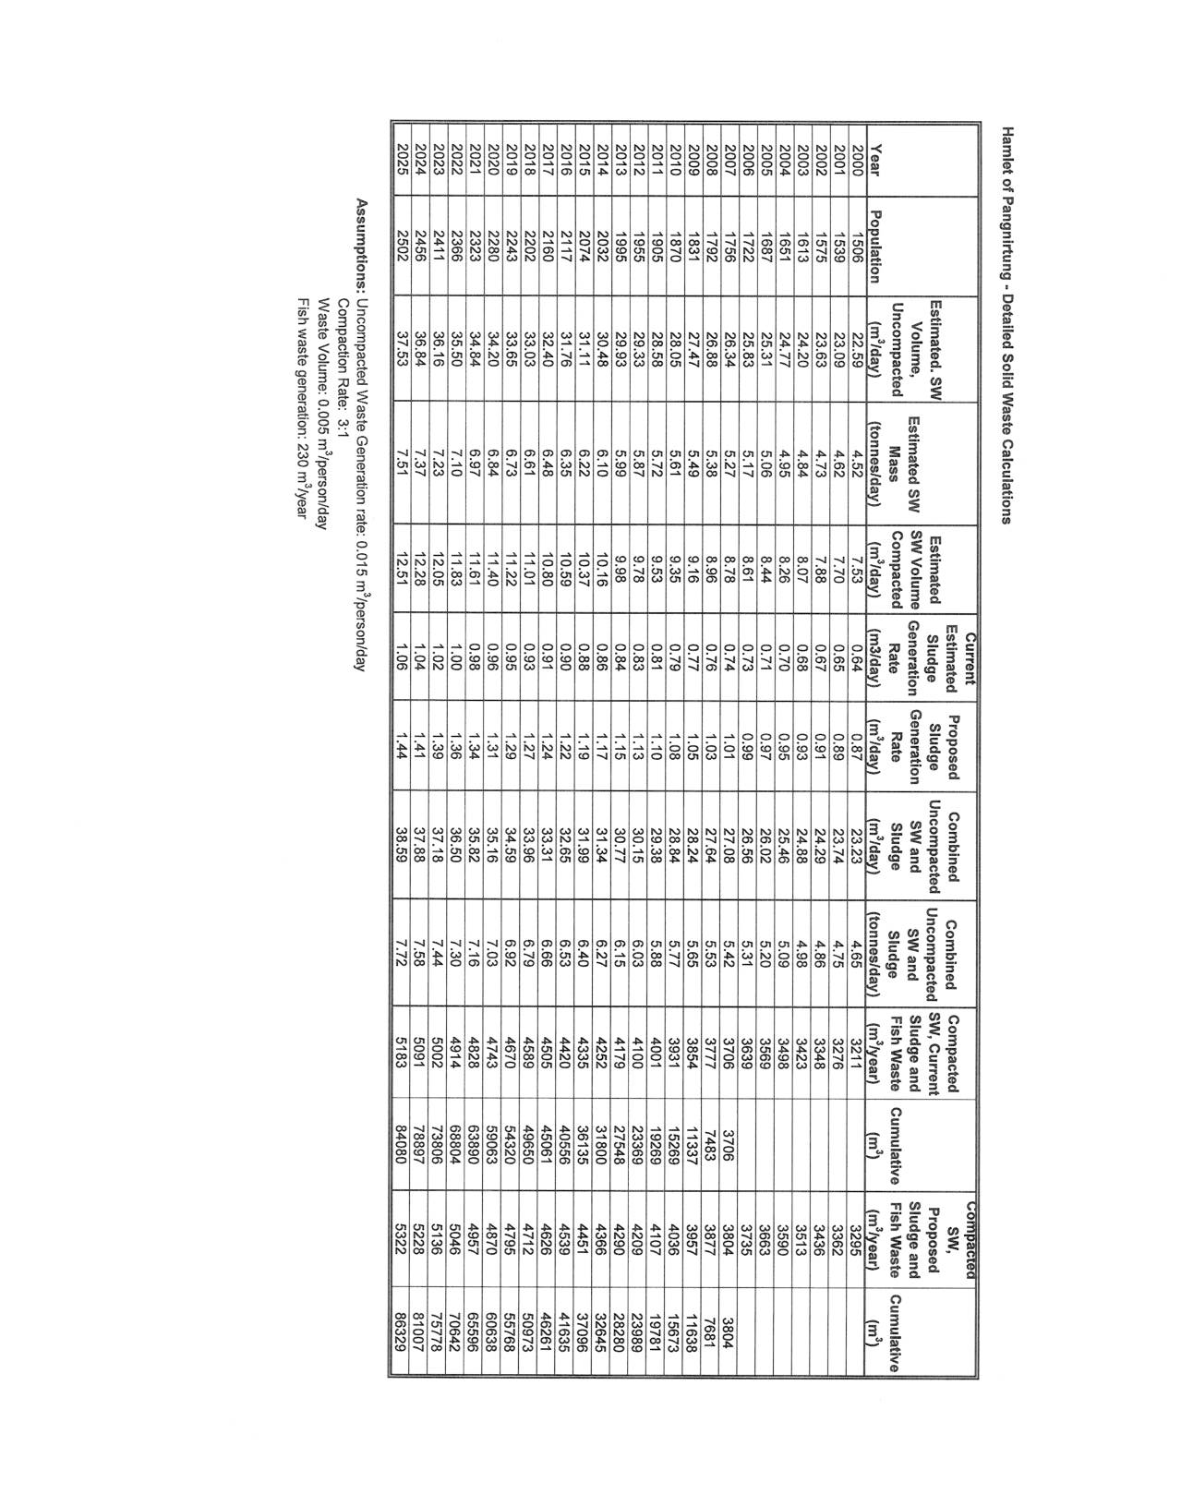

AAPENDIX-F:

FISH WASTE MANAGEMENT

