Quality Assurance and
Quality Control Plan Hamlet of Resolute Bay
Utilidor System,
Resolute Bay, Nunavut
Updated June 29, 2020

Table of Contents
1.0 Introduction---------------------------------------------------------------------------------------4
1.1 Background------------------------------------------------------------------------------------------------4
I .3 Definitions.--------------------------------------------------------------------------------------------------4
2.0 Sampling for Regulatory Compliance------------------------------------------------------------------------- 8
- 1 Sampling Locations---------------------------------------------------------------------------------------8
  - Sampling Frequency.- 8
  - Sampling Parameters..... 9
2.3. I Water Samples..----------------------------------------------------------------------------------9
    - Wastewater and Leachate Samples Sampling Parameters for the Current Licence # 3BM-RUT1520, Type A-----------------------------------------------------------------------10
  - Compliance Point (Part E.3) for Wastewater Effluent for Current Water Licence# 3BMRUT1520, Type B----------------------------------------------------------------------------------11
  - Sampling Procedures (Wastewater & Leachate) .Sampling Collection (Wastewater & Leachate)--------------------------------------------------------------------------------------------------11
2.6 Sampling Collection ( Wastewater and Leachate)---------------------------------------------------12
2.6. I Sampling Equipment.------------------------------------------------------------------------------12
    - Sampling Container----------------------------------------------------------------------------12
    - Sampling Methods-----------------------------------------------------------------------------12
  - Sample Handling.--------------------------------------------------------------------------------------- 13
  - Quality Assurance and Quality Control Program----------------------------------------------------15
- Laboratory-----------------------------------------------------------------------------------------------16
3. I Laboratory Accreditation ---------------------------------------------------------------------------------16
  - Method Detection Limits.-------------------------------------------------------------------------- 16
  - Methodology--------------------------------------------------------------------------------17
4.0 Reporting Requirements ------------------------------------------------------------------18
5.0 References--------------------------------------------------------------------------------------------18
Fig. -I: Location Map of Resolute Bay-----------------------------------------------------------------------7
Fig.- 2: Location of the facilities under the Utilidor System----------------------------------------------8
Tables:

2.1 : Monitoring Locations----------------------------------------------------------------------------9

2.4(A) Monitoring Flow greater than 600lcd----------------------------------------------------------11

2.4 (B) Monitoring Flow from 150 to 600Lcd---------------------------------------------------------11

Appendix A | : Completed Example of Chain of Custody Documentation
Appendix-B:

Ottawa Caduecon Lab Accreditations

.0 Introduction
The purpose of this document is to provide guidance to ensure that the monitoring program samples collected from the Hamlet's Utilidor system (water and wastewater disposal facilities) are done so with a high degree of quality, in order to ensure that they accurately reflect the physical and chemical nature of the matrix being tested.

1.1 Background
The Hamlet of Resolute Bay (Hamlet) is located on the South coast of Cornwallis Island of the Perry Channel at 74⁰43'01 "N and 94⁰58'10"W. The current population is 283 in 2020. This is the National training ground of the Canadian Force. Their population varies from 200 to about 700 in summer.
The Nunavut Water Board (NWB) issued a Class B Water Licence (No. 3RB-RUT1520) to the Government of Nunavut on March 30,2015. This QA/QC document is to fulfill the requirements for the application of a Class B Water Licence. The Water Licence governs water use and waste disposal within the Hamlet. The Class B Water Licence will be expired on March 29,2020. This licence is recommended to be renewed as Type A for 10 (ten) years term.

1.2 Quality Assurance and Quality Control Monitoring
This Water Licence includes a monitoring program. The monitoring program specifies the locations of two (2) sampling locations, along with the analytical parameters to be tested. The following quality assurance (QA) and quality control (QC) program is to be implemented to ensure that the analytical results received are accurate and dependable. A QA/QC program is a system of documented checks that validate the reliability of the data collected regarding any given site. Quality Assurance is a system that ensures that quality control procedures are correctly performed and documented. Quality Control refers to the established procedures observed both in the field and in the laboratory, designed to ensure that the resulting end data meet intended quality objectives. The proposed program will verify compliance with regulations.

1.3 Definitions
The following definitions that are relevant to this plan include:
Quality Assurance is a system that ensures that quality control procedures are correctly performed and documented.
Quality Control refers to the established procedures observed both in the field and in the laboratory, designed to ensure that the resulting end data meet intended quality objectives.
Field Blank is a sample of analyte-free (i.e., clean) water poured into the container in the field, preserved and shipped to the laboratory with field samples and is analyzed along with field samples to check contamination from field conditions during sampling. Blind Duplicate is a duplicate sample that is not labelled as such. The purpose of the blind duplicate sample is to ensure analytical precision.

CALA refers to the Canadian Association for Laboratory Accreditation, formally known as the Canadian Association for Environmental Analytical Laboratories (CAEAL).
Chain of Custody Documentation refers to the documentation that accompanies samples sent to an analytical laboratory. It is a legal document which ensures that the sample taken at a specific site is the same sample received in the laboratory. It also provides information on the sample condition and integrity as receive
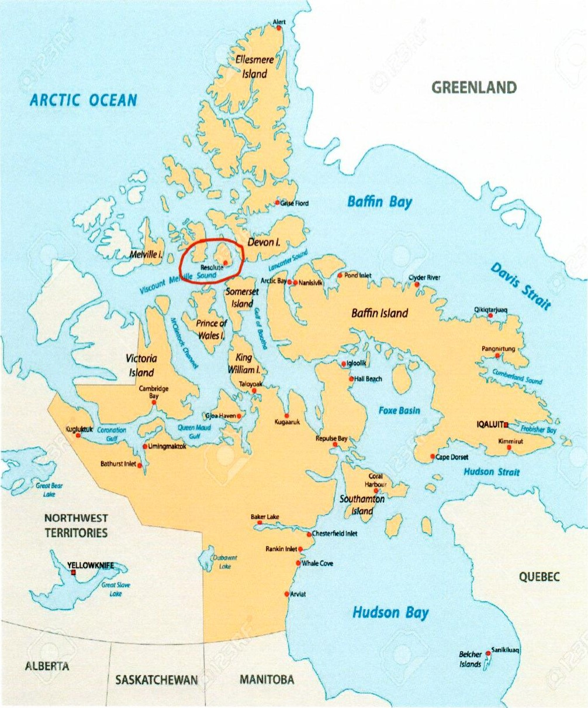
Fig. I : Location of the Municipality of Resolute Bay
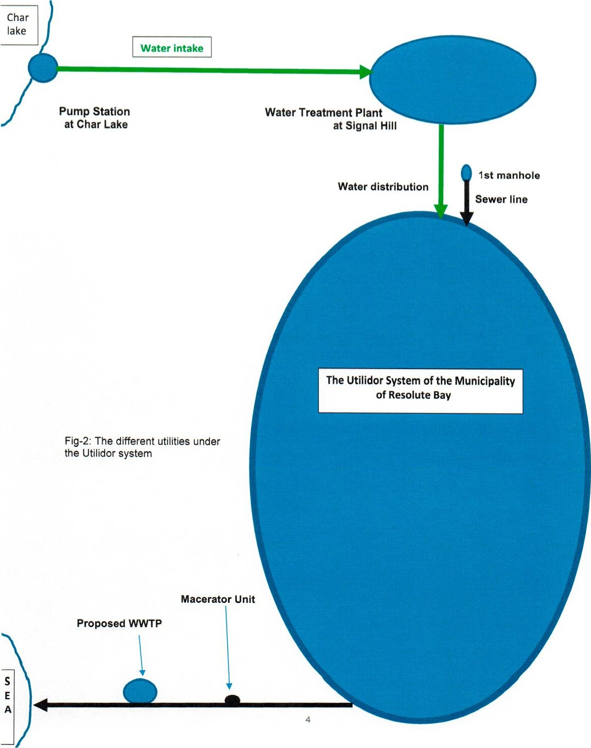

2.0 Sampling for Regulatory Compliance

2.1 Sampling Locations
This Water Licence specifies only two (2) monitoring locations. Table 2.1 provides a description of the sampling points, along with their coordinates.
Table 2.1 — Monitoring Locations
Monitoring Program Station Number  and Coordinates | Description | Status
RUT-I | Raw water supply Prior to Treatment  (Monthly) | Active (Volume)
RUT-2 | Effluent- Sewage disposal Facility  (Monthly) | Active (Volume) and Quality

2.2 Sampling Frequency
The following outlines the Sampling Testing and Compliance requirements, as outlined in the Hamlet's Water Licence. Any other additional sampling during the year will be at the request of the regulatory agencies. Once collected, the samples will be shipped to the laboratory and analyzed using the same test/method/procedure.
The Licensee is required to measure and record, in cubic metres, the daily, monthly and annual quantities of water pumped at Monitoring Program Stations RUT-I at Char Lake Pump station. The Licensee is also required to measure and record, in cubic metres, the daily, monthly and annual quantities of the sewage at the outfall at RUT-2.

2.3 Sampling Parameters

2.3.1 Water Samples
The requirements for drinking water sample collection frequency, and analytical testing is provided below.
Microbiological Properties:
The current population of the community is less than 500. Therefore, monthly bacteria sampling is required. Samples will be collected from five locations: raw water, treated water and three different taps. Each sample bottle is to be filled up to 200 mL mark. The samples are forwarded to the GN- DOH lab in Iqaluit for testing and reporting.

Chemical Analysis:
As required by the Public Health Act, the licensee samples the raw water and treated water twice annually and the samples are forwarded to Caduceon Environmental Laboratories, a CALA accredited lab in Ottawa.
Samples collected from Monitoring Station RUT-I Station shall be analyzed for the following parameters:
• | Alkyl benzene sulfonate (ABS) |  | Iron (Fe)
 | Arsenic (As) |  | Lead (Pb)
 | Barium (Ba) |  | Manganese (Mn)
• | Cadmium (Cd) |  | Nitrate (N03)
 | Carbon Chloroform Extract (CCE) | • | Phenols
 | Chloride (CI) |  | Selenium (Se)
 | Chromium (hexavalent) (Cr6+) |  | Silver (Ag)
 | Copper (Cu) |  | Sulfate (S04)
 | Cyanide (CN) |  | Total dissolved solids
 | Fluoride (F) |  | Zinc (Zn)

2.3.2 Wastewater Samples Sampling Parameters for the Current Licence #
3BM-RET1520
Samples collected from Monitoring Stations RUT-2 shall be analyzed for the following parameters:
- Biochemical Oxygen Demand — BOD5 Faecal Coliforms
 | pH |  |  | Conductivity
 | Total Suspended Solids |  |  | Oil and Grease (visual)
• | Nitrate-Nitrite |  |  | Ammonia Nitrogen
 |  |  |  | Sulphate
 | Sodium |  | • | Potassium
 | Magnesium |  | • | Calcium
 | Total Phenols
 | Total Arsenic
 | Total Cadmium
 | Total Copper |  |  | Total Chromium
 | Total Iron |  |  | Total Lead
 | Total Mercury |  |  | Total Nickel
• | Total Zinc |  |  | Total Phosphorous
  - Compliance Point (Part E.3) for Wastewater Effluent for Current Water Licence # 3BM-RUT1520
The water licence has set the final discharge from the \NWTP (Monitoring Station RES-2) as the compliance point as it is the last point of measurement and control. The effluent released from the WWTP must meet the criteria list in Tables 2.4(A) and Table 2.4 (B).
Table 2.4 (A) for Flow greater than 600 Lcd
Parameter | Maximum concentration of any Grab sample
BOD5 | 80mg/L
Total Suspended Solids | 70mg/L
Oil and Grease | No visible sheen
pH | Between 6 and 9
Fecal Coliforms | To be determined in accordance with Part D, item 4.
Table 2.4 (B)— Effluent Quality Criteria for flow from 150 to 600 Lcd
Parameter | Maximum Concentration of any Grab Sample
pH | Between 6 and 9
BOD5 | 120 mg/L
Total Suspended Solids | 80 mg/L
Faecal Coliforms | TO be established as per exp's report in the new water licence.
Oil and Grease | No Visible Sheen
  - Sampling Procedures (Wastewater & Leachate)
All sampling, sample preservation and analyses are to be conducted in accordance with methods described in the current edition of Standard Methods for the Examination of Water and Wastewater (American Public Health Association, American Water Works Association, and Water Environment Federation, most current edition). Also, additional guidance can be obtained from the contract laboratory (accredited by the Canadian Association for Laboratory Accreditation).
To obtain meaningful results from the analyses, the following six factors are of particular importance:
- Sample collection as per schedule and location.
- Correct usage of container/sample bottle for parameter being tested.
- Correct labelling of sample bottles and filling out record/field sheet.
- Correct procedure for sampling.
- Proper and timely shipment of samples to the laboratory.
- Timely delivery of samples to the laboratory from the air cargo facility.
2.6 Sampling Collection ( Wastewater )
Refer to the future Wastewater Treatment Facility Process Operation Manual, for specific details related to Health and Safety considerations, facility components and processes, as well as monitoring and testing procedures.

2.6.1 Sampling Equipment
Dedicated latex or nitrile gloves (i.e., one pair per sample) are to be used during sample collection and sample handling. Monitoring program samples collected for analysis Of selected chemical parameters are to be placed directly into new pre-cleaned, laboratory-supplied sample bottles (see Appendix B). All monitoring samples are to be placed in clean coolers for transportation to the subcontract laboratory. The samples are transported/submitted under Chain of Custody documentation. Included on a Chain Of Custody form is the client information, the sample information, the analyses requested, the relevant regulations, the turnaround time for the analytical results, comments, and temperature of the samples at the time they arrived in the laboratory. An example of a completed Chain of Custody form is included in Appendix C.

2.6.2 Sampling Containers
Samples for water, wastewater and leachate have their own set of containers. The following photographs indicate the containers in each kit. Specific sample bottle requirements are presented in Appendix B.
WATER 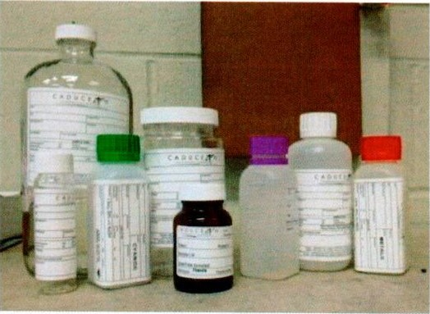
8 eight bottles

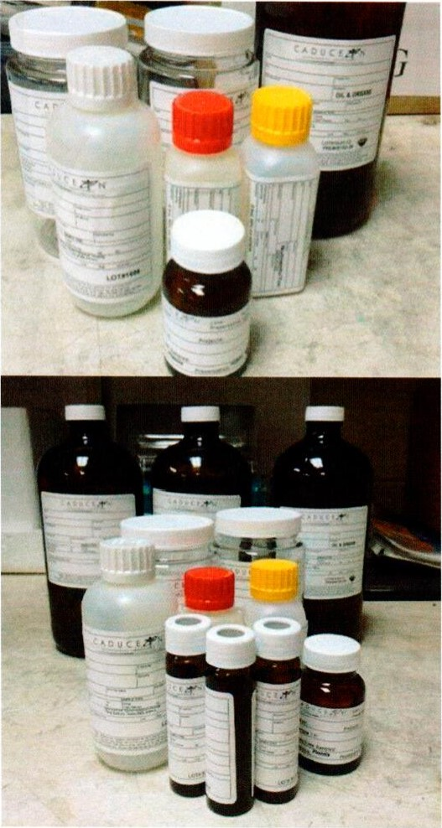
WASTEWATER
7 Bottles
LEACHATE
12 bottles

2.6.3 Sampling Methods
All monitoring program samples will be collected by suitably-trained municipal staff. The following techniques are to be used (when possible) whenever grab samples are collected:
  - If the sample is being collected from a surface water body, a tank or sump, the sample is to be collected from a location where there is good mixing and the sample will be representative. The sample is not to be skimmed from the surface, taken very close to the bottom, or near any sidewalls.
The sample is to be taken from a middle zone, if possible, where there is good mixing and the
geometry of the surface water channel or tank/sump and any equipment within will not affect the quality of the sample.
  - If the sample is taken from a sample tap from a tank or pipe, care is to be taken to flush the sample line. The operator is to open the sample valve to flush the contents of the sample line into a container. This material is disposed of or returned to the process if possible. Immediately after flushing the line, the operator then collects the appropriate volume of sample directly into new precleaned, laboratory-supplied sample bottles. The volume to be flushed prior to sampling will depend on the size of the line and distance between the sample valve and the main line/tank. Ideally, the entire volume of this sample line is to be flushed to ensure the collected sample is fresh and representative.
  - If the treated water is collected from the end of water truck hose, allow flushing for a minimum 30 seconds before sampling. During sampling, reduce the flow through the nozzle.
  - The monitoring program samples need to be shipped to the analytical laboratory for analysis immediately or as soon as practical after collecting the sample.
  - Samples should always be collected into new, pre-cleaned, laboratory-supplied sample bottles.
2.7 Sample Handling
All monitoring program samples are to be collected into new, pre-cleaned laboratory-supplied containers with the proper preservative, where applicable. A complete list of parameter handling and preservatives can be found in Appendix B.
All sample containers are to be tightly sealed and properly labelled with the sample ID, date and time of sample collection, location of sample collection and parameters to be analyzed. The outside of the bottles are to be cleaned with soap and water after sampling and dried off prior to placing the samples in the cooler. The samples are to be stored on ice in a cooler until delivery to the laboratory. A Chain of Custody form is to be filled out completely and is used to track the samples and placed in the cooler with the samples, in a Ziplock bag. Keep the last page of the Chain of Custody and give it to the Hamlet Foreman for their records. The following checks are generally performed by the laboratory upon receipt: Verification of the integrity and condition of all sample coolers.
  - Verification of the integrity and condition of all sample containers.
  - Checks for leakage, cracked or broken closures or containers, evidence of grossly contaminated container exteriors or shipping cooler interiors, and obvious odours, etc.
  - Verification of receipt of complete documentation for each container.
  - Verification that sample identification numbers on sample transmittal forms corresponds to sample identification numbers on the sample containers.
  - Verifications that holding times were met and samples were kept cool during transit.
2.8 Quality Assurance and Quality Control Program
Cross contamination is a common source of error in sampling procedures. QC samples help identify when and how contamination might occur. There are various types of QC samples. I t is recommended the following number of quality control samples based on the number of samples collected:
  - One field blank per cooler.
  - 10% blind duplicates.
If the total number of samples collected is less than five, include at a minimum, one blind duplicate.
It is essential to request extra bottle sets from the contract laboratory when placing the bottle order in order to allow the collection of field blanks and blind duplicate samples.
- Laboratory Analysis
  - Laboratory Accreditation
As indicated in the Guidelines, the Licensee should use an analytical laboratory accredited by the Canadian Association for Laboratory Accreditation (CALA); formally known as the Canadian Association for Environmental Analytical Laboratories (CAEAL) for the Water Licence monitoring program. Appendix D includes a copy Of the laboratory's CALA accreditation certificate and a list of the parameters for which they are certified.
Note that the GN-DOH does bacteria testing in their own lab in Iqaluit following their own guidelines.
  - Method Detection Limits
The method detection limits (MDLs) are provided on the contract laboratory's Certificates of Analysis.
  - Methodology
As indicated above, the contract laboratory is accredited by CALA for specific tests and complies with the requirements of ISO/IEC Standard 17025.
- Reporting Requirements
As a condition of NWB Licence 3BM-RUT1520, the Licensee is required to submit an Annual Report to the NWB, no later than March 31st of the year following the calendar year reported. Among other requirements, the annual report is required to include tabular summaries of all analytical data generated under the Monitoring Program (compared to the Maximum Concentration of any Grab Sample — provided in Part H of the NWB Licence 3BM-RlJTI 520 — where applicable).
- References
Quality Assurance (QA) and Quality Control (QC) Guidelines for use by Class "A" Licensees in Meeting SNP Requirements and for Submission of a QA/QC Plan, Department of Indian and Northern Affairs Canada, Water Resources Division and the Northwest Territories Water Board, July 1996.
Standard Methods for the Examination of Water and Wastewater, American Public Health Association, American Water Works Association, and Water Environment Federation, Latest Edition.

