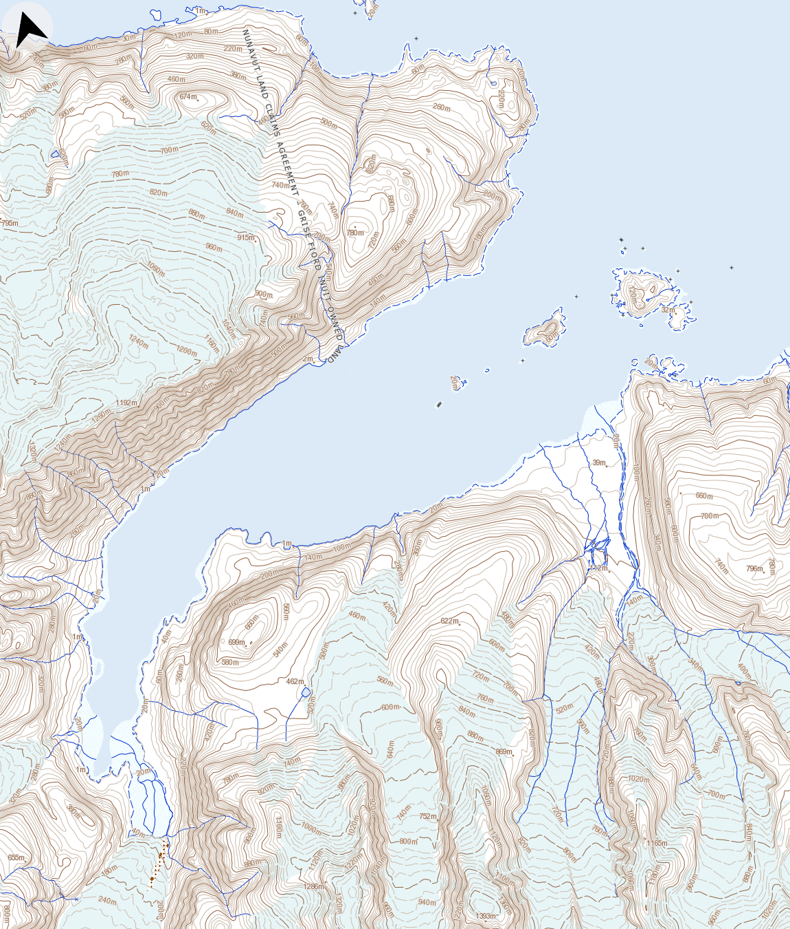
Dome temporary camp
Alexandra Fiord RCMP base camp
78° 51' 33" N 75° 54' 15" W
(In previous work a temporary camp was placed here in 2009)
78º53’N, 75º55’W

Scale: 1: 50 000
Map: 39E
For reference the lowland valley is approximately 8 km².
Alexandra Fiord Dome
Alexandra Fiord RCMP Camp

