Spill Contingency Plan
Dome Temporary Camp Alexandra Fiord, 2012
a) Name and address of person in charge
Steven Siciliano
5E26 - 51 Campus Drive, Saskatoon,
Saskatchewan, Canada S7N 5A8
b) Name of employer
University of Saskatchewan
Campus Drive, Saskatoon,
Saskatchewan, Canada S7N 5A8
c) Description of the facility including the location, size and storage capacity and d) a description of the type and amount of contaminants normally stored on the site
The facility will be a 3 person temporary research camp located on the Dome at Alexandra Fiord (Latitude: ( 78 °51 ’33 ” N Longitude: (75 °54 ’15 ” W)). The camp will include three personal sleeping tents and camping (ex. camp stove, pots, chairs, table) and research equipment (ex. shovels, sampling jars, moisture/light meters) . Gasoline for use in running scientific equipment (i.e. Fourier Transform InfraRed-Multicomponent Gas Analyzer) will be kept at the site in plastic jerrycans approximately 5-10L in size. No more than 4 full jerrycans will be kept on site at any given time for a maximum storage capacity of 40 L. Jerrycans will be kept in a secure location where they cannot be displaced/damaged by wind. Tampering of jerrycans by animals is highly unlikely in this polar desert environment.
e) Steps to be taken to report, contain, clean up and dispose of a contaminant in the case of a spill
In case of a spill all researchers on-site will be immediately notified and take part in the clean-up procedure. Protective equipment for those involved in the spill clean-up will be provided (ex. gloves). A spill report form will be filled out and will be submitted to all relevant agencies. The following steps will be used to contain, clean-up and dispose of contaminant in the case of a spill.
Step 1: Stop the spill.
The leak or spill will be stopped by closing off nozzles from the leaking container and any puncture-type hole will be immediately plugged and gasoline transferred to an intact container.
Step 2: Contain and recover the spill.
Any spillage that was not stopped (i.e. flowing liquid) will be caught using a pan, pail or shovel. Synthetic sorbent pads will be available on-site and if necessary will be spread on areas where the leak occurred.
Step 3: Collect the contaminated sorbent.
The sorbent material will be removed and put it into buckets or garbage bags. The collected contaminated sorbent material will be kept well away from any ignition sources.
Step 4: Secure the waste.
The collected sorbent material will be flown out and will be properly disposed of at PCSP in Resolute.

f) Site map
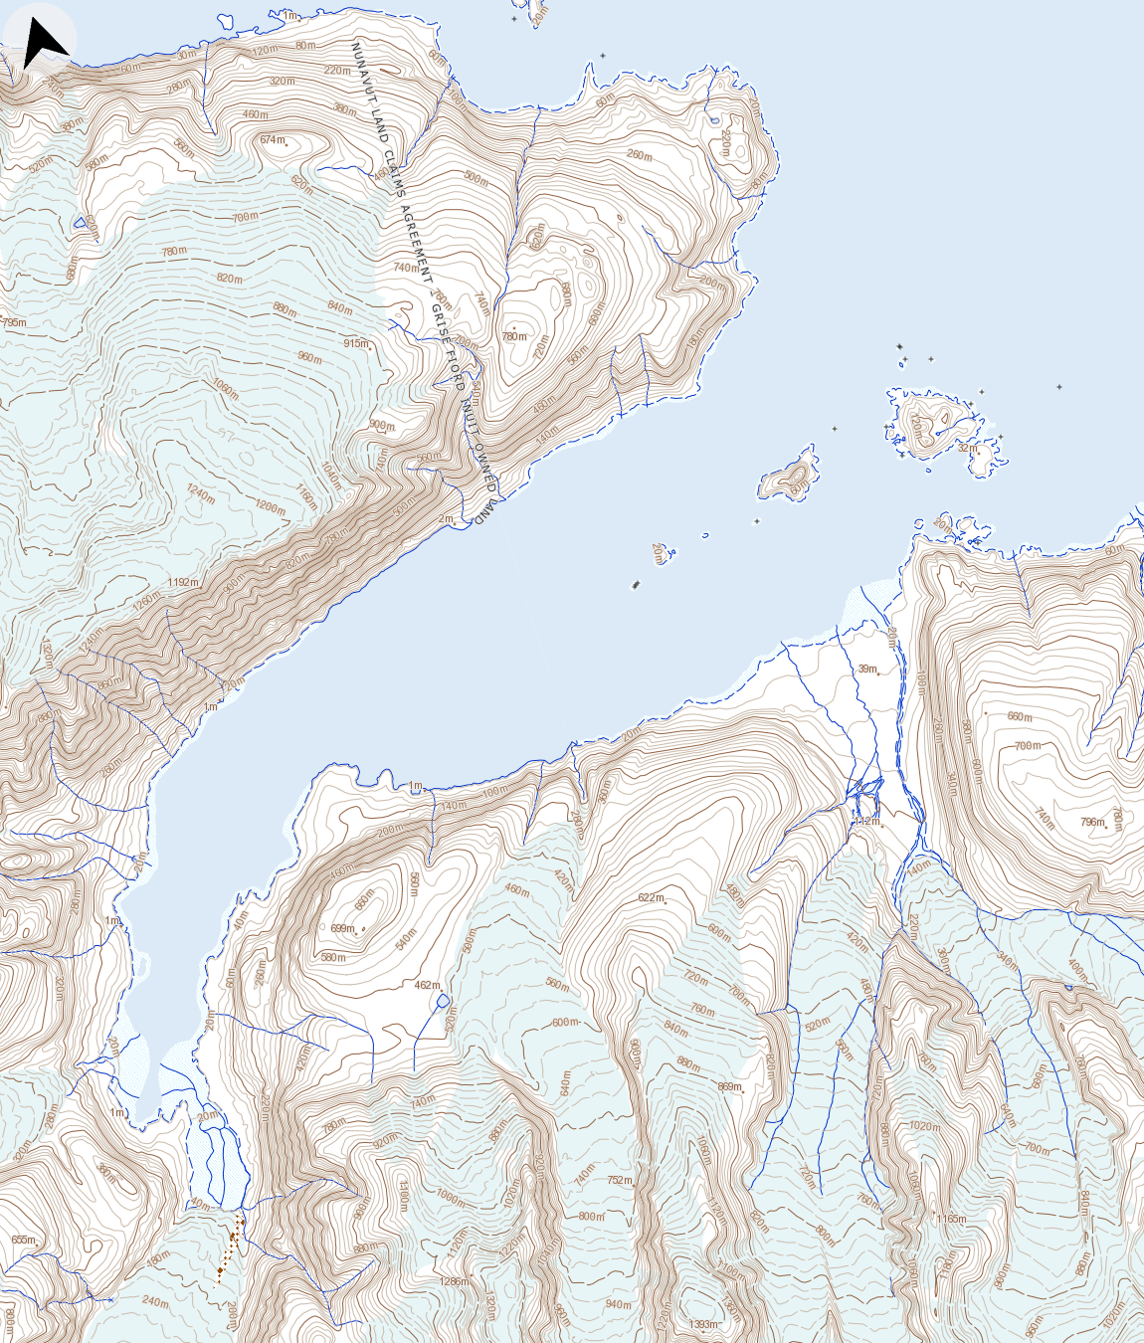
Dome temporary camp
78° 51' 33" N 75° 54' 15" W
78º53’N, 75º55’W
Alexandra Fiord RCMP base camp

Scale: 1: 50 000
Map: 39E

g) The name, job title and 24 hour telephone number for the persons responsible for activating the contingency plan
Steven Siciliano, Professor, University of Saskatchewan, (306) 966-4035
h) Description of the training provided to employees to respond to a spill
All researchers on-site will be given training in the steps taken in case of a spill. All researchers on-site will be aware of where the clean-up materials and protective gear are kept.
i) Means by which the contingency plan is activated
The contingency plan will be activated immediately in case of a spill by any research at the temporary camp. All researchers that are within visual contact or radio contact will be summoned to assist with spill containment and clean-up.
j) Inventory and location of response and clean-up equipment available to implement the plan
Catchment pans, extra empty jerrycans, sorbent pads (minimum 10) and protective equipment will be kept in a clearly labelled spill kit (duffle bag) at the main camp area at a location known to all researchers on-site.
k) Date of contingency plan
May 8th, 2012.

