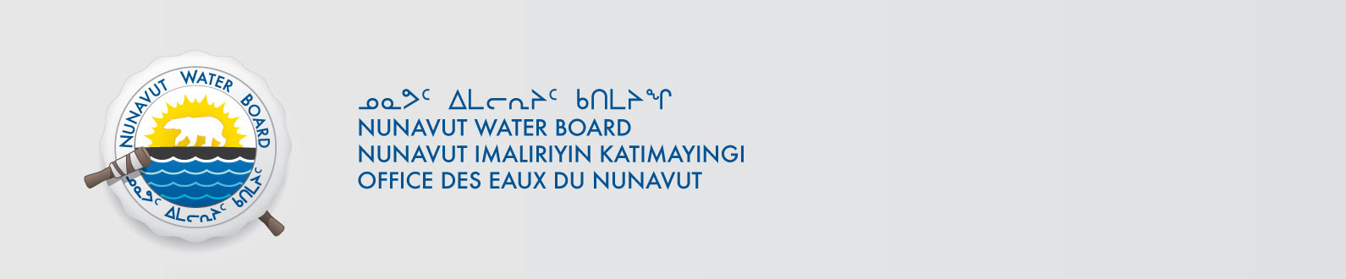
File: 3BC-AMD1212/TR/B2
July 25, 2013

Marc Beauchamp
Department of Earth Sciences,
University of Western Ontario,
1151 Richmond Street,
London, ON N6A 5B7

Email: gosinski@uwo.ca
mbeauchamp6@uwo.ca

Subject: Licence No. 3BC-AMD1212 “Lost Hammer Spring on Axel Heiberg Island Project”;
Submission of the 2012 Annual Report

Dear Ms. LeMoine:

The Nunavut Water Board (“NWB”) received on June 10, 2013, the 2012 Annual Report for the above-mentioned project. The report was forwarded to the distribution list for information.

The submission was found to be meeting the reporting requirement of the licence 3BC-AMD1212.

Should you have any questions, please feel free to contact the undersigned at (867) 360-6338 or k.kharatyan@nunavutwaterboard.org, at your earliest convenience.

Yours truly,

Original Signed By

Karén Kharatyan
Technical Advisor

cc: Distribution List – Qikiqtani

