


Sherbrooke, QC, Canada Prof. Dr. A. Langlois
2015-01-14 Centre d’Applications et Recherches en Télédétection
Université de Sherbrooke
Sherbrooke, Québec, J1K 2R1

Object: Annual report for NWB licence #3BC-BAR1013
Université de Sherbrooke, Département de géomatique appliquée

The project included only one field campaign which occurred in March 2011. The fieldwork over Barnes Ice Cap focused on snow measurements and remote sensing. The work led to the publication of 2 research articles in peer-reviewed literature:

Dupont F., G. Picard, A. Royer, M. Fily, A. Roy, A. Langlois and N. Champollion (2014), Modeling the microwave emission of bubbly ice: Applications to blue ice and superimposed ice in the Antarctic and Arctic, IEEE Transactions on Geoscience and Remote Sensing, 52(10), 6639-6651, doi: 10.1109/TGRS.2014.2299829.

Dupont, F., Royer, A., Langlois, A., Gressent, A., Picard, G., Fily, M., Cliche, P. and Chum, M. (2012), Monitoring the melt season length of the Barnes Ice Cap over the 1979–2010 period using active and passive microwave remote sensing data. Hydrol. Process.. doi: 10.1002/hyp.9382.

- Water use and waste disposal activities.
As specified in the license application, this is a snow research project, on the Barnes Ice Cap, approximately 100 km form the closest stream. Therefore no water was used nor disposed other than freshwater brought from Iqaluit in water containers.

- List of unauthorized discharges and a summary of follow-up actions taken.
No discharges occurred.

- Any revisions to the Spill Contingency Plan, as required by Part B, Item 7, submitted in the form of an Addendum.
No changes to the initial plan were made, and no spill occurred.

- A description of all progressive and or final reclamation work undertaken, including photographic records of site conditions before, during and after completion of operations; e. A summary of all information requested and results of the Monitoring Program;
Since no water was used nor disposed, the reclamation work simply consisted in dismantling the tent. Below three photos of the site before, during and after the work.

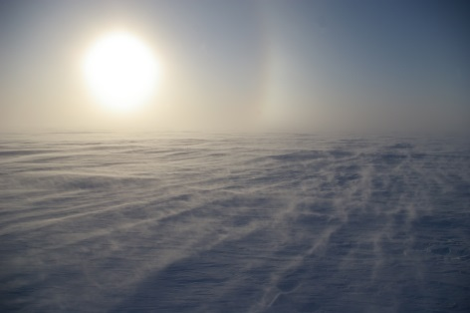
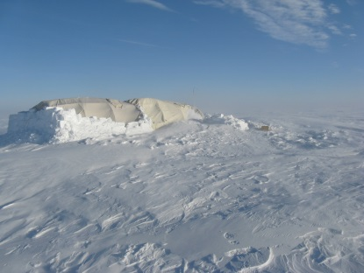
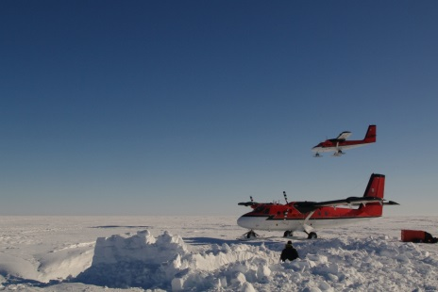
BEFORE DURING AFTER

- Any other details on water use or waste disposal requested by the Board by November 1 of the year being reported; and
Not applicable since no water was used.

- For the first year being reported following issuance of this licence, provide accurate Camp GPS coordinates in latitude and longitude in degrees, minutes and seconds.

