Information to support application for Nunavut Water Board (NWB) Permit

Licence named individual: Scott Lamoureux, Queen’s University
Project name: Cape Bounty Arctic Watershed Observatory (CBAWO)
Project location: Cape Bounty, Melville Island, Nunavut, 74°55’N, 109°30’W
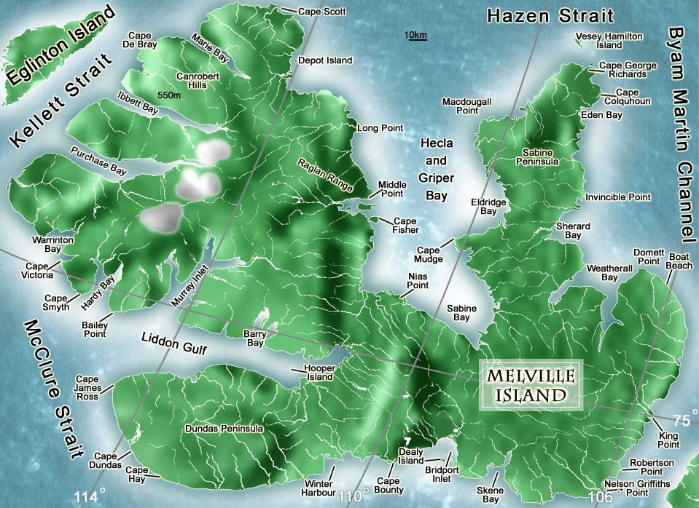
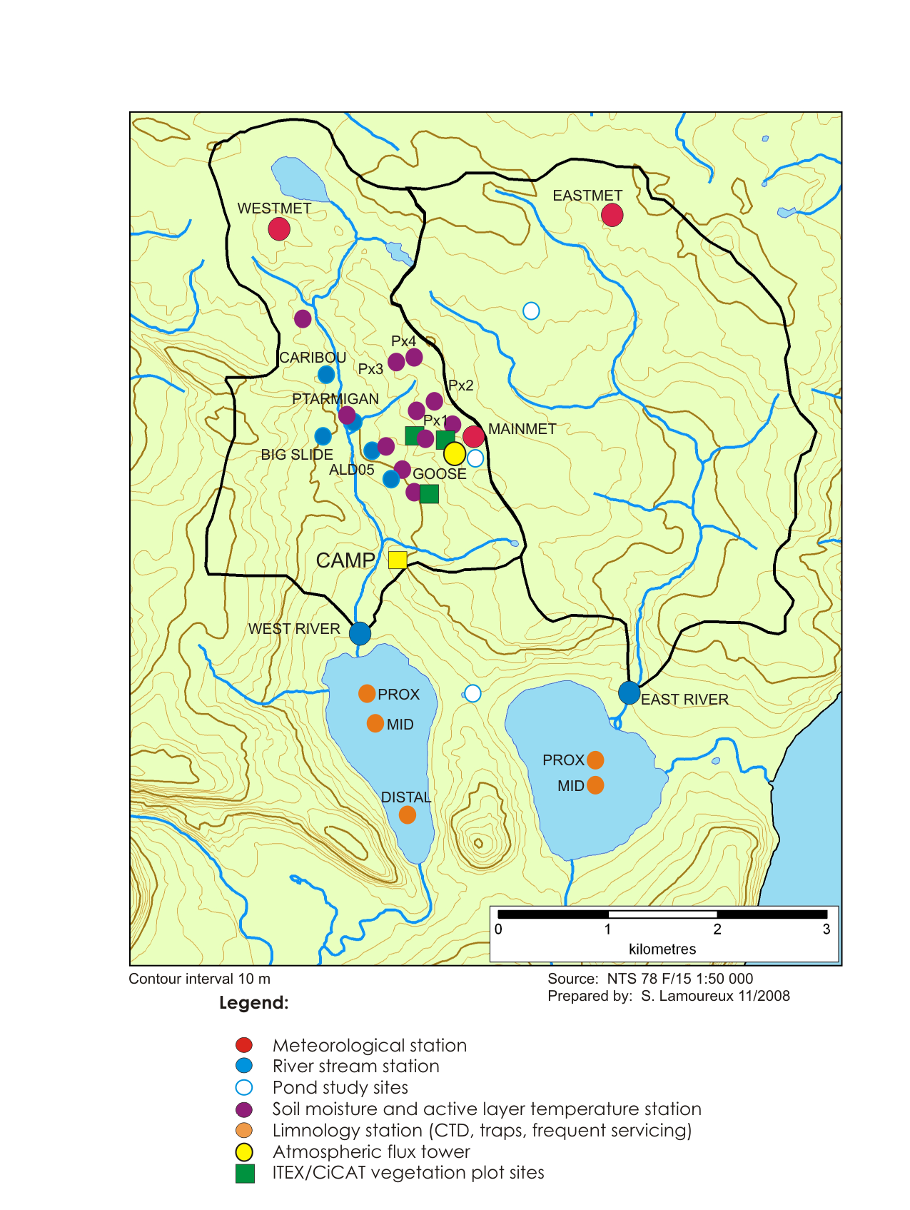

Summary (English):

We study how changes to the climate will affect things like river flow, vegetation, snow cover, permafrost, lake temperature and ice thickness, and the health of charr. We record streamflow, weather conditions, plant communities, and lake temperature. We also obtain sediment cores from the lakes to see how the landscape has changed in the past.
Our principal investigator and several graduate students visited Qarmartalik school in Resolute in May. They described our research and its importance to Inuit communities, answered questions, and did science-related activities with the students.
We hired one person from the hamlet of Resolute to help measure snow thickness and density. Another person was hired to catch charr in the Cape Bounty lakes, which will help determine whether mercury accumulates within the fish.
We plan on continuing to study the lakes and rivers of Cape Bounty in the summer of 2010. There will be four to ten people in the camp, and we will be there from late May to late August. Like all previous years, all activities will be conducted on foot. We will be brought to and from the site by twin otter and helicopter. No permanent structures exist at the site, and none will be constructed. We expect to hire a community member to work with the charr again and plan more trips to the school to share our research with the children.
We also maintain a web site about Cape Bounty (http://geog.queensu.ca/cbawo/).

Summary (Inuktitut, Nunacom font):
Questionnaire: attached

