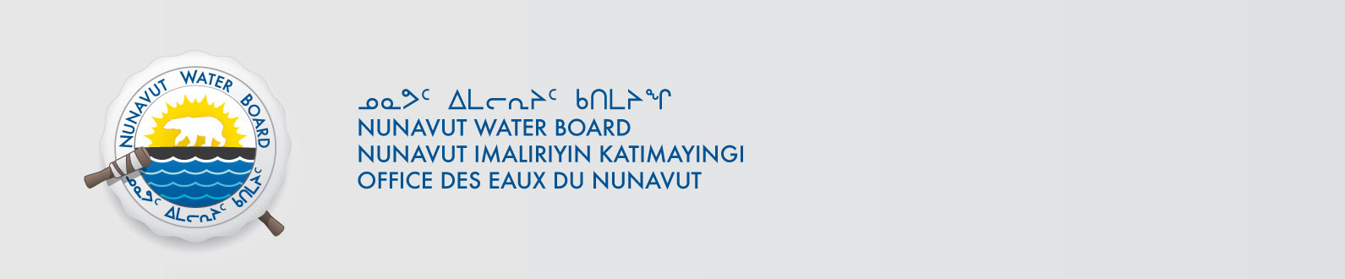

May 25, 2016 File No: NWB2ATU9899 3BC-CBA1015

To: Hamlet, CLARC, HTO, RIA, Coop, and NorthernLocal Organizations – Request to Post Notices

The Nunavut Water Board requests that you post on a bulletin board, until July 04, 2016 the attached notices (in English and Inuktitut), where they can be viewed by the public. The attached letter is for your information and does not require posting.

Your time and effort is greatly appreciated.

Sincerely,

Valerie Kogvek
Licensing Administrator

Cc: Hamlet of Resolute Bay (867) 252-3749
Mayor of Resolute Bay (867) 252-3749
Qikiqtani-IA (867) 252-3129
Resolute Bay HTO (867) 252-3800
Tudjaat Co-op (867) 252-3618

