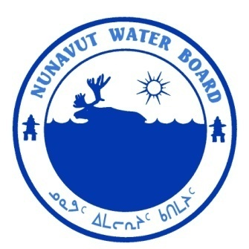  P.O. Box 119 | kNK5 wmoEp5 vtmp5
Gjoa Haven, NU X0B 1J0 | NUNAVUT WATER BOARD
Tel: (867) 360-6338 | NUNAVUT IMALIRIYIN KATIMAYIT
Fax: (867) 360-6369 | OFFICE DES EAUX DU NUNAVUT

File: 3BC-COA0913/TR/B1

June 25, 2012

Anthony Gaston
National Wildlife Research Centre, Environment Canada
Building 33, Raven Road
Carleton University,
Ottawa, ON K1A 0H3
Email: tony.gaston@ec.gc.ca

Subject: Licence No. 3BC-COA0913 “Coats Island Camp” Kivalliq Region, Nunavut – Environment Canada, National Wildlife Research Centre; Submission of the 2011 Annual Report

Dear Mr. Gaston:

The Nunavut Water Board (“NWB”) received, on May 4, 2012, the 2011 Annual Report for the above-mentioned project. The report was forwarded to the distribution list for information.

The annual report was found to be complete and meeting the reporting requirements of licence 3BC-COA0913.

Should you have any questions, please feel free to contact the undersigned at (867)360-6338 Ext. 30 or k.kharatyan@nunavutwaterboard.org, at your earliest convenience.

Yours truly,

Original signed by:
Karén Kharatyan
Technical Advisor

cc: Distribution List – Kivalliq

