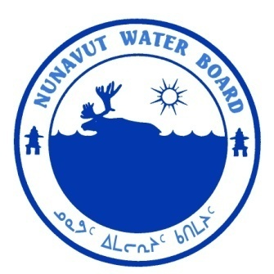  P.O. Box 119 | kNK5 wmoEp5 vtmp5
Gjoa Haven, NU X0B 1J0 | NUNAVUT WATER BOARD
Tel: (867) 360-6338 | NUNAVUT IMALIRIYIN KATIMAYIT
Fax: (867) 360-6369 | OFFICE DES EAUX DU NUNAVUT

File: 3BC-GBI1114/TR/B1

December 10, 2012

Amie Black
Wildlife Technician
Environment Canada, National Wildlife Research Centre
Carleton University
1125 Colonel By Dr.
Ottawa, Ontario K1A 0H3
Email: amie.black@ec.gc.ca

Subject: Licence No. 3BC-GBI1114 “Southern Belcher Island Archipelago Project”, Environment Canada
Submission of the 2012 Annual Report

Dear Ms. Black,

The Nunavut Water Board (“NWB”) received on September 6, 2012 the 2012 Annual Report for the above-mentioned project. The report was distributed for information.

The submission was found to be meeting the reporting requirements of licence 3BC-GBI1114.

Should you have any questions, please feel free to contact the undersigned at (867) 360-6338 Ext. 30 or k.kharatyan@nunavutwaterboard.org at your earliest convenience.

Yours truly,

Original Signed By:

Karén Kharatyan
Technical Advisor

cc: Distribution List – Qikiqtani

