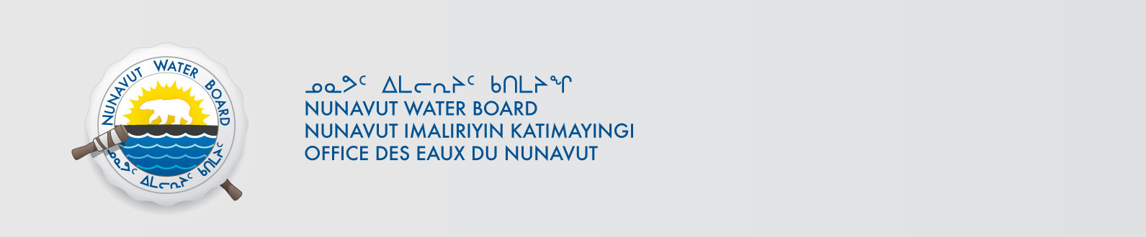

February 20, 2014 NWB File No: 3BC-HEL1015

Kathy Young
York University
Ross Building N415
4700 Keele Street
Toronto, ON M3J 1P3
E-mail: klyoung@yorku.ca

Re: Acknowledgement and Receipt of Water Use Fees for Water Licence Application –3BC-HEL1015

Dear Ms. Young:

The Nunavut Water Board acknowledges receipt on January 17, 2014 of your water use fees, cheque number 254, for the above project. Your payment has been forwarded to Aboriginal Affairs and Northern Development Canada in Iqaluit for processing. A receipt will be issued through their office for fees totaling $30.00 for water use fees.

Please refer to the calculation for water use fees, in the Nunavut Waters Regulations, Section 12, to ensure that the correct fee has been submitted. A copy of this regulation is available from our ftp site or by contacting this office. This is an annual fee which is required to be submitted yearly on the anniversary of the issuance of your water licence.

Please call the undersigned at (867) 360-6338 or e-mail licensing@nunavutwaterboard.org if you have any questions.

Sincerely,

Original signed by:

Megan Porter
Licensing Administrator Assistant

Cc: Jean Allen, AANDC
Leetia Angoyuak, AANDC

