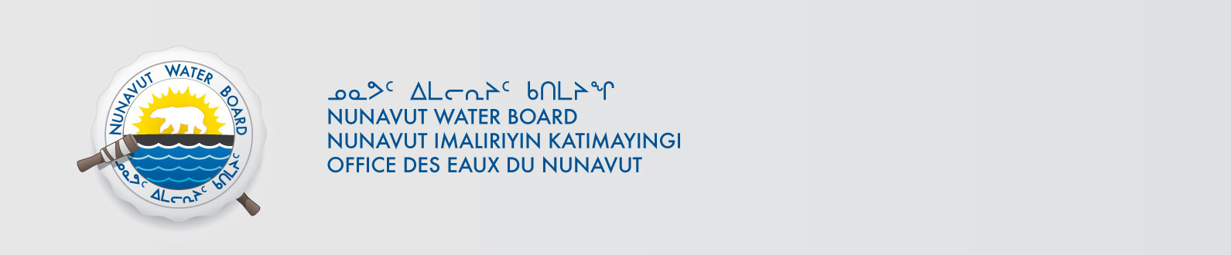

File No: NWB2MEL01--3BC-HMP0712

August 8, 2013

Mr. Pascal Lee, Ph.D.
Planetary Scientist
Mars Institute and SETI Institute
NASA Ames Research Centeer, MS 245-3
Moffett Field, CA 94035-1000, USA
E-mail : pascal.lee@marsinstitute.net

Subject: Mars Institute – WMC International LimitedHaughton-Mars Project – Renewal – Type “B”

Dear Mr. Lee:

The Nunavut Water Board (“NWB”) acknowledges receipt, on August 4, 2013, of a renewal an application for a licence renewalapplication for a Type “B” water license January 5, 2001for water use and waste disposal associated with exploratory drillingactivities in the Qikiqtani region of Nunavut. The application consists of the following documents:
- Application for Water Licence Renewal
- Exploration/Remote Camp Supplementary Questionnaire
- Haughton-Mars Project Description, English and Inuktitut
- HMP-2013 Spill Contingency Plan
The application can be obtained from our ftp site under PRUC with Username: public, Password: registry.

The NWB undertook a preliminary review of your application and concluded that it meets the requirements of section 48(1) of the Nunavut Waters and Nunavut Surface Rights Tribunal Act (“Act”). However, the NWB retains the right to request additional information and studies pursuant to sections 48(2) of the Act or to issue guidelines for the provision of information pursuant to section 48(3) of the Act. A NWB Technical Advisor may be in touch with you to clarify any technical details related to your application.

In accordance with S.11.5.10 of the Agreement Between the Inuit of the Nunavut Settlement Area and Her Majesty the Queen in Right of Canada (“NLCA”), prior to the application being fully processed by the NWB the project proposal shall be reviewed by the Nunavut Planning Commission (“NPC”), to determine whether the project proposal is in conformity with an approved land use plan. By copy of this letter, the NWB requests the NPC provide its determination and recommendations to the NWB pursuant to Sections 13.4.2 through 13.4.5 of the NLCA, or written confirmation that the project proposal falls outside the boundaries of an approved land use plan. Also, by copy of this letter to the Nunavut Impact Review Board (“NIRB”), the NWB requests that if the project proposal requires screening, the NIRB provide the NWB with a determination pursuant to Section 13.5.1 of the NLCA. If the project is exempt from screening pursuant to Schedule 12-1 of the NLCA, the NWB requests written confirmation from the NIRB that the project proposal is in fact exempt from screening.

To ensure this application is dealt with in a timely fashion, the NWB forwards notice of all documentation to regulators and council of the municipality(ies) most affected by the project, inviting interested parties to make representation directly to the NWB within 30 days from the date of this letter. The NWB may provide additional procedural instructions once the application has been reviewed by interested parties.

Subject to Sections 12.10.2 and 13.5.5 of the NLCA, where a review is required pursuant to Article 12, the NWB shall not approve any water application that forms part of that review until Article 12 has been complied with.

Sincerely,

Original signed by:

Phyllis Beaulieu
Manager of Licensing

Enclosure: Notice of Application

Cc: NPC Conformity
NIRB

Distribution List – Qikiqtani

