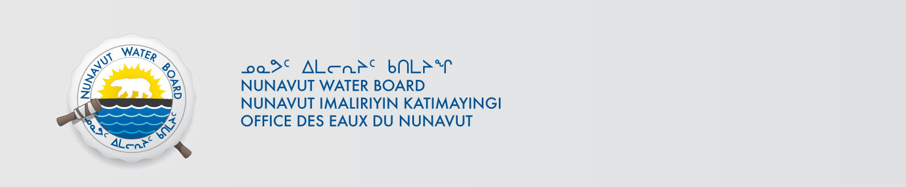

August 8, 2013 File No: NWB2ATU9899 3BC-HMP0712

To: Hamlet, CLARC, HTO, RIA, Coop, and NorthernLocal Organizations – Request to Post Notices

The Nunavut Water Board requests that you post on a bulletin board, until September 8 2013, the attached notice, where it can be viewed by the public. The attached letter is for your information and does not require posting. A translated Notice will be forwarded as soon as possible.

Your time and effort is greatly appreciated.

Sincerely,

Original signed by:

Phyllis Beaulieu
Manager of Licensing

Cc: Hamlet of Grise Fiord (867) 980-9052
Qikiqtani-IA (867) 980-4078
Iviq HTO (867) 980-4311
Grise Fiord Co-op (867) 980-9954
Hamlet of Resolute Bay (867) 252-3749
Qikiqtani-IA (867) 252-3129
Resolute Bay HTO (867) 252-3800
Tudjaat Co-op (867) 252-3618

