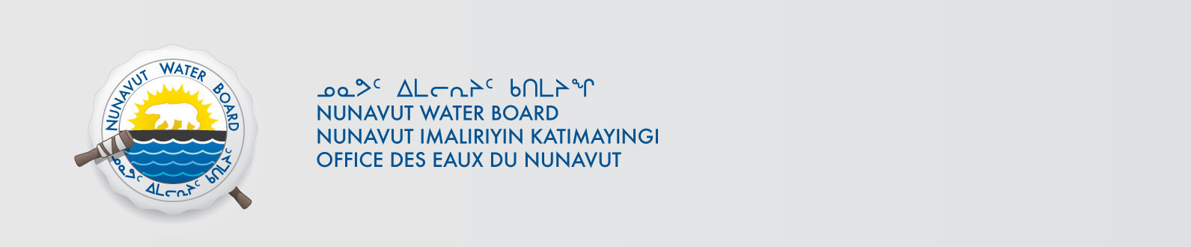

August 12, 2013 File No: NWB2ATU9899 3BC-HMP0712

To: Hamlet, CLARC, HTO, RIA, Coop, and NorthernLocal Organizations – Request to Post Notices

The Nunavut Water Board requests that you post on a bulletin board, until September 8 2013, the attached TRANSLATED notice, where it can be viewed by the public. The English Notice was provided on August 8, 2013.

Your time and effort is greatly appreciated.

Sincerely,

Original signed by:

Phyllis Beaulieu
Manager of Licensing

Cc: Hamlet of Grise Fiord (867) 980-9052
Qikiqtani-IA (867) 980-4078
Iviq HTO (867) 980-4311
Grise Fiord Co-op (867) 980-9954
Hamlet of Resolute Bay (867) 252-3749
Qikiqtani-IA (867) 252-3129
Resolute Bay HTO (867) 252-3800
Tudjaat Co-op (867) 252-3618

