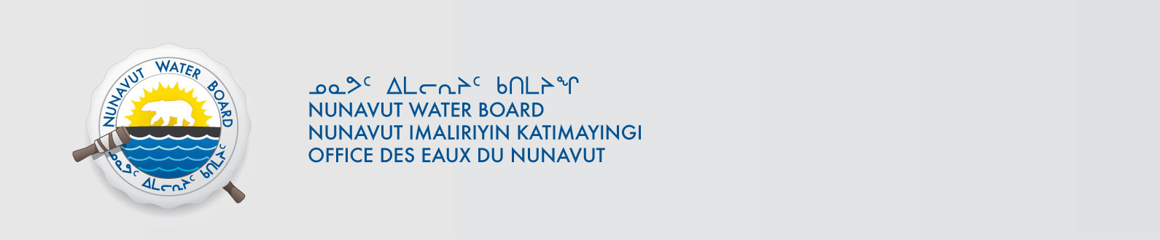

December 15, 2017 NWB File No: 3BC-LPL1111

Dr. J.P. Smol, OC, PhD, FRSC
Dept. Biology, 116 Barrie St.
Queen’s University
Kingston, ON K7L 3N6
Email: smolj@queensu.ca

Subject: Final Inspection – Cancellation of Licence and Closure of NWB File

Dear Dr. Smol:

On July 8, 2015 the Nunavut Water Board (NWB) received a final water inspection report from Indigenous and Northern Affairs Canada (INAC) covering the above noted file. The report indicates there are no outstanding reclamation issues associated with the project. Further, there are no outstanding NWB administrative matters that require attention.

In accordance with section 43.(i)(c) of the Nunavut Waters and Nunavut Surface Rights Tribunal Act (NWNSRTA), the Board may cancel a licence in certain specific cases.

The NWB hereby notifies all parties that the aforementioned licence is now cancelled and that the corresponding NWB file is now considered closed. Any future relevant activities on this site will require a new Water Licence or Approval Without a Licence.

Sincerely,

Licence Administrator

Cc: Qikiqtani Distribution List
INAC Enforcement

