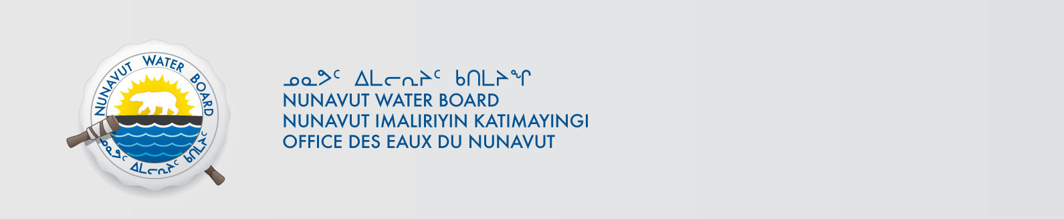

September 6, 2018 NWB File No: 3BC-MIN0606

Holly Steenkamp
1106 Ikaluktuutiak Drive
PO Box 2319
Iqaluit, NU X0A 0H0
E-mail : holly.steenkamp@canada.ca

Subject: Final Inspection – Cancellation of Licence and Closure of NWB File

Dear Ms. Steenkamp:

On September 4, 2018 the Nunavut Water Board (NWB) received a final water inspection report from Crown Indigenous Relations and Northern Affairs Canada (CIRNAC) covering the above noted file. The report indicates there are no outstanding reclamation issues associated with the project. Further, there are no outstanding NWB administrative matters that require attention.

In accordance with section 43.(i)(c) of the Nunavut Waters and Nunavut Surface Rights Tribunal Act (NWNSRTA), the Board may cancel a licence in certain specific cases.

The NWB hereby notifies all parties that the aforementioned licence is now cancelled and that the corresponding NWB file is now considered closed. Any future relevant activities on this site will require a new Water Licence or Approval Without a Licence.

Sincerely,

Richard Dwyer
Manager Licensing

Cc: Qikiqtani Distribution List

