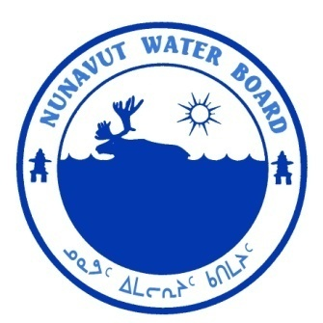  P.O. Box 119 | kNK5 wmoEp5 vtmp5
Gjoa Haven, NU X0B 1J0 | NUNAVUT WATER BOARD
Tel: (867) 360-6338 | NUNAVUT IMALIRIYIN KATIMAYIT
Fax: (867) 360-6369 | OFFICE DES EAUX DU NUNAVUT

File: 3BC-TER0811/TR/B2

April 16, 2012

Mr. Mark Mallory, Ph.D.
Seabird Biologist
Environment Canada
Canadian Wildlife Service
P.O. Box 1714, Qimugjuk Bld. 969
Iqaluit, NU X0A 0H0
E-mail: mark.mallory@ec.gc.ca

Subject: Licence No. 3BC-TER0811 “Tern Island Project”, Environment Canada Canadian Wildlife Service; Submission of the 2010 and 2011 Annual Reports

Dear Mr. Mallory:

The Nunavut Water Board (“NWB”) has completed a technical review of the 2010 and 2011 Annual Reports for the above-mentioned project, which were received on March 10, 2012. The annual reports were distributed for information.

The NWB would like to inform the Licensee that the license 3BC-TER0811 expired on August 31, 2011. The water licence should be renewed to continue the undertaking.

Should you have any further questions, please feel free to contact the undersigned at (867) 360-6338, at your earliest convenience.

Yours truly,

Karén Kharatyan
Technical Advisor

cc: Distribution List – Qikiqtani

