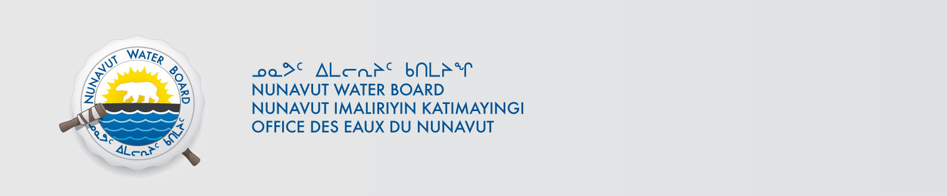

June 28, 2019 NWB File No: 3BM-ARC1419

Debbie Johnson, Senior Administrative Officer | Bhabesh Roy, Municipal Planning Engineer
Hamlet of Arctic Bay | Community & Government Services
PO Box 150 | PO Box 379
Arctic Bay NU | Pond Inlet NU X0A 0S0

Subject: Application Acknowledgement for Hamlet of Arctic Bay Water Licence Renewal

Dear Ms. Johnson:

The Nunavut Water Board (“NWB”) acknowledges receipt on June 2, 2019 of your renewal water licence application, for the Hamlet of Arctic Bay. This application has been assigned file number 3BM-ARC1419. Please refer to this number on future submissions. Application documents received are as follows:

- 190602 3BM-ARC1419 Plan for Compliance
- 190602 3BM-ARC1419 149070 - LUP - Renewal - No Conformity or Screening required
- 190602 3BM-ARC1419 Application Renewal
- 190602 3BM-ARC1419 Cover Letter
- 190602 3BM-ARC1419 Hazardous Waste Segregation, Storage and Transportation
- 190602 3BM-ARC1419 Letter of Authorization
- 190602 3BM-ARC1419 Summary English
- 190602 3BM-ARC1419 Summary Inuktitut
- 190620 3BM-ARC1419 Renewal Application Inquiry Response
- 190628 3BM-ARC1419 Arctic O&M -6 (Revised)

Please be advised that under the Agreement Between the Inuit of the Nunavut Settlement Area and Her Majesty the Queen in Right of Canada (Nunavut Agreement) Article 11, Section 11.5.9 and s. 76 (1) of Nunavut Planning and Project Assessment Act (NuPPAA), the proponent of a project governed by NuPPAA is also required to submit a project proposal document directly to the Nunavut Planning Commission (NPC or Commission) for the NPC’s determination regarding the applicable land use planning requirements and/or directions regarding whether the project is subject to screening by the Nunavut Impact Review Board. In particular, please note that as established under Articles 11, 12 and 13 of the Nunavut Agreement, NuPPAA and Part 3 of the Nunavut Waters and Nunavut Surface Rights Tribunal Act, until the project has completed the applicable land use planning and assessment process required by the NPC and the NIRB, the NWB cannot issue a water licence/approval.

The NWB confirms receipt of NPC conformity under NuPPAA on April 29, 2019 and NIRB determination through NPC under NuPPAA on April 29, 2019. This application is now ready for review and comments. Deadline for submissions is July 29, 2019.

Please call the undersigned at (867) 360-6338 or email to licensing@nwb-oen.ca if you have any questions.

Sincerely,

Richard Dwyer
Manager Licensing

