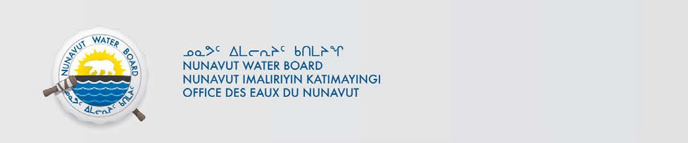

PUBLIC NOTICE OF RENEWAL APPLICATION Hamlet of Arctic Bay

Pursuant to Section 55(1) of the Nunavut Waters and Nunavut Surface Rights Tribunal Act (“Act”), notice is given that the Hamlet of Arctic Bay filed an application for a Renewal water licence to the Nunavut Water Board (“NWB”) to use water or deposit of waste into water for the following project:

File #: 3BM-ARC0810
Project: Municipal Water Use
Location: Latitude: 73º02’00”; Longitude: 83º05’00”;
Purpose: Municipal
Type: “B”

Interested persons are invited to make representations on or before July 29, 2019 to: Manager of Licensing
Nunavut Water Board
P.O. Box 119, Gjoa Haven, Nunavut X0B 1J0
Phone: (867) 360-6338; Fax: (867) 360-6369; E-mail: licensing@nwb-oen.ca

Copies of all application documents may be obtained by affected parties, free of charge, through the internet on our ftp site at the following link:

ftp://ftp.nwb-oen.ca/registry/3%20MUNICIPAL/3B/3BM%20-%20Municipality/3BM-ARC1419/1%20APPLICATION/2019%20Renewal/

or by contacting:
Debbie Johnson, Hamlet of Arctic Bay
Phone: (867) 439-9971; Fax: (867) 439-8260
E-mail: sao_ab@qiniq.com

Failure to respond to this Notice of Application within the specified period shall result in the loss of the right to be compensated, pursuant to Sections 58 to 61 of the Act.

Current Date: June 28, 2019

