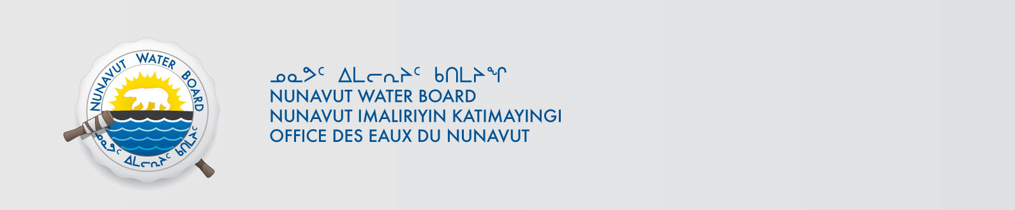

File No: NWB2ATU9899 3BM-CAM0914

March 18, 2014

To: Hamlet, CLARC, HTO, RIA, Coop, and NorthernLocal Organizations – Request to Post Notices

The Nunavut Water Board requests that you post on a bulletin board, until April 10, 2000April 18, 2014, the attached notices (in English and Inuinnaqtun), where they can be viewed by the public. The attached letter is for your information only and does not require posting.

Your time and effort is greatly appreciated.

Sincerely,

Original signed by:

Megan Porter
Licensing Administrator Assistant

Cc: CLARC & KIA – Cambridge Bay (867) 983-2701
HTO – Cambridge Bay (867) 983-2427
Hamlet of Cambridge Bay (867) 983-2193
Northern Store (867) 983-2452
Ikaluktutiak Co-op (867) 983-2085

