Water Resources Division Resource Management Directorate Nunavut Regional Office
P.O. Box 100
Iqaluit, NU, X0A 0H0 October 4, 2018
Ida Porter
Licensing Administrator Nunavut Water Board
  - Box 119
Gjoa Haven, NU, X0B 1J0

Your file - Votre référence
3BM-CAP0810

Our file - Notre référence
CIDM#1228096

Re: Crown-Indigenous Relations and Northern Affairs Canada’s (CIRNAC) reply to responses provided by Government of Nunavut – Community and Government Service to our comments on their renewal application for water licence #3BM-CAP0810 – Hamlet of Cape Dorset

Dear Ms. Porter,

Thank-you for the invitation to reply to the Government of Nunavut – Community and Government Services’ responses to our comments on their renewal application for water licence 3BM-CAP0810 for the hamlet of Cape Dorset.

Recommendation #1 Spill Contingency Plan
The response is not satisfactory. The applicant should provide a stand-alone Spill Contingency Plan prior to any licence being issued, as recommended. As well as deferring producing a stand-alone plan until 2024 or later, the applicant responded to specific deficiencies noted in the Spill Contingency section of the Solid Waste Operation
& Maintenance Plan. They have only integrated two of the six changes into the revised Plan and other changes made create new deficiencies, for example the telephone numbers of contact people have been removed.
Ans. Yes, a standalone SCP is attached. Therefore the item for SCP in the O&M documents for the existing Solidwaste management and sewage lagoon have been removed. However, the standalone SCP will be updated once the new WWTP will be built and commissioned which are anticipated in 2024.

Recommendation #2 Water sources
Both primary and secondary water sources should be included under a renewed licence. The applicant states that bathymetric surveys are available for both sources. We recommend these results be shared to inform the maximum withdrawal quantities set in the licence, particularly for the secondary water source, which is described as shallow. On the map on the next page, the red oval encircles what we are referring to as Ice Lake, which was identified as the secondary water source by locals to the Inspector in 2017. Perhaps this is the same as Dog Lake, which the applicant is referring to.

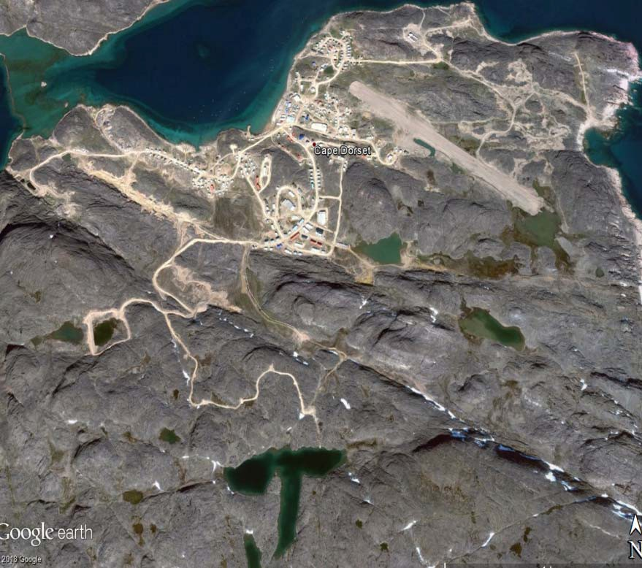

Ans. Yes, both lakes are recommended to be included under the new Water Licence.
Recommendation #3 Sewage treatment
The response is not satisfactory. The applicant should provide the Feasibility Study of Possible Options by Stantec and the Wetland Efficiency Study by Dalhousie University, both cited in their application. Our recommendation included a request for a schedule of next steps for installing adequate sewage treatment in the Hamlet. The response provided is a single date (2024 for plant building and commissioning), which is not sufficiently detailed. We would also like to know milestones with associated dates.
We would like to re-iterate that the 2007 P-Lake sewage lagoon should remain in the water licence until it has been reclaimed. Though it has never been commissioned and used as a sewage lagoon, it is presently storing water by means of a berm.
Ans.
The TOR of the proposed new WWTP has been attached. Yes, it is recommended that
2007 P lake sewage lagoon will be included under the new licence but it will not be used.

Recommendation #4 Sludge monitoring
The response is not satisfactory. When was the sludge last removed from the lagoon? The applicant wrote “the sludge is transported and stored in the different facility”. When is the sludge transported? What “different facility” is it stored in?

Ans. The O&M manual is a typical document since the 3 cells lagoon is not an engineered lagoon. The concept of treating future wastewater in the community will be done by a mechanical plant. Therefore item 3.4.5 Sludge Management Plan of the O&M manual of the 3 cells Sewage Lagoon has been revised and attached.
Sewage was not transported anywhere and will not be transported in future. The sludge stays at the bed of the lagoon all the time.

Recommendation #5 Quality Assurance/Quality Control Plan
We thank the applicant for the copy of the 2013 Quality Assurance/Quality Control (QA/QC) Plan, we had not found it with the initial application. Many of the comments made on the 2016 Cape Dorset Sewage Lagoon QA/QC Plan also apply to this one, in particular:
    - Quality Assurance and Quality Control Program: This section should include the necessity for duplicate samples. If blanks are also to be used, a field blank should be taken, and trip blanks could be taken as a third priority.
Ans. Yes, the revised copy is attached.
    - Laboratory Accreditation & Supporting Documentation: The CALA certification provided expired 3 years ago.
Ans. Here the latest certification is attached.
    - Lab Support Letter: There is no support letter from the laboratory for this plan. It is a requirement.
Ans. Here it is attached.
Recommendation #6 Groundwater monitoring
The response provided is satisfactory. Given that the wells have been dry for eight years, it does not seem likely they will provide data in the future. CIRNAC would therefore recommend removing the groundwater monitoring requirement at all wells, and focus monitoring on seeps and runoff from the lagoons and landfills.

Ans. Thanks. It is recommended not to include these GW wells in the new Licence.

Recommendation #7 Acute lethality testing
The response provided is adequate and we defer to Environment and Climate Change Canada for judgement on the frequency and schedule for acute lethality testing.
Ans. We could use ALS for Acute Toxicity testing. As I explained that it is very much trouble some handling and shipping field samples from Cape Dorset , Nunavut to ALS, Lab in Winnipeg.

Recommendation #8 Metal dump clean-up
The response provided answers some questions, but others remain outstanding. We are glad to read a metal crusher is being used to reduce the volume of materials. Unanswered questions include:
- When will the batteries be shipped south?
Ans. Not known yet. Hamlet is looking for different opportunities and capital dollars.
- When will the crushed metal be removed from site?
Ans. This is in the planning process. No concrete decision was made yet for removal. Working for Capital Dollars.
- When will the recommendations from the Metals Disposal Site Study be implemented? Specifically:
  - Phase I/II site assessment
  - Site restructuring
  - Establishment of a schedule for scrap metal removal.
Ans. The decommissioning of the existing site will be done once the new site is built and commissioned. The new facility is still in CGS Capital planning process and not expected in next 3 years. Working for Capital dollars.
Recommendation #9 Compliance plan
This recommendation was a general encouragement to continue efforts to comply with the Act, Regulations, and expired water licence, therefore the expected response is through actions. The applicant has provided replies to specific inconsistencies noted in the compliance plans and these produce more questions.
- F-2: We were unable to find the 1999 O&M Manual referred to. It also seems improbable that nothing has changed in 20 years, particularly since the Board’s ftp site has a 2001 letter about changes in the water supply pipeline. Where can we find a copy of the Manual? Does it include the use of a secondary water source?
Ans. The O&M manuals of the water supply system, WTFS and Supply Pipe line are attached.
- F-5: Where is the Civil Engineer’s inspection report? We could not find it with the annual report.
Ans. This is the dyke inspection Report and Here it is attached.

CIRNAC appreciates the opportunity to continue participating in this review. If there are any questions or concerns, please contact me at (867) 975-3876 or by e-mail at sarah.forte@canada.ca.

Sincerely,



Sarah Forté
Water Management Specialist

