OPERATION AND MAINTENANCE PROCEDURE OF
THE EXISTING SEWGAE LAGOONS

HAMLET OF CAPE DORSET

BAFFIN REGION, NUNAVUT

FEBRUARY 2019

TABLE OF CONTENTS

Page No.
- INTRODUCTION 4
  - PURPOSE 4
  - SITE SETTING 4
  - POPULATION PROJECTION 6
  - CONTACT LIST 6
- BACKGROUND 7
  - GENERAL 7
    - Sewage Treatment Facility 7
    - Sewage Collection and Transport 7
  - SEWAGE PRODUCTION 10
- SEWAGE DISPOSAL SYSTEM 10
  - MANUAL ORGANIZATION 10
  - EQUIPMENT 10
  - SITE PERSONNEL 11
  - OPERATIONAL PROCEDURES 11
    - Basic Operations 11
    - Decanting Procedure 12
    - Service Disruption Contingency 12
    - Sampling Procedures and Requirements 13
    - Sludge Monitoring Plan 18
    - Geotechnical Reviews 18
    - Record Keeping and Reporting 19
    - Health and Safety 19
  - MAINTENANCE PROCEDURES 19
    - Sewage Trucks and Holding Tanks 19
    - Access Road and Truck Pad 20
    - Drainage 20
  - OPERATION AND MAINTENANCE SUMMARY 20

Appendices
9 REFERENCES. 39

LIST OF FIGURES

Figure 1: Map of Nunavut 5
Figure 2: Location of Sewage Treatment Facility. 8
Figure 3: Three cells Lagoon and emergency Lagoon -------------------------------------------------------------9
Figure 4: Sampling Locations 15

LIST OF TABLES

Table 1: Population Projections for Cape Dorset 6
Table 2: Projected Sewage Generation 10
Table 3: Effluent Quality Limits for the 2001 Sewage Disposal Facility and the Emergency Sewage Disposal Facility----------------------------------------------------------------------------------------------------------12
Table 4: Sampling Station Locations 14
Table 5: Sampling Analysis for Annual Discharge Monitoring 17
Table 6: Summary of Operation and Maintenance Tasks 21

Appendix- A Guidelines for Water and Wastewater Sampling

INTRODUCTION

  - Purpose

The purpose of this manual is to establish existing operation and maintenance protocol for the management of the sewage treatment system for Hamlet of Cape Dorset. Information presented in this manual has been developed based on the document “Guidelines for the Preparation of an Operation and Maintenance Manual for Sewage and Solid Waste Disposal Facilities.” This document fulfills Parts B, D, F and H of the Water License 3BM-CAP0810.

To assist personnel that operate the existing 1990s built sewage lagoon with proper operation and maintenance procedures, the following requirements are addressed in this O&M manual:

    - Proper operation and maintenance procedures for the sewage treatment system to provide effective treatment and operation of the facility;
    - Monitoring program description;
    - Appropriate methods and procedures for wastewater sampling, and;
    - A spill contingency plan.

Site Setting

The Hamlet of Cape Dorset is located on Dorset Island, near the southwest tip of Baffin Island at 64° 14' North latitude and 76°32' West longitude. situated in the Qikiqtaluk Region of Nunavut, the Community is approximately 402 air km southwest of the city of Iqaluit (see Figure 1 in page 5).

Located in the continuous permafrost zone, Cape Dorset has a climate which consists of short cool summers and long cold winters. Annual snowfall and rainfall are approximately 118 cm and 15 cm, respectively. The typical temperature range for January is between a low of about -29°C and a high of about -23°C whereas in July, the temperatures range between a low of 3°C to a high of about 7°C. Usually, freeze up occurs during the month of November but it may happen as early as October or even September. In some years, early freeze up may thaw again before final freeze up occurs. Spring thaw typically takes place during the month of July, but the time frame can vary as much as freeze up. During spring runoff, the community experiences mild flooding.

The community is situated between two valleys of the Kingnait range of hills. Topography consists of areas of moss surrounded by rock outcrops, bedrock and steep cliffs.

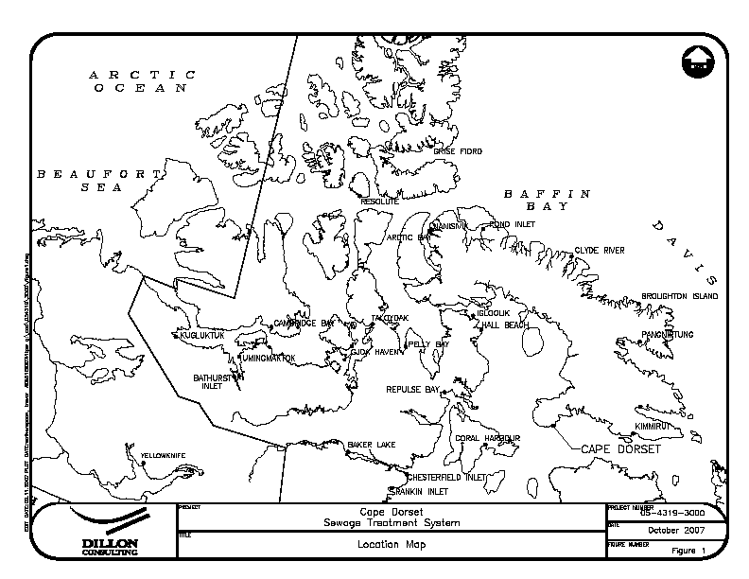

Figure 1: Map of Nunavut

The community uses trucked services for both water delivery and sewage collection. Wastewater is treated using a constructed retention cell treatment system that is located approximately 800 m southwest from the center of the community.

Population Projection

Presently, the population of Cape Dorset is approximately 1,473 people (Based on 2009 GN estimates). Table 1 shows the population growth for the Hamlet over the lifetime of the new plant projected by Nunavut Bureau of Statistics.

Table 1: Population Projections for Cape Dorset

Year | 2000 | 2006 | 2011 | 2016 | 2021 | 2026
Population | 1,213 | 1,382 | 1,536 | 1,692 | 1,848 | 2,002

Source: Nunavut Bureau of Statistics.

Contact List

The Hamlet of Cape Dorset has a Maintenance Management Operation System (MMOS) already in place. Regular maintenance will be conducted as outlined in this manual whereas specific work orders for sewage treatment facility and system will be passed through to the MMOS. A list of the individuals that are responsible for the operation and maintenance of the sewage treatment and waste disposal system are as follows:
Senior Administrative Officer (867) 897-8943
Municipal Works Foreman (867) 897-8004

BACKGROUND

  - General

    - Sewage Treatment Facility

The existing three cell sewage lagoons were built some time in 1900 located at N64013’40.8’’ and W76034’29.5”. These are not engineered facilities. Initially there was a natural valley and it was divided into three cells by constructing two separation berms .Surveys, geotechnical information and design documents are not available. As built drawings were not also prepared. Sewage is being dumped into the first cell. First cell is connected with the second cell with an 8 inches diameter pipe, and second cell is connected to the third cell also with an 8 inches diameter pipe. The third cell also has an 8 inches diameter pipe which controls the overflow. Hamlet maintains these berms in each summer to prevent structural failure.

There is also a natural ditch located at N 64013’49.3” and W 76034’23.7”. This one is used for emergency dumping in case of blizzard or heavy snow fall.

No operational procedure as such was developed at the past.

A new sewage lagoon was built in 2007 and it was not commissioned yet. Until the new Mechanical Wastewater Treatment Plant is built and commissioned, these existing three cells lagoons will be used. The three cells lagoons have a capacity issue. Whereas sewage production in 2017 was recoded for roughly52, 499 cubic meters. These cells are not containment, and once the water level rises at the pipe invert level, over flow starts. The system is in noncompliance.

Sewage Collection and Transport

All municipal wastewater of the community is collected and transported to the sewage lagoon by vacuum trucks. The sewage collection service operates 7 days a week. With three trucks operating, about 15 to 20 trips are made to the sewage lagoon per day.

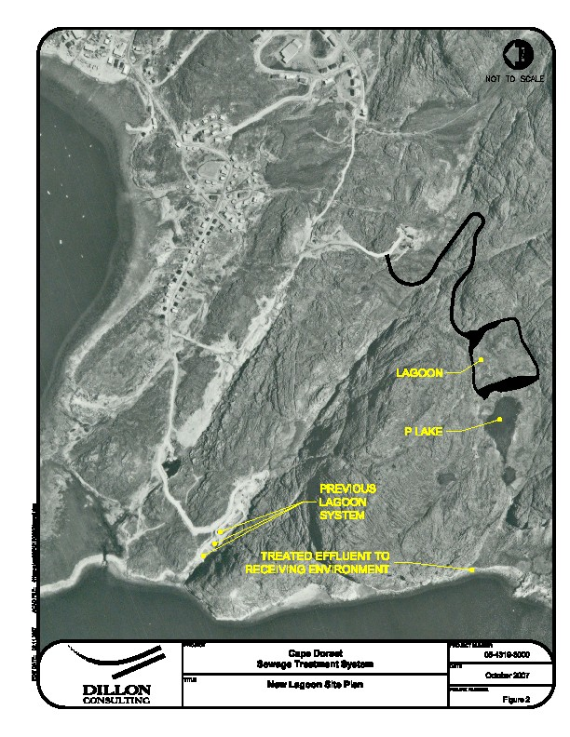
Figure 2: Location of Sewage Treatment Facility -3 cells and P-lake

Emergency cell
CAP-5
CAP-4
Final over flow

Sewage Lagoon Cell-3:
112 ft. X 104 ft.
Sewage Lagoon Cell-1:
314 ft. X 138 ft.
d
Sewage Lagoon Cell-2:
131ft x 119 ft.

Figure : 3: Three cells Lagoon and Emergency cell

2.2 Sewage Production

It is approximated, for smaller communities such as Cape Dorset where water distribution is provided by trucks, that the sewage generation is equal to the water consumption. Therefore, the daily and annual sewage generation rates are approximately equivalent to the water consumption rates. The following equation, proposed by MACA, gives the water consumption rate for small communities on trucked services that have a population less than 2,000 people.

Water Use (L/capita/day) = 90 L/capita/day x (1.0 + 0.00023 x Population)

Using the estimated population projections shown in Table 1, the projected sewage generation are shown in Table 2 below. The new P- lagoon was constructed to hold the annual generation rate of 96,100 m3 of wastewater but never Use. Hamlet has no intention to use in future. This facility is recommended to be decommissioned. Until the new facility is commissioned, the entire sewage will be continued to dump into these three cells lagoons.

Table 2: Projected Sewage Generation

Year | Population | Sewage Generation Rate (L/capita/day) | Annual Generation (m3/yr.)
2000 | 1,213 | 115.11 | 50,964
2006 | 1,382 | 118.61 | 59,829
2011 | 1,536 | 121.80 | 68,283
2016 | 1,692 | 125.02 | 77,213
2021 | 1,848 | 128.26 | 86,530
2026 | 2,002 | 131.44 | 96,047

Physical, chemical and biological characteristics of sewage are referred to as its composition. It is assumed that raw wastewater has a typical average concentration of 625 mg/L for BOD5 and 900 mg/L for TSS. For domestic waste, average raw FC concentration is about 2 x 109 FCU per 100 mL.

SEWAGE DISPOSAL SYSTEM

  - Manual Organization

This section of the manual presents the operation and maintenance procedures that are associated with the wastewater treatment facility that designated operators assigned to the system should be aware of concerning the facility and system.

Equipment

The equipment required to operate the Cape Dorset sewage treatment system consists of three sewage collection trucks with the following capacities:
▪ 9,092 L (2,000 imp. gal); 13,025 L (2,865 imp. gal) and
13,093 L (2,880 imp. gal)

Site Personnel

The overall responsibility of the waste disposal site as well as the overseeing of the operation and maintenance personnel is that of the Senior Administrative Officer. Day-to-day operation and maintenance of the facility is the responsibility of the Municipal Works Foreman. In addition, several other employees operate and maintain the sewage trucks on a day-to-day basis.

Operational Procedures

These procedures must be carried out frequently to ensure efficient operation of the treatment system. Daily operation procedures must/should be carried out frequently to ensure smooth operation of the treatment system.

Basic Operations

      - Municipal wastewater is collected from holding tanks at each residence and commercial building by sewage (vacuum) trucks.
      - Sewage (vacuum) trucks pump the wastewater out of the holding tanks and transport it to the sewage treatment area.
      - Throughout the year, the wastewater is discharged into the lagoon through the offload chute located at the truck pad. The sewage truck backs up to the lagoon (bollards are placed for safety purposes) and the valve is opened. Wastewater is discharged into the lagoon, over the splash pad.
      - The wastewater cannot remain in the lagoons for 12 months because these are under capacity and flow arrangement is made to prevent structural failure. The retention period is minimum to satisfy the effluent quality to the water licence requirement.
      - Natural decanting/overflow occurs throughout summer until freeze up.

At least 10 days’ notice to the Nunavut Water Board (NWB) prior to decanting is not followed in this case.
The effluent discharged from either the existing Sewage Disposal Facility at sampling station CAP-4 and/or the Emergency Sewage Disposal Facility at sampling location CAP-5 should meet the following effluent quality standards prior to decant as listed in Table 3. Practically over flow starts before the sewage quality meets that target. All of these lagoons have capacity issue. In order to prevent structural failure, overflow is the most acceptable approach. During winter, the emergency lagoon is being used.

Table 3: Effluent Quality Limits for the 1990s Sewage Disposal Facility and the Emergency Sewage Disposal Facility

Parameter | Units | Maximum Average Concentration
Fecal Coliforms, FC | CFU/100 mL | 1 x 104
5 Day Biological Oxygen Demand, BOD5 | mg/L | 120
Total Suspended Solids, TSS | mg/L | 180
Oil and Grease | - | No visible sheen
pH |  | 6 - 9

Decanting Procedure

The overflow is uncontrolled at this case. The steps involved with gravity decanting the lagoon cells are as follows:
- Overflow starts once water level rises at the invert of the pipe which is installed at the lower berm.
- Monitor flow rate leaving discharge pipe during gravity decant period.
- Monitor for erosion at the end of the discharge pipe and repair as required.
- Check daily for erosion, blockages and other problems that may occur on the upstream slope of the berm. Apply necessary procedures to fix problem during decanting.
- If the discharge pipe happens to be blocked or frozen at the time of decanting, then the following options should be used:
  - Try to unblock or thaw pipe using a steamer hose. Once unfrozen, proceed with decanting. If necessary, keep applying heat to the discharge pipe to assist with the flow of material.
  - Decant lagoon using a diesel fired pump or siphon system. If a pump system is used for the decanting, then obtain a pump that will give the required flow rate to discharge the lagoon volume over the two week decant timeframe. In year 20, the required pump flow rate is 5,000 L/min.

Service Disruption Contingency

In the event of any disruption in the service of these three cells lagoons, for instance, the road to the lagoon is inaccessible mostly in Winter season; the Hamlet will use the emergency sewage disposal site located at N 64013’49.3’’ and W 76034’23.7”until the disruption has been resolved.

During times when the emergency cell is active, the community will record the following items;

- The date that the emergency commenced;
- The reason for the emergency;
- The date that the emergency ended;
- The number of trucks discharged to the lagoon; and,
- The volume of the sewage deposited in the lagoon.

Sewage deposited in the emergency lagoon cell will be treated until the discharge criteria are met, and then the treated sewage will be discharged to the receiving environment. It is proposed that this cell be decanted on an annual basis in October.

The Hamlet will notify CIRAC when the emergency lagoon is in service, and prior to the decant of the emergency lagoon.

The Senior Administrative Officer of the Hamlet of Cape Dorset will be the responsible party for the actions taken under this emergency procedure.

Sampling Procedures and Requirements

A key component to the operations and maintenance of the proposed sewage treatment system is a sampling program.
The proposed sampling program will help to monitor the treatment while verifying compliance with regulations. As well, it will model the treatment process which with help to understand the behavior of the lagoon for future development and expansions of the system.

It is important such a sampling program be implemented by the Hamlet as a part of the annual operations for the facility. Local members of the community that operate the system are to be trained on the proper operation and procedure methods used in the sampling program. In addition, quality and safety training will also be included which will ensure that the high quality data will be obtained.

All sampling, sample preservation and analyses will be in accordance with methods described in the current edition of Standard Methods for the Examination of Water and Wastewater. In addition, a document has been attached in Appendix A of this manual that provides guidelines and procedures to follow when sampling wastewater.

To obtain meaningful results from the analysis, the following five factors are of particular importance:
- Sample collection at designated time and location;
- Correct usage of container/sample bottle for parameter being tested;
- Correct labeling of sample bottles and filling out record/field sheet;
- Correct procedure for field sampling;
- Proper and timely shipment of samples to the laboratory.

It is critical, from a quality perspective, that sample collection be performed from an area of higher concentration to an area of lower concentration of contaminants. Therefore, a sample will be collected at various locations along the system to monitor the effluent quality at various stages of treatment. Descriptions of each sampling location of the sewage treatment system for the Monitoring Program are listed in Table 4 below in page 10 and shown in Figure 4 on page 11.

Table 4: Sampling Station Locations

Monitoring Program Station Number | Description of Monitoring Program Station
CAP-3 | Influent of Wastewater to Wastewater Facilities at the point of discharge into the first cell
CAP-4 | Effluent Discharge from existing Sewage Disposal Facilities on the third cell overflow pipe
CAP-5 | Effluent Discharge from Emergency Sewage Disposal Facility

CAP-3

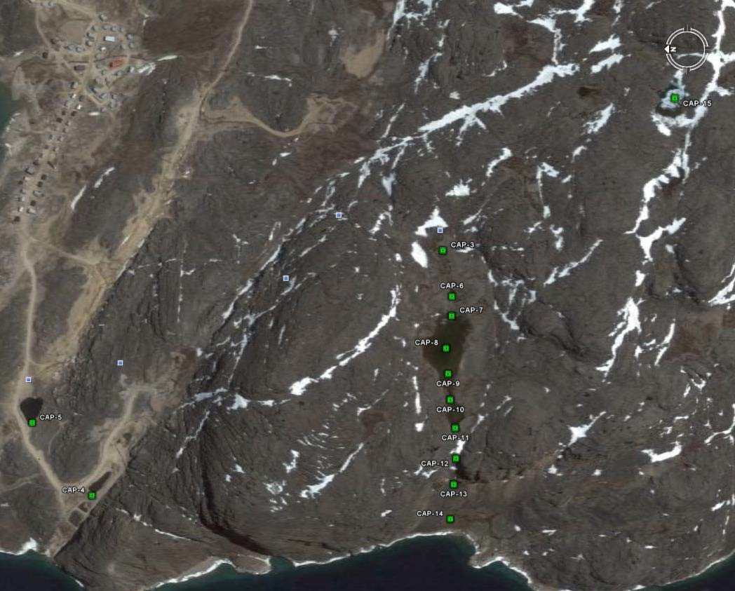
•

This is a station of Truck sewage discharge of the new Lagoon. Currently it is being used at the 1st cell of the existing lagoons since the new lagoon is not commissioned yet.

Figure 4: Sampling Locations

By obtaining samples at each of the locations proposed above, effluent treatment rates can be monitored. According to the water licence, wastewater samples will be taken from locations CAP-3 ,CAP-4 and CAP-5, one (1) week prior to the proposed decant date and weekly during the course of lagoon decant. These wastewater samples will undergo the same analysis which will include the following set of parameters as listed on the following page.

Biochemical Oxygen Demand, BOD5 | Carbonaceous Biochemical Oxygen Demand, CBOD5
Total Suspended Solids, TSS | Fecal Coliforms, FC
pH | Conductivity
Oil and Grease (Visual) | Total Organic Carbon, TOC
Total Hardness | Total Alkalinity
Nitrate-Nitrite | Ammonia Nitrogen, NH3-N
Total Phosphorus, TP | Total Phenols
Magnesium, Mg | Calcium, Ca
Potassium, K | Sodium, Na
Chloride, Cl | Sulphate, SO4
Total Arsenic, As | Total Aluminum, Al
Total Antimony, Sb | Total Barium, Ba
Total Beryllium, Be | Total Cadmium, Cd
Total Chromium, Cr | Total Cobalt, Co
Total Copper, Cu | Total Iron, Fe
Total Lead, Pb | Total Lithium, Li
Total Manganese, Mn | Total Mercury, Hg
Total Molybdenum, Mo | Total Nickel, Ni
Total Selenium, Se | Total Tin, Sn
Total Strontium, Sr | Total Thallium, Tl
Total Titanium, Ti | Total Uranium, U
Total Vanadium, V | Total Zinc, Zn

Table 5: Sampling Analysis for Annual Discharge Monitoring

Test Parameter | Receiving Water Body
Biological Oxygen Demand, BOD5 | X | X
Total Suspended Solids, TSS | X | X
Fecal Coliforms, FC | X | X
Ammonia-Nitrogen, NH3 – N | X | X
Total Phosphorus, TP | X | X
Heavy Metals | X | X

Annual sampling and testing for acute lethality to Rainbow Trout, Oncorhynchus Mykiss and Daphnia Magna will be performed for sampling station CAP-4 are recommended to delete from the water licence due to constrain of sampling, shipping and transportation to the lab. (These tests have been requested to delete from the water licence due to constrain of sampling and transportation of samples to the Lab.)

A grab sample will be taken from each of the three sewage trucks during discharge to the lagoon. Samples from the trucks will provide quality of the raw sewage before it enters the lagoon. The last pipe discharge quality is considered the first point of effluent discharge in the environment after some degree of treatment. This data will assist with monitoring the water quality of these areas by comparing the results of both raw and treated wastewater samples. These samples will be taken four times in summer months. No flow meter exists at the end of the final discharge pipe.

Once collected, the samples will be shipped to the laboratory and analyzed using the same test method/procedure. This sampling program will be conducted over several years to collect sufficient data for trend analysis. All lab results for the monitoring program will be submitted to NWB along with the Hamlet annual report. Note that any other additional sampling during the year will be at the request of the regulatory agencies.
Hamlet will be using the services of the following Accredited Environmental lab in Ottawa, ON. Caduceon Environmental Laboratories
Ottawa, Ontario, K1V 7P1
Phone: (613) 526-0123
Fax: (613) 526-1244

Sludge Monitoring Plan

The sludge blanket will be monitored as part of the annual discharge procedure. It is recommended for storage the sludge blanket at the bed of the lagoons for the life time of operation of the lagoons. If the lab test results from these 3 cells lagoon, specifically BOD and TSS analyses, become non-compliance, then sludge removal study can be conducted prior to decommissioning. This is the decommissioning process of such type of sewage lagoon. The sludge is not tested on annual basis.

The purpose of the sampling is to ensure that the sludge remains of a quality suitable for land disposal. Sampling shall consist of a sample collected from the center point of a grid no less than 10 m by 10 m. Sufficient samples shall be taken to describe the entire sewage lagoon. Results from the sludge analysis
will dictate whether sludge could be used for landfill purposes directly or require treatment before disposal.
Again it is required to know the sludge quality only prior to decommissioning of the Lagoon.

However, considering the present status of the facility, it is recommended to keep the sludge at the bed of the Lagoon for the rest of the life of the Lagoon.

Geotechnical Reviews

A Dam Safety review is to be completed by a qualified engineer and will be executed annually in each summer. Baffin Regional Engineer conducts annual inspection along with the CIRNAC inspector and findings are presented in the Hamlet annual report.

The review is to include a site inspection report of the existing lagoons under operation based on the following items:

- Site inspection of all berms and structures of all three lagoon cells.
- Safety review to include the operation of all discharge and back up equipment and procedures,
- Maintenance review to verify that all facilities required for safety of the dam and monitoring systems are maintained in satisfactory condition.
- Review of the surveillance and monitoring program and methods to verify that the monitoring program will detect any unsafe conditions in a timely manner.
- Review the level of emergency preparedness to verify that it is appropriate for the facility.
- Review previous report to verify that recommendations have been complied with.

The report generated from the geotechnical review in being submitted as a part of the annual report to the Nunavut Water Board.

Record Keeping and Reporting

Records of all activities and operation should be kept to assist in the planning of annual operations and maintenance as well as the evaluation of the effectiveness of the sewage treatment facility. These records should be kept in the Hamlet Office and be maintained by the facility’s supervisor. Sample O&M log sheets for the Cape Dorset Sewage Treatment System are available in the Hamlet office.
Based on the record keeping and reporting requirements listed in Part B of the water licence, the following information and data should be recorded and be included in the annual report that is submitted to the Board:
- Monthly and annual quantities in cubic meters (m3) of raw sewage offloaded from sewage trucks for the existing Sewage Disposal Facility and Emergency Sewage Disposal Facility;
- Number of days of use for the existing Sewage Disposal Facility and Emergency Sewage Disposal Facility;
- Number of trips to each of the Sewage Disposal Facilities;
- Start and end date for discharge of lagoon;
- Date and description of maintenance activities carried out on the Sewage Disposal Facilities; and
- Date, volume and description of any spills that have occurred.

Health and Safety

Due to the potential health hazards associated with municipal wastewater, it is imperative, for those personnel working in this area, to be familiar with and execute all safety precautions involved with the various work tasks associated with the system.
- Equipment is to be kept clean.
- Wear protective clothing such as gloves and boots at all times.
- Work cloths should not be worn home.
- Hands to be washed frequently; as a minimum before eating and after work.
- Personnel should receive appropriate vaccinations and ensure they are kept up-to-date.

Maintenance Procedures

In the proceeding sections, maintenance procedures for the different areas of the wastewater treatment infrastructure are discussed and should be carried out to ensure the system runs efficiently.

Sewage Trucks and Holding Tanks

The most important part of the sewage treatment system and process is the collection and transport of the wastewater from the residences and buildings to the lagoon cell. Therefore, it is crucial that the sewage trucks be kept in good repair. Procedures for truck and tank maintenance are as follows:
      - Repairs should be completed immediate and take high priority;
      - Full tank sewage trucks should not rest for long periods of time, especially during the winter;

      - Holding tanks should be kept in good working order and prevented from freezing in the winter.

Access Road and Truck Pad

Basic road maintenance such as those listed below must be performed on a regular basis to ensure that the site is accessible at all times.
      - Road and truck pad be graded smooth and reshaped at least twice (2) per year;
      - Snow, when necessary during the winter, to be removed to provide unrestricted access to discharge point;
      - During snow removal, care is to be taken not to damage berms and surrounding areas;
      - Any spilled and/or frozen wastewater should be removed with the snow to appropriate disposal site;
      - Discharged point should be monitored for potential erosion problems.

Drainage

The truck pad at the sewage discharge point should be graded such that any wastewater spilled during the offloading procedure will flow into the lagoon cell and sewage treatment system. During the winter months, it is important to monitor the discharge pipe as this may be problems with flow during periods of extreme low temperatures. Wastewater remaining in the pipe may freeze, causing blockage and/or buildup which can potentially damage or break the structures.

Operation and Maintenance Summary

Daily, weekly, monthly and yearly activities and procedures that are required by the operator and maintenance personnel are summarized in Table 6 shown as follows.

Table 6: Summary of Operation and Maintenance Tasks

Frequency | Description of Task
Daily | - Collection, transportation and disposal of wastewater and/or sewage from residential and commercial holding tanks to the truck discharge point at the sewage treatment lagoon.  - Immediate cleaning of any spills.  - Clearing of snow from access road and truck turn-around pad as required during winter.  - Maintaining O&M information records
Weekly | - Inspection of berms, dykes and drainage courses.  - Monitoring of area surrounding thermistor.  - Conduct weekly monitoring program (if required).  - Maintaining O&M information records
Monthly | - Maintenance of access road and truck pad if required.  - Monitoring and recording of thermistor readings for monitoring program.  - Confirm location and readability of signs.  - Conduct monthly monitoring program (if required).  - Maintaining O&M information
Yearly | - Perform annual decanting of lagoon cell in fall.  - Conduct geotechnical review of geothermal monitoring program.  - Grading and reshaping of access road and truck pad.  - Conduct annual monitoring program (if required).  - Maintaining O&M information records

Appendix- A: Guideline of Wastewater Sampling

REFERENCE:

- Dillon Consulting Limited. “P lake Sewage Lagoon System”, produced for Department of Community and Government Services, Government of Nunavut, January 2006.

APPENDIX-A

GUIDELINES FOR WASTEWATER SAMPLING AND TESTING

Guide Lines Wastewater (Sewage) sampling

Wastewater:

- During decanting of Sewage Lagoon, Three times samples are collected from the designated sampling points: at the beginning, at the middle and at the end of decanting period. Collect monthly treated samples from the first point of discharge of Sewage (end of pipe) as long as flow is seen.
- Collect monthly raw samples directly from the truck discharge at the same time of item 1.

All the wastewater samples will be sent to Ottawa Lab.

Gord Murphy/Rebecca Marshall Caduceon Environmental Laboratories 2378 Holly Lane
Ottawa Ontario K1V 7P1
Tel: 613-526-0123
Fax: 613 526 1244

Precautions of sampling:

  - Use hand gloves
  - Record Chain of Custody
  - Ensure each bottle level information is filled:
    - ‐Date and time sample taken
    - ‐Location with GPS coordinates
    - ‐Sampler’s name
  - Person’s name and contact information where to send sample Test Results and invoice.

  - Samples must be arrived Ottawa Lab within 24 hours from the time of sampling. Wall bills could be sent to the Lab so that cooler is located during the shipment.

