SOLIDWASTE OPERATION AND MAINTENANCE PLAN

FEBRUARY 2019

HAMLET OF CAPE DORSET
BAFFIN REGION, NUNAVUT

TABLE OF CONTENTS
Page No.

1.0 Introduction ---3
2.0 Transportation --8
3.0 Site Personnel --8
4.0 Health and safety --9
5.0 Municipal Solid waste Area --9
    - Waste segregation -----9
    - Burning -----10
    - Operational Procedure ---12
6.0 Bulk Metal/Hazardous Waste Storage areas -- 14
6.1 Bulk Metal Management ---14
  - Hazardous Waste Management -14
6.2.1Operations ---------19
6.2.2Maintenance----------------------------------------------------------------------------------------------------------------19
  - Solid waste Disposal Facility Maintenance------------------------------------------------------------------------------------------22
  - Inspection and Audit --22
  - Maintenance Activities ----22
  - Fence and signs -----23
  - Monitoring and sampling ---24
  - Monitoring Requirement -24
  - sampling procedures -26
  - Record Keeping ----26
9.0 Emergency Response -27
Fig-1: Location Map of Cape Dorset------------------------------------------------------------------------------------------------5
Fig-2: Site locations of Waste Facilities 6
Figs. 3 and 4: Solid Wastes (landfills) 7
Fig. 5: metals --7
Figs. 6 and 7: Metals -8
Fig-8: Identification of Hazardous Wastes 16
Table-1: Burn and non-burn wastes-------------------------------------------------------------------------------------------------11
Table-2: Monitoring Station-----------------------------------------------------------------------------------------------------------24

1.0 Introduction:
The object of this document is to describe the existing Solid wastes Operation and Maintenance Plan. The Hamlet of Cape Dorset has two waste sites: the domestic waste site and the Bulky metal waste site.

The Hamlet of Cape Dorset a small Community of Baffin Region. The population in 2014 is 1,473. The Community is situated at N 64014N’ and W 76032’ on Dorset Island near Fox Peninsula at the southwest tip of Baffin Island. The average annual rainfall is 15 cm and the average annual snowfall is 118 cm. The typical temperature range for January is between a low of about -290C and a high of about -230C whereas in July, the temperature ranges between a low of 30C to a high of about 70C. Usually, freeze up occurs during the month of November but it may happen as early as October or even September. In some years, early freeze up may thaw again before final freeze up occurs. Spring thaw typically takes place during the month of July, but the time frame can vary a much as freeze up. During spring runoff, the community experiences mild flooding.

Cape Dorset is situated between two Valleys of the Kingnait range of hills. Topography consists of areas of moss surrounded by rock outcrops, bedrock and steep cliffs. The Community is challenged by the local geography and climate, both which create natural barriers to transportation services. Cape Dorset is also located within the continuous permafrost zone.

The community has been managing two wastes sites: Domestic wastes site and Bulky metal wastes site as shown in Fig-1. These sites are isolated and about 0.50 km access road from the Community to the sewage lagoon connects both facilities. Both facilities are non- engineered. No design, drawings and O&M Manuals are available. As a result, Hamlet is not following any acceptable protocol to manage their wastes.

The landfill does not have berms, gate, lights or designated areas for different wastes. The average waste
generation rate is considered is 0.015m3/person / day and for population of 1,473 in 2014, total 8064.68 cubic meters waste is expected, which is equivalent to uncompacted volume for 798,403 kg (considering uncompacted density=99 kg/m3 of waste (Following Arktis design study for Hamlet of Resolute Bay Solid waste Management in 2010). This facility has a capacity issue.

The bulky metal waste site is not being maintained. The sorted areas have begun to spread and new waste has not been sorted to the piles. The hazardous waste area has not been maintained and the waste is placed randomly around the area. There is no fencing around the site and it is open to the public. There is a berm located at the bottom of the site but the berm has been breached in one area. A project was undertaken by the community by way of a contribution agreement with the Government of Nunavut in November 2006. The project was broken into different phases. Phase 1 was to sort the metal waste into piles of similar metals. Phase 2 was acquiring the services of an environmental engineer to study and provide solutions on how to store, dispose and remediate the bulky metal waste. Phase 3 was to contain the hazardous waste on site. Phase 4 was to remediate the waste but Phase 4 was not started.

There is no engineered Land farm built to accommodate and treat contaminated soil of this community. The soil conditions and ground water quality in the active layer during warmer months was unknown. Two monitoring wells were installed to monitor the ground water quality.

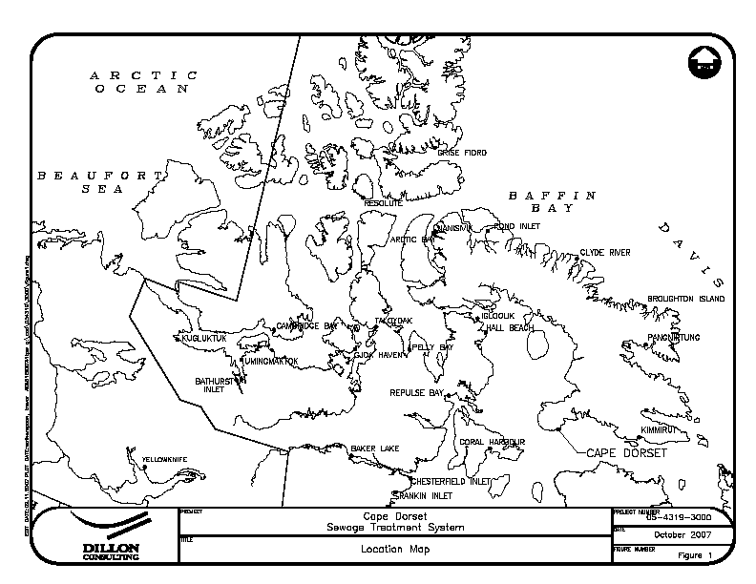

Hamlet of Cape Dorset

Fig.-1: Location Map of Hamlet of Cape Dorset

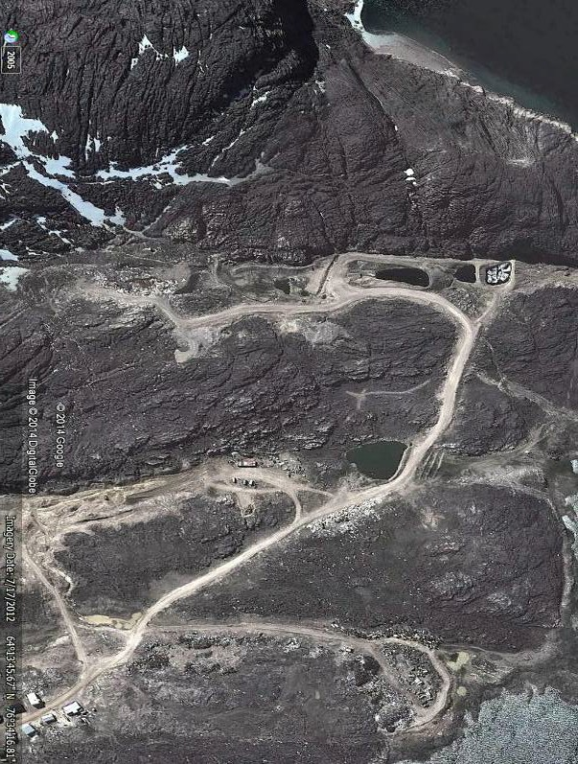
Land fill site
Future Waste site
3 cells lagoon

Bulk Metal wastes

Fig-2: Site Locations of the Wastes Facilities

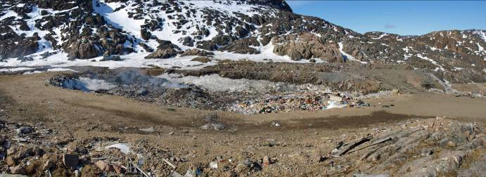
Fig.-3: Current Solid Waste Site

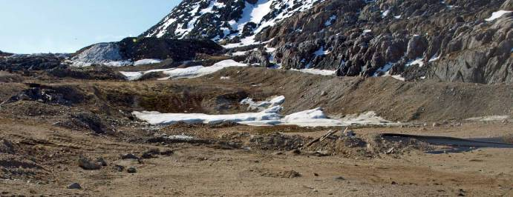
Fig.-4: Future Proposed Solid Waste Site

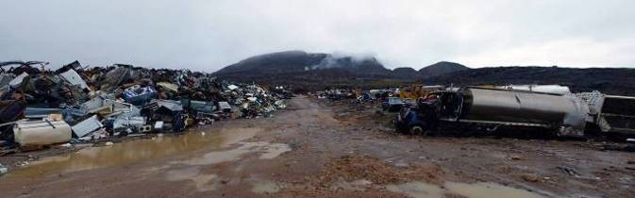

Fig. - 5: Bulky Metal Waste Site - Bottom

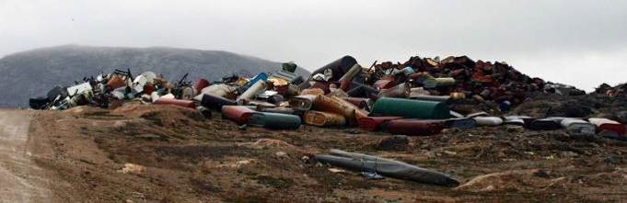

Fig.-6: Bulky Metal Waste Site - Entrance

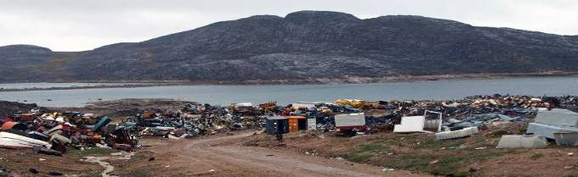

Fig.-7: Bulky Metal Waste Site – Looking Down from Entrance

2.0 Transportation of Wastes
The Hamlet operates one ordinary garbage truck for collection of MSW within the community and transfer to the solid waste facility at Cape Dorset. Front end loader is used to haul metal objects such as old automobiles/fridges etc. to the metal dump. The access road 0.50 km long from the Community to the Sewage lagoon connects both the Landfill site and Bulky metal site. This access is adequately maintained for all types of vehicular traffics throughout the year.

3.0 Site Personnel
The Hamlet Foreman has overall responsibility of the solid waste disposal facility to ensure proper operation

reporting to the NWB.
The Foreman is responsible for day-to-day operation and maintenance of the solid waste facility. Day-to-day activities include managing waste collection, proper segregation of waste, compacting and burning of waste, sampling leachate from the facility, completing inspections and other maintenance activities.
The Hamlet typically has one individual hired to operate the compactor truck and collect waste from community buildings five days a week. This Waste Truck Driver is also responsible for ensuring collected waste is properly segregated, and refusing the collection of hazardous waste if present. If properly trained, this individual may also be required to operate heavy equipment within the solid waste disposal facility.

4.0 Health and Safety
The public and all personnel working within the solid waste disposal facility should be made aware of potential health and safety hazards associated with working around municipal solid wastes and hazardous wastes. This is imperative so individuals make a conscious effort to perform all necessary safety procedures to protect themselves, their co-workers and family members at home. The requirements of the Nunavut Safety Act will be followed at all times. A site-specific safety plan should be developed by the Hamlet for the solid waste disposal facility and followed once developed. The site-specific safety plans should outline all potential hazards, safe work practices, training requirements, equipment requirements (e.g., fire extinguishers, spill response kits, etc.), and emergency procedures.
Public access to the solid waste disposal facility should be restricted to specific areas and/or times to minimize potential hazards to the public. Public access to any hazardous waste storage areas should always be restricted. Additional health and safety precautions for the public and site personnel will be taken during burning of MSW and accidental spills.
See Section 9 of this O&M Manual for emergency response procedures in the event of a fire or spill at the solid waste disposal facility.

5.0 Municipal Solid waste Disposal Area

Operations

Waste segregation
The MSW disposal area is partially fenced and the Hamlet presently does not limit who disposes of waste and where. Proper waste segregation is imperative to the long-term operation of the facility as it helps ensure potential human health and environmental hazards are minimized, un-compactable wastes (e.g., bulky metal wastes) are kept out of the landfill, hazardous wastes are not properly managed.
The MSW disposal area at Cape Dorset is used as a natural attenuation landfill. This means that the landfill is not lined and small amounts of contaminants can enter the surrounding environment to be naturally broken down. In

this type of landfill, the rate that contaminants enter the environment is expected to occur at a rate such that
contaminants can easily be broken down and the surrounding environment is not overwhelmed. Natural attenuation landfills also rely on permafrost aggrading into the covered waste cells of the landfill and eventually freezing them. However, as contaminants are able to freely enter the environment in this type of landfill, proper waste segregation is important to ensure harmful contaminants are kept out of the landfill.
Initial waste segregation should begin at the community’s residences and other buildings, ensuring residents and business are familiar with acceptable wastes for the MSW disposal area. Household hazardous or bulky wastes are kept out of the landfill and Burn Area.
The Waste Truck Driver should be familiar with operational procedures for the MSW disposal area, acceptable wastes for burning and landfilling and proper waste segregation practices. Ultimately the Foreman is responsible to ensure proper waste segregation occurs.
The Waste Truck Driver should monitor the waste they collect from community buildings every day, collecting only that which is acceptable for disposal at the MSW disposal area. The Hamlet could provide a ‘grace’ day once or twice per year to collect residents’ household hazardous and/or bulky metal waste. The Hamlet could also provide help to residents who have larger items to dispose of and have no means of transporting them to the correct disposal area.
The MSW disposal area needs to be properly signed to inform operators and residents of the correct location to dispose of or store certain wastes. At a minimum, the MSW disposal area should have disposal/storage areas for:

- Domestic burnable waste (for burning and landfilling) – a selected Burn Area
- Domestic non-burnable waste (for landfilling)
- Treated wood and wood products
- Building/construction materials
- Bulk metal waste – a separate bulk metal waste disposal area
- Re-usable/recyclable material (i.e., salvage area)
- Household hazardous waste (i.e., drop-off hazardous waste disposal area).

Sea cans or constructed drum shelters can be used to store specific household hazardous wastes in a designated area before being shipped out of the community. Hazardous waste management is described in Section 6.2.

Burning
Once waste has been properly segregated, burnable waste should be burned at least once per week to keep the volume of waste manageable. Burning should only occur when winds are light and blowing away from the community. Table 1 outlines wastes acceptable for burning.

Table-1: Burnable and non-burn

Burnable Wastes | Non-Burnable Wastes
Domestic Waste (e.g. food waste, paper  products,  paper  board/cardboard packaging, etc.) | Non-wood building /construction materials (e.g. roofing  materials, electrical wire, insulation, plastics, asbestos, etc.)
Non-treated wood | Treated wood 9e.g. telephone poles, pilings, cribbing,  foundation wood)
(this may also be recyclable / salvageable) | Asphalt and asphalt products
 | Tires
 | Hazardous wastes
 | Waste Paint
 | Fuel and lubricant containers
Aerosol cans and other compressed gas containers (e.g.
propane tanks.)

Hamlet issues the permits according to the By-law. The Hamlet presently does not apply for a permit to burn
through the Clyde River Fire Department, though they should. Hamlet personnel (e.g., Foreman and crew) typically carry out and control burning of waste at the MSW disposal area. Controlling the open burn is extremely important to reduce the risk of uncontrolled fire and hazards to the public, employees and the surrounding environment. Burning practices at the MSW disposal area should include:

      - Confirmation of weather forecasts prior to any burning. If heavy rain is or will be present, burning should be potential postponed (burning during heavy rain events may result in poor or incomplete combustion and the to generate harmful contaminants).

      - Confirmation of wind speed and direction prior to any burning. If loose debris can be carried by the wind,
burning should be postponed.
      - Obtaining a Permit to Burn through the Cape Dorset Municipality.
      - Burning in the selected Burn Area only and ensuring burning does not occur in landfill piles.

      - Presence of an attendant during initial stages of the burn and periodic inspection of the burn once it has

been established.
- Maintaining a minimum of 5 m buffer zone around the burning area and all ensuring attendants or personnel remain upwind of the burn area.
- Closing the MSW disposal facility to the public during burn events.
- Confirmation the MSW is no longer hot or burning prior to the addition of more waste, or
covering with granular material. This can be accomplished by moving around the ash and
remaining materials to ensure the Fire is out and material can cool.

Operational Procedure
The MSW disposal area requires daily, weekly and monthly operational procedures to ensure it continues to optimally function as the Hamlet’s primary MSW disposal site, and potential public health and environmental hazards are minimized. The current municipal By-law 145 only covers the garbage pickup and disposal rates with a brief section stating no burning or disposal by customers without first receiving a dumping permit. It does not cover any information or instruction in regards to maintenance of the MSW.
Specific information regarding waste segregation and burning were provided in the preceding section. Further information on hazardous waste management at the MSW disposal area is provided in Section 6.2. The following general procedure should be followed to ensure proper operation of the MSW disposal area:

      - The Waste Truck Driver collects MSW from community buildings five times per week using the compactor garbage truck. The MSW is then transported to the MSW disposal area.

      - The number of trips and estimated weight of every load transported to the MSW disposal area should be recorded in a log book or on a record form kept in the garbage truck (a Solid Waste Quantity Form is included in Appendix C). If waste is present at the MSW disposal area that has been brought by others, the Waste Truck Driver should make an estimate of the quantity and record this as well. Trip records should be filed at the Hamlet Office daily. The SAO will include results in the Hamlet’s Annual Report to the NWB.
5, 1.3.3 At the MSW disposal area, waste from the garbage truck will be tipped into the cold Burn Area. Waste should not be tipped onto the Burn Area if a burn is occurring. An alternate tipping/burning area should be designated.

The Waste Truck Driver should then complete an initial inspection of the waste pile to ensure it does not contain

any non-burnable wastes (see Table 1). If it does, that specific wastes should be diverted to the appropriate
disposal areas:
- Household waste is dumped out of the compactor truck in the selected Burn Area of the MSW disposal
area. Waste is properly segregated into burnable and non-burnable waste.
- Any non-burnable, non-hazardous waste should be moved to the edge of the covered portion of the MSW
disposal area landfill (tipping face).
- Any materials requiring disposal in the bulk metal/hazardous waste disposal area should be transported
there.
- Hazardous waste materials need to be transported to their appropriate storage areas and properly stored.
- Reusable/recyclable materials (e.g., wood) should be transported to a Salvage Area of the MSW disposal
area. Salvaging of materials will only be supported in the designated Salvage Area due to public
health and Safety concerns.

      - Burning of combustible waste should only occur in the designated Burn Area(s). Burning should occur at
least weekly to ensure materials are burned in manageable volumes. However conditions for open burning depends on weather and burning should only occur when winds are light and blowing away from the community. A permit to burn must be obtained from the Municipality before any burning occurs. The guideline for Municipal Solid Wastes Suitable for Open Burning from the GN Department of Environment (GN-DOE) can be found at their website (http://www.gov.nu.ca/env/environment.shtml).

      - After every burn, once the operator confirms the MSW to be cold and no longer burning, the CAT D6
bulldozer should be used to push the ash and remaining material to the landfill tipping face (presumably downslope, if the depression method for landfilling is used).
      - At least twice per month, the CAT D6 bulldozer should push the collected MSW pile over the edge of the landfill tipping face and spread out the MSW. The waste should be worked upslope gradually, to a maximum 3:1 grade (e.g., 3 m wide by 1 m tall). The CAT D6 bulldozer should drive over the waste pile at least three to five times to ensure it is packed down and the 3:1 grade is achieved.
      - The act of burning (waste reduction) and compaction should result in a manageable waste mound on the landfill tipping face that can be covered annually, or when waste volume requires covering. The waste mound should only be allowed to reach two meters high. Annually, or once the waste mound is approximately three meters wide, the waste mound should be covered with 0.3 m (12 in.) of granular material and packed down to form a covered waste cell.

Cover material can be limited and hard to find in Cape Dorset. Though dry, sandy material is
the preferred cover material for landfilling, sand, gravel and cobbles are also appropriate cover material. Landfilling operations can be made easier by stock piling cover materials close to the MSW disposal area.

5.1.3.8 Landfilling can continue beside and behind the covered waste cell until the landfilling area is full. Once the landfill site is full, the MSW disposal area must be closed out. To close out the site, cover with 0.6 m (24 in.) of granular material and pack. Water must run off waste piles.

6.0 Bulk Metal / Hazardous Waste Storage Area

It is critical that all hazardous materials are dealt with correctly and efficiently. Appropriate containers that are sealable and leak proof and appropriately labeled must be provided. Attention must also be given to the storage of incompatible wastes. Information on storage requirements for specific wastes is available in seven guides developed by the Nunavut Environmental Protection services. It should be noted the removal of CVC’s must be done by a licensed technician.

Bulk Metal Waste Management
Any bulk metal waste from the community should be disposed of within the bulk metal/hazardous waste disposal area. Handling of bulk metal waste requires less operational activity than MSW (e.g., will not be burned or covered) however proper waste segregation is still required and only specific bulk metal materials should be disposed of. The following is a list of bulk metal materials acceptable for disposal within the bulk metal/hazardous waste disposal area:
  - Large metal wastes (i.e., decommissioned fuel tanks, drums, towers, poles/posts, culverts, etc.)
  - Tires
  - Appliances

  - Properly abandoned vehicles, snowmobiles, and all-terrain vehicles (ATVs):

  - Properly abandoned implies all vehicles have had their batteries removed and have been drained of fuel,

oil,Antifreeze, transmission fluid, and other fluids; these wastes should be properly stored in the

Hazardous waste storage area.
  - Vehicles can also contain ozone-depleting substances (ODS’) in their air conditioning systems. These
systems should be properly decommissioned by a qualified technician/Operator.
  - Once vehicles have been properly abandoned, they should be tagged to indicate they have been inspected
and meet these criteria.

All bulk metal waste should be segregated into separate disposal areas for the above listed items (e.g., a vehicle disposal area, an appliance disposal area, etc.). Eventually all bulk metal waste should be removed from the community through a back haul program and properly disposed of at appropriate receivers. The Hamlet could work with other communities, the GN and a transportation company to establish a backhaul program to remove and dispose of bulk metal waste materials.

Hazardous Waste Management

Hazardous waste means any material no longer of use to the possessor whose chemical or biological properties have the potential to endanger personnel, material, or the environment if handled improperly. Such wastes contain one or more hazardous properties. Hazardous wastes come from a wide range of sources, including households, businesses of all types, and public services, such as health service, schools etc.

The Hazardous wastes include waste such as paint, waste fuel, mercury thermometers and switches from household appliances, capacitors and batteries, antifreeze, propane tanks, small flammable or explosive containers, etc. These items should be stored within a marked and separate area located at the solid waste site, until the wastes can be properly crated and shipped to an appropriate disposal facility. It is imperative that these wastes be kept separate from each other and that no mixing of these materials is to occur.

Is the material
Potentially harmful to people,
Equipment or the Environment?

NO Maybe
Manage as a Landfill
Management Process
Manage as Hazardous waste

YES
Is the waste a biological waste, used fluorescent lamp, used battery, used oil, used oil filter or radioactive material?
Managed as a hazardous waste

Refer to the specific procedure for these wastes

Fig. 8: Identification of Hazardous wastes

Hazardous wastes are those that are known to be dangerous due to their chemical, physical or biological
properties, are no longer used for their original purpose, and are intended for recycling, treatment, disposal or storage (GNWT 1998, GN-DOE 2002). All hazardous wastes require special handling, storage and disposal methods to prevent human health and environmental exposure.
The Environmental Guideline for the General Management of Hazardous Waste (GN-DOE 2002) provides information

regarding the proper management of hazardous waste in Nunavut, and has the intent to establish a monitoring system for hazardous wastes, from generation to final disposal. From the Guide, the generator of any hazardous waste is ultimately responsible for ensuring it will be properly managed from is creation to its disposal (GN-DOE 2002). Generators typically use carriers to transport the hazardous waste to appropriate receivers for disposal. Both carriers and receivers need to be registered with GN Environmental Protection Service and follow specific regulations and training.

The bulk metal/hazardous waste storage area is currently used to store hazardous wastes from the community.

This area is filled but not bermed or lined and runoff from the facility presently flows into the sewage treatment
wetland. If use of this area is to continue for storage of hazardous wastes, it is recommended that an engineered berm and liner system be installed as this will limit the amount of potentially hazardous leachate entering the surrounding environment.
Generally any household items which have the following symbols as considered
HHW:

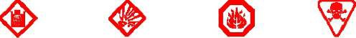

Corrosive Explosive Flammable Poison

Cape Dorset solid waste disposal facility is only licensed to accept municipal wastes for disposal and shall only accept household hazardous wastes for storage. Industrial hazardous was sets shall not be accepted for storage or disposal at the Cape Dorset solid waste disposal facility. Industrial sources (generators) are responsible to manage their own hazardous wastes.

The following hazardous waste operations and maintenance procedures deal with household hazardous wastes (HHW) only. Typical HHW which may be found in Cape Dorset include:
  - Pesticides and herbicide as
  - Oil filters
  - Paint
  - Antifreeze
  - Solvents (e.g., paint cleaners)
  - Propane tanks and cylinders
  - Flammable liquids
  - Aerosol cans (not empty )

  - Fluorescent light tubes and compact fluorescent light bulbs
  - Batteries (wet and dry cell)
  - Fire extinguisher
  - Used and waste fuel and oil

  - Corrosive cleaners

These include:
However there are certain items considered HHW that cannot be stored within the solid waste facility.

  - Ammunition, flares and explosives (including fireworks) – contact the Cape Dorset RCMP for proper
Disposal.
  - Prescriptions, medications and bio-hazardous wastes (includes syringes) – dispose of these at the Health
Care Centre.
  - Reactive chemicals (e.g.., ammonium nitrate) – contact the GN-DOE Environmental Protection Services for
disposal options.

Contaminated soil or snow from the Hamlet’s own spill clean-up is the only non-HHW that should be accepted by the Hamlet for storage at the Hazardous Waste Storage Area. Contaminated soil or snow should be stored in 205 L steel drums and shipped out of the community every year. Industry, businesses or individuals wishing to store contaminated soil at the Hazardous Waste Storage Area must contact the Operations Manager or WSSW Foreman to discuss storage options and fees for any contaminated soil or snow. The decision to accept contaminated soil or snow for storage from industrial, commercial or private sources rests with the Hamlet.

6.2.1 Operations
As the current bulk metal/hazardous waste storage area is used for HHW storage, this area needs to be properly signed as the “Hazardous Waste Storage Area”. This area should also be fenced with a lockable gate and have appropriate storage options for expected HHW. Proper signage helps operators of the area properly store the wastes. Fencing around the area will allow only trained personnel access to the bulk metal/hazardous waste storage area and help minimize health and safety risks to the public from hazardous wastes and reduce the potential for vandalism.
The bulk metal/hazardous waste storage area is intended for storage only, not disposal. It is expected that

hazardous wastes will be stored for up to five years. This should be sufficient time for the community to build up
enough waste to make it economical for a back haul out of the community to a licensed waste receiver. Additionally, the Hamlet should create a site map of the solid waste disposal facility, detailing disposal and storage locations for various wastes. This site map should be posted at the solid waste disposal facility, the Hamlet Garage and contained within the Spill Contingency Plan. All site personnel should be familiar with the layout and disposal/storage areas.

Collection
Since the entire solid waste disposal facility is generally accessible to the public, residents can come and drop off HHW throughout the year. However the general public should not have direct access to the bulk metal/hazardous waste storage area for health and safety reasons. If the Hamlet does not restrict access to the bulk metal/hazardous waste storage area (i.e., through a fence and locked gate), the public should be discouraged from entering the bulk metal/hazardous waste storage area and a designated public drop-off area for HHW should be used. The public drop-off area could be located within the MSW disposal area and tended to on a daily basis by the Foreman, Waste Truck Driver, or other designated and trained site personnel, to remove and properly store any deposited HHW into the bulk metal/hazardous waste storage area.

The Hamlet should also hold a ‘grace’ day for residents, helping them collect and drop off their HHW or bulky metal wastes. This grace day can be held once or twice per year (e.g., in spring and/or fall) and should be advertised in the community up to 30 days before the event. This grace day will encourage residents to drop off their HHW and bulky metals wastes, and provide information pamphlets on HHW, waste disposal, segregation, and recycling. Like many community-based management programs, successful implementation comes from informed and concerned residents.
Providing facts and figures supporting proper disposal, segregation and minimization of hazardous wastes will help sustain hazardous waste management in the community.

Storage

All HHW collected needs to be properly stored in sea cans to ensure any environmental and human health hazards are minimized. The GN-DOE provides information on proper storage of specific HHW; these include:

  - Antifreeze – use original containers where possible, or bulk-store waste antifreeze into good condition 16 gauge or lower gauge steel or plastic 205 L drums.

  - Batteries – bulk-store waste batteries into good condition 16 gauge or lower gauge steel or plastic 205 L drums, or other form of containment away from weather; wooden pallets should be used to keep
batteries and containers off the ground during storage and transport.

  - Fluorescent light tubes/compact fluorescent light bulbs – use original containers where possible and
prevent breakage of light tubes/bulbs; keep away from weather.

  - Ozone Depleting Substances (ODS’) – do not landfill; wastes with ODS’ (i.e., refrigerators and refrigeration equipment, vehicle air conditioners, ODS-containing fire extinguishers (typically purchased before 1997)
should be diverted to the bulk metal waste disposal area. The Hamlet can hire technicians to
remove ODS’ from stored equipment.

  - Paint – use original containers where possible, or bulk-store compatible paints into good condition 16 gauge
or lower gauge steel or plastic 205 L drums; do not mix different types of paint (i.e., alkyd and latex).

    - Solvent – use original containers where possible, or bulk-store compatible waste solvents into good condition 16 gauge or lower gauge steel or plastic 205 L drums.

See the GN-DOE website (http://www.gov.nu.ca/env/environment.shtml) for further information on guidelines for storage and disposal of HHW.

As the Hamlet currently stores waste oil in drums at the bulk metal/hazardous waste storage area (if not burned within BLCS’ waste oil burners), it is recommended they register the site as a hazardous waste storage facility with the GN-DOE Environmental Protection Services (R. Eno, pers. comm.). Registering the facility will help the GN-DOE monitor and track hazardous wastes, and eventually improve handling and disposal in the territory. When developing and operating the bulk metal/hazardous waste storage area in Clyde River, several factors also need to be considered. From Phifer and McTigue Jr. (1988) and GN-DOE (2002), these are:

Regulatory Compliance

The GN-DOE Environmental Guideline for the General Management of Hazardous Waste and hazardous waste minimum storage volumes should be considered when planning and operating the bulk metal/hazardous waste storage area.

Compatibility

Compatibility of wastes and their storage containers, and wastes and nearby materials should be considered. For example, some wastes need to be stored in specific containers to minimize the potential for corrosion and leaks (e.g., acids cannot be stored in steel drums due to corrosion; waste fuel should not be stored long-term in plastic

drums). Additionally, not all wastes can be stored in the same area (e.g., flammable wastes near ignition sources).

Packaging

Storage of HHW in original containers is acceptable. Bulk storage of compatible HHW in 205 L 16 gauge or lower gauge steel or plastic drums is generally acceptable though may depend on the type of waste. All containers need to be in good condition and sealable. Contact the GN-DOE or a licensed waste carrier or receiver for advice on specific wastes. All storage containers also need to be properly labeled, following requirements of WHMIS or Transportation of Dangerous Goods regulations, if transport is planned.

Segregation

If some HHW can be recovered or recycled at a later time, the HHW should be segregated and stored in a manner to allow this. Final destination of the HHW should be considered during storage.

Ventilation

All HHW should be properly ventilated to reduce buildup of potentially poisonous or noxious fumes. Most wastes should be stored outside in sheds or under roofs providing free air movement.

    - Climate
Not all HHW can be stored directly outside. Waste containers should be stored with some
(e.g., roof or tarp) and on an impermeable base to prevent contact with rain, snow and direct
Overhead cover sunlight. This
also makes cleanup of spills and leaks easier and cheaper. Some communities utilize old sea storage of some HHW.

Handling
All handlers of HHW will have proper training. At a minimum, all handlers should have WHMIS

(WorkplaceHazardous Materials Information System) training.

Security

Certain security precautions may need to be taken to prevent theft, accidental discharge or
Harm to the Public.

Only persons authorized and trained to handle HHW should have access to
the bulk Metal/hazardous waste storage area.

6.2.2 Maintenance

General maintenance procedures for the bulk metal/hazardous waste storage area should occur during daily operations at the solid waste disposal facility. These maintenance procedures involve ensuring proper segregation and storage of wastes, prompt cleaning and reporting of any leaks or spills, and general site tidiness.
Inspections of the bulk metal/hazardous waste storage area should occur with the weekly inspections of the entire solid waste disposal facility by the Foreman or other trained personnel (see Appendix-C).

7.0 Solid Waste Disposal Facility Maintenance
(“Guidelines for the Preparation of an Operations and Maintenance Manual for Sewage and Solid Waste Disposal Facilities in the Northwest Territories, Duong and Kent, 1996”)

7.1 Inspections and Audits
Regular inspections of the solid waste disposal facility will provide the Foreman, SAO and other personnel with information on the effectiveness of waste segregation, burning, landfilling, signage, and any remedial activities. Inspections are an integral part of the maintenance procedures at the solid waste disposal facility as they identify any concerns and deficiencies, and recognize areas or items which need improvement, correction, repair, and/or replacement.
The Foreman, or trained personnel appointed by the Foreman, should complete weekly inspections of the MSW disposal facility and bulk metal/hazardous waste storage area; monthly or bi-monthly inspections by the Foreman could also be performed. Site Inspection Forms will be used to document the findings of the inspections and ensure basic items requiring weekly inspection and/or maintenance are examined. Site Inspection Forms will also document other relevant information, such as weather conditions, health and safety concerns, and follow-up on any incidents which may have occurred (e.g., accident, fires, flooding, spills, etc.) or deficiencies noted in previous inspections. The following factors will be inspected:
  - Site equipment (including heavy equipment, signage, and any storage containers)
  - Site infrastructure (including access road, truck pads, drainage systems, fencing, berms, landfill cover and erosion)

  - Waste segregation

  - Burn completion and proper burn practices
  - Proper landfilling practices
  - Health and safety concerns (public and personnel)
  - Hazardous waste storage area.

The Site Inspection Forms should be filed at the Hamlet Office and results reported to the SAO monthly. The SAO is required to include inspection results and maintenance activities in the Hamlet’s Annual Report to the NWB. A Solid Waste Disposal Facility Inspection Form has been included in Appendix C.
Following year end, the Hamlet will undertake a review of the past year’s inspection results and follow-ups to determine where improvements to the solid waste disposal facility operations and maintenance are required. These improvements should be documented and the O&M Manual is updated accordingly.

Maintenance Activities
Specific maintenance activities may need to be completed on portions of the solid waste disposal facility. This will help ensure the facility, including the MSW disposal area and bulk metal/hazardous waste storage area, remain in good condition, appropriate practices are followed, and human health, safety, and environmental hazards are minimized. The following maintenance activities may be required periodically:
  - Grading (in summer) or clearing snow (in winter) of all access roads and truck pads used for the solid
waste disposal facilities.
  - Repair of drainage ditches from erosion
  - Fence repair
  - Repair or replacement of signage
  - Litter which has been wind carried to the surrounding area outside the MSW disposal area fence should be removed and deposited back in the MSW disposal area
  - Litter which has accumulated against the fence of the MSW disposal area should be removed and
deposited.
  - back in the MSW disposal area
  - Repair of the MSW disposal area landfill cover from erosion or settling.

Fence and Signs
At present, there is no fence that prevents the migration of windblown debris out of the MSW disposal area.

Hamlet is planning to fence the solid waste facility soon. Maintenance activities should be performed on the fence
around the solid waste disposal facility and on signage within the solid waste disposal facility to ensure they remain in good condition. Signage was installed at the Monitoring stations CAP-19 and CAP-20. Maintenance activities of the fence and signs include:

    - Weekly inspection of the fence around the solid waste disposal facility to remove any windblown material
which has accumulated; this can be performed by the Waste Truck Driver(s) and/or the Foreman to reduce loading on the fence and improve site aesthetics.

    - Monthly inspection of the fence around the solid waste disposal facility to ensure the chain-link is in good
condition, fence posts are stable (e.g., no evidence of frost heave), gates are in good working
condition and snow drifts are removed.

    - Monthly inspection of signage at the Ground water Monitoring stations to ensure it is still present and
readable.

8.0 Monitoring and Sampling

Monitoring Requirement
Table-2: Monitoring Stations

Monitoring Station | Description | Location
CAP-2 | Runoff from the Solid waste disposal  Facilities | To be decided
CAP-19 | Ground Water Monitoring well | N64013’47.5”;W76033’53.8”
CAP-20 | Ground Water Monitoring Well | N64013’59.4”;W76034’06.50”

Monitoring programs are carried out to help ensure all systems are functioning correctly as they provide important
Feedback to the operators, helping them track progress of the system and providing warning or notice when issues arise. Monitoring programs also ensure any requirements or guidelines for water quantity and/or quality are being met; these requirements are typically provided in the community’s water license. Monitoring programs form an integral part of the O&M process for all facilities and it is important to ensure they are being completed successfully.
The Monitoring Program outlined in the Hamlet’s Water License requires that one station is monitored downstream

of the solid waste disposal facility. The solid waste disposal facility monitoring station will provide water quality
information to operators and regulators and help assess the leachate quality leaving the solid waste disposal facility and entering the sewage treatment. Leachate quality data will also help assess leachate treatment performance of the sewage treatment wetland and provide an indication of waste segregation success. A description and the location of this station are provided in Table 2.

The leachate at the CAP2 sampling station should be sampled annually when flow is present. All samples taken from CAP-2 will be analyzed for:
  - Biochemical Oxygen Demand (BOD5)
  - Carbonaceous Biochemical Oxygen Demand (cBOD)
  - Total Metals (including aluminum, arsenic, cadmium, cobalt, chromium, copper, iron, lead, nickel,
Manganese, mercury and zinc)
  - Total Alkalinity
  - Total Suspended Solids (TSS)
  - Conductivity
  - Total Organic Carbon (TOC)
  - Fecal Coliforms
  - Polycyclic Aromatic Hydrocarbons (PAHs)

  - Ammonia Nitrogen
  - Nitrate-Nitrite
  - Anions and Cations (including calcium, chloride, magnesium, potassium, sodium and sulphate)
  - Total Hardness
  - pH
  - Total Phenols
  - Oil and Grease (visual)
  - Total Petroleum Hydrocarbons (TPHs)
  - Benzene, Toluene, Ethyl benzene and Xylene (BTEX)

Two ground water Monitoring wells were installed. CAP-19 was installed at up gradient of the Solid Waste Disposal Facility and CAP-20 was installed at down gradient of Solid Waste Disposal Facility. The Hamlet has a standalone

O&M manual to monitor ground water quality in summer.

Sampling Procedures

As mentioned above, the leachate at station CAP-2 should be annually during periods of flow. Water samples will be taken by the Foreman, or other trained personnel appointed by the WSSW Foreman, and sent to Caduceon Environmental Lab in Ottawa, ON for analyses. The parameters listed above will be examined in water samples of leachate from the solid waste disposal facility.
Guidelines for the collection of leachate samples from downstream of the solid waste disposal facility are found in Appendix A. The sample collection procedures should be carried out for all sampling within or downstream of the solid waste facilities to ensure the correct sample bottles are obtained, proper sampling procedures are completed, and contamination of the samples is minimized.

Record Keeping
Records of activities, inspections, and sampling at the solid waste disposal facility should be kept. These records should be stored at the Hamlet office and kept by the Foreman and SAO. These records will assist with the planning of annual operations and maintenance of the solid waste disposal facility, as well as assess how successful facility practices (e.g., waste segregation, HHW storage, etc.) are operating.
st
Every year by March 31 , the Hamlet is required to submit an Annual Report to the NWB. The Annual Report
provides the NWB with information pertaining to the results of the Monitoring Program, quantities of solid waste disposed, and summaries of any modifications, major maintenance work, and spills. Therefore, at a minimum, the following records should be kept:

  - Number of trips the garbage truck makes per day;
  - Quantity (weight) of MSW disposed of per day (tallied for monthly and annual quantities);
  - Quantity (weight and/or volume) and types of HHW stored at the bulk metal/hazardous waste storage area;
  - Dates any leachate sampling has been completed;
  - Results from any leachate sampling;
  - Dates and description of any maintenance activities (including inspections) carried out on the disposal
Facilities by Hamlet personnel or other Inspectors;
  - Dates and descriptions of any modifications and/or major maintenance work, and abandonment and
restoration work carried out on the disposal facilities, including on associated structures, facilities and

equipment (e.g., old waste oil pit, compactor truck, CAT bulldozer, grader, etc.); and,
  - Dates, description and clean-up activities of any spills (fuel, oil, hazardous waste, etc.) related to the MSW
disposal area, or bulk metal/hazardous waste storage area.

9.00 EMERGENCY RESPONSE

Surface Fires
If site personnel discover a surface fire in the solid waste disposal facility, the Hamlet of Cape Dorset Fire Department will be called immediately and informed of the situation.

Cape Dorset FIRE DEPARTMENT: (867) -897-8888
In the event of an uncontrolled fire during routine burning of MSW, the Fire Department will be contacted and should assess the danger of the burn. Depending on the burn severity, the Fire Department may assume control of the MSW disposal area. The MSW disposal area should normally be closed to the public during any controlled open burn of MSW and will remain closed if a burn becomes uncontrolled, until the Fire Department has deemed the site safe. If site personnel discover a small surface fire, fire extinguishers located at the solid waste disposal facility or in site vehicles can be used to manage small fires. Covering a fire with soil by hand or using the CAT D6 bulldozer may also be used. However, site personnel should not attempt to fight a fire if it cannot be done safely.

The cause of any surface fires will be investigated and necessary steps taken to prevent an uncontrolled
surface fire from recurring. The fire incident and all response measures should be documented on the weekly Solid Waste Disposal Facility Inspection Form (Appendix C), and reported to the Hamlet Foreman and Hamlet SAO.

Subsurface Fires
If a subsurface fire is suspected within the MSW disposal area, the Cape Dorset Fire Department will be called and informed of the situation. The solid waste disposal facility should be closed to the public whenever a subsurface fire is suspected.
The Fire Department should be called to site to determine if a subsurface fire is present and to assess the danger of the fire. The Fire Department may assume control of the solid waste disposal facility if the subsurface fire is deemed an emergency. Hamlet personnel should not excavate a suspected subsurface as the fire may quickly get worse when exposed to more oxygen, may release toxic or poisonous fumes, or may have caused underground voids causing an unstable surface prone to collapse. The Fire Department should manage the suppression of any

subsurface fires.
The cause of any subsurface fires will be investigated and necessary steps taken to prevent a subsurface fire from recurring. The fire incident and all response measures should be documented on the weekly Solid Waste Disposal Facility Inspection Form (Appendix C), and reported to the Hamlet Foreman and Hamlet SAO.

References:

    - Operation and Maintenance Manual for Water, Sewage and Solid waste Facilities of Baker Lake Nunavut prepared by Stantec, 2011

    - Operation and Maintenance Manual of P lake Sewage Lagoon of Cape Dorset, Nunavut prepared By Dillon Consulting Ltd in 2009

    - Operation and Maintenance Manual of Solid waste Facilities of Resolute Bay, Nunavut prepared by Arktis Solutions Inc. in 2010.

    - Cape Dorset Metal Waste Disposal Feasibility Study by Concentric Associates International

Incorporated in 2010.

    - “Guidelines for the Preparation of an Operations and Maintenance Manual for Sewage and Solid Waste Disposal Facilities in the Northwest Territories, Duong and Kent, 1996”

Appendices:

Appendix-A: Guidelines for sampling program
Appendix-B: Monthly Municipal Solid waste Quantity Form Appendix-C: Monthly Solid waste Disposal Facility Inspection Form

APPENDIX-A

GUIDELINES FOR WASTEWATER AND LEACHATE SAMPLING AND TESTING

Guide Lines for Wastewater & Leachate Sampling
Baffin Communities

Wastewater (Ground Water):

- Collect ground water samples from CAP-19 and CAP-20
1 set contains 7 bottles :Different sizes.
Leachate:

- Collect four leachate samples from the land fill site as and when seen the surface flows.

1 set contains 12 bottles different sizes.

All the wastewater and Leachate samples will be sent to Ottawa Lab.
Gord Murphy
Caduceon Environmental Laboratories Gord Murphy
2378 Holly Lane
Ottawa Ontario K1V 7P1 Tel: 613-526-0123
Fax: 613 526 1244

Precautions of sampling:

Use hand gloves

Fill up the chain of Custody sheet
  - Ensure each bottle level information is filled:
    - -Date and time sample taken
    - -Location with GPS coordinates
    - -Sampler’s name
  - Person’s name and contact information where to send sample Test Results and invoice.

  - Samples must be arrived Ottawa Lab within 24 hours from the time of sampling.

APPENDIX-B

MONTHLY MUNICIPAL SOLIDWASTE QUANTITY FORM

Hamlet of Cape Dorset
Monthly Municipal Solid waste Quantity Form
Date: Month: Year:

Date | Monthly  Loads by Hamlet | Estimated  Quantity for Hamlet (m3) | Estimated  quantity by others (m3) | Total (m3) | Activities  completed | Staffs initial

APPENDIX-C

MONTHLY SOLIDWASTE DISPOSAL FACILITY INSPECTION FORM

Hamlet of Cape Dorset

Monthly Municipal Solid waste Disposal Facility Inspection Form

Date: Inspector:
Air Temperature:

Issues | Yes | No | Description | Action taken | Refer to: Yes | Refer to: NO
Health and
Safety
Access Road
Signs
Litter
Fence
Waste
Segregation
Burning
Wildelife
Odour
Equipment

