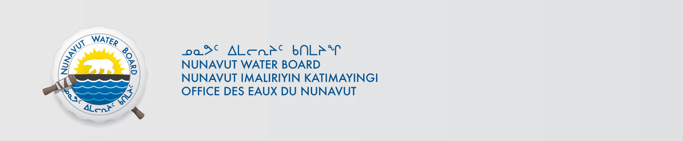

June 26, 2019 NWB File No: 3BM-CLY1419

James Arreak, Senior Administrative Officer  Hamlet of Clyde River  PO Box 205  Clyde River NU X0A 0E0  cao@clyderiver.ca | Bhabesh Roy, Municipal Planning Engineer  Community & Government Services  PO Box 379  Pond Inlet NU X0A 0S0  broy@gov.nu.ca

Subject: Application Acknowledgement for Hamlet of Clyde River Application Renewal

Dear Mr. Arreak:

The Nunavut Water Board (“NWB”) acknowledges receipt on May 30, 2019 of your renewal water licence application, for the Hamlet of Clyde River. This application has been assigned file number 3BM-CLY1419. Please refer to this number on future submissions. Application documents received are as follows:

190530 3BM-CLY1419 Application Renewal_Amendment
190530 3BM-CLY1419 Cover Letter
190530 3BM-CLY1419 Executive Summary English
190530 3BM-CLY1419 Executive Summary Inuktitut
190530 3BM-CLY1419 Hazardous Waste Segregation , Storage and Transportation ,2019
190530 3BM-CLY1419 Letter of Authorization
190530 3BM-CLY1419 NPC letter re 149071
190530 3BM-CLY1419 Plan for Compliance-Revised May 29 2019
190620 3BM-CLY1419 Application Inquiry Repsonse
190626 3BM-CLY1419 Stand alone Spill Response Plan

Please be advised that under the Agreement Between the Inuit of the Nunavut Settlement Area and Her Majesty the Queen in Right of Canada (Nunavut Agreement) Article 11, Section 11.5.9 and s. 76 (1) of Nunavut Planning and Project Assessment Act (NuPPAA), the proponent of a project governed by NuPPAA is also required to submit a project proposal document directly to the Nunavut Planning Commission (NPC or Commission) for the NPC’s determination regarding the applicable land use planning requirements and/or directions regarding whether the project is subject to screening by the Nunavut Impact Review Board. In particular, please note that as established under Articles 11, 12 and 13 of the Nunavut Agreement, NuPPAA and Part 3 of the Nunavut Waters and Nunavut Surface Rights Tribunal Act, until the project has completed the applicable land use planning and assessment process required by the NPC and the NIRB, the NWB cannot issue a water licence/approval.

The NWB confirms receipt of NPC conformity under NuPPAA on April 26, 2019 and NIRB determination through NPC under NuPPAA on April 26, 2019. This application is now ready for review and comments. Deadline for submissions is July 16, 2019.

Please call the undersigned at (867) 360-6338 or email to licensing@nwb-oen.ca if you have any questions.

Sincerely,

Richard Dwyer
Manager Licensing

Copy Qikiqtani Distribution List

