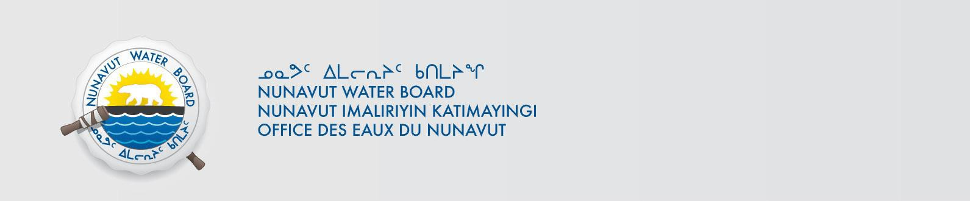

PUBLIC NOTICE OF RENEWAL APPLICATION Municipality of Clyde River

Pursuant to Section 55(1) of the Nunavut Waters and Nunavut Surface Rights Tribunal Act
(“Act”), notice is given that Municipality of Clyde River filed an application for a Renewal water licence to the Nunavut Water Board (“NWB”) to use water or deposit of waste into water for the following project:

File #: 3BM-CLY1419
Project: Municipal Undertaking
Location: Latitude: 70º27’0’’; Longitude: 68º33’0’’W
Purpose: Municpal
Type: “B”

Interested persons are invited to make representations on or before July 16, 2019 to: Manager of Licensing
Nunavut Water Board
P.O. Box 119, Gjoa Haven, Nunavut X0B 1J0
Phone: (867) 360-6338; Fax: (867) 360-6369; E-mail: licensing@nwb-oen.ca

Copies of all application documents may be obtained by affected parties, free of charge, through the internet on our ftp site at the following link:

ftp://ftp.nwb-oen.ca/registry/3%20MUNICIPAL/3B/3BM%20-%20Municipality/3BM-CLY1419/1%20APPLICATION/2019%20Renewal/

or by contacting:
James Arreak, Hamlet of Clyde River
Phone: (867) 924-6220; Fax: (867) 924-6293
E-mail: cao@clyderiver.ca

Failure to respond to this Notice of Application within the specified period shall result in the loss of the right to be compensated, pursuant to Sections 58 to 61 of the Act.

Current Date: June 26,2019

