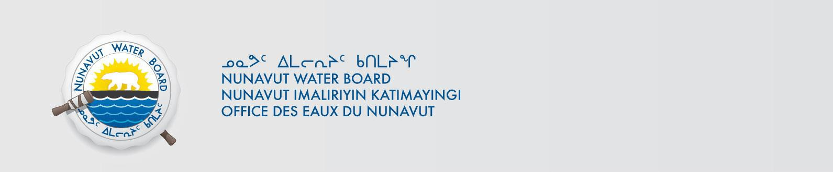

ᐃᓄᖕᓂᒃ ᖃᐅᔨᒃᑲᐃᔾᔪᑎ ᓄᑖᖑᕆᐊᕐᑎᑦᑎᔪᒪᔪᑦ ᐱᓇᓱᒍᑎ ᕼᐊᒻᓚᒃᑯᑦ ᑲᖏᕐᑐᒐᐱᖕᒥ

ᒪᓕᒃᓗᒍ ᑎᑎᕋᕐᓯᒪᔪᖅ ᐃᓚᖓᓂ 55(1) ᓄᓇᕗᑦ ᐃᒥᖏᑦ ᐊᒻᒪᓗ ᓄᓇᕗᑦ ᓄᓇᖓᓂ ᖄᖓᓂ ᐱᔪᓐᓇᐅᑎᓕᕆᓂᕐᒧᑦ ᑲᑎᒪᔨᐅᔪᑦ ᐱᖁᔭᐃᑦ (ᐱᖁᔭᐃᑦ), ᖃᐅᔨᒃᑲᐃᕗᑦ ᐅᑯᐊ ᕼᐊᒻᓚᒃᑯᑦ ᑲᖏᕐᑐᒑᐱᒃ ᑎᑎᕋᕐᓯᒪᒃᒪᑕ ᐱᓇᓲᑎᒥᒃ ᑕᕙᓂ ᐅᓪᓗᖓᓂ ᓄᑕᖑᕆᐊᕐᑎᑦᑎᔪᒪᓪᓗᑎᒃ ᓄᓇᕗᑦ ᐃᒥᓕᕆᓂᕐᒧᑦ ᑲᑎᒪᔨᖏᓐᓄᑦ ᐊᑐᕈᒪᓪᓗᑎᒃ ᐃᒥᕐᒥᒃ ᐅᕙᓘᓐᓂᑦ ᑯᕕᓯᖃᑦᑕᕐᓗᑎᒃ ᐅᑯᓂᖓ ᐱᓕᕆᐊᒃᓴᖃᕐᑎᓪᓗᒋᑦ:

ᑎᑎᕋᖓ #: 3BM-CLY1419
ᐱᓕᕆᐊᖓ: ᕼᐊᒻᓚᒃᑯᑦ ᐱᓕᕆᐊᖓᑦ
ᓄᓇᖓᓂ: Latitude: 70º27’0’’; Longitude: 68º33’0’’W
ᐱᔾᔪᑎᖓ: ᓄᓇᓕᖕᓂ
ᐃᒪᐃᑦᑐᖅ: “B”

ᑭᓇᑐᐃᓐᓇᖅ ᐱᔪᒪᒍᓂ ᑐᖓᓱᒃᑎᑕᐅᔪᖅ ᐅᖃᐅᓯᒃᓴᖃᕈᓂ ᑕᕙᓂ ᑐᖓᓃᓘᓐᓃᑦ ᔪᓚᐃ 16, 2019 ᐅᕗᖓ:
ᐊᐅᓚᑦᑎᔨ ᐱᔪᓐᓇᐅᑎᓕᕆᓂᕐᒧᑦ
ᓄᓇᕗᑦ ᐃᒥᓕᕆᓂᕐᒧᑦ ᑲᑎᒪᔨᖏᑦ
ᑎᑎᕋᒃᑯᕕᐊᐅ 119, ᐅᕐᓱᕐᑐᖅ, ᓄᓇᕗᑦ X0B 1J0
ᐅᖄᓚᐅᑖ: (867) 360-6338; ᓱᒃᑲᔪᒃᑯᑦ: (867) 360-6369; ᖃᕋᓴᐅᔭᒃᑯᑦ: licensing@nwb-oen.ca

ᑎᑎᕋᕐᓯᒪᔪᒥᒃ ᐊᔾᔨᖏᓐᓂᒃ ᐱᔭᒃᓴᐅᔪᑦ ᐃᒃᐱᒃᓂᕐᑎᑕᐅᔪᓄᑦ, ᐊᑭᖃᖏᓪᓗᓂ, ᖃᕋᓴᐅᔭᒃᑯᑦ ᑕᑯᒋᐊᕐᕕᖓᓂ ᐅᕗᖓᕐᓗᓂ:

ftp://ftp.nwb-oen.ca/registry/3%20MUNICIPAL/3B/3BM%20-%20Municipality/3BM-CLY1419/1%20APPLICATION/2019%20Renewal/

ᐅᕙᓘᓐᓂᑦ ᖃᐅᔨᒋᐊᕐᕕᒋᓗᒍ ᐅᓇ:
James Arreak, Hamlet of Clyde River
ᐅᖄᓚᐅᑖ: (867) 924-6220; ᓱᒃᑲᔪᒃᑯᑦ: (867) 924-6293
ᖃᕋᓴᐅᔭᒃᑯᑦ: cao@clyderiver.ca

ᑭᐅᔭᐅᖏᒃᑯᓂ ᖃᐅᔨᒃᑲᐃᔾᔪᑎ ᐱᓇᓱᒃᑐᖃᕐᓂᖓᓂᒃ ᐅᓪᓗᐃᑦ ᓇᓗᓇᐃᕐᑕᐅᓯᒪᔪᑦ ᐃᓗᐊᓂ ᐊᓯᐅᔨᓂᐊᕐᐳᖅ ᐱᔪᓐᓇᐅᑎᖓᓂᒃ ᐊᑭᓕᕐᑕᐅᓇᓱᒃᓗᓂ, ᒪᓕᒃᓗᒍ ᑎᑎᕐᓯᒪᔪᖅ ᐃᓚᖓᓂ 58 ᑎᑭᓪᓗᒍ 61 ᐱᖁᔭᓂ.
.

Current Date: June 26,2019

