Spill Contingency Plan

Municipality of Grise Fiord, Nunavut

October 2020

Prepared for:
Municipality of Grise Fiord
BOX 30
Grise Fiord, Nunavut, X0A 0L0

Table of Contents

Page No
1 Introduction and Project Details 1
1.1 Purpose 1
1.2 Regulatory 1
1.3 Communication 1
2 Site Description 3
2.1 Project Location 3
3 Regulations 5
4 Contacts and Regulatory Authorities 6
5 Potential Contaminants and Spill Scenarios 7
5.1 List of Hazardous Materials 7
5.2 Spill Scenarios 7
6 Existing Preventative Measures 8
6.1 Additional Copies 8
6.2 Process for Staff Response to Media and Public Enquiries 8
7 Response Organization 9
7.1 Flow Chart of Response Organization 9
8 Action Plan 10
8.1 Potential Impacts of Spill 10
8.2 Procedures 10
8.2.1 Chemical Spills 10
8.2.2 Petroleum Product Spills 11
8.2.3 Spill Reporting Procedures 13
8.2.4 Procedures for Containing the Spill 13
8.2.5 Procedures for Transferring, Storing, and Managing Spill-related Wastes 15
8.2.6 Procedures for Restoring Affected Areas 16
8.2.7 Procedures for Disposal Method for Temporarily Contained Spill Material 16
8.2.8 Additional Spill Delineation Monitoring 16
9 Spill Kit Locations 17
10 Standard Spill Kit Requirements 18
10.1 Spill Kit 18
10.2 Additional Spill Contingency Supplies 18
11 Resource Inventory 19
11.1 On-site Resources 19
11.2 Off-site Resources 19
12 Training Program 20
12.1 Outline of Training Program 20
12.2 Training Schedule and Record Keeping 20
13 General Safety Practices and Site Rules 21
14 Closure 22
Appendix A – Figures
Figure 1 – Grise Fiord on Nunavut Map
Figure 2 – Licensed Facilities
Figure 3: Airport Location
Appendix B – Spills Reporting Form

Introduction and Project Details
The Hamlet is located on the southern coast of Ellesmere Island, approximately 1,160 km north of the Arctic Circle at 76°25’N and 83°01’W. Grise Fiord is located in the Qikiqtani Region of Nunavut and has an estimated population of 129 (2016). The Atlas of Canada Permafrost Map1 shows Grise Fiord to be in a zone of extensive widespread continuous permafrost.
The Hamlet is located on the southern coast of Ellesmere Island, approximately 1,160 km north of the Arctic Circle at 76°25’N and 83°01’W. Grise Fiord is located in the Qikiqtani Region of Nunavut and has an estimated population of 129 (2016). The Atlas of Canada Permafrost Map1 shows Grise Fiord to be in a zone of extensive widespread continuous permafrost. This means that there are no thawed areas except under larger lakes and rivers that never freeze solid2 The Permafrost Map gives a permafrost and ground ice classification symbol of ‘Cl’ for Grise Fiord. This classification means that approximately 90% to 100% of the land area is underlain by permafrost, and that the ground ice content in the upper 10 m to 20 m is (% by volume of visible ice) is low (<10%). This includes segregated ice, intrusive ice, reticulate ice veins, ice crystals, and ice coatings on soil particles.

The spill contingency plan (SCP) has been prepared for the Municipality of Grise Fiord (Municipality), Nunavut to demonstrate the Municipality’s capabilities to address potential spills that may affect public health and safety, and the environment. Figure 1 in Appendix A shows the location of Grise Fiord on a map of Nunavut.

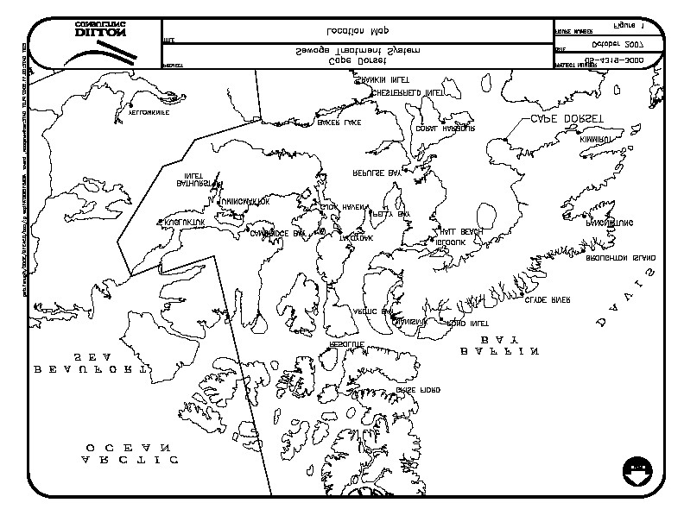
1.1 Purpose

Fig. 1: Hamlet of Grise Fiord
The purpose of the SCP is to address the proper responses to the anticipated types of spills that may occur during the routine operation and maintenance activities of the Municipality’s facilities associated with wastewater treatment and disposal (sewage lagoon system), water supply and treatment, and solid waste disposal. The SCP structured to protect public health and safety and to protect the local environment.
A site plan of the town showing the relative location of all the three facilities is included in Figure 2 in Appendix A.
Access Road
to the town

Compliance Point

Monitoring Point

Bulk Metal wastes /Hazardous wastes

SEWAGE LAGOON

Landfill site

Metal Dump site
S
E
A
Fig. 2 : Grise Fiord Water Licensed Facilities
Situations may arise during the site operations that are beyond the scope of the safety procedures stated in this document. In such a situation, it may be necessary to stop on-site work until a revised procedure or SCP is prepared to reflect the changing conditions.
It is recommended that all persons who are directly involved with community water and sanitation operations or who have responsibilities associated with community water and sanitation operations read the SCP.

Regulatory
The SCP includes a review of appropriate government acts and regulations, the identification of anticipated spill scenarios, spill contingency procedures and general health, safety and emergency contingency requirements necessary when conducting activities that may require contact with the subsurface materials. The SCP does not replace any Health & Safety protocols and procedures already established by the Municipality but is intended to be complimentary to existing protocols. Communication
The contact list and their phone numbers are provided in Table 1.

Table 1: Contact List
Title | Email | Phone Number
CAO, Municipality of Grise Fiord | gfsao@qiniq.com | (867) 980-9959
Foreman, Municipality of Grise Fiord | gfforeman@qiniq.com | (867) 980-9920
Fire Chief (Julius Kappianaq) | officemanager@GriseFiord.ca | (867) 934-8888
Chief Administrative Officer (CAO) |  | (867) 934-8940
Municipal Planning Engineer (Bhabesh Roy, P.Eng.) | broy@gov.nu.ca | (867) 899-7314
Spill Contact: Emergency Spill Hotline (24-hour line) |  | (867) 920-8130
Crown-Indigenous Relations and Northern Affairs Canada (CIRNAC) Inspector |  | (867) 975-4295
GN Emergency Measures Officer |  | (888) 624-4043
Grise fiord Health Centre |  | (867) 934-2100
RCMP Grise Fiord |  | (867) 934-0123
Environment Canada Emergency Iqaluit |  | (867) 975-4644
GN Environment Health Office |  | (867) 473-2676
Canadian North (First Air) Air Cargo |  | +1 (800) 267-1247

Site Description

Project Location
With respect to spills, the Environmental Protection Act (R-068-93) requires that all SCPs include:
- The name, address and job title of the owner or person in charge, management or control of the facility;
- The name, job title and 24-hour telephone number for the person(s) responsible for activating the SCP;
- A description of the facility, including the location, size, and storage capacity;
- A description of the type and amount of contaminants normally stored at the facility;
- A site map of the location;
- The steps to be taken to report, contain, clean up and dispose of contaminants in the case of a spill;
- The means by which the SCP is activated;
- A description of the training provided to employees to respond to a spill;
- An inventory of and the location of response and clean-up equipment available to implement the SCP; and,
- The date the SCP was prepared.

Contacts and Regulatory Authorities
Table 4 includes the contact information for the persons responsible. The persons listed below should be contacted in the event of a spill.
Table 4: Contacts
Name | Job Title | Email | 24-Hour Telephone #
Marjorie Dobbson | CAO | gfsao@qiniq.com | 867-899-9959
Pauloosie Qamaniq | Foeman | Gfforeman@quniq.com | 867 980 9959
Joseph Monteith | WRO,CIRNAC | Joseph.monteith@canada.ca | 867975 4289
Bhabesh Roy, P.Eng. | MPE, GN-CGS | broy@gov.nu.ca | 8678997314

In each instance that a spill is identified, the Emergency Spill Hotline and the CIRNAC Water Resources Inspector shall be contacted as soon as possible. A NT-NU Spill Report Form (see Appendix C) should also be completed and faxed to the Emergency Spill Hotline (24-hour line). The necessity to contact the other agencies will be contingent upon direction from the Emergency Spill Hotline (24-hour line).
Emergency Spill Hotline (24-hour line): Phone: (867) 920-8130, Fax (867) 873-6924
CIRNAC Water Resources Inspector: Phone: (867) 975-4295
Municipal Planning Engineer: Phone: (867)-899-7314; cell (867 )899 1345; E mail: broy@gov.nu.ca
In addition to the local contacts described above, Table 5 summarizes the additional regulatory authorities that have a vested interest in the event of a spill.
Table 5: Additional Agencies
Agency Name | Regulation | 24-Hour Telephone #
Nunavut Water Board | Nunavut Waters and  Surface Right Tribunal Act | (867) 360-6338
GN-Emergency Measures Officer |  | 888-624-4043
Nunavut Impact Review Board | Nunavut Land Claims Agreement Act | (866) 233-3033
Environment Canada | Canadian Environmental  Protection Act, 1999 | (867) 975-4464
Transport Canada  (Coast Guard) | Transportation of  Dangerous Goods Act | (867) 979-5269
Department of Fisheries and Oceans | Fisheries Act | (867) 645-2871

Potential Contaminants and Spill Scenarios

List of Hazardous Materials
The primary potential spill contaminants at the sewage lagoon site is the raw sewage. Other materials (potential contaminants) that are anticipated to be present on the site include gasoline, diesel fuel, hydraulic oil, motor oil and other lubricants, antifreeze and coolants from sewage delivery trucks, the decant pumps and any heavy equipment in used on the site for maintenance purposes.

Spill Scenarios
Potential spill scenarios are dependent on the types and volumes of materials that are being used on the sites and the activities being carried out. For the purpose of this SCP, spill sizes are described as small (<10 litres), medium (>10 litres and <100 litres) or large (>100 litres).
Spills may be the result of any of the following occurrences:
- Spills during transfer of liquids (sewage);
- Leaks or ruptures of vehicular fuel or hydraulic oil storage tanks;
- Valve or line failure in systems on vehicles or operating equipment;
- Heat expansion due to overfilling;
- Vehicular accidents; and/or,
- Vandalism.

Existing Preventative Measures
All hazardous materials arrive by road as needed through the year. They are unloaded and placed in the chemical storage area.
Plant operators conduct daily visual inspection for leaks or damage.

Additional Copies
Several copies of the plan are kept on-site at all times at the WTP/Truckfill, the municipal garage and the Municipality’s office. Additional copies can be requested by contacting the Municipality administration office at phone number and address presented in Section 1.

Process for Staff Response to Media and Public Enquiries
All media enquiries will be directed to the Chief Administrative Officer. If a reporter or member of the public arrives unexpectedly to the site, the official in charge of responding the questions will be the Chief Administrative Officer.

Response Organization

Flow Chart of Response Organization
The flow chart depicted in Figure 3 in Appendix A shows the response organization for minor and major spills.
A major spill is defined as a release of a substance that is likely to be in imminent environmental or human health hazard or exceeds the volumes outlined in Appendix B. Any spill less than these quantities is considered a minor spill and does not need to be reported immediately; however, these minor spills should be documented and reported at a pre-determined reported interval.

Action Plan

Potential Impacts of Spill
Sodium Hypochlorite
Sodium Hypochlorite can cause several adverse health effects, including skin, eye and respiratory system irritation or burns. If ingested in significant amounts, this chemical can cause a wide range of symptoms, from nausea to death. Sodium Hypochlorite can cause dangerous reactions with some chemicals, and therefore should not be allowed to mix with other chemicals. Sodium Hypochlorite is highly toxic to freshwater fish and invertebrates. Necrosis and chlorosis and leaf abscission have been noted when applied to plants.
Diesel Fuel
Diesel fuel eye contact may cause a mild eye irritation, and skin contact can cause moderate to severe irritation and produce drying and cracking skin. Vapour inhalation may cause nausea, headaches, vomiting, dizziness, and fatigue and continued exposure may ultimately cause death. A diesel fuel spill may potentially contaminate water supplies and damage the local ecosystems. Diesel is one of the most acutely toxic oil types; fish, and invertebrates, that come in direct contact may be killed.

Procedures

Chemical Spills
The WTP at the Municipality uses and Sodium Hypochlorite (12% sln) to treat the water. This solution is stored and applied in the WTP and diesel fuel is stored outside the WTP. Possible Sodium Hypochlorite spills range from a small leak or spillage during normal operation, to a major spill caused by damage to a drum.
Hazardous waste leachate is considered a chemical spill.

Procedures for Initial Actions
In the event of a chemical spill, the following measures should be taken immediately:
- Evacuate unnecessary personnel.
- Ventilate area of leak or spill (opening all doors and windows).
- Wear personal protective equipment (gloves, safety glasses, impervious material long-sleeved shirt/coat).
- If available wear respirator/self-contained breathing apparatus (SCBA), especially for large spills.
- Remove all other chemicals from the area if safe to do so.
- For small spills, dilute with water, mop or wipe up and place in proper container.
- For large spills, contain by diking (soil/dry sand/kitty litter), absorb with inert material (soil/dry sand/kitty litter) and place in chemical waste container.
- After mopping up chemical, wash area well with soap and water, mopping into spill container and not to the ground.
- Do not use combustible material! (i.e. sawdust or cardboard).
- Contain runoff from spill clean-up.
- Notify the Northwest Territories/Nunavut twenty-four (24) hour spill reporting centre at (867) 920-8130 and receive disposal information.

Follow-up Actions
After the spill has been cleaned up, other reporting, disposal, and follow-up activities may be required. The following measures should be taken if applicable.
- Dispose of chemical, inert absorbent material, and mop-up water as directed by Spill Reporting Line personnel.
- Arrange for repair or replacement of chemical containers, pipelines and equipment, if damaged or leaking
- Submit a detailed report on the occurrence to an CIRNAC Inspector, within thirty (30) days of reporting the event.

Spill Kit
A spill kit should be on-hand in the WTP in the event of a chemical spill. The kit should include:
- Heavy-duty gloves
- Safety glasses
- Mop/wringer/spill squeegee
- Shovel/broom/dustpan
- Chemical spill container with sealable lid
- Sand/kitty litter (absorbent, none-flammable material).

Petroleum Product Spills
Petroleum products have many operational uses in the Municipality's water and sanitation systems and used petroleum product drums or other containers end up at the Municipality's solid waste disposal facility. Petroleum product spills range from minor spills during operations such as gas tank filling, to constant leakage from pipelines in need of repair, to major spills causing large contaminated soil/water issues.
Depending on the location of the spill, a petroleum product spill may result in contaminated soil, snow, ice or water. The contaminated material must be cleaned up and removed for disposal along with the spilled petroleum product.

Procedures for Initial Actions
In the event of a petroleum product spill, the following measures should be taken immediately:
- Shut off ignition sources, if safe to do so.
- Identify the spilled material and locate the source.
- Stop the spill at the source, if safe to do so.
- Take actions to contain/clean up spilled material.
- Record relevant information for reporting: this includes quantity of material spilled, product type, location, date, weather, and other relevant information.
- Notify the Northwest Territories/Nunavut twenty-four (24) hour spill reporting centre at (867) 920-8130 and receive disposal information.

Follow-up Action
After the initial clean-up and reporting procedures, other activities may be required such as reporting and disposal. The following measures should be taken if applicable:
- Dispose of soil as directed by twenty-four (24) hour Spill reporting Line personnel or an CIRNAC Inspector.
- Arrange for repair or replacement of petroleum product containers, pipelines and equipment, if damaged or leaking.
- Submit a detailed report on the occurrence to an CIRNAC Inspector, within thirty (30) days of reporting the event.
- For large spills, install wells to monitor the groundwater for signs of contamination as explained in the Subsurface Monitoring Plan (Earth Tech, 2008). Determine the level of final clean-up in consultation with an CIRNAC inspector.

Spill Kit
A spill kit should be on-hand in the event of a petroleum product spill. The spill kit should include:
- Heavy-duty gloves
- Safety glasses
- Shovel/bucket
- Petroleum product spill container with sealable lid
- Inert (non-flammable), absorbent material (sand, kitty litter).

Spill Reporting Procedures
Report spill immediately to Municipality manager, who will determine if spill is to be reported to the Emergency Spill Hotline (24-hour line) at 867 920 8130.
A spill kit is located in the mechanical garage. Additional spill kits are located in the WTP.
Each spill kit, as well as the office and Municipality manager, will have copies of the NT-NU Spill Report Form to be filled out (see Appendix C). Fill out and fax or email the NT-NU Spill Report Form to the staff of the Emergency Spill Hotline (24-hour line). Also fax or email the filled-out NT-NU Spill Report Form to the head office (see contact list).
Organization Phone number
Emergency Spill Hotline (24-hour line) Phone 867 920 8130
Emergency Spill Hotline (24-hour line) Fax 867 873 6924
Emergency Spill Hotline (24-hour line) Email spills@gov.nt.ca
Municipality Office 867 934 8830
Government of Nunavut Regional Office 867 899 7314

Procedures for Containing the Spill

Containment of Spills on Land
Spills on land include spills on rock, gravel, soil and/or vegetation. It is important to note that soil is a natural sorbent, thus spills on soil are generally less serious than spills on water as contaminated soil can be more easily recovered. Generally, spills on land occur during the late spring, summer or fall when snow cover is at a minimum. It is important that all measures be undertaken to avoid spills reaching open water bodies.
Dykes
Dykes can be created using soil surrounding a spill on land. These dykes are constructed around the perimeter or down slope of the spilled fuel. A dyke needs to be built up to a size that will ensure containment of the maximum quantity of fuel that may reach it. A plastic tarp can be placed on and at the base of the dyke such that fuel can pool up and subsequently be removed with sorbent materials or by pump into barrels or bags. If the spill is migrating very slowly a dyke may not be necessary and sorbents can be used to soak up fuels before they migrate away from the source of the spill.
Trenches
Trenches can be dug out to contain spills if the top layer of soil is thawed. Shovels, pick, axes or a loader can be used depending on the size of trench required. It is recommended that the trench be dug to the bedrock or permafrost, which will then provide containment layer for the spilled fuel. Fuel can then be recovered using a pump or sorbent materials.

Containment of Spills on Water
Spills on water such as rivers, streams or lakes are the most serious types of spills as they can negatively impact water quality and aquatic life. All measures need to be undertaken to contain spills on open water.
Booms
Booms are commonly used to recover fuel floating on the surface of lakes or slow-moving streams. They are released from the shore of a water body to create a circle around the spill. If the spill is away from the shoreline a boat will need to be used to reach the spill, then the boom can be set out. More than one boom may be used at once. Booms may also be used in streams and should be set out at an angle to the current. Booms are designed to float and have sorbent materials built into them to absorb fuels at the edge of the boom. Fuel contained within the circle of the boom will need to be recovered using sorbent materials or pumps and placed into barrels or bags for disposal.
Weirs
Weirs can be used to contain spills in streams and to prevent further migration downstream. Plywood or other materials found on site can be placed into and across the width of the stream, such that water can still flow under the weir. Spilled fuel will float on the water surface and be contained at the foot of the weir. It can then be removed using sorbents, booms or pumps and placed into barrels or plastic bags.
Barriers
In some situations, barriers made of netting or fence material can be installed across a stream, and sorbent materials placed at the base to absorb spilled fuel. Sorbents will need to be replaced as soon as they are saturated. Water will be allowed to flow through.
Note that in some cases, it may be appropriate to burn fuel or to let volatile fuels such as gasoline evaporate after containment on the water surface. This should only be undertaken in consultation with, and after approval from the CIRNAC or lead agency Inspector.

Containment of Spills on Ice
Spills on ice are generally the easiest spills to contain due to the predominantly impermeable nature of the ice. For small spills, sorbent materials are used to soak up spilled fuel. Remaining contaminated ice/ slush can be scraped and shoveled into a plastic bag or barrel. However, all possible attempts should be made to prevent spills from entering ice covered waters as no easy method exists for containment and recovery of spills if they seep under ice.
Dykes
Dykes can be used to contain fuel spills on ice. By collecting surrounding snow, compacting it and mounding it to form a dyke down slope of the spill, a barrier is created thus helping to contain the spill. If the quantity of spill is large, a plastic tarp can be placed over the dyke such that the spill pools at the base of the dyke. The collected fuel can then be pumped into barrels or collected with sorbent materials.
Trenches
For significant spills on ice, trenches can be cut into the ice surrounding and/or down slope of the spill such that fuel can pool in the trench. It can then be removed via pump into barrels, collected with sorbent materials, or mixed with snow and shoveled into barrels or bags.
Burning
Burning should only be considered if other approaches are not feasible and is only to be undertaken with the permission of the CIRNAC or lead agency Inspector.

Containment of Spills on Snow
Snow is a natural sorbent, thus as with spills on soil, spilled fuel can be more easily recovered. Generally, small spills on snow can be easily cleaned up by raking and shoveling the contaminated snow into plastic bags or empty barrels and storing these at an approved location.
Dykes
Dykes can be used to contain fuel spills on snow. By compacting snow down slope from the spill, and mounding it to form a dyke, a barrier or berm is created thus helping to contain the spill. If the quantity of spill is large, a plastic tarp can be placed over the dyke such that the spill pools at the base of the dyke. The collected fuel/snow mixture can then be shoveled into barrels or bags or collected with sorbent materials.

Worst Case Scenarios
Dealing with spilled fuel which exceeds the freeboard of a dyke or barrier would present a possible worst-case scenario. To contain the overflow, a trench or collection pit would have to be created downstream of the spill to contain the overflow.
Another worst-case scenario would be an excessive spill on water may be difficult to contain with the booms present at the site. In this case, an emergency response mobile unit would have to be called in to deal with the spill using appropriate equipment.

Procedures for Transferring, Storing, and Managing Spill-related Wastes
In most cases, spill cleanups are initiated at the far end of the spill and contained moving toward the center of the spill. Sorbent socks and pads are generally used for small spill cleanup. A pump with attached fuel transfer hose can suction spills from leaking containers or large accumulations on land or ice and direct these larger quantities into empty drums. Hand tools such as cans, shovels, and rakes are also very effective for small spills or hard to reach areas. Heavy equipment can be used if deemed necessary and given space and time constraints.
Used sorbent materials are to be placed in plastic bags for future disposal. All materials mentioned in this section are available in the spill kits located at WTP. Following clean up, any tools or equipment used will be properly washed and decontaminated or replaced if this is not possible.
For most of the containment procedures spilled petroleum products and materials used for containment will be placed into empty waste oil containers and sealed for proper disposal at an approved disposal facility.

Procedures for Restoring Affected Areas
Once a spill of reportable size has been contained, the Municipality will consult with the CIRNAC or lead agency Inspector assigned to the file to determine the level of cleanup required. The Inspector may require a site-specific study to ensure appropriate clean up levels are met. Criteria that may be considered include natural biodegradation of oil, replacement of soil and revegetation.

Procedures for Disposal Method for Temporarily Contained Spill Material
Treatment and disposal of contaminated material will be completed in consultation with the regulatory agencies and may include techniques and technologies for stabilization, remediation, destruction and long-term containment.

Additional Spill Delineation Monitoring
As a result of a large spill in which not all of the spilled material can be readily recovered as described above, additional delineation in the form of a subsurface investigation (i.e., test pits, boreholes, and monitoring wells) may be required to determine the lateral and vertical extents of the impacts to the subsurface soil and/or groundwater. The additional delineation/monitoring information will be used to develop an appropriate remediation plan. In such cases, a qualified environmental consultant should be retained to provide advice with respect to how to proceed with the additional assessment.

Spill Kit Locations
A spill kit is located in the mechanical garage. Additional spill kits are located in the Water Treatment Plant (WTP).
The spill kit, except for the shovel, can be contained within the 205 L drum which should be sealed securely to protect the contents. The drum should also be accessible without the use of tools (i.e., bolt ring only finger tight). The bolt ring should be inspected regularly to ensure that it turns freely and lubricated if it does not. At least one spill kit should be clearly identified and readily available during any maintenance work undertaken.

Standard Spill Kit Requirements
The following section presents the recommended minimum requirements for the content and number of spill kits that should be present.

Spill Kit
Each spill kit should be inspected regularly to ensure that it contains, as a minimum, the following:
- 1 – 205 L, open top steel drum with a lid, bolting ring and gasket;
- 1 spark proof shovel;
- 1 package of 10 disposable 5 mil polyethylene bags (approx. 65 cm x 100 cm);
- 2 – 12.5 cm (approx. 5”) x 3 m (approx. 10’) sorbent (oil-absorbing) booms;
- 10 kg bag of sorbent particulate;
- 1 bail of 50 cm x 50 cm (approx.) sorbent sheet (100 Sheets/bail);
- 1 – 5 m x 5 m approx. plastic tarp;
- 2 pairs of oil resistant gloves; and,
- 2 pairs of splash protective goggles.

Additional Spill Contingency Supplies
In addition to the materials contained in the spill kits, an inventory of the following supplies should be available for use if required:
- 2 – 205 litre, open top steel drum with a lid, bolting ring and gasket;
- 1 spark proof shovels;
- 2 packages of 10 disposable 5 mil polyethylene bags (approx. 65 cm x 100 cm);
- 2 – 12.5 cm x 3 m sorbent (oil-absorbing) booms;
- 5 – 10 kg bags of sorbent particulate;
- 5 bails of 50 cm x 50 cm (approx.) sorbent sheet (100 Sheets/bail);
- 2 pairs of oil resistant gloves; and,
- 2 pairs of splash protective goggles.

On-site Resources
The following telephone numbers will contact local resources in the Municipality.
Municipality Office (867) 934-8830
Royal Canadian Mounted Police (RCMP) Grise Fiord General Inquiries (867) 934-0123
Emergency Only (867) 934-1111
Fire Emergency (867) 934-8888
Grise Fiord Health Centre (867) 934-2100

Off-site Resources
The off-site contacts listed below could reach the community within several hours. However, realistically government officials would not be able to reach the site until the next business day, depending on the severity of the spill.
Emergency Spill Hotline (24-hour line) (867) 920-8130
Crown-Indigenous Relations and Northern Affairs Canada (CIRNAC) Inspector (867) 975-4295
Environment and Climate Change Canada (Emergency) Yellowknife (867) 920-8130
GN-Community Government Services - Pond Inlet Regional Office (867) 899-7314
GN Department of Environment (867) 975-7700
GN Regional Environmental Health Officer for Grise Fiord (867) 473-2676
Royal Canadian Mounted Police (RCMP) Iqaluit General Inquiries (867) 979-0123

9.5 Training Program
Municipality operations personnel should have up-to-date spill training, so they are prepared in the event of a chemical, fuel or waste spill. This training will at least include on-the-job training and may include formal spill training courses and on-site spill training exercises (mock spills). Municipality personnel may receive formal spill response training from the Department of Environment, Government of Nunavut.
If the Municipality brings contractors on-site to make modifications to the water and waste facilities, the contractors should be made aware of procedures to be followed in the event of a spill.
Workplace Hazardous Materials Information System (WHMIS) training should be given to employees. WHMIS training is legally required in Canada for all employees who are exposed/likely will be exposed to a hazardous material at the workplace.

Outline of Training Program
The employee and contractor training program were developed by the manager of environmental health and safety and has been disseminated by the municipal foreman. The following are key steps in the program:
- All individuals entering the site are required to participate in an orientation session.
- During this session, all locations of the spill plan and spill kits are provided on a map in hard copy.
- An overview of the plan is provided by the municipal foreman leading the orientation session.
- Specific training sessions, including mock spill exercises, are scheduled for individuals directly involved in handling hazardous materials to ensure they know all steps to be undertaken in handling these materials, as well as the steps involved in the event of a spill, including the proper use of spill kits.
- All employees and contractors are required to have their basic first aid training, as well as WHMIS training, before working on the site
- Supervisors are required to have advanced level first aid training, as well as transport of dangerous goods training

Training Schedule and Record Keeping
A spreadsheet is kept by the Chief Administrative Officer and Municipality office indicating the training undertaken and expire dates of specific training e.g. first aid. It is regularly updated

1o.oo General Safety Practices and Site Rules
The following is a list of site rules that should be followed to maintain safe working conditions during a spill response:
- Eating, drinking, chewing gum and smoking are prohibited in contaminated or potentially contaminated areas, or where the possibility for the transfer of contamination exists.
- Personnel who have worked on-site shall wash their hands and face thoroughly with soap and water and remove themselves from the spill area prior to eating, drinking or smoking.
- All field crew workers should be aware of potentially dangerous situations that they should avoid (i.e. the presence of strong, irritating or nauseating odours). Field crew workers should also be familiar with the physical characteristics of the site including:
  - wind direction in relation to areas of known contamination
  - accessibility to equipment and vehicles
  - communications
  - site access

Closure
This SCP has been prepared for the Municipality of Grise Fiord as part of the operation and maintenance of the Municipality’s facilities associated with wastewater treatment and disposal (sewage lagoon system), water supply and treatment, and solid waste disposal. It does not replace, nor is intended to replace, the general provision of the applicable Federal and Territorial statutes regarding workplace safety or any protocols previously established by the Municipality. Instead, it may be used to augment any existing plans.

Appendix A –Location Map of Grise Fiord, the relative location of the Licensed facilities and Airport Location

Fig. 1: Hamlet of Grise Fiord

Access road to
the Town

Compliance Point

Monitoring Point

Bulk Metal wastes /Hazardous wastes

SEWAGE LAGOON

Landfill site

Metal Dump site
S
E
A

Fig. 2: Relative location of the Water Licensed Facilities

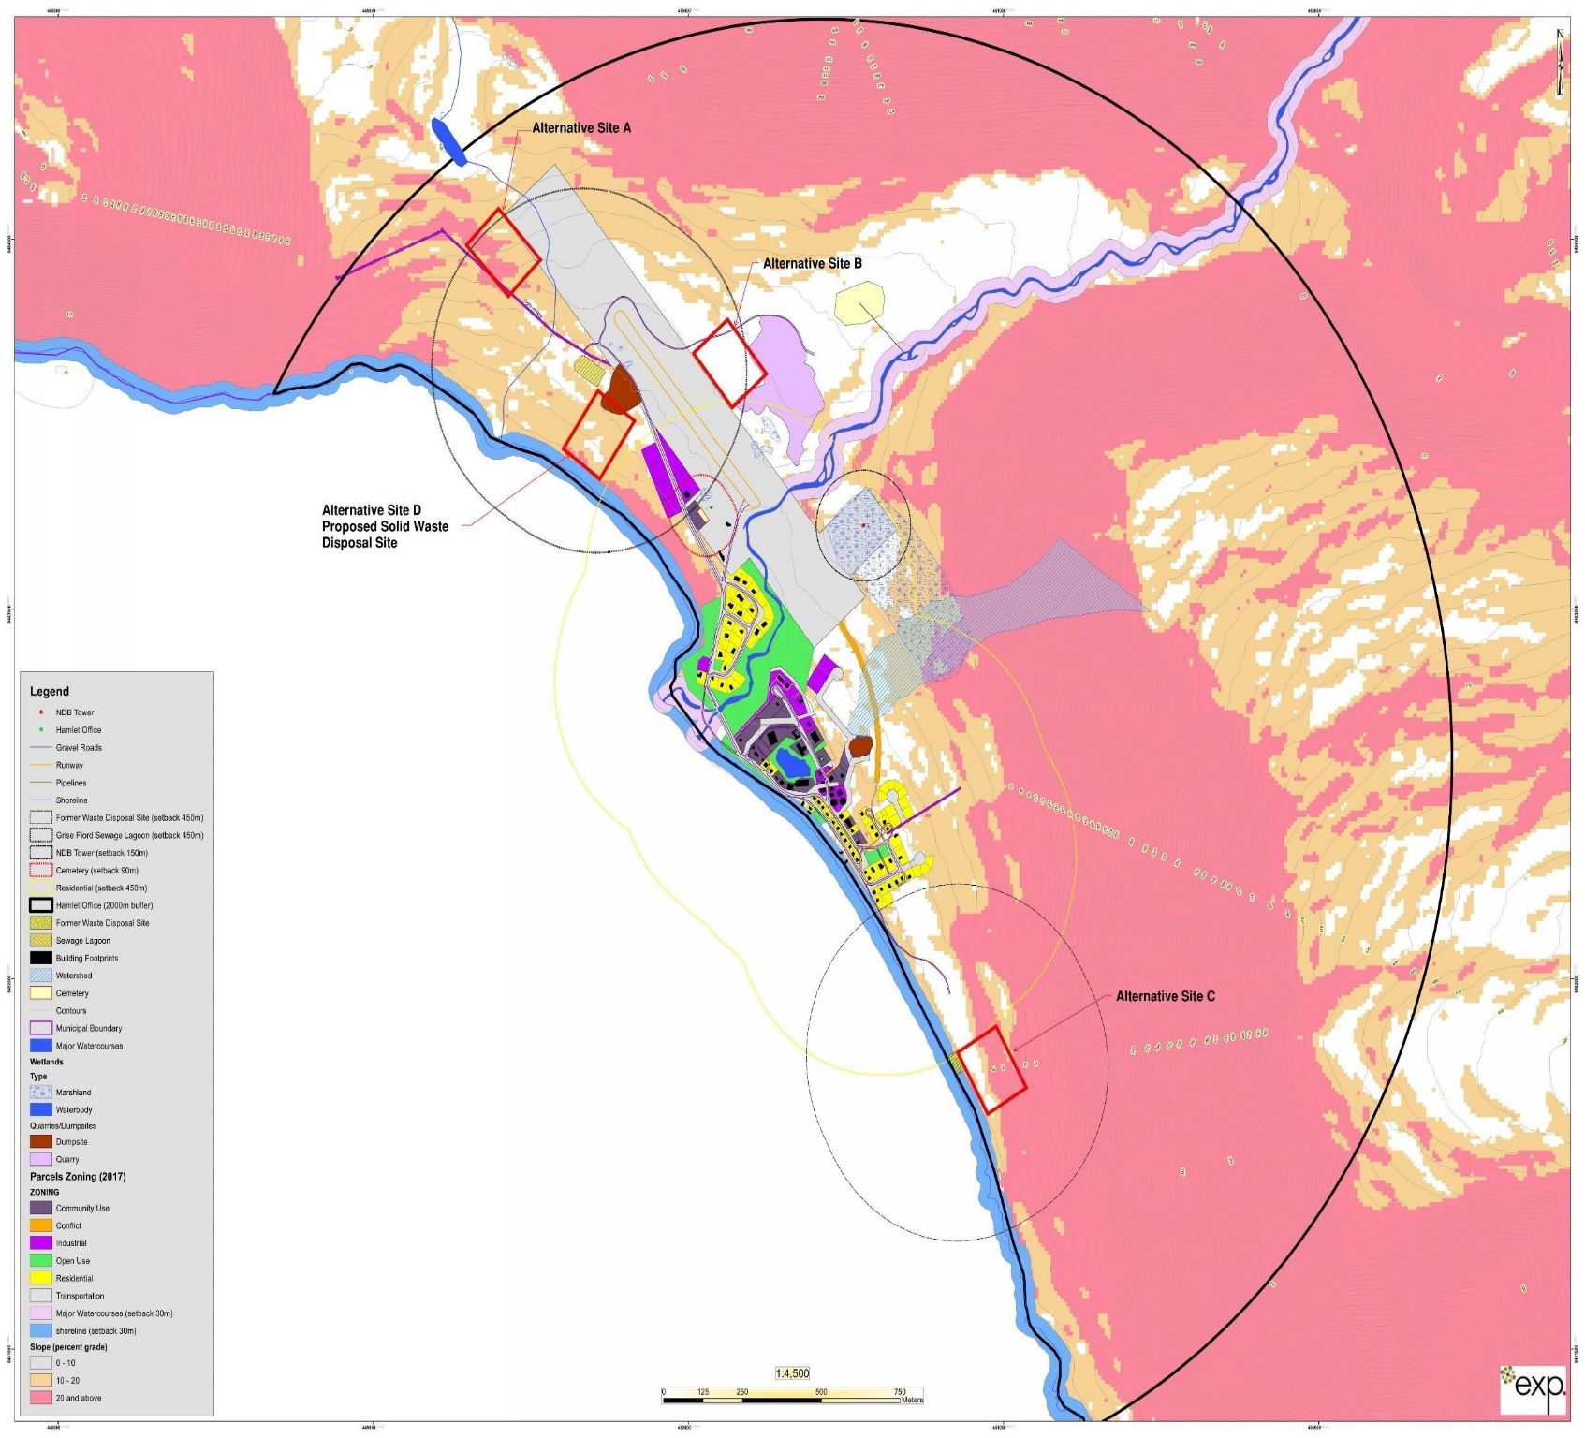

Fig.: Airport Location

APPENDIX-B: SPILL FORM

A | REPORT DATE: MONTH – DAY – YEAR |  |  | REPORT TIME |  |  | ORIGINAL SPILL REPORT, OR UPDATE #  TO THE ORIGINAL SPILL REPORT |  |  |  |  | REPORT NUMBER -
B | OCCURRENCE DATE: MONTH – DAY – YEAR |  |  | OCCURRENCE TIME
C | LAND USE PERMIT NUMBER (IF APPLICABLE) |  |  |  |  | WATER LICENCE NUMBER (IF APPLICABLE)
D | GEOGRAPHIC PLACE NAME OR DISTANCE AND DIRECTION FROM THE NAMED LOCATION |  |  |  |  |  |  |  | REGION  NWT NUNAVUT ADJACENT JURISDICTION OR
E | LATITUDE  DEGREES MINUTES SECONDS |  |  |  |  | LONGITUDE  DEGREES MINUTES SECONDS
F | RESPONSIBLE PARTY OR VESSEL NAME |  | RESPONSIBLE PARTY ADDRESS OR OFFICE LOCATION
G | ANY CONTRACTOR INVOLVED |  | CONTRACTOR ADDRESS OR OFFICE LOCATION
H | PRODUCT SPILLED |  | QUANTITY IN LITRES, KILOGRAMS OR CUBIC METRES |  |  |  |  |  |  |  | U.N. NUMBER
H | SECOND PRODUCT SPILL ED (IF APPLICABLE) |  | QUANTITY IN LITRES, KILOGRAMS OR CUBIC METRES |  |  |  |  |  |  |  | U.N. NUMBER
I | SPILL SOURCE |  | SPILL CAUSE |  |  |  |  |  |  | AREA OF CONTAMINATION IN SQUARE METRES
J | FACTORS AFFECTING SP ILL OR RECOVERY |  | DESCRIBE ANY ASSISTANCE REQUIRED |  |  |  |  |  |  | HAZARDS TO PERSONS, PROPERTY OR ENVIRONMENT
K | ADDITIONAL INFORMATION, COMMENTS, ACTIONS PROPOSED OR TAKEN TO CONTAIN, RECOVER OR DISPOSE OF SPILLED PRODUCT AND CONTAMINATED MATERIALS  44
L | REPORTED TO SPILL LINE BY | POSITION |  |  | EMPLOYER |  |  | LOCATION CALLING FROM |  |  |  |  | TELEPHONE
M | ANY ALTERNATE CONTACT | POSITION |  |  | EMPLOYER |  |  | ALTERNATE CONTACT LOCATION |  |  |  |  | ALTERNATE TELEPHONE
