OPERATION AND MAINTENACE PROCEDURE FOR THE EXISTING SEWAGE DISPOSAL SYSTEM

Revised March 2019

HAMLET OF KIMMIRUT BAFFIN REGION, NUNAVUT

TABLE OF CONTENTS

Page No.

- INTRODUCTION 5
  - PURPOSE 5
  - SITE SETTING 5
  - POPULATION PROJECTION 8
  - CONTACT LIST 8
- BACKGROUND 9
  - GENERAL 9
    - Sewage Treatment Facility 9
    - Sewage Collection and Transport 10
  - SEWAGE PRODUCTION 12
- SEWAGE DISPOSAL SYSTEM 12
  - MANUAL ORGANIZATION 12
  - EQUIPMENT 13
  - SITE PERSONNEL 13
  - OPERATIONAL PROCEDURES 13
    - Basic Operations 13
    - Decanting Procedure 14
    - Service Disruption Contingency 14
    - Sampling Procedures and Requirements 14
    - Sludge Monitoring Plan 17
    - Geotechnical Reviews 17
    - Record Keeping and Reporting 17
    - Health and Safety 17
  - MAINTENANCE PROCEDURES 18
    - Sewage Trucks and Holding Tanks 18
    - Access Road and Truck Pad 18
    - Drainage 18
  - OPERATION AND MAINTENANCE SUMMARY 18
- SPILL CONTINGENCY PLAN 19
  - COMMUNITY CONTACT INFORMATION 19
  - DISTRIBUTION LIST 19
  - PURPOSE AND SCOPE 19
  - COMMUNITY ENVIRONMENTAL POLICY 20
  - PROJECT DESCRIPTION 20
  - SITE DESCRIPTION 20
  - FIRE 20
  - SPILLS 21
    - Initial Response 21
    - Containment Procedures 21
    - Spot Spills 22
    - Spills in Proximity to a Waterbody 22
  - EXISTING PREVENTATIVE MEASURES 22
  - ADDITIONAL COPIES 22
  - PROCESS FOR STAFF RESPONSE TO MEDIA AND PUBLIC INQUIRES 23

- RESPONSE ORGANIZATION 23
  - RESPONSE PERSONNEL 23
  - FLOWCHART OF RESPONSE ORGANIZATION AND COMMUNICATION LINES 23
  - SUMMARY OF AVAILABLE COMMUNICATION EQUIPMENT 25
- ACTION PLAN 25
  - POTENTIAL ENVIRONMENTAL IMPACTS OF SPILL 25
  - PROCEDURES 26
    - Procedures for Initial Actions 26
    - Spill Reporting Procedures 27
    - Procedures for the Protection of Human Health and Safety 27
    - Procedures for Containing and Controlling Spill 27
    - Procedures for Transferring, Storing and Managing Spill Related Wastes 29
    - Procedures for Restoring Affected Areas 29
- RESOURCE INVENTORY 29
  - ON-SITE RESOURCES 29
  - OFF-SITE RESOURCES 30
  - TRAINING SCHEDULE AND RECORDKEEPING 30
8 Appendices 28
9 REFERENCES 30

LIST OF FIGURES

Figure 1: Map of Nunavut 6
Figure 2: Location of Kimmirut Sewage discharge location 7
Figure 3: Location of Upper lagoon of the new wastewater treatment process---------------------------------- 9
Figure 4: Location of the lower lagoon of the new wastewater treatment process----------------------- 10
Figure-5:Location of upper lagoon, gulch, lower lagoon, wetlands and existing sewage truck discharge--- 11 Figure 6: Flow Chart of Spill Communication Line---------------------------------------------------------24

LIST OF TABLES

Table 1: Population Projections for Kimmirut 8
Table 2: Projected Sewage Generation 12
Table 3: Effluent Quality Limits for Sewage Disposal Facility 14
Table 4: Sampling Station Locations 15
Table 5: Parameters to be tested at Monitoring station KIM-3 -----16
Table 6: Sampling Analysis for Annual Discharge Monitoring 16
Table 7: Summary of Operation and Maintenance Tasks 19
Table 8: Personnel Contact ----23

Appendix- A Guidelines for Water and Wastewater Sampling
Appendix- B Sketch of the Sewage discharge location and Sampling station Appendix- C Spill Reporting Form

INTRODUCTION

Purpose

The purpose of this manual is to establish existing operation and maintenance protocol for the management of the sewage treatment system for Hamlet of Kimmirut. Information presented in this manual has been developed based on the document “Guidelines for the Preparation of an Operation and Maintenance Manual for Sewage and Solid Waste Disposal Facilities.” This document fulfills Parts B, D, F and H of the Water License 3BM-KIM 0911.

To assist personnel that operate the existing sewage disposal system with proper operation and maintenance procedures, the following requirements are addressed in this O&M manual:

    - Proper operation and maintenance procedure for the sewage disposal system to provide effective treatment and operation of the facility;
    - Monitoring program description;
    - Appropriate methods and procedures for wastewater sampling, and;
    - A spill contingency plan.

Site Setting

The Hamlet of Kimmirut is located on the south tip of Baffin Island in Nunavut, at 62050’06”' North latitude and 69052’04” West longitude.

Kimmirut was chosen as the site of an Anglican Church in 1909 and the Hudson’s Bay Company set up a trading post here in 1911. The previously uninhabited site is now home to about 473 people, of which approximately 91 per cent are Inuit.

Formerly known as Lake Harbour, the hamlet of Kimmirut, which means “a heel” in Inuktitut, the language of the Inuit, is named after a geological feature resembling a heel located across the Inlet opposite the community.

Kimmirut is named for a marble outcrop located opposite the community and many unusual minerals and gemstones have been discovered on nearby marble hills. Precious and semi-precious gems such as sapphire, spinel, scapolite, tourmaline, iolite, apatite, zircon, moonstone, garnet, diopside, pargasite and lapis lazuli have been discovered here. The geological setting of Southern Baffin Island, where Kimmirut is located, is analogous to productive gem minerals.

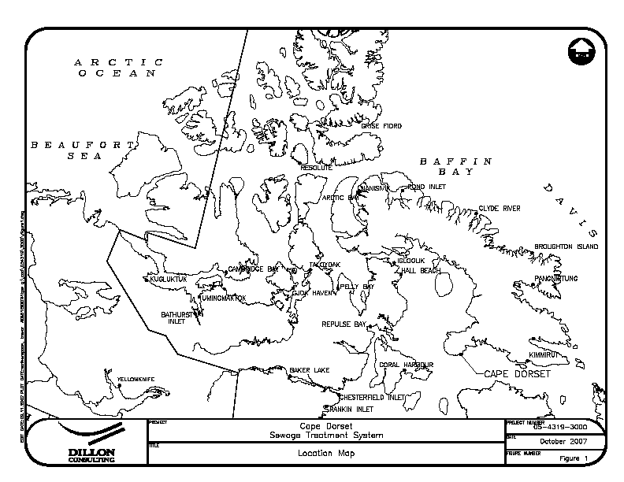

Figure -1: Location map of Kimmirut in Nunavut

Hamlet of Kimmirut location in Nunavut



Figure 2: Kimmirut Sewage Discharge location

Existing Sewage Disposal Location

The community uses trucked services for both water delivery and sewage collection. The community discharges its untreated wastewater directly into the sea adjacent to the existing solid waste site, approximately 750m south of the community.

Population Projection

Presently, the population of Kimmirut is approximately 473 people (Based on 2009 GN estimates). Table 1 shows the population growth for the Hamlet over the lifetime of the new plant projected by Nunavut Bureau of Statistics.

Table 1: Population Projections for Kimmirut

Year | 2000 | 2008 | 2013 | 2018 | 2023 | 2028
Population | 450 | 546 | 612 | 675 | 755 | 846

Source: Nunavut Bureau of Statistics.

Contact List

The Hamlet of Kimmirut has a Maintenance Management Operation System (MMOS) already in place. Regular maintenance will be conducted as outlined in this manual whereas specific work orders for sewage treatment facility and system will be passed through to the MMOS. A list of the individuals that are responsible for the operation and maintenance of the sewage treatment and waste disposal system are as follows:
Senior Administrative Officer (867) 939-2247
Municipal Works Foreman (867) 939-2256

BACKGROUND

General

Sewage Treatment Facility

The Hamlet of Kimmirut currently discharges its untreated wastewater into the sea adjacent to the existing waste disposal facility, about 750 m south of the Community. In 2001, a new sewage lagoon was constructed approximately 1.5km to the west of the Community and has never operated due to unsafe access road built at the same time. Later on the assessment of this sewage lagoon determined that this did not has sufficient capacity to meet the over winter storage of the community. Thus much of the over winter sewage would accumulate in the form of an ice pack in the gulch downward of the sewage lagoon. The sewage in the ice pack would be released uncontrolled and without treatment during the spring melt.

The assessment of the wetlands potential for treatment determined the large wetlands, which the sewage would ultimately drain into below the sewage lagoon and gulch, provided potential for meeting treatment requirements of the Hamlet. The geotechnical investigation of the existing lagoon recommended that
that the existing earth berm which forms the lagoon be upgraded to provide slope stability and to prevent overtopping and erosion.

Following the recommendation, the lower lagoon was built in 2012 at the bottom of the gulch to capture and retain the runoff from the ice pack. These two lagoons are supposed to work in series with each other to provide a pretreatment prior to the sewage being released to the wetlands. The wetlands assessment determined that given the sewage released at the time when the wetlands are capable of providing treatment and that there is a level of pre-treatment as projected from the sewage lagoons, the wetlands will provide sufficient treatment to meet and exceed the requirements of the water licence.
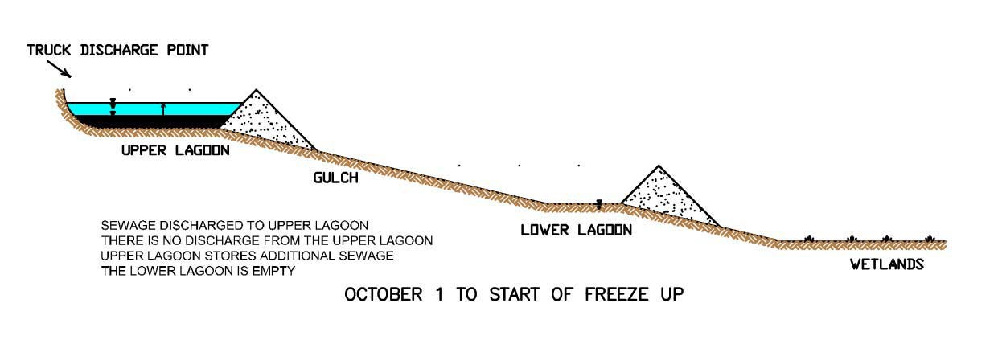

Figure-3: Location of Upper Lagoon Operation of the new wastewater treatment process

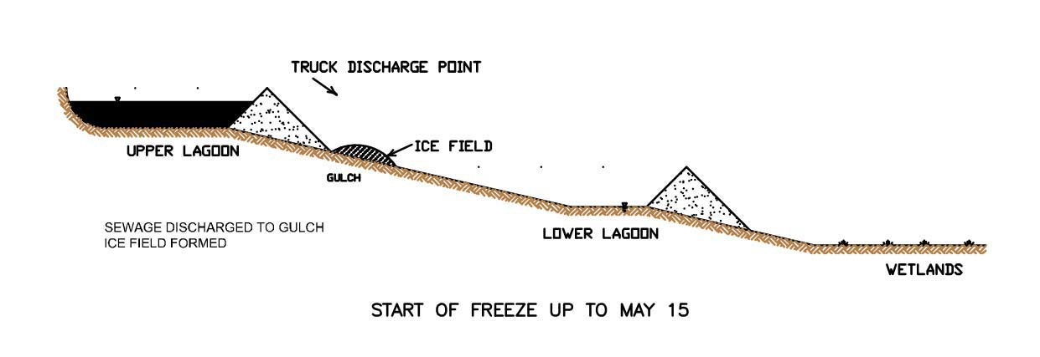
Figure -4: Location of Lower lagoon operation of the new wastewater treatment process

A fish study was conducted and it was confirm the presence of Fish in the wetland. Therefore these
facilities were not commissioned and these have been abandoned permanently. Therefore, the Community continues discharging raw sewage at the top of the Hill as shown in Appendix-B in order to sliding down into the sea. The community has been practicing this process since the day the community was born.
A new site has been identified and supported by the Transport Canada. Once the new lagoon at this new Site #9 is built and the sewage will be redirected into the new Lagoon. At the same time, the existing dumping site will be remediated. A new O&M manual will be developed once the new lagoon is built and commissioned.

Sewage Collection and Transport

All municipal wastewater of the community is collected and transported to the sewage disposal site by vacuum trucks. The sewage collection service operates 7 days a week. With only one truck operating, about 10 to 12 trips are made to the sewage disposal site per day.

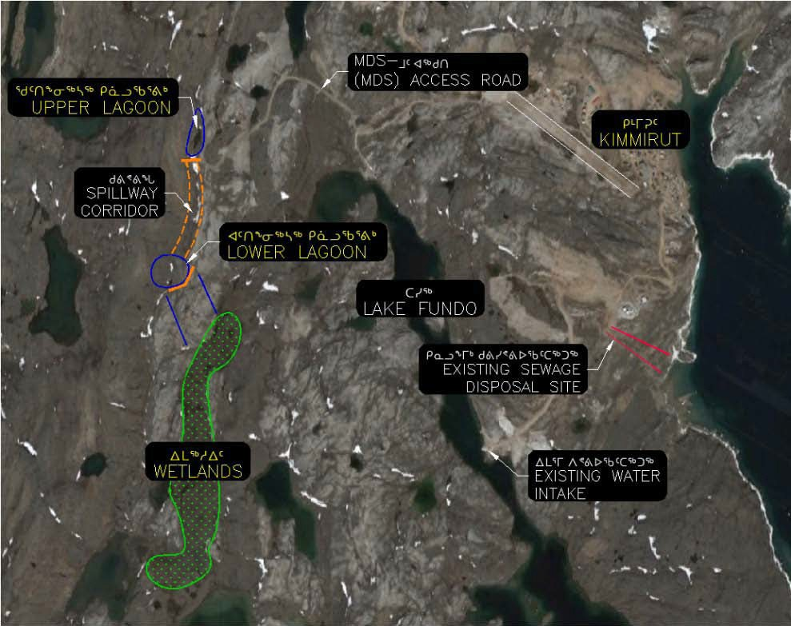

Figure 5: Location Upper lagoon, Gulch, Lower lagoon, Wetlands and also existing Truck Raw Sewage disposal location

2.2 Sewage Production

It is approximated, for smaller communities such as Kimmirut where water distribution is provided by trucks, that the sewage generation is equal to the water consumption. Therefore, the daily and annual sewage generation rates are approximately equivalent to the water consumption rates. The following equation, proposed by MACA, gives the water consumption rate for small communities on trucked services that have a population less than 2,000 people.

Water Use (L/capita/day) = 90 L/capita/day x (1.0 + 0.00023 x Population)

Using the estimated population projections shown in Table 1, the projected sewage generation rates over the new facility lifetime are shown in Table 2 below. The new lagoon was constructed to hold the annual generation rate of 33,195 m3 of wastewater. Until the new facility is commissioned, the entire sewage will be continued to dump into this existing Sewage disposal site.

Table 2: Projected Sewage Generation in Kimmirut

Year | Population | Sewage Generation Rate (L/capita/day) | Annual Generation (m3/yr.)
2000 | 450 | 99.32 | 16,313
2008 | 546 | 101.30 | 20,188
2013 | 612 | 102.67 | 22,934
2018 | 675 | 103.97 | 25,616
2023 | 755 | 105.63 | 29,109
2028 | 846 | 107.51 | 33,195

Physical, chemical and biological characteristics of sewage are referred to as its composition. It is assumed that raw wastewater has a typical average concentration of 625 mg/L for BOD5 and 900 mg/L for TSS. For domestic waste, average raw FC concentration is about 2 x 109 FCU per 100 mL.

SEWAGE DISPOSAL SYSTEM

Manual Organization

This section of the manual presents the operation and maintenance procedures that are associated with the wastewater treatment facility that designated operators assigned to the system should be aware of concerning the facility and system.

Equipment

The equipment required to operate the Kimmirut t sewage treatment system consists of only one sewage collection truck with the following capacity
▪ 9,092 L (2,000 imp. gal);

Site Personnel

The overall responsibility of the waste disposal site as well as the overseeing of the operation and maintenance personnel is that of the Senior Administrative Officer. Day-to-day operation and maintenance of the facility is the responsibility of the Municipal Works Foreman. In addition, several other employees operate and maintain the sewage trucks on a day-to-day basis.

Operational Procedures

These procedures must be carried out frequently to ensure efficient operation of the treatment system. Daily operation procedures must/should be carried out frequently to ensure smooth operation of the treatment system.

Basic Operations

      - Municipal wastewater is collected from holding tanks at each residence and commercial building by sewage (vacuum) trucks.
      - Sewage (vacuum) trucks pump the wastewater out of the holding tanks and transport it to the sewage disposal location.
      - Throughout the year, the wastewater is discharged into the designated disposal point through the offload chute located at the truck pad. The sewage truck backs up to this point (bollards are placed for safety purposes) and the valve is opened. Wastewater is discharged into the slope of the hill, over the splash pad.
      - The wastewater cannot be retained because of the steep slope of the hill. Once truck discharges on the ground, within few minutes, the raw sewage rolls downwards of the hill and meets the sea water. This untreated sewage disposal process has been continuing for years.
      - Sewage effluent does not meet the Water licence requirements.

At least 10 days’ notice to the Nunavut Water Board (NWB) prior to decanting is not applicable in this case.
The effluent discharged from the existing Sewage Disposal process at sampling station KIM-3(N 62050’27.30’’ and W 69052’24.80”) should meet the following effluent quality standards prior to discharge as listed in Table 3. Since no treatment occurs prior to discharge, the effluent does not meet the requirements of the water licence.

Table 3: Effluent Quality Limits for the Sewage Disposal Facility

Parameter | Units | Maximum Average Concentration
Fecal Coliforms, FC | CFU/100 mL | 1 x 106
5 Day Biological Oxygen Demand, BOD5 | mg/L | 120
Total Suspended Solids, TSS | mg/L | 180
Oil and Grease | - | No visible sheen
pH |  | 6 - 9

Decanting Procedure

This process is not applicable in this case.

Service Disruption Contingency

In the event of any disruption of services, due to blizzard or sudden sewage truck breakdown, the next operation becomes frequent discharges to the slope of the hill following the acceptance by the CIRNAC inspector and the Chief Medical officer of GN- DOH . Quality does not matter for that situation. This is definitely a short term emergency measures.
For short and long term contingency, a designated as and when certified mechanic must be chartered to the Community to repair the Sewage Truck.

The Senior Administrative Officer of the Hamlet of Kimmirut will be the 1st responsible officer for the effective sewage collection from house to house and immediate disposal.

Sampling Procedures and Requirements

A key component to the operations and maintenance of the proposed sewage treatment system is a sampling program.
The proposed sampling program will help to monitor only the raw sewage quality on daily basis.
It is important such a sampling program be implemented by the Hamlet as a part of the annual operations for the facility. Local members of the community that operate the system are to be trained on the proper operation and procedure methods used in the sampling program. In addition, quality and safety training will also be included which will ensure that the high quality data will be obtained.

All sampling, sample preservation and analyses will be in accordance with methods described in the current edition of Standard Methods for the Examination of Water and Wastewater. In addition, a document has been attached in Appendix A of this manual that provides guidelines and procedures to follow when sampling wastewater.

To obtain meaningful results from the analysis, the following five factors are of particular importance:
- Sample collection at designated time and location;
- Correct usage of container/sample bottle for parameter being tested;

- Correct labeling of sample bottles and filling out record/field sheet;
- Correct procedure for field sampling;
- Proper and timely shipment of samples to the laboratory.

It is critical, from a quality perspective, that sample collection be performed from an area of higher concentration to an area of lower concentration of contaminants. Therefore, a sample will be collected at various locations along the system to monitor the effluent quality at various stages of treatment. Descriptions of each sampling location of the sewage treatment system for the Monitoring Program are listed in Table 4 below in page 15 and shown in Appendix-B.

Table 4: Sampling Station Locations

Monitoring Program Station Number | Description of Monitoring Program Station
KIM-3 | Effluent discharge from existing Sewage Disposal Facilities.  point.
 | Location: N 62050’27.30”:W 69052’24.80”
This is the designated compliance point located at the slope of the Hill about 50 ft.
down from the sewage dumping location.
.

Samples will be taken from location KIM-3 on monthly basis in Summer season as the flow is observed from May to August inclusive.
Raw sewage from the Sewage Truck is also monitored to develop a historical data for design purposes of a new facility. This wastewater sample will undergo the same analysis which will include the following set of parameters as listed in the following page.

Table-5: Parameters are required to be tested at Monitoring station at KIM-3.

Biochemical Oxygen Demand, BOD5 | Total Lead, Pb
Total Suspended Solids, TSS | Fecal Coliforms, FC
pH | Conductivity
Oil and Grease (Visual) | Total Organic Carbon, TOC
Total Hardness | Total Alkalinity
Nitrate-Nitrite | Ammonia Nitrogen, NH3-N
Total Zinc,Zn | Total Phenols
Magnesium, Mg | Calcium, Ca
Potassium, K | Sodium, Na
Chloride, Cl | Sulphate, SO4
Total Arsenic, As | Total Aluminum, Al
Total Cadmium | Total Cobalt, Co
Total Nickel, Ni | Total Iron, Fe
Total Chromium, Cr | Total Mercury, Hg
Total Copper, Cu | Total Manganese, Mn

Table 6: Sampling Analysis for Annual Discharge Monitoring

Test Parameter | Receiving Water Body
Biological Oxygen Demand, BOD5 | X | X
Total Suspended Solids, TSS | X | X
Fecal Coliforms, FC | X | X
Ammonia-Nitrogen, NH3 – N | X | X
Total Phosphorus, TP | X | X
Heavy Metals | X | X

A grab sample will be taken from each of the sewage trucks during discharge to the hill slope. Samples from the trucks will provide quality of the raw sewage before it enters the slope of the hill.
Once collected, the samples will be shipped to the laboratory and analyzed using the same test method/procedure. This sampling program will be conducted over several years to collect sufficient data for trend analysis. All lab results for the monitoring program will be submitted to NWB along with the Hamlet annual report. Note that any other additional sampling during the year will be at the request of the regulatory agencies.

Hamlet will be using the services of the following Accredited Environmental lab in Ottawa, ON.

Caduceon Environmental Laboratories Ottawa, Ontario, K1V 7P1
Phone: (613) 526-0123
Fax: (613) 526-1244

Sludge Monitoring Plan

This is not applicable in this case. The sewage is not retained. Therefore there is not any opportunity for sludge settlement. Once sewage truck valve is opened, sewage falls on the chute built on the top of the hill and runs towards the sea by gravity following the steep slope of the hill shown in Appendix-B.

Geotechnical Reviews

The hill slope is natural and being eroded day by day. No treatment is possible to stop erosion.

Record Keeping and Reporting

Records of all activities and operation should be kept to assist in the planning of annual operations and maintenance as well as the evaluation of the effectiveness of the sewage treatment facility. These records should be kept in the Hamlet Office and be maintained by the facility’s supervisor. Sample O&M log sheets for the Kimmirut Sewage Treatment System are available in the Hamlet office.
Sampling, Record keeping and reporting requirements are listed in the water license which is attached in Appendix A of this document. Based on the record keeping and reporting requirements listed in Part B of the water license, the following information and data should be recorded and be included in the annual report that is submitted to the Board:
- Monthly and annual quantities in cubic meters (m3) of raw sewage offloaded from sewage trucks
for the existing Sewage Disposal Facility and Emergency Sewage Disposal Facility;
- Number of days of use for the existing Sewage Disposal Facility
- Number of trips to each of the Sewage Disposal Facilities;
- Start and end date for discharge ;
- Date and description of maintenance activities carried out on the Sewage Disposal site; and
- Date, volume and description of any spills that have occurred.

Health and Safety

Due to the potential health hazards associated with municipal wastewater, it is imperative, for those personnel working in this area, to be familiar with and execute all safety precautions involved with the various work tasks associated with the system.
- Equipment is to be kept clean.
- Wear protective clothing such as gloves and boots at all times.
- Work cloths should not be worn home.

- Hands to be washed frequently; as a minimum before eating and after work.
- Personnel should receive appropriate vaccinations and ensure they are kept up-to-date.

3.5 Maintenance Procedures

In the proceeding sections, maintenance procedures for the different areas of the wastewater treatment infrastructure are discussed and should be carried out to ensure the system runs efficiently.

Sewage Trucks and Holding Tanks

The most important part of the sewage treatment system and process is the collection and transport of the wastewater from the residences and buildings to the lagoon cell. Therefore, it is crucial that the sewage trucks be kept in good repair. Procedures for truck and tank maintenance are as follows:
      - Repairs should be completed immediate and take high priority;
      - Full tank sewage trucks should not rest for long periods of time, especially during the winter;
      - Holding tanks should be kept in good working order and prevented from freezing in the winter.

Access Road and Truck Pad

Basic road maintenance such as those listed below must be performed on a regular basis to ensure that the site is accessible at all times.
      - Road and truck pad be graded smooth and reshaped at least twice (2) per year;
      - Snow, when necessary during the winter, to be removed to provide unrestricted access to discharge point;
      - During snow removal, care is to be taken not to damage berms and surrounding areas;
      - Any spilled and/or frozen wastewater should be removed with the snow to appropriate disposal site;
      - Discharged point should be monitored for potential erosion problems.

Drainage

The truck pad at the sewage discharge point should be graded such that any wastewater spilled during the offloading procedure will flow downwards following the slope of the Hill.

3.6 Operation and Maintenance Summary

Daily, weekly, monthly and yearly activities and procedures that are required by the operator and maintenance personnel are summarized in Table 6 shown as follows.

Table 7: Summary of Operation and Maintenance Tasks

Frequency | Description of Task
Daily | - Collection, transportation and disposal of wastewater and/or sewage from residential and commercial holding tanks to the truck discharge point at the sewage treatment lagoon.  - Immediate cleaning of any spills.  - Clearing of snow from access road and truck turn-around pad as required during winter.  - Maintaining O&M information records
Weekly | - Inspection of berms, dykes and drainage courses.  - Monitoring of area surrounding thermistor.  - Conduct weekly monitoring program (if required).  - Maintaining O&M information records
Monthly | - Maintenance of access road and truck pad if required.  - Monitoring and recording of thermistor readings for monitoring program.  - Confirm location and readability of signs.  - Conduct monthly monitoring program (if required).  - Maintaining O&M information
Yearly | - Perform annual decanting of lagoon cell in fall.  - Conduct geotechnical review of geothermal monitoring program.  - Grading and reshaping of access road and truck pad.  - Conduct annual monitoring program (if required).  - Maintaining O&M information records

SPILL CONTINGENCY PLAN

Community Contact Information

Senior Administrative Officer Hamlet of Kimmirut
Kimmirut, Box 120, X0A0S0, NU Tel: (867) 939 227

4.2 Distribution List
This plan and most recent revisions will be distributed to:

Bhabesh Roy Municipal Planning Engineer, GN- CGS
John Mabberi Mudoriyi Senior Administrative Officer
Richard Dwyer Manager of Licensing, Nunavut Water Board
Joseph Monteith Water Resource Officer, CIRNAC

Purpose and Scope

The purpose of this plan is to outline response actions for potential spills of any size, including a worst case scenario for the Hamlet of Kimmirut. The plan identifies key response personnel and their roles and

responsibilities in the event of a spill, as well as the equipment and other resources available to clean up a spill. It details spill response procedures that will minimize potential health and safety hazards, environmental damage and clean-up efforts. The plan has been prepared to ensure quick access to all the information required in responding to a spill.

Community Environmental Policy

The Hamlet of Kimmirut has no formal environmental policy; however, Kimmirut is committed to operating in an environmentally sensitive manner, and complying with requirements of the Nunavut Water Board.

Project Description

This spill contingency plan will be used by the Hamlet, for activities associated with Hamlet operations. This includes:

- Operation of the existing sewage disposal site

Personnel training

Hamlet personnel that are responsible for the sewage treatment and disposal facility should be trained in Workplace Hazardous Materials Information System (WHMIS), Transportation of Dangerous Goods Act and Regulation (TDGA and TDGR) as well as First Aid. In addition, personnel should ensure that proper vaccinations of employees are kept current and that they are familiar with the response plan. It is good practice to obtain copies of a list of procedures and equipment that are to be used for such emergencies in all sewage trucks and the common work area.

In all response cases, personnel should place their own safety as the highest priority. The procedures that should be taken in the likelihood of a potential fire or spill are described in the following sections.

Fire

A contingency plan should be developed by the Hamlet Fire Department to describe the response and action protocols to be implemented in the case of a fire. Special precautions should be used in the case of waste burning as it can produce harmful, poisonous gases. If an uncontrolled fire occurs, the following procedure should be implemented:
- Immediately evacuate area and go to community’s designated meeting place.
- Keep all personnel up-wind from the source.
- Notify the Hamlet Fire Department

Spills

A spill contingency plan has been developed by the Hamlet that identifies the procedures to follow when a spill of any hazardous material has occurred. Similar procedures can be used for the case of sewage spills.
Below, in the subsequent sections, the measures that are to be implemented if a spill or uncontrolled release of a substance occurs during the collection and transportation of wastewater are described for the following areas:
- Initial Response
- Containment Procedures
- Spot Spills
- Spills in Proximity to a Water body

Initial Response

If a spill occurs, the first person at the scene will:

Perform an initial assessment to identity immediate danger.
Identify the material spilled and verify the nature of the hazard by corresponding to the Material Safety Data Sheets (MSDS) so to apply appropriate safety procedures.
If possible and safe to do so, cut off and/or stop the source of the spill.
Control danger to the human life without further assistance, if possible. If, for instance, the spill creates a fire, explosion or other hazard, remove all potential ignition sources.
Obtain immediately assistance from others and start to contain and/or clean up the spill.
Contact the Municipal Works Foreman to notify them of the spill as they will contact relevant regulators and community residents of the occurrence.
Mark off the spill site as to warn the public of the incident and to prevent access.
Once the Municipal Works Foreman has been contacted and have arrived on site, he/she will immediately ensure that:
- Necessary arrangements for first aid and removal of injured personnel have been made. Where possible, necessary action will be taken to secure the site to protect human safety.
- If not already done and is safe to do so, take the appropriate action to stop the flow or release of material/substance as well as to contain or prevent the spread of the spilled material if at all possible.
- Contact the 24 Hour Spill Line at (867) 920-8130 to report spill and obtain additional assistance.
- Contact the Hamlet’s Senior Administrative Officer.
- If required, notify the Fire Department and Hamlet RCMP Detachment

    - Containment Procedures

Response personnel will immediately start to contain the spill to ensure that the spill does not spread and contaminant other areas and/or environment. The following actions might also be taken if relevant to the spill situation:
- If the source of the spill is coming from a leaking fuel truck, then pump fuel into a suitable container or another tank until the tank is dry.
- Culverts that have been potentially affected by the spill should be blocked off to minimize travel of the substance.
- Dig a basin or construct a berm to stop and contain the pathway and flow of the spill.
- Apply absorbent materials to contain and recover small volumes of spilled substance.
- Spilled substance and/or material are to be collected and transported to an approved waste disposal facility in the appropriate matter.

Spot Spills

Spot spills are those that involve a small volume of substance in a controlled material over a small, contained surface area. For spot spills involving hazardous materials, the following steps may be taken by personnel:
- Immediately take action to clean up spill by implementing proper or suitable handling and containment procedures for the material spilled.
- Report spill to the Municipal Works Foreman and Hamlet’s Senior Administrative Officer.
- Determine suitable methods for removal of contaminated soils and restoring site of the spill. Consult environmental and government agencies for assistance.
- Flag and record locations and information of spot spills for future reference and monitoring.
- In the case of a spot sewage spill, place lime over the sewage, collect and transport the material to the solid waste facility for proper disposal.

Spills in Proximity to a Water body

If a spill occurs in close proximity to a water body, take necessary actions to prevent the spill entering the nearby water body. Similar containment procedures discussed above in Section 4.9.2 can be used to assist with the likelihood of spills located near water bodies.

4.9 Existing Preventative Measures

The community is concerned about the environment and the possibility of a spill occurring and takes precautions when working with hazardous materials; however, no formal preventative measures are in place.

4.10 Additional Copies

Several copies of this plan will be kept in the community, in the Hamlet Office.

Process for Staff Response to Media and Public Inquires

All media enquiries are directed to the SAO, John Mabberi Mudoriyi

RESPONSE ORGANIZATION

  - Response Personnel

The following table lists the personnel who will be involved in the spill response. Contact information is also provided.

Table 8. Response Personnel Contact Information

Name | Contact Information
John Mabberi Mudoriyi , SAO | 867-939-2247
Joshua Aqpik ,Works Foreman at Fire Department | 867-939-2256

  - Flowchart of Response Organization and Communication Lines

The following flowchart outlines the chain of communication to be followed, upon discovery of a spill or release by an employee of the community.

Spill or Release Identified by
Employee
Assess personal safety
and safety of others
Identify product used
(If possible)
Stop flow of spill if
Safe to do so
Notify Municipal
Supervisor
Notify Senior Administration
Officer
Consult with other community
personnel on level of action required
Call NWT Spill Line at (867)
920-8130 if necessary
Contain spill using procedures set out in
Section 3.0 of Spill Contingency Plan
Consult with regulatory
personnel
Clean- up spill using procedures set out in
Section 3.0 of Spill Contingency Plan
Consult with regulatory
personnel
Keep track of actions and file in Hamlet
Office

Figure 6: Flow chart of Spill Communication Lines

  - Summary of Available Communication Equipment

The following equipment is available in the community for communication purposes:

    - Telephone with land line
    - Computers with internet connection in Hamlet Office
    - Fax machine

ACTION PLAN

  - Potential Environmental Impacts of Spill

Generally, for the hazardous materials discussed below, environmental impacts are lower during the winter, as snow is a natural sorbent and ice forms a barrier lining for eliminating soil or water contamination. Spills can be more readily recovered when identified and reported.

Gasoline:
Environmental Impacts:
- Harmful to wildlife and aquatic life
- Not readily biodegradable
- Has potential to bio accumulate in environment
- Volatilizes easily
- Runoff into water bodies must be avoided

Worst Case Scenario: All fuel drums open simultaneously and contents pour onto ground and surrounding environment.

Diesel:
Environmental Impacts:
- Harmful to wildlife and aquatic life
- Not readily biodegradable
- Has potential to bio accumulate in environment
- Burns slowly (more readily contained than volatile fuels)
- Runoff into water bodies must be avoided

Worst Case Scenario: All fuel drums open simultaneously and contents pour onto ground and surrounding environment.

Waste Oil and Miscellaneous Oils and Grease:
Environmental Impacts:
- Harmful to wildlife and aquatic life
- Not readily biodegradable
- Has potential to bio accumulate in environment
- Runoff into water bodies must be avoided

Worst Case Scenario: All storage drums open simultaneously and contents pour onto ground and surrounding environment.

Sewage:
Environmental Impacts:
- Human health hazard, and unsightly appearance
- High nutrient concentrations could negatively impact water bodies and runoff into water bodies must be avoided

Worst Case Scenario: Full sewage truck releases all of its contents onto ground and surrounding environment.

Procedures

    - Procedures for Initial Actions

The following list of actions should be followed by the first person on the scene:

      - Ensure safety of all personnel
      - Identify the product spilled
      - Assess the hazards and risks to persons in the vicinity of the spill
      - If possible, without further assistance, control the danger to human life
      - If it is safe to do so, and if possible, stop the spill (i.e. shut off pump, replace cap, tip drum upward, etc.)
      - Gather information on the status of the situation, including:
        - Estimated size of spill
        - Estimated migration route
      - Contact Municipal Supervisor, as per flowchart in Figure 3.

    - Spill Reporting Procedures

Spills should be reported immediately to the Municipal Supervisor, who will notify the SAO. Together they will determine if the spill is to be reported to the NWT 24-Hour Spill Line at 867-920-8130.

Copies of the Spill Report form are available in each spill kit and at the back of this manual. The form will be filled out by the Public Works Foreman (or designate), and faxed or emailed to the NWT Spill Line. Contact information is as follows:

Territorial 24-Hour Spill Line Phone: (867) 920-8130
Fax: (867) 873-6924
Email: spills@gov.nt.ca

    - Procedures for the Protection of Human Health and Safety
Following a spill, the health and safety of workers as well as the general public is a priority. Actions taken will depend on the type of spill.

      - In the event of a chemical spill: Restrict public access to the spill area. Workers involved in the clean-up of the spill should wear personal protective equipment (PPE).
      - In the event of a flammable or combustible material spill: Evacuate adjacent buildings and restrict public access to the spill area. Remove sources of ignition if safe to do so (no smoking, flares, sparks or flames in the area). Never walk through or touch the spilled material. De- energize electrical equipment from a remote location if safe to do so. If ignition sources cannot be removed safely, evacuate the area immediately and report the spill situation. All equipment used when handling the material must be grounded. Only spark-arresting equipment should be used during clean-up of the spill. PPE should also be worn by workers involved in the clean-up. Refer to the product Material Safety Data Sheet (MSDS) for further instruction.
      - In the event of a sewage spill: Restrict public access (including pets and animals) to the spill area.

    - Procedures for Containing and Controlling Spill
General procedures noted below will be used to contain and control all spills. Specific procedures for spills on land, water, snow and ice follow.

      - First anticipate what will be affected by the spill.
      - Assess direction and speed of spill, and any factors that could affect these.
      - Determine best location for containing spill.

Spills on Land:
Dykes and trenches can be constructed to contain spills on land. Soil surrounding the spill area can be dug out, and piled up, to create a barrier for the spill. A plastic tarp can be placed at the base of the dyke, so that the pooled material can be removed with sorbent materials. Conversely, trenches can be excavated to permafrost, which will provide a natural containment of the spill. Once the material is contained, it can be pumped out, or removed by using sorbent materials. If the spill is moving very slowly, such structures may not be necessary and the material can be removed before migrating away from the spill location.

Spills on Water:
Spills on water are considered the most serious types of spills, as there is often no containment of the spilled material and water quality and aquatic life are negatively impacted. Booms and weirs can be installed to contain the spill. Booms are designed to float, and are made of absorbent material to soak up the spilled fuel. They are deployed from the shore or a boat, to create a circle around the spill. Weirs are installed across a stream, to prevent further migration. Plywood or other materials found onsite can be used. Barriers made of fence or netting can be used as well, with sorbent material placed at the base of the barrier. Once contained, the fuel can be removed by absorbent materials, pumped out or allowed to volatilize.

Spills on Snow:
Snow acts as a natural sorbent for spilled fuel. Impacted snow is easily visible, and can be shoveled into empty drums or barrels for proper disposal. If the spill is migrating down a hill, a snow dyke can be constructed to contain the spill. A plastic tarp can be placed at the base of the dyke, where spilled fuel is expected to pool. The collected fuel and impacted snow ban be removed with absorbent materials, pumped out, or shoveled into barrels for disposal.

Spills on Ice:
Ice is considered impermeable to fuel, so these spills are generally easy to clean up. Small spills can be cleaned up by placing absorbent materials on top of the ice. Impacted snow and slush can then be removed by shovels, and placed in barrels for disposal. For larger spills, dykes of snow and trenches can be constructed to contain the spill. Pooled fuel can then be removed by adsorbent materials or pumped out. Impacted snow and slush can be shoveled into barrels for disposal.

Worst Case Scenarios:
Worst case scenarios include a dyke or trench overflowing and a large spill on water that cannot be contained with materials available in the community. In the first case, a trench or collection pit could be constructed downstream to collect the fuel. In the second case, an emergency response team would need to be called, with appropriate equipment to deal with the spill.

Procedures for Transferring, Storing and Managing Spill Related Wastes

Spills are generally cleaned up starting at the outer limit of the spill, and working towards the point of the spill. Sorbent materials and hand tools such as cans and shovels are used for smaller spills. Larger spills can be contained with the use of a pump and/or heavy equipment.

Spill wastes include used absorbent materials and containers of impacted water and snow. Sorbent materials should be placed in plastic bags for proper disposal. The containers of impacted water and snow should be sealed and stored until disposal at an approved facility can be arranged.

Following a spill, all used materials need to be properly washed and/or replaced.

Procedures for Restoring Affected Areas

Once a spill has been contained, community personnel will consult with regulatory personnel assigned to the file to determine the level of clean-up required. Regulatory personnel may request that a site specific study be conducted, to ensure appropriate clean-up levels are met.

RESOURCE INVENTORY

  - On-site Resources

It is recommended that the Hamlet of Kimmirut retain one spill kit in the community, located at the Maintenance Garage. The spill kit should contain the following:

- 30 socks/booms (3” x 4’)
- 30 pillows (2L)
- 24 dispersal bags
- 4 pairs gloves
- 2 pairs goggles
- 6 pairs Tyke coveralls
- 4 shovels
- 2 spill signs
- 2 repair putty
- 1 Emergency Response Guidebook
- 1 Safety and Compliance Directory
- 1 Spill Response Pocket Guide

This response kit is designed to contain and collect up to 56 gallons of spilled oil. Additional volumes will be accommodated with the use of absorbent products that will be maintained in inventory in sufficient quantities.

The following heavy equipment is also available in the community for spill containment:
- Loader
- Dozer

Off-site Resources

The following resources are available for assistance if needed:

Territorial 24-Hour Spill Line | (867) 920-8130
Aboriginal and Northern affair Canada (AANDC) | (867) 669-2761
GN – Emergency Measures Officer | (888) 624-4043
Kimmirut Health Centre | (867) 939-2217
RCMP (Kimmirut) | (867) 939-1111
Environment Canada (Emergency) Yellowknife | (867) 669-4725
GN Environmental Health Office | (867) 975-4817
Kimmirut Fire Emergency Calls | ( 867) 939-4422
First Air Cargo | 1-800-267-1247 or (867) 939-2250

Training Schedule and Recordkeeping

Training will be conducted on an as-needed basis. Records will be kept in the community office.

Appendix- A: Guideline of wastewater Sampling

Appendix- B: Sketch of Sewage Disposal site
Appendix- C: Spill Reporting Form

REFERENCE:

- Dillon Consulting Limited. “P lake Sewage Lagoon System”, produced for Department of Community and Government Services, Government of Nunavut, January 2006.

APPENDIX-A

GUIDELINES FOR WASTEWATER SAMPLING AND TESTING

Guide Lines for Wastewater sampling in Baffin Communities

Wastewater:

- Collect treated samples 4 times from KIM-3 from May to August inclusive.
- Collect raw sewage samples 4 times directly from the Sewage truck discharge

Sample bottles specifications for Wastewater and leachate:

Seven samples should be taken from a point KIM-3 in seven different sampling bottles.

All the wastewater and Leachate samples will be sent to Ottawa Lab.

Superviosr for Arctic Region
Caduceon Environmental Laboratories
2378 Holly Lane
Ottawa Ontario K1V 7P1 Tel: 613-526-0123
Fax: 613 526 1244

Precautions of Sampling:

  - Use hand gloves
  - Ensure each bottle level information is filled and follow Lab Chain of Custody Form:
    - ‐Date and time sample taken
    - ‐Location with GPS coordinates
    - ‐Sampler’s name
  - Person’s name and contact information where to send sample Test Results and invoice.

  - Samples must be arrived Ottawa Lab within 24 hours from the time of sampling.

APPENDIX-B

SKETCH OF SEWAGE DISPOSAL SITE

Sewage Truck
Untreated sewage running downwards of the Hill following its slope about 1:1






Sewage Truck
Truck discharge Chute

KIM-3

SEA



APPENDIX-C: SPILL REPORTING FORM

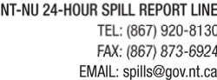

REPORT LINE USE ONLY
A | REPORT DATE: MONTH – DAY – YEAR |  |  |  | REPORT TIME |  |  | ORIGINAL SPILL REPORT, OR UPDATE #  TO THE ORIGINAL SPILL REPORT |  |  |  |  |  | REPORT NUMBER  -
B | OCCURRENCE DATE: MONTH – DAY – YEAR |  |  |  | OCCURRENCE TIME
C | LAND USE PERMIT NUMBER (IF APPLICABLE) |  |  |  |  |  | WATER LICENCE NUMBER (IF APPLICABLE)
D | GEOGRAPHIC PLACE NAME OR DISTANCE AND DIRECTION FROM THE NAMED LOCATION |  |  |  |  |  |  |  |  | REGION  NWT NUNAVUT ADJACENT JURISDICTION OR
E | LATITUDE  DEGREES MINUTES SECONDS |  |  |  |  |  | LONGITUDE  DEGREES MINUTES SECONDS
F | RESPONSIBLE PARTY OR VESSEL NAME |  |  | RESPONSIBLE PARTY ADDRESS OR OFFICE LOCATION
G | ANY CONTRACTOR INVOLVED |  |  | CONTRACTOR ADDRESS OR OFFICE LOCATION
H | PRODUCT SPILLED |  |  | QUANTITY IN LITRES, KILOGRAMS OR CUBIC METRES |  |  |  |  |  |  |  | U.N. NUMBER
H | SECOND PRODUCT SPILLED (IF APPLICABLE) |  |  | QUANTITY IN LITRES, KILOGRAMS OR CUBIC METRES |  |  |  |  |  |  |  | U.N. NUMBER
I | SPILL SOURCE |  |  | SPILL CAUSE |  |  |  |  |  |  | AREA OF CONTAMINATION IN SQUARE METRES
J | FACTORS AFFECTING SPILL OR RECOVERY |  |  | DESCRIBE ANY ASSISTANCE REQUIRED |  |  |  |  |  |  | HAZARDS TO PERSONS, PROPERTY OR ENVIRONMENT
K | ADDITIONAL INFORMATION, COMMENTS, ACTIONS PROPOSED OR TAKEN TO CONTAIN, RECOVER OR DISPOSE OF SPILLED PRODUCT AND CONTAMINATED MATERIALS
L | REPORTED TO SPILL LINE BY |  | POSITION |  |  | EMPLOYER |  |  | LOCATION CALLING FROM |  |  |  |  |  | TELEPHONE
M | ANY ALTERNATE CONTACT |  | POSITION |  |  | EMPLOYER |  |  | ALTERNATE CONTACT LOCATION |  |  |  |  |  | ALTERNATE TELEPHONE
REPORT LINE USE ONLY
N | RECEIVED AT SPILL LINE BY |  | POSITION  Station operator |  |  | EMPLOYER |  |  | LOCATION CALLED  Yellowknife, NT |  |  |  |  |  | REPORT LINE NUMBER  (867) 920-8130
LEAD AGENCY EC CCG GNWT GN ILA INAC NEB TC |  |  |  |  |  | SIGNIFICANCE MINOR MAJOR UNKNOWN |  |  |  |  |  |  | FILE STATUS OPEN CLOSED
AGENCY |  | CONTACT NAME |  |  |  | CONTACT TIME |  |  | REMARKS
LEAD AGENCY
FIRST SUPPORT AGENCY
SECOND SUPPORT AGENCY
THIRD SUPPORT AGENCY

Page 1 of

