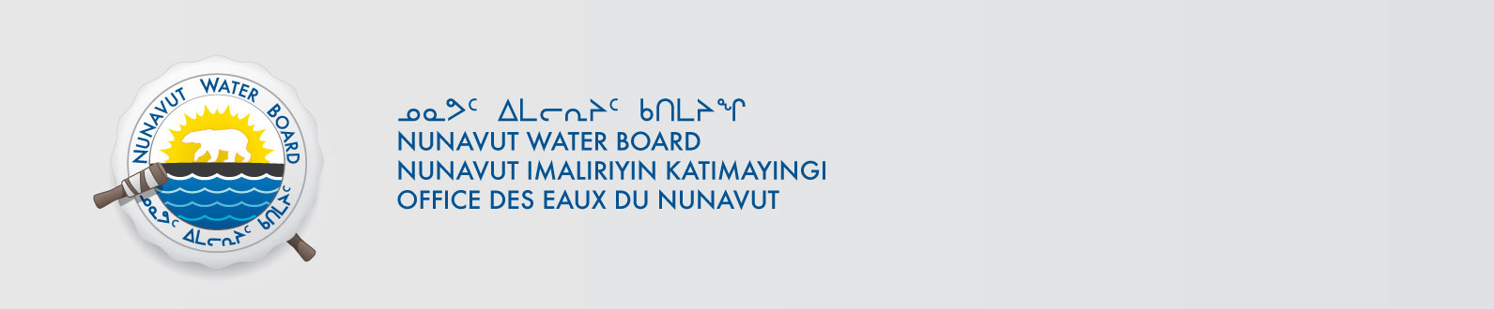

September 21, 2020 NWB File No: 3BM-REP1520

Kevin Tegumiar  Senior Administrative Officer  Hamlet of Naujaat  PO Box 10  Naujaat NU X0C 0H0  E-mail: saonaujaat@qiniq.com | Sarah Collins, P. Eng  Government of Nunavut  Community and Government Services  PO Box 490  Rankin Inlet, NU X0C 0G0  Email: scollins@gov.nu.ca

Subject: Hamlet of Naujaat water licence amendment and renewal application

Dear Mr. Tegumiar:

The Nunavut Water Board (“NWB”) acknowledges receipt on September 16, 2020 of your amendment and renewal water licence application, for the Hamlet of Naujaat. This application has been assigned file number 3BM-REP1520. Please refer to this number on future submissions. Application documents received are as follows:

- NPC Letter re 149379 Municipal Water Licence Amendment and Renewal
- Hamlet of Naujaat 2019 Annual Report
- Hamlet Permission to Represent
- Naujaat 100 Percent Submission
- Naujaat Application for Submission
- Naujaat Design Update 2020-03-20
- Naujaat Executive Summary - English
- Naujaat Executive Summary - Inuktitut
- Naujaat Map
- Plan for Compliance 2020 – FINAL

Please be advised that under the Agreement Between the Inuit of the Nunavut Settlement Area and Her Majesty the Queen in Right of Canada (Nunavut Agreement) Article 11, Section 11.5.9 and s. 76 (1) of Nunavut Planning and Project Assessment Act (NuPPAA), the proponent of a project governed by NuPPAA is also required to submit a project proposal document directly to the Nunavut Planning Commission (NPC or Commission) for the NPC’s determination regarding the applicable land use planning requirements and/or directions regarding whether the project is subject to screening by the Nunavut Impact Review Board. In particular, please note that as established under Articles 11, 12 and 13 of the Nunavut Agreement, NuPPAA and Part 3 of the Nunavut Waters and Nunavut Surface Rights Tribunal Act, until the project has completed the applicable land use planning and assessment process required by the NPC and the NIRB, the NWB cannot issue a water licence/approval.

The NWB confirms receipt of NPC conformity under NuPPAA on July 29, 2020 and NIRB determination through NPC under NuPPAA on July 29, 2020. This application is now ready for review and comments. Deadline for submissions is October 21, 2020.

Please call the undersigned at (867) 360-6338 or email to licensing@nwb-oen.ca if you have any questions.

Sincerely,

Richard Dwyer

Copy Kivalliq Distribution List

