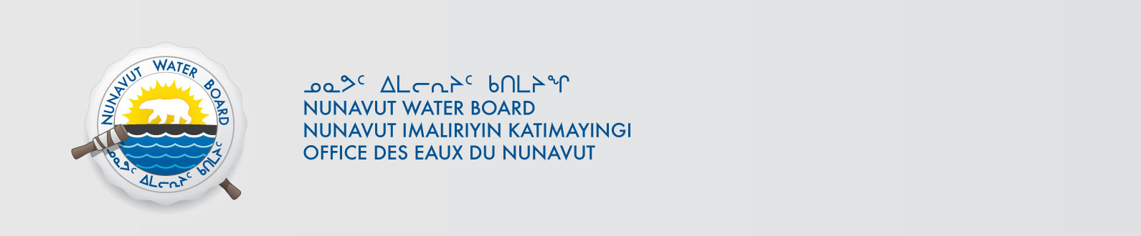

September 21, 2020 File No: 3BM-REP1520

To: Hamlet, CLARC, HTO, RIA, Coop, and NorthernLocal Organizations – Request to Post Notices

The Nunavut Water Board requests that you post on a bulletin board, until October 21, 2020, the attached notices (in English and Inuktitut), where they can be viewed by the public. The attached letter is for your information and does not require posting.

Your time and effort is greatly appreciated.

Sincerely,

Richard Dwyer

Cc: Hamlet of Naujaat (867) 462-4411
Mayor of Naujaat (867) 462-4411
KivIA (867) 462-4439
Ariq HTO (867) 462-4335
Northern Store (867) 462-4011
Naujat Co-op (867) 462-4152

