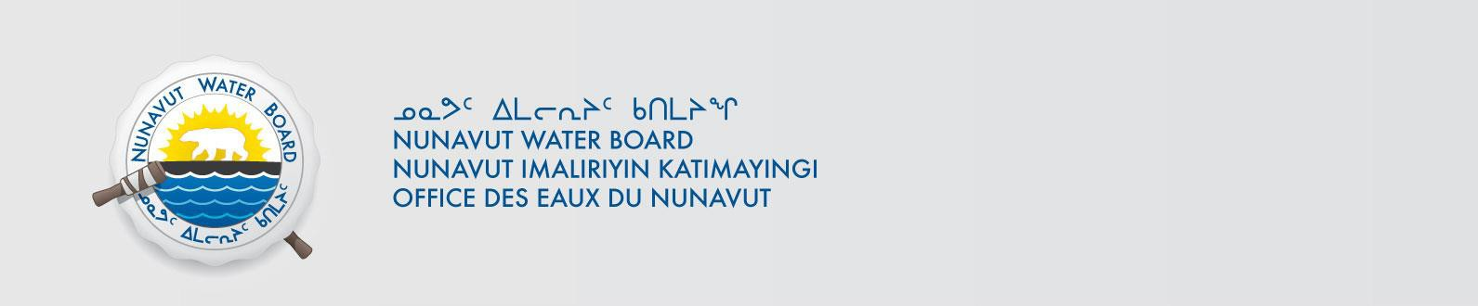

PUBLIC NOTICE OF AMENDMENT APPLICATION
Hamlet of Naujaat

Pursuant to Section 55(1) of the Nunavut Waters and Nunavut Surface Rights Tribunal Act
(“Act”), notice is given that Hamlet of Naujaat filed an application for an Amendment to water licence with the Nunavut Water Board (“NWB”) to use water or deposit of waste into water for the following project:

File #: 3BM-NAU2126
Project: Municipal Water Use
Location: Latitude: 66º31’N; Longitude: 86º14’W
Purpose: Municipal
Type: “B”

Interested persons are invited to make representations on or before February 3, 2023 to: Manager of Licensing
Nunavut Water Board
P.O. Box 119, Gjoa Haven, Nunavut X0B 1J0
Phone: (867) 360-6338; Fax: (867) 360-6369; E-mail: licensing@nwb-oen.ca

Copies of all application documents may be obtained by affected parties, free of charge, through the internet on our ftp site at the following link:

ftp://rdwyer@ftp.nwb-oen.ca/registry/3%20MUNICIPAL/3B/3BM%20-%20Municipality/3BM-NAU2126/1%20APPLICATION/2022%20Amendment

or by contacting:
Sandra Clark, SAO Hamlet of Naujaat
Phone: (867) 462-9952;
E-mail: saonaujaat@qiniq.com

Failure to respond to this Notice of Application within the specified period shall result in the loss of the right to be compensated, pursuant to Sections 58 to 61 of the Act.

CURRENT DATE: January 3, 2023

