Desktop Review on the Sustainability of Nunavut’s Drinking Water Sources

Prepared for:
Community and Government Services (CGS)
Government of Nunavut
P.O.Box 1000 STN 700
4th Floor, W.G. Brown Building
Iqaluit, NU X0A 0H0



February 1, 2017

Prepared by:
Centre for Water Resources Studies
Dalhousie University
1360 Barrington St. D514
Halifax, NS B3H 4R2

Table of Contents
Table of Contents iii
List of Figures v
List of Tables vi
List of Abbreviations vii
Executive Summary viii
1. Introduction 1
1.1 Project Scope 1
1.2 Project Background 1
1.3 Project Objectives 3
1.4 Study Limitations 3
2. Methodology 4
2.1 Study Site Descriptions and Overview of Approach 4
2.2 Watershed Delineation 7
2.3 Historical Water Use 8
2.4 Projected Water Use 8
2.5 Historical Climate Data 9
2.6 Evapotranspiration 11
2.7 Water Budget Calculations 12
2.7.1 Water Availability Indicator 12
2.8 Verification of PET Estimates and Assessment of Maintenance Flow 13
2.9 Future Climate Projections 15
2.9.1 GCM Selection 15
2.9.2 RCP Analysis 15
2.9.3 Selection of Study Periods 16
2.10 Statistical Analysis 16
2.10.1 Median and 50-Year Return Periods Minimum Computations 16
2.10.2 Mann-Kendall Test 17
3. Results 18
3.1 Hydrological Settings 18
3.2 Water Availability 18
3.2.1 Summary of Availability Using Median Values 18
3.2.2 Summary of Availability Using 50-Year Return Period Minimum Values 20
3.3 Climate Projection Verification 26
3.3.1 Statistical Trends 26
3.3.2 Comparison of GCM and Historical Datasets 27
3.4 Hydrometric Station Analysis 27
3.4.1 Inter-seasonal Variability in River Discharge 27
3.4.2 Operational Days Based upon Fisheries Maintenance Flows 28
3.4.3 Permissible Withdrawals 28
3.4.4 Verification of PET 29
3.4.5 Water Use versus Permissible Withdrawals 30
3.5 Overall Risk Assessment 31
4. Conclusions 35
References 36

List of Figures
Figure 1. Map of the communities in Nunavut. 6
Figure 2. Climate station locations in relation to the study sites. 10
Figure 3. Location of study sites in relation to the hydrometric stations. 14
Figure 4. Four RCPs for climate modeling according to IPCC (2014). 16
Figure 5: Watershed areas for each of the study sites. 18
Figure 6. Historic water shortage threat level map based on 50-yr probability estimates. 23
Figure 7. Projected water shortage threat map for 2016 - 2040 based on 50-yr probability estimates. 24
Figure 8. Projected water shortage threat map for 2041 - 2070 based on 50-year probability estimates. 25
Figure 9. Statistical trends in historical precipitation datasets from Environment Canada. 26
Figure 10. Statistical trends in evapotranspiration based on historical data. 27
Figure 11: Inter-seasonal variability in discharge values for 2010 used for the Cambridge Bay site (Freshwater Creek 10TF001 ). 28
Figure 12: Inter-Annual Variability in Average Daily Permissible Withdrawal Rates for Cambridge Bay. 29
Figure 13: Water demand versus worst case permissible withdrawal considering fisheries maintenance flow constraints. 30
Figure 14: Projected 2070 water use versus permissible withdrawal considering fisheries maintenance flow requirements. 31
Figure 15. Pie-charts showing the distribution of risk levels for the 26 source water locations according to median water balance values (all are trucked except Rankin Inlet and Resolute). 32
Figure 16. Pie-charts showing the distribution of risk levels for the 26 source water locations according to the 50-year return periods (all are trucked except Rankin Inlet and Resolute). 32

List of Tables
Table 1. Community information including current and future populations and source water characteristics. 4
Table 2. Specifications for the watershed delineation inputs. 7
Table 3. Study sites and corresponding climate stations. 9
Table 4. Comparison of the results obtained from the methods for PET estimation. 11
Table 5. Assumptions for the Priestley-Taylor PET method. 11
Table 6. Water availability threat classifications (OECD, 2009). 13
Table 7. Study sites and corresponding hydrometric stations. 15
Table 8. Water shortage threat levels based on median water availability estimates. 19
Table 9: Water shortage threat levels based on 50-year return period minimums. 21
Table 10. Number of operational days based on DFO maintenance requirements. 28
Table 11. Permissible average daily withdrawal rates based on DFO requirements. 29
Table 12. Comparison of annual estimates of PET with water balance estimates from hydat data. 30
Table 13. Summary of communities which have risk of water stress based on water availability indicator. 34

List of Abbreviations
BCCAQ Bias Correction/Constructed Analogues with Quantile mapping reordering
CWRS Centre for Water Resources Studies
DEM Digital elevation model
DFO Department of Fisheries and Oceans
ET Evapotranspiration
GCM Global Climate Model
GEV General Extreme Value
GN Government of Nunavut
IPCC Intergovernmental Panel on Climate Change
MAD Mean Annual Discharge
OECD Organization for Economic Cooperation and Development
PET Potential Evapotranspiration
PCIC Pacific Climate Impacts Consortium
RCP Relative Concentration Pathway
RWU Residential Water Use
WAI Water Availability Indicator

Executive Summary
The Canadian arctic territory of Nunavut is comprised of 25 small (< 10,000 people) communities distributed throughout an area of approximately 1.9 million km². The entire territory is located in the zone of continuous permafrost, and lacks ground based transportation infrastructure (roads or railways) linking the communities to each other, or to southern regions of Canada. These factors result in significant challenges in building and operating community water infrastructure. Every community in Nunavut currently relies on surface water sources for potable water supply. Water is either extracted directly from a lake or river for treatment and delivery to residents, or pumped to reservoirs during the ice-free period in the short arctic summer. The reservoirs are sized to store water required for the entire year. Due to the remote location of many of these communities, it would be extremely challenging to respond to a scenario in which the surface water sources provided inadequate quantities of water for a community during a dry year. Recent events in Igloolik have illustrated the challenges associated with responding to water supply shortages. The Government of Nunavut recognized a need to conduct a comprehensive assessment of water availability across the territory, which accounted for climate change and population growth.
The Centre for Water Resources Studies at Dalhousie University has completed a hydrologic analysis of the water supply systems in all Nunavut communities, excluding the capital City of Iqaluit. For each community, contributing watershed areas were delineated, and a water budget model was used to predict water availability using historical climate data, and projected future climate data generated from downscaled Global Circulation Model (GCM) output. A water availability index (WAI) was computed for each community for both historical and future climate scenarios, accounting for population growth, and varying per capita water usage rates. The 24 communities were then ranked according to the WAI to provide guidance on prioritizing water supply upgrades.
Based on the water balance analysis there are some communities which currently have, or may experience, water stress as a result of community demands and climate change. The risk of water shortage was assessed based on median water balance estimates, as well as 50-year return period minimum water availability estimates. The 50 year return period estimates provide a more realistic understanding of which communities may be at risk at some point in the future. A total of 8 communities were classed as high risk for water stress using historical climate records, and 7 were classed as high risk using future climate projections, when the 50 year probability low precipitation and high ET scenarios are considered, along with no changes in water delivery system. The eight communities where high water stress was observed using historical records included Arctic Bay, Cambridge Bay, Cape Dorset, Clyde River, Igloolik, Rankin Inlet (Nipissar), Whale Cove (Preferred Water Withdrawal Location), and Taloyoak. When future conditions were considered, Arctic Bay was downgraded to medium risk due to higher precipitation. Small watershed size (< 1000 ha) was observed to be the primary factor contributing to the level of risk.

Municipal infrastructure planning should take into the consideration the results of this analysis and allocate resources with efforts to reduce risks of high, medium, and moderate source water sites, in sequential order. In some cases, it may be necessary to site alternative back-up source water supplies in communities where the risk of water shortage is particularly high. This assessment provided a high-level desktop methodology with limitations for ranking risk of water scarcity in multiple communities with consideration for changing climate and demographics. This type of planning tool will be useful for managers of territorial drinking water infrastructure and may be translatable to other northern Canadian jurisdictions.

Introduction

Project Scope
This study was initiated to understand drinking water availability challenges, and uncertainty in the sustainability of future withdrawal quantities for community water supplies in the Territory of Nunavut. The study was requested by the Community and Government Services Department and the Department of Health within the Government of Nunavut (GN) and conducted by the Centre for Water Resources Studies (CWRS) at Dalhousie University. The territorial government expressed interest in identification of communities that may be susceptible to water shortages in the future with consideration for changing climate and demographics. This study included analysis of drinking water availability in all communities in Nunavut, with the exception of Iqaluit. This type of planning tool will be useful for managers of territorial drinking water infrastructure and may be translatable to other northern Canadian jurisdictions. This report is a deliverable of a broader project conducted by CWRS which provides recommendations to inform the development of new regulations to govern drinking water treatment standards in Nunavut. The scope of this project is limited to a desktop study using readily available datasets from territorial and federal government sources.

Project Background
The territory of Nunavut covers a large expanse of the Canadian arctic of approximately 1.9 million km² (Statistics Canada, 2012). There are twenty-five communities in Nunavut, which are sparsely distributed across the territory (Figure 1). Each community is relatively small with populations of generally less than 2,500 people, with the exception of Iqaluit (6,700) (Government of Nunavut, 2012). Notably, there are no roads connecting communities to each other or to the south; therefore all transport of goods and materials is via aircraft, and cargo ships during the ice-free season. As a result, the construction of drinking water infrastructure is relatively expensive and more challenging compared to southern Canada due to the remote geographic locations of many communities.
Further pressures on the provision of safe and ample drinking water include the extreme climatic conditions characteristic of Nunavut. Source water is extracted solely from surface water rivers and lakes in Nunavut. Typically, the ice-free season on freshwater rivers and lakes spans a short 3 to 4 month period from approximately June until September or October. This short season generally constrains when drinking water can be collected and stored for the community’s supply requirements for an entire year. Drinking water is collected from source locations and commonly stored in reservoirs before treatment and distribution. Another challenge associated with the provision of drinking water in Nunavut includes the presence of continuous permafrost, which hinders the use of buried infrastructure; therefore the majority of communities are reliant of water delivery trucks to convey treated drinking water to each individual household and establishment (Smith, 1996). Residents in Nunavut’s communities typically use much less water than residents in Southern Canada—approximately 100 L per capita per day in comparison to 330 L per capita per day (Daley et al., 2014). This is partly due to the inherent capacity challenges associated with conveyance of drinking water with a trucked distribution system.
In recent years, there has been research focused on drinking water quality in arctic communities (Dudarev et al., 2000; Goldfarb et al, 2013). There has been less focus on the quantity and provisions of adequate drinking water within arctic communities (Daley et al., 2014). However, Daley et al. (2014) identified that recent research frameworks on water security have highlighted the importance of the provision of adequate drinking water quantities, in addition to water quality (Loring et al., 2013; Bakker, 2012; Cook & Bakker, 2012).
In Nunavut specifically, there have been a few recent challenges associated with drinking water supply quantities. Notably, the hamlet of Igloolik experienced water shortages in 2015 due to a frozen water reservoir and cold spring (Nunatsiaq News, 2015). Residents of Grise Fiord (pop. 150) expressed concern with the long-term sustainability of their source water supply due to their secondary source being a glacier-fed stream (CBC, 2014). To further investigate this risk, Arktis Piusitippaa Inc. (2015) conducted a desktop assessment of the secondary drinking water source in Grise Fiord and concluded that the potential for further glacier melt presents threatens the long-term sustainability of this source of drinking water. Furthermore, saltwater intrusion—which is both a quality and quantity issue—into the source drinking water supplies has been problematic in both Kugaaruk and Sanikiluaq (CBC, 2016; CBC, 2012).
Climate change poses new uncertainties in the future availability of source water for communities in Nunavut. On a global scale, the Intergovernmental Panel on Climate Change (IPCC) reports that with consideration for future changes in the climate, the availability of reliable surface freshwater supplies is anticipated to decrease. This decrease in surface water availability is expected due to increased variability in river hydrology, as a result of variability in precipitation, and decreased snow and ice accumulation throughout the winter months (IPCC, 2014) More specifically in high latitude environments characteristic of the arctic, the precipitation is projected to increase; however, water shortages may still be anticipated due to the increased variability in river hydrology. In addition, higher average ambient air temperatures are projected to increase the rate of evaporation from freshwater lakes and water storage reservoirs and evapotranspiration from the tundra landscape; hence placing further pressures on the water resources in arctic regions (IPCC, 2014).
Additional considerations for sustainable withdrawal of source water includes maintenance flow requirements for fish passage, which are set by the Department of Fisheries and Oceans (DFO). According to the DFO (2013), the maximum amount of water withdrawal from a river cannot exceed 30% of the mean annual discharge (MAD) at any given time, and not more than 10% of the instantaneous river flow at any given time. These minimum requirements for fish passage set further constraints on the availability of source water for communities in Nunavut and should be considered within the assessment of water availability.

Project Objectives
The objectives of this task of the project were to:
- assess the long-term sustainability of water withdrawals from the drinking water source locations in all of the Nunavut’s 24 hamlets; and
- rank the communities in terms of relative risk levels for water scarcity.

Study Limitations
There were a few limitations to this study, and its ultimate accuracy which included that:
- this study was limited to a desktop environment; therefore, many assumptions had to be made to generate the risk ranking;
- the climate datasets were at times sparse and had to be adopted from the nearest weather station to the community; which at times may be distant;
- the statistically down-scaled climate change projections are computer model generated estimates and dependent on assumptions regarding the relative concentration pathway (RCP);
- No consideration was given to permafrost melt and the possible changes to the water balance due to uncertainty in timing and effect of this process;
- It was assumed that the source water locations in each community were not glacial fed, which was confirmed based on satellite imagery; however, this may not have been the case for the community in Pangnirtung. This was considered to be a conservative assumption;
- For lake sources, the volume of freshwater stored in the lake was not considered. This was considered to be a conservative assumption; and
- Iqaluit was not included in the assessment.

Methodology

Study Site Descriptions and Overview of Approach
This study examines 24 communities located in Nunavut. Table 1 below provides location, population, and water supply information for each community. Community locations are illustrated in Figure 1. For each community, the assessment process first consisted of delineating the contributing watershed area of the source water extraction point. An annual water balance was then computed for each source watershed using available meteorological data from the nearest Environment Canada Climate Station. The water balance computations were then repeated using statistically downscaled future climate projections. A water availability indicator was used to characterize and rank the risk of water shortage in each community based on the water balance results. Finally, the impact of fisheries maintenance flow requirements on water availability was assessed in a select number of communities where continuous discharge data was available.
Table 1. Community information including current and future populations and source water characteristics.
Community | Coordinates | Population |  |  | Water Source | Water Supply
Community | Coordinates | 2011 Censusª | 2040 Projected | 2070 Projected | Water Source | Water Supply
Arctic Bay | 73°02’11”N 085°09’09”W | 823 | 1,111 | 1,170 | Marcil Lake | Trucked
Arviat | 61°06’29”N 094°03’25”W | 2,318 | 4,477 | 9,067 | River | Trucked
Baker Lake | 64°19’05”N 096°01’03”W | 1,872 | 3,076 | 4,751 | Baker Lake | Trucked
Cambridge Bay | 69°07’02”N 105°03’11”W | 1,608 | 2,048 | 2,578 | Lake | Trucked
Cape Dorset | 64°13’54”N 076°32’25”W | 1,363 | 2,027 | 2,908 | Lake | Trucked
Chesterfield Inlet | 63°20’27”N 090°42’22”W | 313 | 535 | 798 | Lake | Trucked
Clyde River | 70°28’26”N 068°35’10”W | 934 | 1,504 | 2,385 | Lake | Trucked
Coral Harbour | 64°08’13”N 083°09’51”W | 834 | 1,594 | 3,062 | River | Trucked
Gjoa Haven | 68°37’33”N 095°52’30”W | 1,279 | 1,842 | 2,643 | Lake | Trucked
Grise Fiord | 76°25’03”N 082°53’38”W | 130 | 171 | 201 | Snowmelt runoff | Trucked
Hall Beach | 68°46’38”N 081°13’27”W | 546 | 1,455 | 2,722 | Lake | Trucked
Igloolik | 69°22’34”N 081°47’58”W | 1,454 | 2,949 | 4,775 | Lake | Trucked
Kimmirut | 62°50’48”N 069°52’07”W | 455 | 568 | 690 | Lake | Trucked
Kugaaruk | 68°31’59”N 089°49’36”W | 771 | 1,320 | 1,984 | River | Trucked
Kugluktuk | 67°49’32”N 115°05’42”W | 1,450 | 1,904 | 2,355 | River | Trucked
Naujaat | 66°31’19”N 086°14’06”W | 945 | 1,997 | 4,627 | Lake | Trucked
Pangnirtung | 66°08’52”N 065°41’58”W | 1,425 | 2,144 | 2,483 | Duval River | Trucked
Pond Inlet | 72°41’57”N 077°57’33”W | 1,549 | 2,515 | 4,220 | Lake | Trucked
Qikiqtarjuaq | 67°33’29”N 064°01’29”W | 520 | 597 | 692 | River | Trucked
Rankin Inlet | 62°48’35”N 092°05’58”W | 2,266 | 4,102 | 6,545 | River & Lake | Piped
Resolute | 74°41’51”N 094°49’56”W | 214 | 287 | 341 | Char Lake | Piped
Sanikiluaq | 56°32’34”N 079°13’30”W | 812 | 1,408 | 2,397 | Lake | Trucked
Taloyoak | 69°32’13”N 093°31’36”W | 899 | 1,424 | 2,212 | Canso Lake | Trucked
Whale Cove | 62°10’22”N 092°34’46”W | 407 | 653 | 1,021 | Lake | Trucked
ª(Government of Nunavut, 2012).
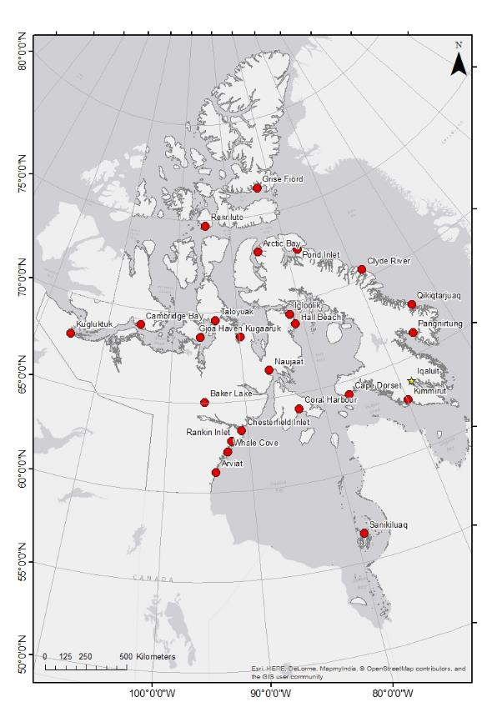
Figure 1. Map of the communities in Nunavut.

Watershed Delineation
Study site watersheds were delineated using ArcGIS using data obtained from Natural Resources Canada – GeoGratis (Government of Canada, 2016a). The Geospatial Data Extraction tool was used to download digital elevation models (DEM) and hydro topography with the specifications outlined in Table 2.
Table 2. Specifications for the watershed delineation inputs.
Elevation data
 | Input | Specification
 | DEM | GeoTiff
 | Datum | NAD83-CSR
 | Projection | Geographic
 | Output format | File Geodatabase (10.1)
Topographic data
 | Input | Specification
 | Datum | NAD83-CSR
 | Projection | Geographic
 | Scale | 1: 50,000
 | Clip data | Yes

To minimize distortion, all data was projected in the UTM zone the community is situated in, (e.g. NAD 1983 UTM Zone 15N). The Project Raster tool was used to transform the DEM, and the Project tool was used to transform the Hydro data (water_linear_flow_1).
Arc Hydro was used to complete terrain preprocessing steps in the following order (Maidment, 2002):
- DEM Manipulation > DEM Reconditioning
- DEM Manipulation > Fill Sinks
- Flow Direction
- Flow Accumulation
- Stream Definition
- Stream Segmentation
- Catchment Grid Delineation
- Catchment Polygon Processing
- Drainage Line Processing
- Adjoint Catchment Processing
- Drainage Point Processing
The Point Delineation feature was used to create the watershed. Flowing watercourses were delineated at the designated intake point, while lakes were delineated using the lake outlet, such that the entire contributing area of the lake was included. The polygon was edited to include any water storage bodies it intersected. Polygon area was available in the attribute table and automatically updated, as Arc Hydro saves the output as a feature class in a file geodatabase.
Due to the nature of the topography and the quality of DEM available, some watersheds could not be delineated using Arc Hydro. Grise Fiord and Sanikiluaq were delineated manually using topographic maps. The Baker Lake watershed was too large to delineate; thus the Thelon River drainage basin was used from the Atlas of Canada. The Atlas of Canada National Frameworks Hydrology data (Natural Resources, 2003) provides shapefiles for drainage area boundaries on a sub-sub-basin level. The Thelon River sub-drainage basin pictured in the Atlas of Canada consists of sub-sub-basins for the Kazan, Dubawnt, and Thelon rivers. These sub-sub-basins were augmented with an additional polygon to include the contributing area immediately surrounding Baker Lake.

Historical Water Use
The annual historical water values were calculated considering the most recent population according to census data. These water use values were held constant throughout the hindcast water budget calculations to provide a conservative estimate of water availability based on the historical datasets. The census data from the GN was used to obtain the most recent population estimate for each community (Government of Nunavut, 2012). Assumptions of per capita water use of 90 and 225 litres per person per day for trucked and piped water delivery systems based on Smith (1996) were used. To verify the validity of the water use assumptions, the annual water use estimates were compared to the annual hamlet reports provided to the Nunavut Water Board.

Projected Water Use
The projected water usage from 2014 to 2035 was determined based on population projections available from the Government of Nunavut (Government of Nunavut, 2014). The population growth rate from 2014 to 2035 was calculated and used to project the populations to 2070. Equation 1 was used to calculate the population growth rate from 2035 to 2070 for each of the communities.
 | $$P_{gr}=\frac{P_{35}-P_{14}}{n}$$ | [Eq.1]

Where $P_{gr}$ is the population growth rate, $P_{35}$ is the population projection for 2035, $P_{14}$ is the population projection for 2014 and $n$ is the number of years between $P_{35}$ and $P_{14}$.
The annual projected water usage for each community, based upon the calculated population and residential water use, was then determined using the Equations 2 and 3 from Heinke et al (1991). The residential water use (RWU) was assumed to be 90 litres per person per day for trucked water, and 225 litres per person per day for piped water as provided by Smith (1986).
For a population size of 0 to 2,000 people, the total water use per capita was estimated using:
 | $$RWU×\left[1.0+\left(0.00023×P\right)\right]$$ | [Eq.2]
For a population size of 2,000 to 10,000 people, the total water use per capita was estimated using:
 | $$RWU×\left[-1.0+\left(0.323×\ln{P}\right)\right]$$ | [Eq.3]
where P is population.

Historical Climate Data
Historical climate data was downloaded from the Environment Canada historical climate data website (Government of Canada, 2016a). Bulk downloads of multi-year datasets were performed according to the directions provided by Government of Canada (2015b). The statistical software package R was used to generate annual amounts of precipitation based on the historical climate records at each site. No data was reported when more than 30 consecutive days of data were missing from any given year. In addition, the monthly mean minimum, maximum, and mean temperature for each month were generated for each site with R statistical software. Weather stations are not situated in every community, therefore in these cases, the nearest weather station to the study site was used.
Table 3 indicates which climate station was used for each community, as well as the distance between the station and community, and the years of data available. Figure 2 shows the communities; climate station locations are designated with red pentagons.
Table 3. Study sites and corresponding climate stations.
Community | Climate Station Name | Distance to Community (km) | Number of Years of Historical Data
Arctic Bay | Arctic Bay CS | 7 | 28
Arviat | Arviat A/Climate | 1 | 29
Baker Lake | Baker Lake A/Climate | 3 | 63
Cambridge Bay | Cambridge Bay A/Climate | 3 | 69
Cape Dorset | Cape Dorset A/Climate | 1 | 30
Chesterfield Inlet | Rankin Inlet A | 90 | 34
Clyde River | Clyde River A/Climate | 3 | 55
Coral Harbour | Coral Harbour A | 11 | 68
Gjoa Haven | Gjoa Haven A | 1 | 29
Grise Fiord | Resolute Bay A/CS | 385 | 66
Hall Beach | Hall Beach A/Climate | 1 | 50
Igloolik | Hall Beach A/Climate | 70 | 50
Kimmirut | Iqaluit UA/Climate | 120 | 61
Kugaaruk | Kugaaruk Climate | 1 | 55
Kugluktuk | Kugluktuk Climate | 2 | 77
Naujaat | Coral Harbour A | 300 | 68
Pangnirtung | Qikiqtarjuaq A/Climate | 173 | 41
Pond Inlet | Pond Inlet A/Climate | 1 | 38
Qikiqtarjuaq | Qikiqtarjuaq A/Climate | 1 | 41
Rankin Inlet | Rankin Inlet A | 1 | 34
Resolute | Resolute Bay A/CS | 5 | 66
Sanikiluaq | Kuujjuarapik Climate | 168 | 67
Taloyoak | Taloyoak Climate | 2 | 43
Whale Cove | Rankin Inlet A | 1 | 34

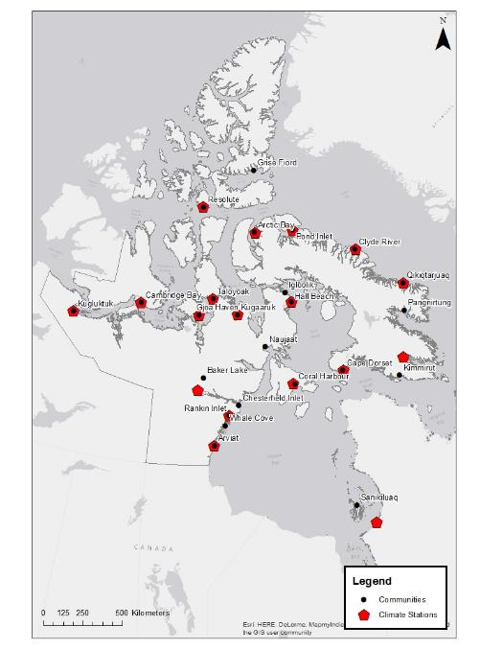
Figure 2. Climate station locations in relation to the study sites.

Evapotranspiration
Potential evapotranspiration (PET) was estimated using the Priestley and Taylor (1972) method according to Xu and Singh (2002). Additionally, the Hamon (1960) method—which is described in Dingman (2002)—was assessed for applicability for this study. The Hamon (1960) method is a temperature based method, whereas the Priestley-Taylor (1972) method also considers radiation. A comparison calculation was performed between the Hamon (1960) and Priestley-Taylor (1972) methods for Coral Harbour and compared to literature from Resolute. Table 4 summarizes the results of this comparison of the methods. The Priestley Taylor with measured solar radiation used global horizontal irradiance data from Environment Canada (Government of Canada, 2016a).
Table 4. Comparison of the results obtained from the methods for PET estimation.
PET Method | Community | Average (mm/year) | Maximum (mm/year) | Minimum (mm/year)
Hamon | Coral Harbour | 279 | 337 | 225
Priestley Taylor | Coral Harbour | 61 | 70 | 35
Priestley Taylor with measured solar radiation | Coral Harbour | 38 | 66 | 21
Priestley-Taylorª | Resolute | 46 | 61 | 39
ªData from Kane et al (1990).
Based on the results of the two methodologies, the estimates for PET obtained from the Hamon method were determined to be less reliable than the Priestley-Taylor method. This was concluded because of the relatively high PET rates in comparison to literature values for the North American arctic presented in Kane et al (1990). Therefore the Priestley-Taylor method was used to estimate PET for all the study sites.
Radiation data was estimated from temperature data from historical datasets and climate model projections. Assumptions for the Priestley-Taylor calculations are summarized in Table 5. The alpha value (α) was assumed to be 1.26, which is a common assumption when land conditions are wet or humid (Xu and Singh, 2002). Due to the typical arid conditions in the arctic, the alpha coefficient is occasionally adjusted by lowering the value in some cases. For instance, an alpha value of 0.95 was used to represent an upland lichen heath in a small Alaskan arctic watershed (Kane et al., 1990).
Table 5. Assumptions for the Priestley-Taylor PET method.
Parameter | Value | Units | Source
Specific heat of moist air | 1.013 | KJ/kg/°C | Xu and Singh (2002)
Ratio of molecular weight of water vapour/dry air | 0.622 |  | Allen et al (1998)
Solar constant | 0.082 | MJ/m²/min | Xu and Singh (2002)
Albedo | 0.155 |  | SNAP (2011)
Stefan-Boltzmann constant | 4.9x10⁻⁹ | MJ/K⁴/m²/d | Xu and Singh (2002)
Regression constant, a_{s} | 0.25 |  | Allen et al (1998)
Regression constant, b_{s} | 0.5 |  | Allen et al (1998)
α | 1.26 |  | Xu and Singh (2002)
The methodology that was followed for the Priestley-Taylor PET calculation is described in detail in Allen et al (1998) and Xu and Singh (2002).

Water Budget Calculations
The total annual water available was calculated by determining the volume of precipitation added to the watershed area, then subtracting the total volume of water lost from the watershed through evapotranspiration and total volume of water extracted for drinking water. Two extraction scenarios were considered which consisted of the trucked and piped water conveyance systems. This was completed to consider the water availability if a community switches to piped drinking water infrastructure in the future. Percolation to groundwater was assumed to be negligible due to permafrost. The water budget calculation is shown in Equation 4:
 | $$W_{a}=P-PET-W_{use}$$ | [Eq. 4]

Where $W_{a}$ is the water volume available after abstractions, $P$ is the precipitation volume, PET is the evapotranspiration volume, and $W_{use}$ is the water used for drinking water.

Water Availability Indicator
The Water Availability Indicator (WAI) is used by Environment Canada to assess water resources, and is based on the Water Stress Indicator developed by the Organization for Economic Cooperation and Development (OECD) (OECD, 2009). The WAI is determined by calculating the ratio of freshwater demand to freshwater supply as per Equation 5 (Environment Canada, 2011).
 | $$WAI= \frac{freshwater supply}{freshwater demand}×100$$ | [Eq. 5]

After the WAI is calculated, the threat to water availability is ranked using OECD’s scheme shown below in Table 6:

Table 6. Water availability threat classifications (OECD, 2009).
Risk Level | WAI | Description
High | > 40% | Severe water stress
Medium | 20% - 40% | Both water supply and water demand need to be managed; conflicts among competing uses will need to be resolved
Moderate | 10% - 40% | Water availability becomes a constraint on development; significant investment is needed to provide for adequate water supply.
Low | < 10% | Low water stress
Freshwater demand includes total municipal, industrial, and agricultural withdrawals (OECD, 2009); predicted trucked/piped community water demands are used in this study.

Verification of PET Estimates and Assessment of Maintenance Flow
A second verification on the validity of the PET estimates was performed using available historical hydrometric data (HYDAT database) from the Environment Canada Water Survey of Canada (Government of Canada, 2015b). Historical hydrometric datasets were downloaded for the closest sites to the study communities. Annual estimates of evaporation were determined based on the total annual precipitation over the water year minus the total cumulative flow exiting the watershed. This was completed by summing the daily flows measured at the hydrometric station over a monitoring season (e.g., approximately June to September). The summed daily flows over a season equates to a runoff volume from the watershed area of the hydrometric station. In addition, the daily precipitation for the water year were summed and multiplied by the watershed area of the hydrometric station. The water year spans from October 1st to September 30th for a given year. The total estimated ET was calculated with the following Equation 6:
 | $${ET}_{e}=\left(\frac{P_{vol}-Q_{vol}}{A_{hyd}}\right)*0.001$$ | [Eq.6]

Where: ${ET}_{e}$ is the estimated yearly evapotranspiration (mm/year), $P_{vol}$ is the precipitation volume for a water year, $Q_{vol}$ is the runoff volume for a monitoring season, and $A_{hyd}$ is the watershed area of the hydrometric station. This analysis was completed on three communities where the quantity and quality of discharge data was found to be sufficient for the analysis.
In addition, the hydrometric data was used to perform an analysis on the maintenance flows required to maintain ecological flow in the rivers. This was performed by pro-rating the discharge data from the nearest Environment Canada hydrometric station to a select number of study site watersheds where data was available. The 30% mean annual discharge (MAD) was calculated for each year of historical data according to DFO (2013). Periods where the 30% MAD exceeded the instantaneous flow rate were identified as periods when drinking water extraction was not favorable. Flows exceeding the 30% MAD were multiplied by 0.1 to find the permissible withdrawal rate (10% of the instantaneous flow). The mean daily permissible withdrawal rate (m³/day) was calculated with a 95% confidence interval. Additionally, the minimum, maximum, and average operational days were determined for each community. The annual permissible withdrawal volume was calculated by multiplying the average permissible daily withdrawal by the operational days that year.
The communities and corresponding hydrometric stations are displayed below in Figure 3 and Table 7. Stations were selected on the basis of proximity to the community, Figure 3 shows that all stations are relatively close to the community and should accurately depict the hydrological regime.
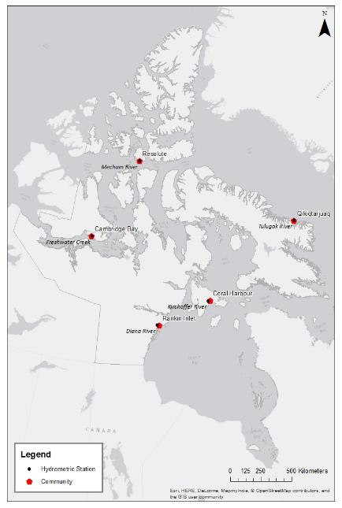
Figure 3. Location of study sites in relation to the hydrometric stations.
Table 7. Study sites and corresponding hydrometric stations.
Community | Contributing Area (km²) | Station Used | ID | Years of Data | Contributing Area (km²)
Rankin Inlet - Nipissar | 2.7 | Diana River | 06NC001 | 7 | 1460
Rankin Inlet - Char | 67.6 | Diana River | 06NC001 | 7 | 1460
Qikiqtarjuaq | 24.0 | Tulugak River | 10UE001 | 9 | 27.4
Resolute Bay | 4.1 | Mecham River | 10VC002 | 43 | 86.8
Cambridge Bay | 2.8 | Freshwater Creek | 10TF001 | 45 | 1490
Coral Harbour | 256.2 | Kirchoffer River | 06PA001 | 6 | 3160

Future Climate Projections
Assessment of future climate scenarios were performed using Global Climate Model (GCM) generated precipitation and temperature datasets. There are numerous GCMs available to generate projections of future climate conditions that are described in detail in IPCC (2014). The GCM datasets were sourced from the Pacific Climate Impacts Consortium (PCIC) based at the University of Victoria (PCIC, 2016). The PCIC provides statistically downscaled climate datasets for Canada.

GCM Selection
Four GCMs were selected to provide a range of possible future climate projections. The GCMs were selected based on the 12 models available through the PCIC portal. The number of GCMs were reduced from 12 to 4 by selecting the GCMs with the lowest observed bias for precipitation and temperature presented by Sheffield (2013). The four GCMs selected for the future climate projections were CCSM4-r2, CNRM-CM5-r1, CSIRO-Mk3-6-0-r1 and MRI-CGCM3-r1. The Bias Correction/Constructed Analogues with Quantile mapping reordering (BCCAQ) method was used for statistical downscaling of the GCMs to the sites.

RCP Analysis
Three representative concentration pathways (RCPs) (e.g., 2.6, 4.5 and 8.5) were assessed for generation of future climate projections for one site (Coral Harbour). These represent three different scenarios for future climate change based on carbon concentrations in the atmosphere. Figure 4 demonstrates the difference in the RCPs. For subsequent sites, a middle ground RCP of 4.5 was selected to simplify data analysis, and due to few observed differences in water availability between the RCP scenarios.
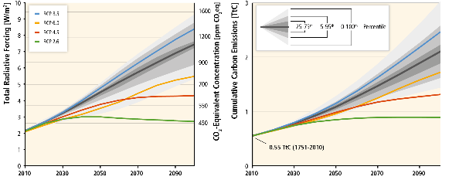
Figure 4. Four RCPs for climate modeling according to IPCC (2014).
The GCM historical and projected datasets generated at three different RCPs were generally similar. There were also no obvious trends in water availability in correlation with RCP for the period ranging from 2016 - 2040. However, there is a slight increase in water availability with RCPs 4.5 and 8.5 later in the century (2040 – 2070). This trend reflects the RCPs trends projected in the IPCC (2014); whereby the RCPs notably diverge in carbon concentrations post 2030 (Figure 4). Since the results between the three RCPs were quite similar this provides justification for selection of only one RCP for subsequent calculations associated with the other communities. Based on this analysis it was concluded that a middle ground RCP of 4.5 is used for subsequent communities.

Selection of Study Periods
Three study periods were selected to run the water budget analysis. These periods consisted of 1950 to 2015 (historical), 2016 – 2040, and 2041 – 2070. Hindcast GCM datasets (i.e., 1950 – 2015) were compared to historical climate data to verify the validity of the future climate projections. These study periods were selected to provide verification of past known climatic conditions at the sites (i.e., past 65 years), to generate projections of near-term water availability for infrastructure planning decisions (i.e., 25-year planning horizon) and to verify far-term projections of water availability (i.e., 25 – 50-year planning horizon).

Statistical Analysis

Median and 50-Year Return Periods Minimum Computations
The median water availability and 50-year return periods for annual minimum precipitation and annual maximum ET were determined for each of the three study periods, the historical dataset and for each GCM modeled dataset. EasyFit 5.6 Professional statistical software was used to fit the annual time series to chosen probability distributions. The 50-year return period minimum precipitation was calculated by fitting each dataset to a lognormal probability density function. The 50-year return period maximum ET was calculated by fitting each dataset to a general extreme value (GEV) probability density function.

Mann-Kendall Test
A Mann-Kendall statistical test was performed on the historical datasets of precipitation and estimated evapotranspiration, as well as, each of the hindcast climate datasets. The null hypothesis, which assumed a trend, was tested at 95% confidence level for precipitation and evapotranspiration for all communities with complete datasets (historical, CCSM4, CNRM, CSIRO, MRI). This test was performed to verify whether the time series trends had statistically significant decreases, increases, or neutrality. This was then compared to the hindcast climate projections from the PCIC datasets to verify for consistency in climate trends. The Mann-Kendall tests were performed with MATLAB R2015b and Microsoft Excel 2013 software packages according to the method described in Gocic and Trajkovic (2013). In order to be used in the statistical assessment, criteria were applied which consisted of: a minimum dataset length of 30 years; no more than 3 consecutive years of data missing, for a maximum of two occurrences; and a dataset which spans until at least the year 2000.

Results

Hydrological Settings
A variety of factors, such as topography, soil type, land use, and climate, can impact water availability, however the driving factor behind water availability in this study is watershed area. A large contributing area (e.g., Baker Lake watershed) will yield more water than a small contributing area (e.g., Igloolik watershed). The study site watersheds delineated in this study ranged in area from less than 8 ha to 240,000 km², as shown in Figure 5. Vulnerability of source water availability corresponds largely with watershed area and will increase as the watershed area decreases. The watershed maps for each of the study sites are included in Appendix A.

Figure 5: Watershed areas for each of the study sites.

Water Availability

Summary of Availability Using Median Values
The median water availability indicator, in percentage, was calculated for each scenario and for each community based upon the ratio of water demand to water availability. A risk level was then applied to each scenario and the highest percentage for each of the three study periods was identified in order to remain conservative. The results are displayed in Table 8. The detailed tables describing the median water balance results for each study site are presented in Appendix B.
Table 8. Water shortage threat levels based on median water availability estimates.
Legend
High |  |  |  | Medium |  |  |  | Moderate |  |  |  | Low
Community |  |  | Water Availability Indicator (%)
 |  |  | Historical |  |  |  | 2016-2040 |  |  |  | 2041-2070
 |  |  | Trucked |  | Piped |  | Trucked |  | Piped |  | Trucked |  | Piped
Arctic Bay |  |  | <1 |  | 1.1 |  | <1 |  | <1 |  | <1 |  | <1
Arviat |  |  | <1 |  | <1 |  | <1 |  | <1 |  | <1 |  | 1.1
Baker Lake |  |  | <1 |  | <1 |  | <1 |  | <1 |  | <1 |  | <1
Cambridge Bay |  |  | 35 |  | 89 |  | 29 |  | 73 |  | 39 |  | 96
Cape Dorset |  |  | 30 |  | 75 |  | 44 |  | 111 |  | 67 |  | 168
Chesterfield Inlet |  |  | <1 |  | <1 |  | <1 |  | 1.2 |  | <1 |  | 1.9
Clyde River |  |  | 40 |  | 101 |  | 61 |  | 152 |  | 90 |  | 225
Coral Harbour |  |  | <1 |  | <1 |  | <1 |  | <1 |  | <1 |  | <1
Gjoa Haven |  |  | 5.5 |  | 14 |  | 9.4 |  | 18 |  | 13 |  | 29
Grise Fiord |  |  | 13 |  | 32 |  | 16 |  | 39 |  | 16 |  | 41
Hall Beach |  |  | 1.4 |  | 3.4 |  | 3.5 |  | 8.8 |  | 7.0 |  | 18
Igloolik |  |  | 27 |  | 67 |  | 66 |  | 166 |  | 108 |  | 269
Kimmirut |  |  | <1 |  | 1.6 |  | <1 |  | 1.8 |  | 1.4 |  | 2.1
Kugaaruk |  |  | <1 |  | <1 |  | <1 |  | <1 |  | <1 |  | <1
Kugluktuk |  |  | <1 |  | <1 |  | <1 |  | <1 |  | <1 |  | <1
Naujaat |  |  | <1 |  | 1.7 |  | 1.5 |  | 3.9 |  | 5.2 |  | 11
Pangnirtung |  |  | <1 |  | <1 |  | <1 |  | 1.5 |  | <1 |  | 1.6
Pond Inlet |  |  | 1.6 |  | 3.9 |  | 2.9 |  | 7.3 |  | 4.3 |  | 11
Qikiqtarjuaq |  |  | <1 |  | 1.1 |  | <1 |  | 1.2 |  | <1 |  | 1.5
Rankin Inlet | Char |  | <1 |  | 1.9 |  | 1.6 |  | 3.9 |  | 2.7 |  | 6.6
Rankin Inlet | Nipissar |  | 19 |  | 47 |  | 39 |  | 98 |  | 67 |  | 167
Resolute |  |  | 2.0 |  | 4.9 |  | 1.8 |  | 4.4 |  | 1.9 |  | 4.7
Sanikiluaq |  |  | <1 |  | <1 |  | <1 |  | 1.7 |  | 1.6 |  | 3.0
Taloyoak |  |  | 10 |  | 25 |  | 18 |  | 45 |  | 27 |  | 69
Whale Cove | Main |  | 2.8 |  | 7.1 |  | 4.9 |  | 12 |  | 7.9 |  | 20
Whale Cove | Preferred |  | 85 |  | 213 |  | 146 |  | 365 |  | 239 |  | 598
Based upon the median water availability, approximately 33% of the study sites displayed the potential for severe water stress sometime between 1950 and 2070, with approximately 21% of the study sites displaying a water demand that exceeded 100% of the water available. In addition, 25% of the communities displayed a medium risk for water availability, and approximately 33% of the communities displayed a moderate risk for water availability during at least one of the study periods examined. Over 50% of the communities were determined to have a low water stress level throughout the entirety of the study period.
The most obvious contributing factor to the risk level was the size of the watershed utilized for source water. The seven communities displaying years with a water demand over 40% of the total water available (high risk) were also determined to be the study sites withdrawing from watersheds with the smallest surface areas. The study sites of concern withdrew from watersheds ranging in size from 8 to 330 hectares (ha). Whale Cove (Preferred Withdrawal Location) displayed the most concerning water availability ratios and possessed the smallest watershed with an area of just 8 ha, while the community of Baker Lake utilized less than 1% of the water available and withdrew from the largest watershed at 24,000,000 ha. Study sites withdrawing from a watershed with an area over 940 ha generally displayed low water stress levels, with the exception of Pond Inlet (3,739 ha) which displayed moderate stress levels between 2041 and 2070; the decrease in water availability for this time period is largely due to the increase in water demand.
Climate trends throughout the three study periods generally appeared to show an increase in both precipitation and evapotranspiration with time, but did not appear to have a significant impact on water availability.

Summary of Availability Using 50-Year Return Period Minimum Values
The water availability indicator was also calculated as discussed in Section 3.2.1 while using 50-year low precipitation and 50-year high evapotranspiration values in place of median values. The risk level was applied to the most conservative value for each time period, as shown in Table 9. The detailed tables describing the 50-year return period results for each study site are presented in Appendix C.

Table 9: Water shortage threat levels based on 50-year return period minimums.
Legend
High |  |  |  | Medium |  |  |  | Moderate |  |  |  | Low
Community |  |  | Water Availability Indicator (%)
 |  |  | Historical |  |  |  | 2016-2040 |  |  |  | 2041-2070
 |  |  | Trucked |  | Piped |  | Trucked |  | Piped |  | Trucked |  | Piped
Arctic Bay* |  |  | 100 |  | 100 |  | <1 |  | 1.6 |  | <1 |  | 1.3
Arviat |  |  | <1 |  | <1 |  | <1 |  | <1 |  | <1 |  | 1.8
Baker Lake |  |  | <1 |  | <1 |  | <1 |  | <1 |  | <1 |  | <1
Cambridge Bay |  |  | 97 |  | 244 |  | 88 |  | 221 |  | 91 |  | 229
Cape Dorset |  |  | 51 |  | 127 |  | 74 |  | 185 |  | 117 |  | 292
Chesterfield Inlet |  |  | 1.1 |  | 2.8 |  | 1.1 |  | 2.9 |  | 1.7 |  | 4.2
Clyde River |  |  | 245 |  | 612 |  | 124 |  | 310 |  | 168 |  | 421
Coral Harbour |  |  | <1 |  | <1 |  | <1 |  | <1 |  | <1 |  | 1
Gjoa Haven |  |  | 16 |  | 41 |  | 28 |  | 54 |  | 29 |  | 63
Grise Fiord |  |  | 39 |  | 97 |  | 32 |  | 80 |  | 30 |  | 76
Hall Beach |  |  | 3.7 |  | 9.3 |  | 7.0 |  | 18 |  | 13 |  | 31
Igloolik |  |  | 51 |  | 129 |  | 132 |  | 330 |  | 193 |  | 483
Kimmirut |  |  | 1.2 |  | 3.0 |  | 1.1 |  | 2.8 |  | 2.1 |  | 3.1
Kugaaruk |  |  | <1 |  | <1 |  | <1 |  | <1 |  | <1 |  | <1
Kugluktuk |  |  | <1 |  | <1 |  | <1 |  | <1 |  | <1 |  | <1
Naujaat |  |  | 1.2 |  | 3.1 |  | 2.8 |  | 7.0 |  | 8.1 |  | 17
Pangnirtung |  |  | <1 |  | 1.9 |  | 1.3 |  | 3.1 |  | 1.4 |  | 3.6
Pond Inlet |  |  | 5.1 |  | 13 |  | 5.1 |  | 13 |  | 8.4 |  | 21
Qikiqtarjuaq |  |  | <1 |  | 2.3 |  | 1.1 |  | 2.6 |  | 1.2 |  | 2.9
Rankin Inlet | Char |  | 1.4 |  | 3.6 |  | 3.3 |  | 8.2 |  | 5.1 |  | 13
Rankin Inlet | Nipissar |  | 19 |  | 47 |  | 39 |  | 98 |  | 67 |  | 167
Resolute |  |  | 5.6 |  | 14 |  | 3.6 |  | 9.0 |  | 3.5 |  | 8.7
Sanikiluaq |  |  | <1 |  | 1.3 |  | 1.0 |  | 2.7 |  | 2.3 |  | 4.4
Taloyoak |  |  | 46 |  | 115 |  | 45 |  | 113 |  | 61 |  | 152
Whale Cove | Main |  | 5.3 |  | 13 |  | 10 |  | 25 |  | 15 |  | 38
Whale Cove | Preferred |  | 161 |  | 401 |  | 305 |  | 762 |  | 464 |  | 1160
*Arctic Bay was classed as high risk of water shortage based on one extreme year of low precipitation in combination with high ET. Statistical analysis of historical climate datasets indicated increased precipitation for this community, and therefore the risk level is downgraded in future simulation periods.
The results obtained from the 50-year minimum probability analysis displayed an increase in the number of communities with higher risk levels when compared to the median water availability results. Approximately 42% of the study sites displayed the potential for severe water stress sometime between 1950 and 2070, with approximately 33% of the study sites displaying a water demand of at least 100% of the water available. The percentage of study sites displaying moderate and medium stress levels remained proportional to the median water availably values, with 25% of the communities displaying medium levels and 33% showing moderate risk levels. Only 42% of the communities were determined to have a low water stress level throughout the entirety of the study period.
Figures 6, 7, and 8 illustrate the geographic trends in risk levels associate with water availability across the territory for historic, 2016-2040, and 2041-2070, respectively. Generally, the geographic distribution of communities that are high risk do not show obvious spatial trends. As previously discussed in Section 3.2.1, the most influential trend appeared to be the size of the watershed utilized for source water; study sites utilizing watersheds with a smaller surface area appeared to be more frequently subjected to concerning water availability ratios. Arctic Bay displayed an extreme variation in climate during the historical period, where the 50-year low precipitation value was slightly less than that of the 50-year high evapotranspiration, resulting in a potentially severe water stress level for this type of water year. Overall, the water availability appeared to decrease overtime, as the water demand increased with population growth and with changing climate projections.

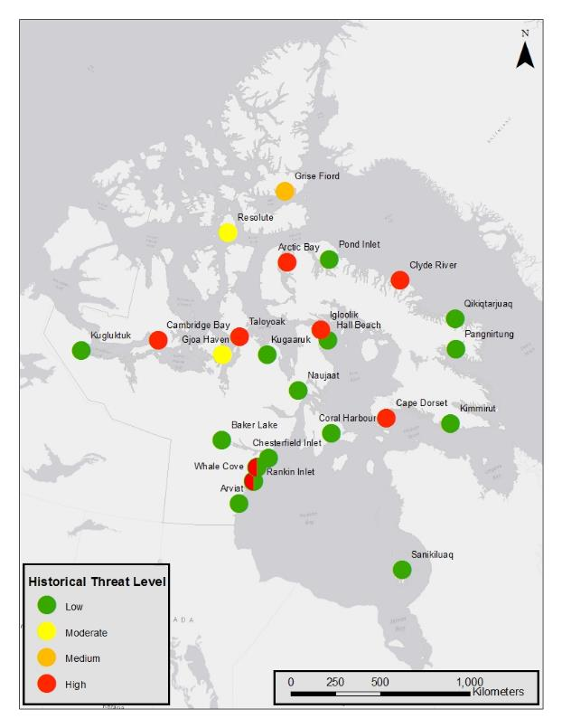
Figure 6. Historic water shortage threat level map based on 50-yr probability estimates.
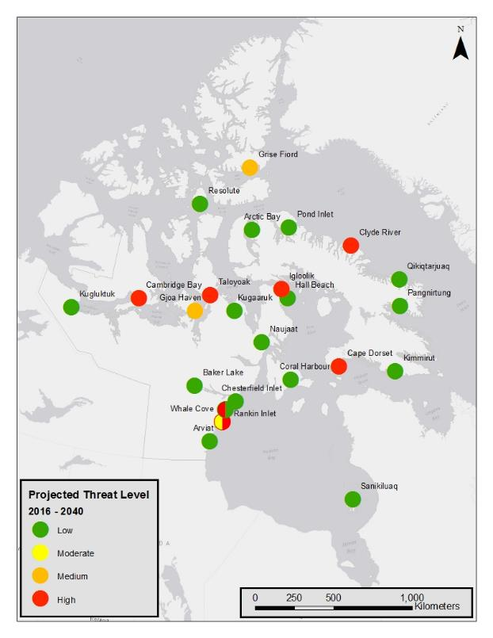
Figure 7. Projected water shortage threat map for 2016 - 2040 based on 50-yr probability estimates.
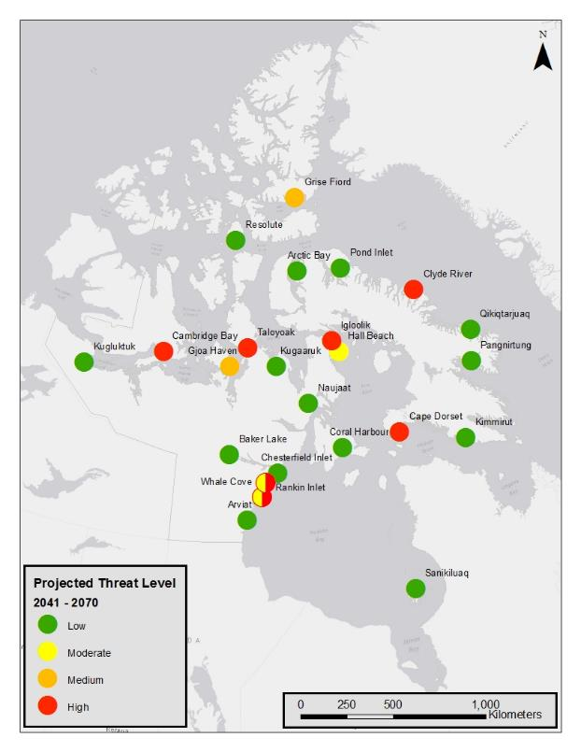
Figure 8. Projected water shortage threat map for 2041 - 2070 based on 50-year probability estimates.

Climate Projection Verification

Statistical Trends
The Mann Kendall statistical test indicated overall trends of neutrality in precipitation, and increasing trends in evapotranspiration. Figure 9 shows that the historical dataset from Environment Canada largely showed no significant trends in precipitation. Only 3 out of 14 communities showed a statistical increase in historical precipitation, which were Coral Harbour, Naujaat, and Resolute. Only Kimmirut showed a statistical decrease in precipitation. The other communities showed no significant trends in historical precipitation. Based on the PCIC hindcast datasets, 4 out of 24 communities had statistically increasing precipitation, which included: Arctic Bay, Grise Fiord, Kugaaruk, and Resolute. This suggests there are differences at times between the trends observed between the historical and climate model hindcast datasets.
Figure 10 shows that the historical dataset demonstrated that 15 out of 20 communities had statistically increasing trends in evapotranspiration. While, the statistics performed on the PCIC hindcast datasets generally agreed with significant increases in evapotranspiration observed in 22 out of 24 communities. Detailed results of the statistical analysis including the historical and PCIC datasets is presented in Appendix D.
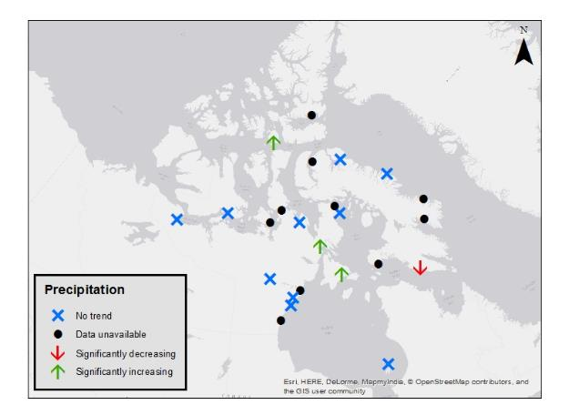
Figure 9. Statistical trends in historical precipitation datasets from Environment Canada.
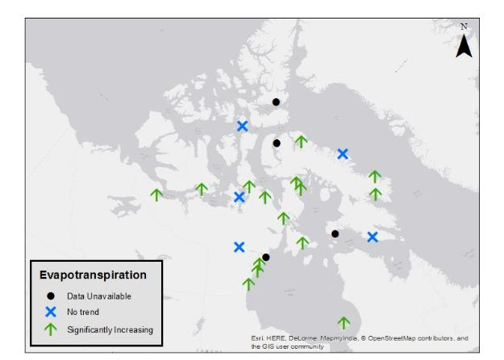
Figure 10. Statistical trends in evapotranspiration based on historical data.

Comparison of GCM and Historical Datasets
Overall, the GCM hindcast statistically downscaled water availability estimates compared well with the water availability calculated from the observed historical climate data. In Coral Harbour for example, the percent differences between the GCM hindcast calculated and historical median water availability consisted of 2% for both CCSM4 and CNRM-CM5, 6% for CSIRO and 9% for MRI. This suggests that the selected models are appropriate to use in calculations for future projections of water availability.

Hydrometric Station Analysis

Inter-seasonal Variability in River Discharge
Since lakes and rivers freeze during the winter, water availability varies seasonally. The spring freshet usually occurs in June, resulting in peak spring flows that drop off in summer and autumn, as seen in Figure 11. Water must be extracted during this period for use the remainder of the year.

Figure 11: Inter-seasonal variability in discharge values for 2010 used for the Cambridge Bay site (Freshwater Creek 10TF001 ).

Operational Days Based upon Fisheries Maintenance Flows
In this study, an operational day was defined as a day where the flow exceeds 30% of the MAD, thus water can be withdrawn while meeting DFO’s fisheries maintenance flow requirements. The mean, minimum, and maximum number of operational days for the historical dataset are shown in Table 10 for the five communities examined. Notably, the number of operational days in Qikitarjuaq and Resolute Bay were at their minimum only 8 days in length, which suggests that in worst case hydrological scenarios the window for water withdrawal may be very short.
Table 10. Number of operational days based on DFO maintenance requirements.
Community | Mean | Minimum | Maximum
Rankin Inlet | 127 | 106 | 136
Qikiqtarjuaq | 34 | 8 | 61
Resolute Bay | 33 | 8 | 59
Cambridge Bay | 82 | 40 | 133
Coral Harbour | 65 | 34 | 93

Permissible Withdrawals
In addition to the increased risk associated with flow alterations resulting in instantaneous flows less than 30% of the MAD, DFO states that cumulative flow alterations less than 10% of the instantaneous flow have a low likelihood of impacting fisheries (DFO, 2013). Thus, withdrawals on operational days cannot exceed 10% of the instantaneous flow. Considering this constraint, Table 11 shows the permissible average daily withdrawals (m³/day), with a 95% confidence interval.

Table 11. Permissible average daily withdrawal rates based on DFO requirements.
Community | Source | Mean (m³/day) | 95% Confidence Limit
Community | Source | Mean (m³/day) | Lower Bound | Upper Bound
Rankin Inlet | Char River | 2760 | 2300 | 3221
Rankin Inlet | Nipissar Lake | 401 | 383 | 419
Qikiqtarjuaq | Tulugak River | 11677 | 10274 | 13079
Resolute Bay | Char Lake | 2192 | 1933 | 2451
Cambridge Bay | Lake | 276 | 268 | 284
Coral Harbour | River | 87161 | 76679 | 97642
The permissible daily withdrawal can vary significantly from year to year; an example of this is shown in Figure 12, where Cambridge Bay’s permissible withdrawals fluctuate widely between the years 1970 and 2014.

Figure 12: Inter-Annual Variability in Average Daily Permissible Withdrawal Rates for Cambridge Bay.

Verification of PET
PET values used in the water balances were estimated using the Priestley-Taylor model. To verify these estimates, PET was also calculated using discharge and climate data for three locations where data availability was adequate. Precipitation and streamflow were summed from October 1 – September 30 for each year and streamflow was subtracted from precipitation to determine PET. The results are shown below in Table 12. The Priestley-Taylor model produced comparable values and were more conservative (higher) for nine of the fourteen years examined. This information provided additional support for the use of the Priestley Taylor method in this study.

Table 12. Comparison of annual estimates of PET with water balance estimates from hydat data.
Community | Year | Annual PET Hydat (mm) | Annual PET Priestley-Taylor Method (mm)
Cambridge Bay | 2010 | 8 | 66
Cambridge Bay | 2011 | 16 | 66
Cambridge Bay | 2012 | 53 | 67
Cambridge Bay | 2013 | 49 | 65
Cambridge Bay | 2014 | 48 | 62
Rankin Inlet | 1991 | 101 | 70
Rankin Inlet | 1992 | 24 | 63
Rankin Inlet | 1993 | 112 | 70
Rankin Inlet | 1994 | 64 | 71
Rankin Inlet | 1995 | 138 | 69
Coral Harbour | 1985 | 138 | 68
Coral Harbour | 1988 | 24 | 65
Coral Harbour | 1989 | 70 | 65
Coral Harbour | 1990 | 39 | 63

Water Use versus Permissible Withdrawals
For a select number of communities where data was available, permissible withdrawals were compared against community water use, to determine if communities could feasibly meet DFO Ecological Flow requirements. These constraints would only be applicable to communities withdrawing water directly from a flowing, fish bearing watercourse. The results for three sample communities withdrawing from a flowing watercourse are shown in Figure 13 and Figure 14. Both the trucked and piped water scenarios are shown to assess the difference in water demand based on the type of distribution infrastructure. All three of the communities were able to meet their demand while adhering to DFO requirements. Coral Harbour has the largest watershed, resulting in the largest permissible annual withdrawal volume.

Figure 13: Water demand versus worst case permissible withdrawal considering fisheries maintenance flow constraints.
Figure 13 shows the permissible withdrawal and water use for the driest year in the historical dataset for each community. Figure 14 shows the permissible withdrawal for the driest year in the historical dataset and the projected 2070 water use. By 2070, Rankin Inlet may be at risk of surpassing the permissible withdrawals in worst case scenarios.

Figure 14: Projected 2070 water use versus permissible withdrawal considering fisheries maintenance flow requirements.

Overall Risk Assessment
Based on the water balance analysis there are some communities which currently have, or may experience, water stress as a result of community demands and climate change. The results of the median water balance analysis demonstrated that 3 communities historically have had high risk of water stress, and in the future scenarios there is anticipated to be an increase to 6 communities vulnerable to high water stress by 2070 (Figure 15). The number of communities classed as high risk for water stress increases to 8 historically and 7 for future climate projection, when the 50-year return period low precipitation and high ET scenarios are considered (Figure 16).
Figure 15. Pie-charts showing the distribution of risk levels for the 26 source water locations according to median water balance values (all are trucked except Rankin Inlet and Resolute).

Figure 16. Pie-charts showing the distribution of risk levels for the 26 source water locations according to the 50-year return periods (all are trucked except Rankin Inlet and Resolute).

Table 13 summarizes the communities where elevated levels of risk of water stress based on the water availability index were observed. Based on historical data, there were a total of eight communities where high water stress was observed when the 50-year return periods which were: Arctic Bay, Cambridge Bay, Cape Dorset, Clyde River, Igloolik, Rankin Inlet (Nipissar), Taloyoak, and Whale Cove (Preferred Water Withdrawal Location). The same communities are at high risk into the future with climate projections except Arctic Bay because precipitation is anticipated to increase in this community. Grise Fiord was identified as being medium risk of water scarcity based on the 50-year return periods from the historical datasets. Gjoa Haven was upgraded to medium risk levels for future climate projections. Communities at moderate risk of water scarcity based on historical datasets were Gjoa Haven and Resolute. In future climate projections, Gjoa Haven’s risk level is increased to medium and Resolute is anticipated to decrease in risk due to increased precipitation. Whale Cove (Main source) is anticipated to become at moderate risk level for water scarcity by 2040. While, further into the future (i.e., 2041 -2070) Hall Beach, Rankin Inlet (Char) are anticipated to be upgraded to moderate risk of water scarcity.

Table 13. Summary of communities which have risk of water stress based on water availability indicator.
Period | Median estimates |  |  |  | 50 year probability worst case
Period | High | Medium | Moderate | High |  | Medium | Moderate
Historical | - Clyde River | - Cambridge Bay | - Grise Fiord | - Arctic Bay |  | - Grise Fiord | - Gjoa Haven
Historical | - Rankin Inlet (Nipissar) | - Cape Dorset | - Taloyoak | - Cambridge Bay |  |  | - Resolute
Historical | - Whale Cove (Preferred) | - Igoolik |  | - Cape Dorset
Historical |  |  |  | - Clyde River
Historical |  |  |  | - Igloolik
Historical |  |  |  | - Rankin Inlet (Nipissar)
Historical |  |  |  | - Taloyoak
Historical |  |  |  | - Whale Cove (Preferred)
2016 - 2040 | - Cape Dorset | - Cambridge Bay | - Grise Fiord | - Cambridge Bay |  | - Gjoa Haven | - Whale Cove (Main)
2016 - 2040 | - Clyde River |  | - Taloyoak | - Cape Dorset |  | - Grise Fiord
2016 - 2040 | - Igloolik |  |  | - Clyde River
2016 - 2040 | - Rankin Inlet (Nipissar) |  |  | - Igloolik
2016 - 2040 | - Whale Cove (Preferred) |  |  | - Rankin Inlet (Nipissar)
2016 - 2040 |  |  |  | - Taloyoak
2016 - 2040 |  |  |  | - Whale Cove (Preferred)
2041-2070 | - Cambridge Bay | - Taloyoak | - Gjoa Haven | - Cambridge Bay |  | - Gjoa Haven | - Hall Beach
2041-2070 | - Cape Dorset |  | - Grise Fiord | - Cape Dorset |  | - Grise Fiord | - Rankin Inlet (Char)
2041-2070 | - Clyde River |  |  | - Clyde River |  |  | - Whale Cove (Main)
2041-2070 | - Igloolik |  |  | - Igloolik
2041-2070 | - Rankin Inlet (Nipissar) |  |  | - Rankin Inlet (Nipissar)
2041-2070 | - Whale Cove (Preferred) |  |  | - Taloyoak
2041-2070 |  |  |  | - Whale Cove (Preferred)

Conclusions
In conclusion, this desktop assessment of the sustainability of water withdrawal from the source drinking water locations for Nunavut’s hamlets demonstrated that there are several communities that are at high risk of water shortages both now and in the future. Generally, the degree of risk was directly related to the size of the watershed contributing to source water intake location.
Based on the water balance analysis there are some communities which currently have, or may experience, water stress as a result of community demands and climate change. The risk of water shortage was assessed based on median water balance estimates, as well as 50-year return period minimum water availability estimates. The 50-year return period estimates provide a more realistic understanding of which communities may be at risk at some point in the future. A total of 8 communities were classed as high risk for water stress using historical climate records, when the 50-year probability low precipitation and high ET scenarios are considered, along with no changes in water delivery system. The eight communities where high water stress was observed using historical records included: Arctic Bay, Clyde River, Whale Cove (Preferred Water Withdrawal Location), Rankin Inlet (Nipissar), Cape Dorset, Igloolik, Cambridge Bay, and Taloyoak. When future conditions were considered, 7 communities were classed as high risk of water shortages. Arctic Bay was downgraded to medium risk and the rest remained as high risk of water scarcity.
Very little change was observed in risk levels of water shortages when comparing historical and future climate scenarios. However, a few communities changed from low to moderate risk levels for the worst case (50-year probabilities) for future climate scenarios. These communities included: Whale Cove (Main Withdrawal Location), Rankin Inlet (Char) and Hall Beach.
Based on this desktop analysis, it would be advised to focus efforts on reducing risks of high, medium, and moderate source water sites, in sequential order. This may entail siting alternate back-up source water supplies in some communities where the risk is particularly high. Overall, this assessment has provided a high-level desktop methodology for ranking risk in multiple communities to identify potential scarcity problems with consideration for changing climate and demographics. This type of planning tool will be useful for managers of territorial drinking water infrastructure and may be translatable to other northern Canadian jurisdictions.

References
Allen, R.G., Pereira, L.S., Raes & D., Smith, M. (1998). Crop evapotranspiration – guidelines for computing crop water requirements – FAO Irrigation and drainage paper 56. Food and Agriculture Organization of the United Nations. Rome, Italy.
Arktis Piusitippaa Inc. (2015). Secondary water source hydrology assessment Grise Fiord, Nunavut. Technical report prepared for the Community and Government Services department of the Government of Nunavut. Iqaluit, Nunavut.
Bakker K. (2012). Water security: research challenges and opportunities. Science, 337(6097), 914-915.
CBC (Canadian Broadcasting Corporation) (2012). Kugaaruk’s summer water source still uncertain. Available online at: http://www.cbc.ca/beta/news/canada/north/kugaaruk-s-summer-water-source-still-uncertain-1.1231576
CBC (Canadian Broadcasting Corporation) (2014). As glacier melts, Grise Fiord residents fear for water supply. Available online at: http:www.cbc.ca/beta/news/Canada/north/as-glacier-melts-grise-fiord-residents-fear-for-water-supply-1.2840562 [August 7, 2016].
CBC (Canadian Broadcasting Corporation) (2016). Temporary fix completed for Sanikiluaq’s high sodium water problem. Available online at: http://www.cbc.ca/beta/news/canada/north/temporary-fix-complete-sanikiluaq-high-sodium-water-1.3699791 [August 7, 2016]
Cook C., Bakker K. Water security: debating an emerging paradigm. Global Environ Change. 2012;22:92_102.
Daley, K., Castleden, H., Jamieson, R., Furgal, C., & Ell, L. (2014). Municipal water quantities and health in Nunavut households: an exploratory case study in Coral Harbour, Nunavut, Canada. International journal of circumpolar health, 73.
DFO (Department of Fisheries and Oceans Canada) (2013). Framework for assessing the ecological flow requirements to support fisheries in Canada. DFO Can. Sci. Advis. Sec. Sci. Advis. Rep. 2013/017.
Dingman, S.L. (2002). Physical Hydrology. Second edition. Waveland Press Inc. Long Grove, Illinois, United States.
Dudarev A, Dushkina E, Sladkova Y, Alloyarov P, Chupakhin, V, Dorofeyev V, et al. (2013) Food and water security issues in Russia II: water security in general population of Russian Arctic, Siberia and Far East, 2000-2011. Int J Circumpolar Health, 72.
Environment Canada. (2011). Data Sources and Methods for the Water Availability Indicator. Retrieved from http://www.publications.gc.ca/collections/collection_2012/ec/En4-144-30-2011-eng.pdf
Gocic, M., & Trajkovic, S. (2013). Analysis of changes in meteorological variables using Mann-Kendall and Sen's slope estimator statistical tests in Serbia. Global and Planetary Change, 100, 172-182.
Goldfarb D, Dixon B, Moldovan I, Barrowman N, Mattison, K, Zentner C, et al. (2013). Nanolitre real-time PCR detection of bacterial, parasitic, and viral agents from patients with diarrhoea in Nunavut, Canada. Int J Circumpolar Health, 72.
Government of Canada (2016a). Historical climate data. Environment Canada. Accessed online at: http://www.climate.weather.gc.ca [January 8, 2016]
Government of Canada (2016b). Geospatial data extraction. GeoGratis. Natural Resources Canada. Accessed online at: http://geogratis.gc.ca/site/eng/extraction [March 4, 2016].
Government of Canada (2015a). Readme_Lisezmoi. Index of/Pub/Get_more_data_plus_de_donnees. Environment Canada. Accessed online at: ftp://ftp.tor.ec.gc.ca/Pub/Get_More_Data_Plus_de_donnees/ [March 7, 2016].
Government of Canada (2015b). Historical hydrometric data search. Environment Canada. Water Office. Accessed online at: http://wateroffice.ec.gc.ca/search/search_e.html?sType=h2oArc [August 28, 2015].
Government of Nunavut (2012). Nunavut population counts by region and community, 1981 to 2011 censuses. Nunavut Bureau of Statistics. Accessed online at: http://www.stats.gov.nu.ca/en/Census.aspx [March 6, 2016].
Government of Nunavut (2014). Nunavut population projections by region and community, 2014 to 2035. Nunavut Bureau of Statistics. Accessed online at http://www.stats.gov.nu.ca/en/Population.aspx [December 21, 2015].
Hamon, W.R. (1960) Estimating potential evapotranspiration. Honour’s thesis. Massachusetts Institute of Technology. Cambridge, Massachusetts, United States.
Heinke, G. W., Smith, D. W., & Finch, G. R. (1991). Guidelines for the planning and design of wastewater lagoon systems in cold climates. Canadian Journal of Civil Engineering, 18(4), 556-567.
IPCC (Intergovernmental Panel on Climate Change) (2014). Fifth assessment report (AR5). Accessed online at: http://www.ipcc.ch/report/ar5/ [March 8, 2016].
Kane, D.L., Gieck, R.E., & Hinzman, L.D. (1990). Evapotranspiration from a small Alaskan Arctic watershed. Nordic Hydrology, 21, 253-272.
Loring P, Gerlach S, Huntington H. (2013). The new environmental security: linking food, water and energy for integrative and diagnostic social-ecological research. J Agric Food Syst Community Dev. 3, 55-61.
Maidment, D. R. (Ed.). (2002). ArcHydro: GIS for Water Resources. ESRI Inc. Redlands, California, United States.
National Resources Canada (2003) Atlas of Canada, 1,000,000 National Frameworks Data,
Hydrology – Drainage Areas. Available from: http://geogratis.cgdi.gc.ca/geogratis/en/option/select.do;jsessionid=88E14B25D09C934291775D7204F4D901?id=87B4BE8F-C67C-5545-80B5-AB6FC056149E.
Nunatsiaq News (2015). Nunavut hamlet continues to struggle with water scarcity. Available online at: www.nunatsiaqonline.ca/stories/article/65674nunavut_hamlet_continues_to_struggle_with_water_scarcity [August 7, 2016].
OECD (2009), Managing water for all, An OECD perspective on pricing and financing, OECD, Paris. (page 32)
PCIC (Pacific Climate Consortium) (2016). Statistically downscaled climate scenarios. Data portal. Accessed online at: https://www.pacificclimate.org/data/statistically-downscaled-climate-scenarios [March 8, 2016].
Priestley, C. H. B. & Taylor, R.J. (1972). On the assessment of surface heat flux and evaporation using large-scale parameters. Monthly weather review. 100, 81-92.
Sheffield, J., Barrett, A. P., Colle, B., Nelun Fernando, D., Fu, R., Geil, K. L., ... & Lombardo, K. (2013). North American climate in CMIP5 experiments. Part I: evaluation of historical simulations of continental and regional climatology. Journal of Climate, 26(23), 9209-9245.
Smith D. (1996). Introduction. In: D. W. Smith (Ed.), Cold regions utilities monograph (pp. 1.1-1.6). 2nd ed. Reston, VA: American Society of Civil Engineers.
Smith, D., Kent, R., Prince, D., & Crum, J. (1996). Wastewater treatment and disposal. In: D. W. Smith (Ed.), Cold regions utilities monograph. American Society of Civil Engineers.
SNAP (Scenarios Network for Arctic Planning) (2011). Yukon water availability analysis – an assessment of the potential impacts of climate change on the balance between precipitation and potential evapotranspiration in the Yukon, Canada. Technical report prepared for the Northern Climate Exchange, Yukon College.
Statistics Canada (2012). Nunavut (Code 62) and Canada (Code 01) (table). Census Profile. 2011 Census. Statistics Canada Catalogue no. 98-316-XWE. Ottawa. Released October 24, 2012. Available online at: http://www.12.statcan.gc.ca/census-recensement/2011/dp-pd/prof/index.cfm?Lang=E [August 6, 2016].
Xu, C.-Y. & Singh, V.P. (2002). Cross comparison of empirical equations for calculating potential evapotranspiration with data from Switzerland. Water Resources Management. 16, 197-219.

Appendix A:
Watershed Areas

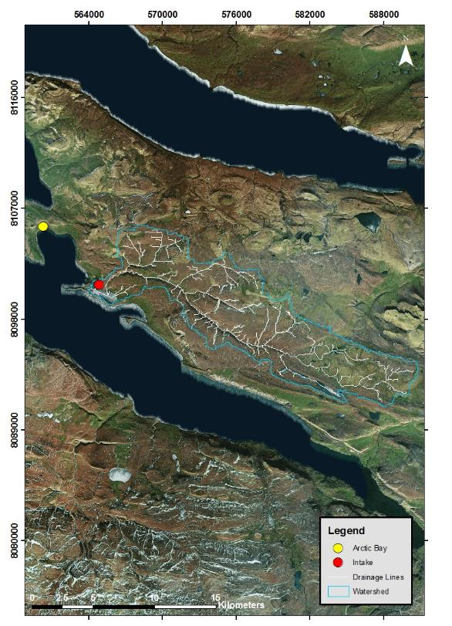
Figure A - 1 Arctic Bay located at 73°02’11”N, 085°09’09”W has a lake source water with a total watershed area of 132 km².
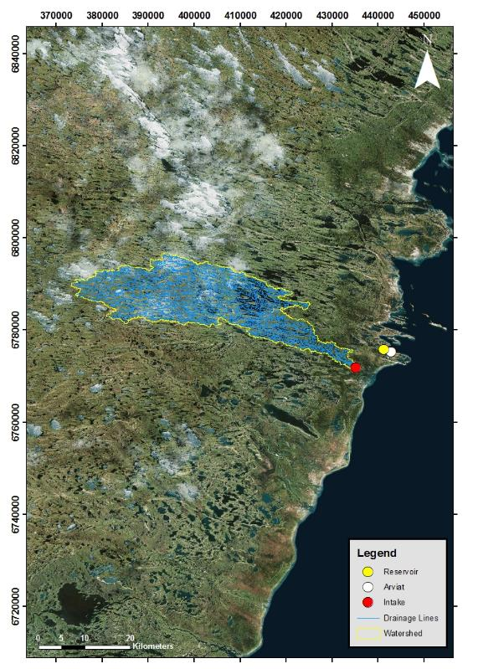
Figure A - 2 Arviat located at 61°06’29”N, 094°03’25”W has a river source water with a total watershed area of 582 km².
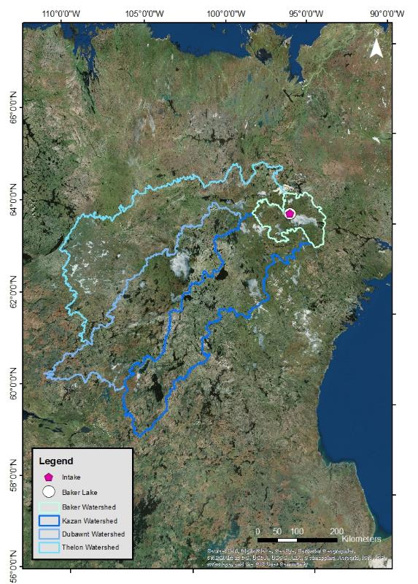
Figure A - 3 Baker Lake located at 64°19’05”N, 096°01’03”W has a lake source water with a total watershed area of 240,000 km².

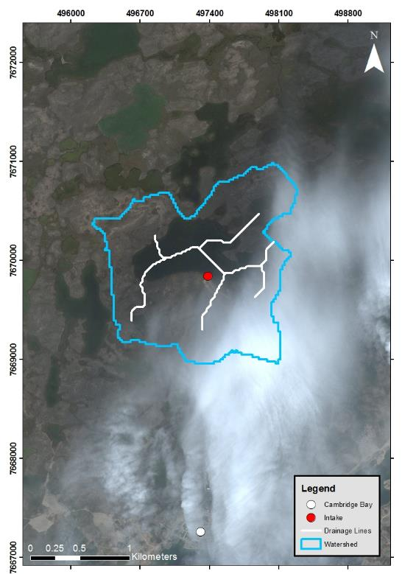
Figure A - 4 Cambridge Bay located at 69°07’02”N, 105°03’11”W has a lake source water with a total watershed area of 2.78 km².
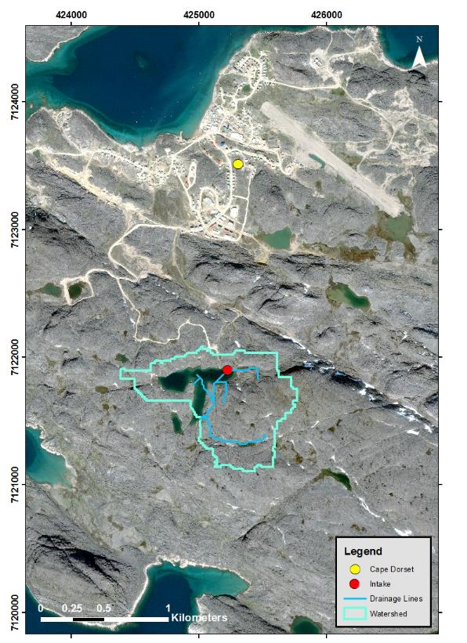
Figure A - 5 Cape Dorset located at 64°13’54”N, 076°32’25”W has a lake source water with a total watershed area of 0.73 km².
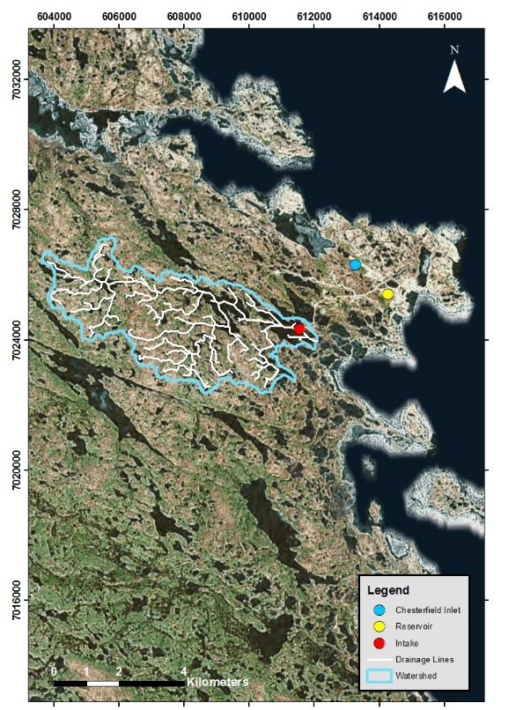
Figure A - 6 Chesterfield Inlet located at 63°20’27”N, 090°42’22”W has a lake source water with a total watershed area of 19.7 km².
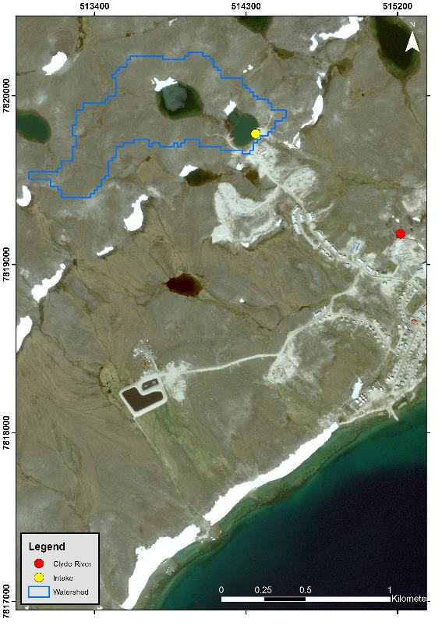
Figure A - 7 Clyde River located at 70°28’26”N, 068°35’10”W has a lake source water with a total watershed area of 0.57 km².
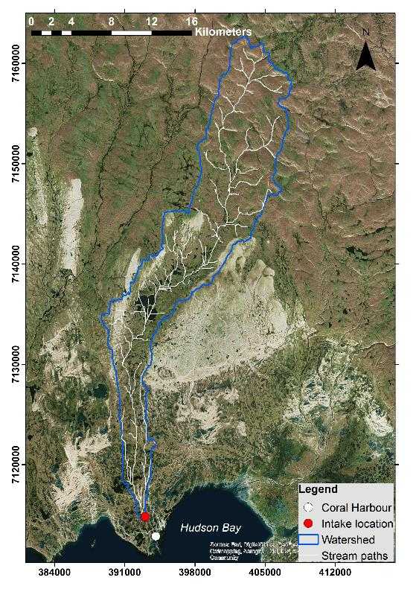
Figure A - 8 Coral Harbour located at 64°08’13”N, 083°09’51”W has a river source water with a total watershed area of 256 km².
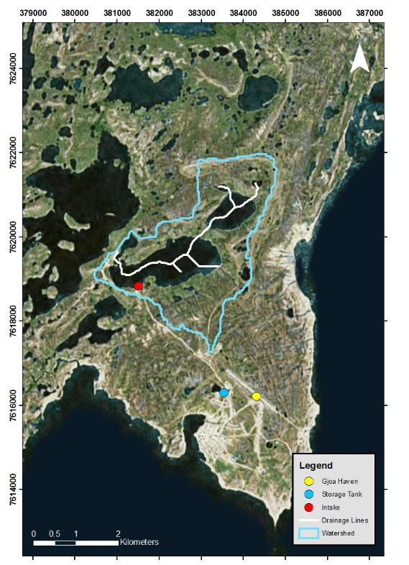
Figure A - 9 Gjoa Haven located at 68°37’33”N, 095°52’30”W has a lake source water with a total watershed area of 9.4 km².

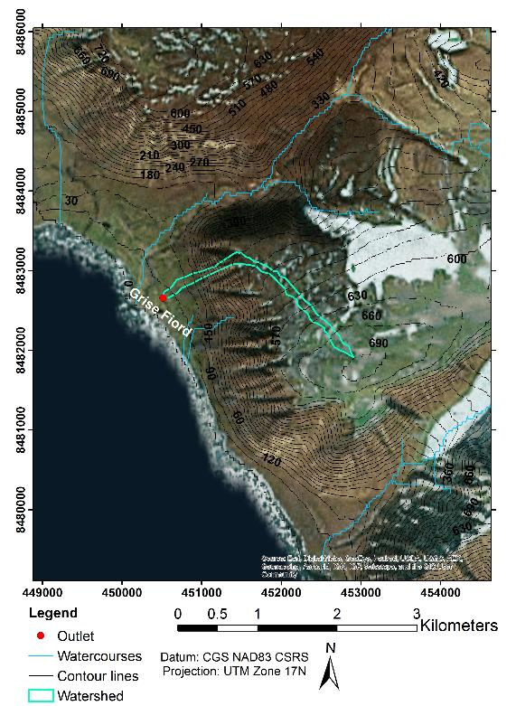
Figure A - 10 Grise Fiord located at 76°25’03”N, 082°53’38”W has a snowmelt runoff source water with a total watershed area of 0.27 km².
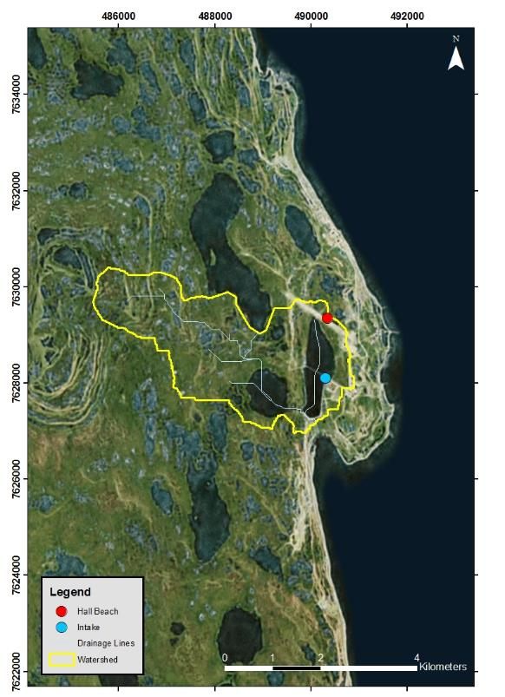
Figure A - 11 Hall Beach located at 68°46’38”N, 081°13’27”W has a lake source water with a total watershed area of 10.1 km².

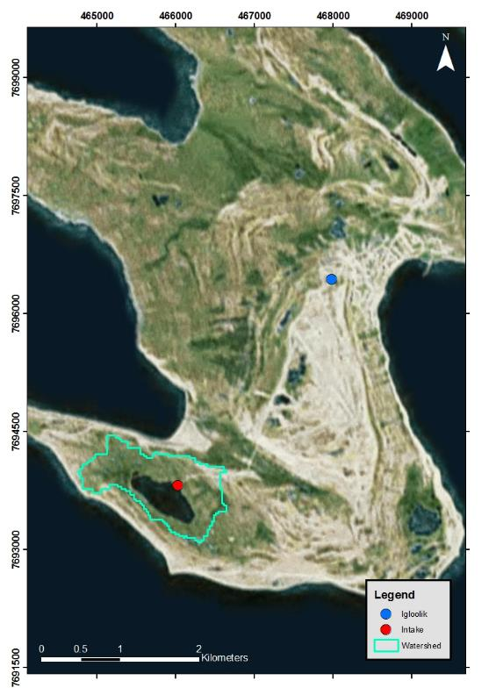
Figure A - 12 Igloolik located at 69°22’34”N, 081°47’58”W has a lake source water with a total watershed area of 1.3 km².
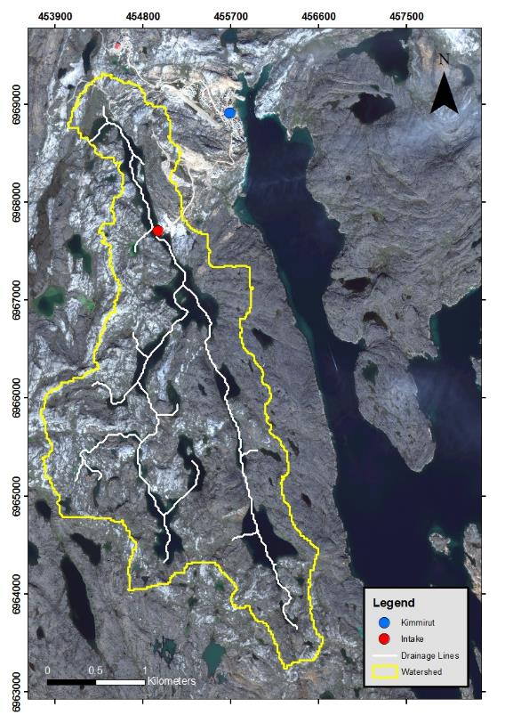
Figure A - 13 Kimmirut located at 62°50’48”N, 069°52’07”W has a lake source water with a total watershed area of 8.1 km².
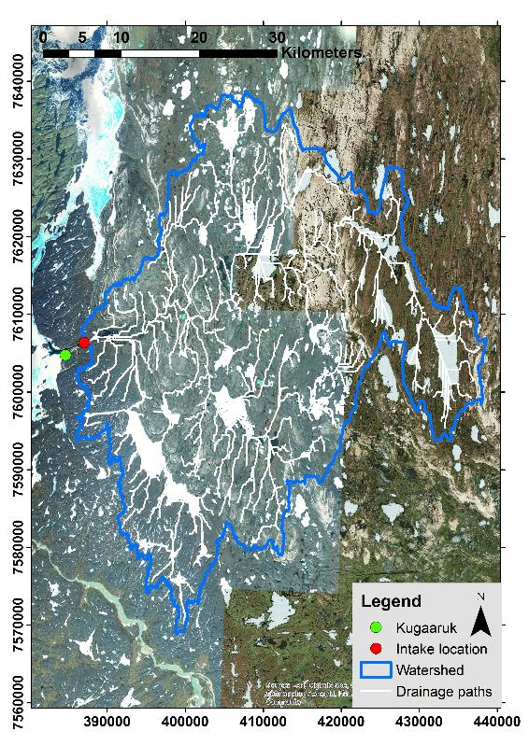
Figure A - 14 Kugaaruk located at 68°31’59”N, 089°49’36”W has a river source water with a total watershed area of 1,819 km².
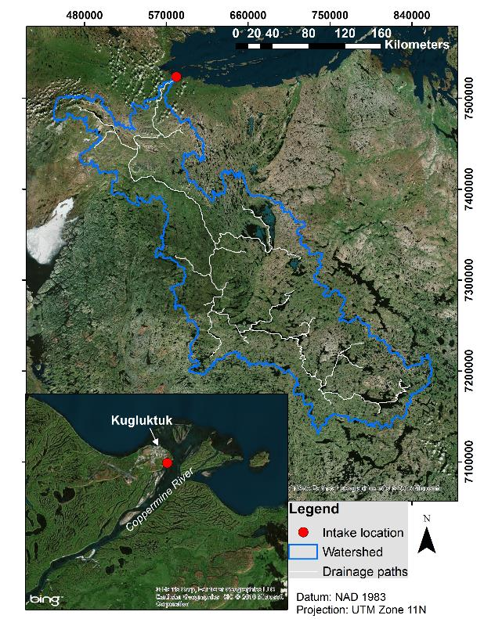
Figure A - 15 Kugluktuk located at 67°49’32”N, 115°05’42”W has a river source water with a total watershed area of 51,324 km².
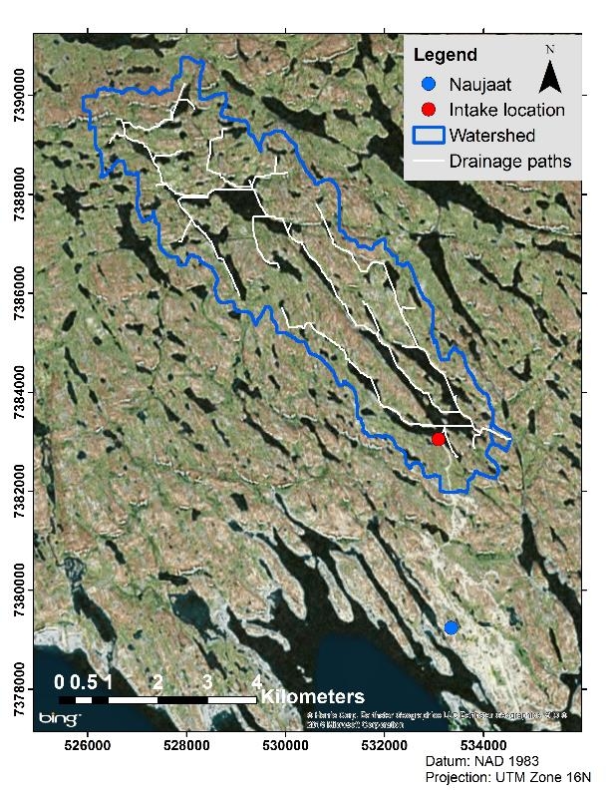
Figure A - 16 Naujaat located at 66°31’19”N, 086°14’06”W has a lake source water with a total watershed area of 25.9 km².
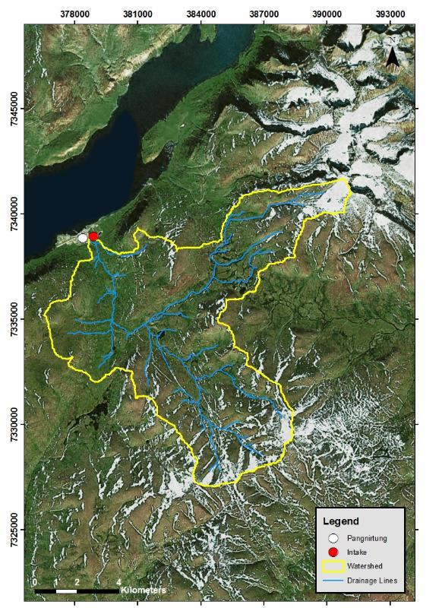
Figure A - 17 Pangnirtung located at 66°08’52”N, 065°41’58”W has a river source water with a total watershed area of 92.7 km².
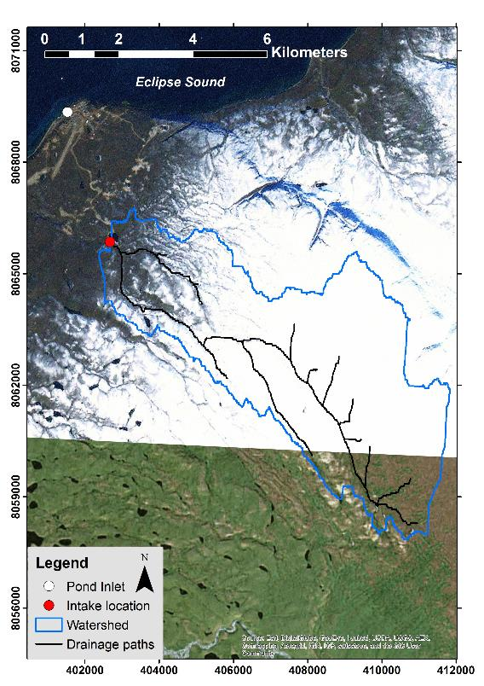
Figure A - 18 Pond Inlet located at 72°41’57”N, 077°57’33”W has a lake source water with a total watershed area of 37.4 km².
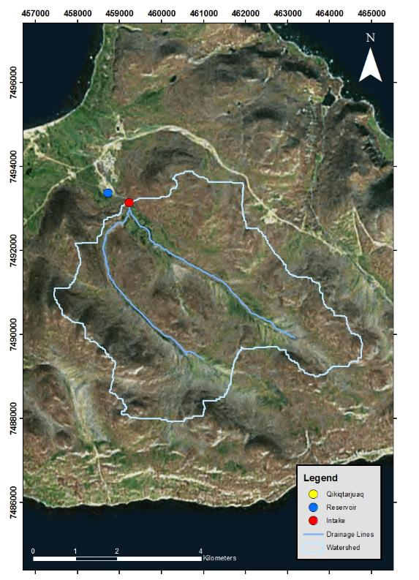
Figure A - 19 Qikiqtarjuaq located at 67°33’29”N, 064°01’29”W has a river source water with a total watershed area of 24 km².
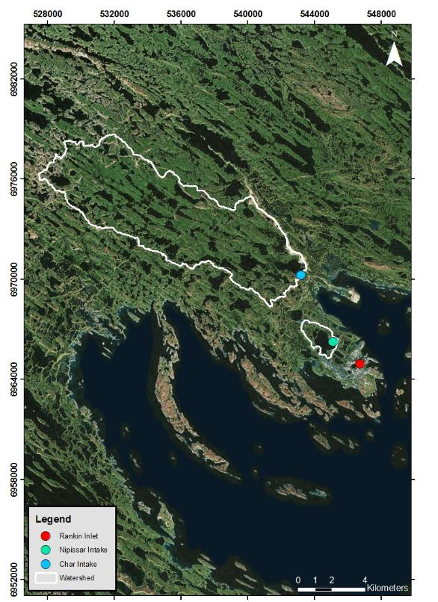
Figure A - 20 Rankin Inlet located at 62°48’35”N, 092°05’58”W has both lake and river sources with total watershed areas of 67.6 km² (Char) and 2.7 km² (Nipissar).
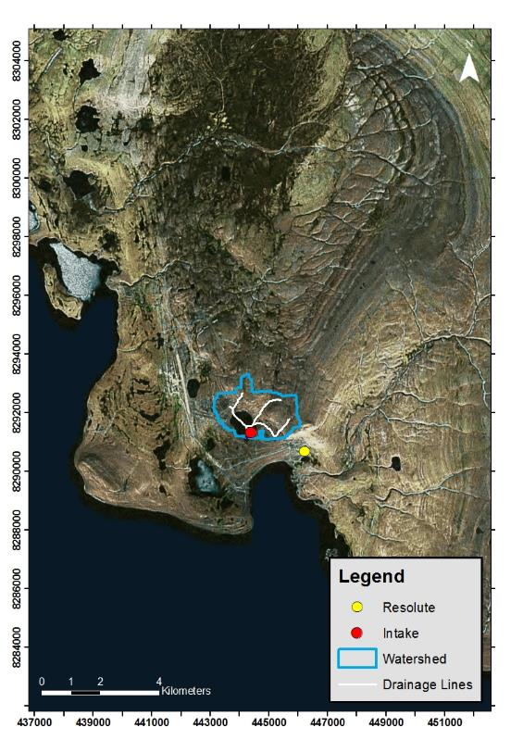
Figure A - 21 Resolute Bay located at 74°41’51”N, 094°49’56”W has a lake source water with a total watershed area of 4.1 km².
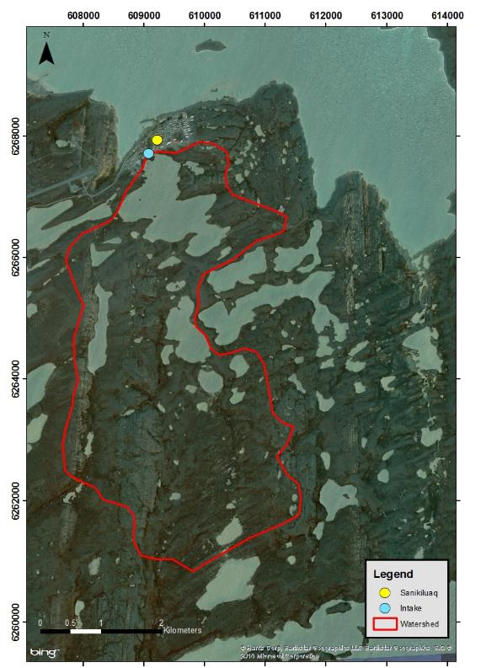
Figure A - 22 Sanikiluaq located at 56°32’34”N, 079°13’30”W has a lake source water with a total watershed area of 17.8 km².
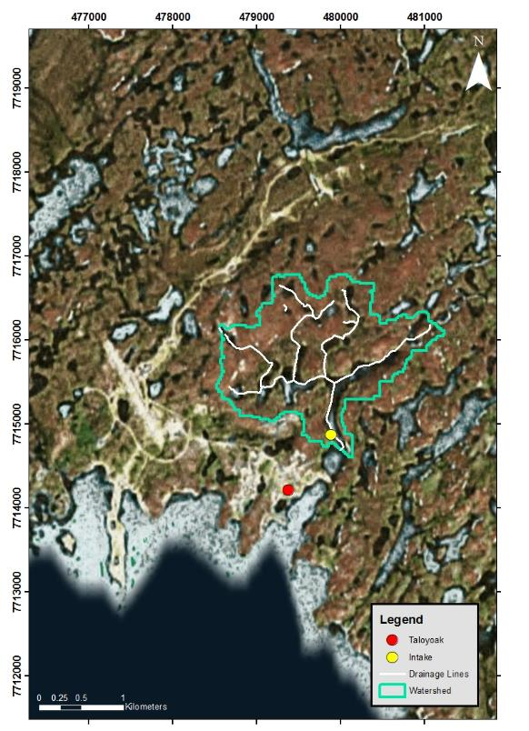
Figure A - 23 Taloyoak located at 69°32’13”N, 093°31’36”W has a lake source water with a total watershed area of 3.3 km².
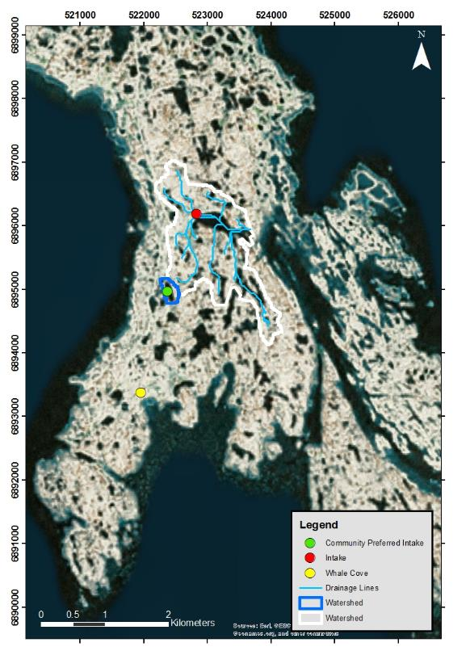
Figure A - 24 Whale cove located at 62°10’22”N, 092°34’46”W has two lake source water locations with total watershed areas of 0.08km² (Preferred) and 2.3 km² (Main) .

Appendix B:
Median Water Availability Tables

Table B - 1 Arctic Bay.
Simulation Period | Climate Model | Median Precipitation (mm) | Median ET (mm) | Net Water Availability - Trucked (ML)ª | Net Water Availability - Piped (ML)^{b} | Water Availability Indicator - Trucked (%) | Water Availability Indicator - Piped (%)
1950-2015 | Historical | 100 | 55 | 7.2E+03 | 7.1E+03 | 0.4 | 1.1
1950-2015 | CCSM4 | 185 | 53 | 1.7E+04 | 1.7E+04 | 0.2 | 0.5
1950-2015 | CNRM-CM5 | 185 | 53 | 1.7E+04 | 1.7E+04 | 0.2 | 0.5
1950-2015 | CSIRO | 179 | 52 | 1.7E+04 | 1.7E+04 | 0.2 | 0.5
1950-2015 | MRI | 179 | 52 | 1.7E+04 | 1.7E+04 | 0.2 | 0.5
2016-2040 | CCSM4 | 218 | 66 | 2.0E+04 | 2.0E+04 | 0.2 | 0.6
2016-2040 | CNRM-CM5 | 191 | 59 | 1.8E+04 | 1.7E+04 | 0.3 | 0.7
2016-2040 | CSIRO | 205 | 54 | 2.0E+04 | 2.0E+04 | 0.2 | 0.6
2016-2040 | MRI | 184 | 54 | 1.7E+04 | 1.7E+04 | 0.3 | 0.7
2041-2070 | CCSM4 | 249 | 68 | 2.4E+04 | 2.4E+04 | 0.2 | 0.5
2041-2070 | CNRM-CM5 | 226 | 60 | 2.2E+04 | 2.2E+04 | 0.2 | 0.6
2041-2070 | CSIRO | 215 | 72 | 1.9E+04 | 1.9E+04 | 0.3 | 0.6
2041-2070 | MRI | 213 | 59 | 2.0E+04 | 2.0E+04 | 0.2 | 0.6
ªTrucked water use was estimated to be 32 ML in 2015; 46 ML in 2040; and 49 ML in 2070.
^{b}Piped water use was estimated to be 80 ML in 2015; 115 ML in 2040; and 122 ML in 2070.

Table B - 2 Arviat.
Simulation Period | Climate Model | Median Precipitation (mm) | Median ET (mm) | Net Water Availability - Trucked (ML)ª | Net Water Availability - Piped (ML)^{b} | Water Availability Indicator - Trucked (%) | Water Availability Indicator - Piped (%)
1950-2015 | Historical | 277 | 75 | 1.2E+05 | 1.2E+05 | 0.1 | 0.2
1950-2015 | CCSM4 | 310 | 84 | 1.3E+05 | 1.3E+05 | 0.1 | 0.2
1950-2015 | CNRM-CM5 | 302 | 79 | 1.3E+05 | 1.3E+05 | 0.1 | 0.2
1950-2015 | CSIRO | 300 | 77 | 1.3E+05 | 1.3E+05 | 0.1 | 0.2
1950-2015 | MRI | 302 | 80 | 1.3E+05 | 1.3E+05 | 0.1 | 0.2
2016-2040 | CCSM4 | 327 | 88 | 1.4E+05 | 1.4E+05 | 0.2 | 0.5
2016-2040 | CNRM-CM5 | 309 | 82 | 1.3E+05 | 1.3E+05 | 0.2 | 0.5
2016-2040 | CSIRO | 315 | 80 | 1.4E+05 | 1.4E+05 | 0.2 | 0.5
2016-2040 | MRI | 308 | 79 | 1.3E+05 | 1.3E+05 | 0.2 | 0.5
2041-2070 | CCSM4 | 312 | 91 | 1.3E+05 | 1.3E+05 | 0.5 | 1.1
2041-2070 | CNRM-CM5 | 334 | 91 | 1.4E+05 | 1.4E+05 | 0.4 | 1.0
2041-2070 | CSIRO | 362 | 84 | 1.6E+05 | 1.6E+05 | 0.4 | 0.9
2041-2070 | MRI | 344 | 84 | 1.5E+05 | 1.5E+05 | 0.4 | 1.0
ªTrucked water use was estimated to be 114 ML in 2015; 252 ML in 2040; and 579 ML in 2070.
^{b}Piped water use was estimated to be 286 ML in 2015; 631 ML in 2040; and 1447 ML in 2070.

Table B - 3 Baker Lake.
Simulation Period | Climate Model | Median Precipitation (mm) | Median ET (mm) | Net Water Availability - Trucked (ML)ª | Net Water Availability - Piped (ML)^{b} | Water Availability Indicator - Trucked (%) | Water Availability Indicator - Piped (%)
1950-2015 | Historical | 241 | 67 | 4.2E+07 | 4.2E+07 | 0.0 | 0.0
1950-2015 | CCSM4 | 262 | 78 | 4.4E+07 | 4.4E+07 | 0.0 | 0.0
1950-2015 | CNRM-CM5 | 271 | 76 | 4.7E+07 | 4.7E+07 | 0.0 | 0.0
1950-2015 | CSIRO | 270 | 79 | 4.6E+07 | 4.6E+07 | 0.0 | 0.0
1950-2015 | MRI | 274 | 69 | 4.9E+07 | 4.9E+07 | 0.0 | 0.0
2016-2040 | CCSM4 | 311 | 84 | 5.4E+07 | 5.4E+07 | 0.0 | 0.0
2016-2040 | CNRM-CM5 | 274 | 80 | 4.6E+07 | 4.6E+07 | 0.0 | 0.0
2016-2040 | CSIRO | 293 | 81 | 5.1E+07 | 5.1E+07 | 0.0 | 0.0
2016-2040 | MRI | 288 | 70 | 5.2E+07 | 5.2E+07 | 0.0 | 0.0
2041-2070 | CCSM4 | 301 | 83 | 5.2E+07 | 5.2E+07 | 0.0 | 0.0
2041-2070 | CNRM-CM5 | 303 | 88 | 5.2E+07 | 5.2E+07 | 0.0 | 0.0
2041-2070 | CSIRO | 301 | 77 | 5.4E+07 | 5.4E+07 | 0.0 | 0.0
2041-2070 | MRI | 253 | 72 | 4.3E+07 | 4.3E+07 | 0.0 | 0.0
ªTrucked water use was estimated to be 88 ML in 2015; 161 ML in 2040; and 271 ML in 2070.
^{b}Piped water use was estimated to be 220 ML in 2015; 403 ML in 2040; and 677 ML in 2070.

Table B - 4 Cambridge Bay.
Simulation Period | Climate Model | Median Precipitation (mm) | Median ET (mm) | Net Water Availability - Trucked (ML)ª | Net Water Availability - Piped (ML)^{b} | Water Availability Indicator - Trucked (%) | Water Availability Indicator - Piped (%)
1950-2015 | Historical | 136 | 63 | 1.3E+02 | 2.3E+01 | 35 | 89
1950-2015 | CCSM4 | 180 | 62 | 2.6E+02 | 1.5E+02 | 22 | 55
1950-2015 | CNRM-CM5 | 174 | 63 | 2.4E+02 | 1.3E+02 | 23 | 58
1950-2015 | CSIRO | 180 | 63 | 2.5E+02 | 1.4E+02 | 22 | 56
1950-2015 | MRI | 178 | 63 | 2.5E+02 | 1.4E+02 | 23 | 56
2016-2040 | CCSM4 | 206 | 70 | 2.8E+02 | 1.3E+02 | 26 | 65
2016-2040 | CNRM-CM5 | 199 | 65 | 2.7E+02 | 1.3E+02 | 26 | 66
2016-2040 | CSIRO | 195 | 67 | 2.6E+02 | 1.1E+02 | 28 | 69
2016-2040 | MRI | 184 | 64 | 2.4E+02 | 9.0E+01 | 29 | 73
2041-2070 | CCSM4 | 230 | 72 | 3.1E+02 | 1.1E+02 | 30 | 74
2041-2070 | CNRM-CM5 | 188 | 67 | 2.1E+02 | 1.3E+01 | 39 | 96
2041-2070 | CSIRO | 216 | 68 | 2.8E+02 | 8.6E+01 | 32 | 79
2041-2070 | MRI | 194 | 65 | 2.3E+02 | 3.5E+01 | 36 | 90
ªTrucked water use was estimated to be 72 ML in 2015; 98 ML in 2040; and 130 ML in 2070.
^{b}Piped water use was estimated to be 181 ML in 2015; 246 ML in 2040; and 325 ML in 2070.

Table B - 5 Cape Dorset.
Simulation Period | Climate Model | Median Precipitation (mm) | Median ET (mm) | Net Water Availability - Trucked (ML)ª | Net Water Availability - Piped (ML)^{b} | Water Availability Indicator - Trucked (%) | Water Availability Indicator - Piped (%)
1950-2015 | Historical | 372 | 63 | 1.7E+02 | 7.9E+01 | 26 | 65
1950-2015 | CCSM4 | 340 | 71 | 1.4E+02 | 4.8E+01 | 30 | 75
1950-2015 | CNRM-CM5 | 339 | 65 | 1.4E+02 | 5.2E+01 | 30 | 74
1950-2015 | CSIRO | 343 | 71 | 1.4E+02 | 5.1E+01 | 30 | 74
1950-2015 | MRI | 343 | 64 | 1.4E+02 | 5.6E+01 | 29 | 72
2016-2040 | CCSM4 | 377 | 76 | 1.2E+02 | -2.4E+01 | 44 | 111
2016-2040 | CNRM-CM5 | 400 | 69 | 1.4E+02 | -1.4E+00 | 40 | 101
2016-2040 | CSIRO | 377 | 75 | 1.2E+02 | -2.3E+01 | 44 | 110
2016-2040 | MRI | 364 | 64 | 1.2E+02 | -2.4E+01 | 44 | 111
2041-2070 | CCSM4 | 395 | 79 | 8.0E+01 | -1.5E+02 | 65 | 163
2041-2070 | CNRM-CM5 | 429 | 72 | 1.1E+02 | -1.2E+02 | 58 | 145
2041-2070 | CSIRO | 401 | 75 | 8.7E+01 | -1.4E+02 | 63 | 159
2041-2070 | MRI | 375 | 68 | 7.3E+01 | -1.5E+02 | 67 | 168
ªTrucked water use was estimated to be 59 ML in 2015; 97 ML in 2040; and 151 ML in 2070.
^{b}Piped water use was estimated to be 147 ML in 2015; 243 ML in 2040; and 376 ML in 2070.

Table B - 6 Chesterfield Inlet.
Simulation Period | Climate Model | Median Precipitation (mm) | Median ET (mm) | Net Water Availability - Trucked (ML)ª | Net Water Availability - Piped (ML)^{b} | Water Availability Indicator - Trucked (%) | Water Availability Indicator - Piped (%)
1950-2015 | Historical | 245 | 68 | 3.5E+03 | 3.5E+03 | 0.3 | 0.8
1950-2015 | CCSM4 | 281 | 79 | 4.0E+03 | 3.9E+03 | 0.3 | 0.7
1950-2015 | CNRM-CM5 | 286 | 69 | 4.1E+03 | 4.1E+03 | 0.3 | 0.6
1950-2015 | CSIRO | 284 | 78 | 4.1E+03 | 4.1E+03 | 0.3 | 0.7
1950-2015 | MRI | 280 | 69 | 4.1E+03 | 4.1E+03 | 0.3 | 0.7
2016-2040 | CCSM4 | 296 | 84 | 4.1E+03 | 4.1E+03 | 0.5 | 1.2
2016-2040 | CNRM-CM5 | 309 | 75 | 4.6E+03 | 4.6E+03 | 0.4 | 1.1
2016-2040 | CSIRO | 316 | 81 | 4.6E+03 | 4.6E+03 | 0.4 | 1.1
2016-2040 | MRI | 277 | 69 | 4.1E+03 | 4.0E+03 | 0.5 | 1.2
2041-2070 | CCSM4 | 296 | 86 | 4.1E+03 | 4.1E+03 | 0.7 | 1.9
2041-2070 | CNRM-CM5 | 330 | 79 | 4.9E+03 | 4.8E+03 | 0.6 | 1.6
2041-2070 | CSIRO | 327 | 83 | 4.8E+03 | 4.7E+03 | 0.6 | 1.6
2041-2070 | MRI | 302 | 72 | 4.5E+03 | 4.4E+03 | 0.7 | 1.7
ªTrucked water use was estimated to be 11 ML in 2015; 20 ML in 2040; and 31 ML in 2070.
^{b}Piped water use was estimated to be 28 ML in 2015; 49 ML in 2040; and 78 ML in 2070.

Table B - 7 Clyde River.
Simulation Period | Climate Model | Median Precipitation (mm) | Median ET (mm) | Net Water Availability - Trucked (ML)ª | Net Water Availability - Piped (ML)^{b} | Water Availability Indicator - Trucked (%) | Water Availability Indicator - Piped (%)
1950-2015 | Historical | 219 | 58 | 5.5E+01 | -8.4E-01 | 40 | 101
1950-2015 | CCSM4 | 268 | 58 | 8.3E+01 | 2.7E+01 | 31 | 77
1950-2015 | CNRM-CM5 | 267 | 58 | 8.2E+01 | 2.6E+01 | 31 | 78
1950-2015 | CSIRO | 255 | 59 | 7.6E+01 | 2.0E+01 | 33 | 82
1950-2015 | MRI | 262 | 58 | 8.0E+01 | 2.4E+01 | 32 | 80
2016-2040 | CCSM4 | 284 | 70 | 5.6E+01 | 4.3E+01 | 54 | 135
2016-2040 | CNRM-CM5 | 281 | 59 | 6.0E+01 | 3.9E+01 | 52 | 131
2016-2040 | CSIRO | 259 | 69 | 4.3E+01 | 5.7E+01 | 61 | 152
2016-2040 | MRI | 283 | 59 | 6.2E+01 | 3.8E+01 | 52 | 129
2041-2070 | CCSM4 | 310 | 74 | 1.7E+01 | -1.6E+02 | 87 | 218
2041-2070 | CNRM-CM5 | 300 | 60 | 1.9E+01 | -1.6E+02 | 86 | 216
2041-2070 | CSIRO | 301 | 72 | 1.3E+01 | -1.6E+02 | 90 | 225
2041-2070 | MRI | 333 | 61 | 3.8E+01 | -1.4E+02 | 76 | 190
ªTrucked water use was estimated to be 37 ML in 2015; 66 ML in 2040; and 118 ML in 2070.
^{b}Piped water use was estimated to be 93 ML in 2015; 166 ML in 2040; and 296 ML in 2070.

Table B - 8 Coral Harbour.
Simulation Period | Climate Model | Median Precipitation (mm) | Median ET (mm) | Net Water Availability - Trucked (ML)ª | Net Water Availability - Piped (ML)^{b} | Water Availability Indicator - Trucked (%) | Water Availability Indicator - Piped (%)
1950-2015 | Historical | 283 | 65 | 5.6E+04 | 5.6E+04 | 0.0 | 0.1
1950-2015 | CCSM4 | 295 | 72 | 5.7E+04 | 5.7E+04 | 0.0 | 0.1
1950-2015 | CNRM-CM5 | 289 | 66 | 5.7E+04 | 5.7E+04 | 0.0 | 0.1
1950-2015 | CSIRO | 302 | 70 | 5.9E+04 | 5.9E+04 | 0.0 | 0.1
1950-2015 | MRI | 304 | 65 | 6.1E+04 | 6.1E+04 | 0.0 | 0.1
2016-2040 | CCSM4 | 320 | 80 | 6.1E+04 | 6.1E+04 | 0.1 | 0.2
2016-2040 | CNRM-CM5 | 331 | 69 | 6.7E+04 | 6.7E+04 | 0.1 | 0.2
2016-2040 | CSIRO | 317 | 78 | 6.1E+04 | 6.1E+04 | 0.1 | 0.2
2016-2040 | MRI | 329 | 67 | 6.7E+04 | 6.7E+04 | 0.1 | 0.2
2041-2070 | CCSM4 | 337 | 82 | 6.5E+04 | 6.5E+04 | 0.2 | 0.4
2041-2070 | CNRM-CM5 | 382 | 77 | 7.8E+04 | 7.8E+04 | 0.2 | 0.3
2041-2070 | CSIRO | 375 | 74 | 7.7E+04 | 7.7E+04 | 0.2 | 0.3
2041-2070 | MRI | 354 | 69 | 7.3E+04 | 7.3E+04 | 0.2 | 0.3
ªTrucked water use was estimated to be 27 ML in 2015; 81 ML in 2040; and 156 ML in 2070.
^{b}Piped water use was estimated to be 68 ML in 2015; 131 ML in 2040; and 251 ML in 2070.

Table B - 9 Gjoa Haven.
Simulation Period | Climate Model | Median Precipitation (mm) | Median ET (mm) | Net Water Availability - Trucked (ML)ª | Net Water Availability - Piped (ML)^{b} | Water Availability Indicator - Trucked (%) | Water Availability Indicator - Piped (%)
1950-2015 | Historical | 171 | 61 | 9.7E+02 | 8.9E+02 | 5.3 | 13
1950-2015 | CCSM4 | 167 | 59 | 9.7E+02 | 8.8E+02 | 5.3 | 13
1950-2015 | CNRM-CM5 | 171 | 61 | 9.7E+02 | 8.9E+02 | 5.3 | 13
1950-2015 | CSIRO | 169 | 61 | 9.6E+02 | 8.8E+02 | 5.4 | 13
1950-2015 | MRI | 167 | 61 | 9.4E+02 | 8.6E+02 | 5.5 | 14
2016-2040 | CCSM4 | 219 | 67 | 1.3E+03 | 1.3E+03 | 6.0 | 12
2016-2040 | CNRM-CM5 | 170 | 64 | 9.1E+02 | 8.3E+02 | 8.6 | 17
2016-2040 | CSIRO | 176 | 66 | 9.5E+02 | 8.7E+02 | 8.3 | 16
2016-2040 | MRI | 160 | 62 | 8.3E+02 | 7.5E+02 | 9.4 | 18
2041-2070 | CCSM4 | 212 | 71 | 1.2E+03 | 1.0E+03 | 10 | 22
2041-2070 | CNRM-CM5 | 190 | 66 | 1.0E+03 | 8.7E+02 | 12 | 25
2041-2070 | CSIRO | 193 | 75 | 9.7E+02 | 8.1E+02 | 12 | 27
2041-2070 | MRI | 172 | 64 | 8.9E+02 | 7.2E+02 | 13 | 29
ªTrucked water use was estimated to be 54 ML in 2015; 86 ML in 2040; and 134 ML in 2070.
^{b}Piped water use was estimated to be 136 ML in 2015; 166 ML in 2040; and 296 ML in 2070.
Table B - 10 Grise Fiord.
Simulation Period | Climate Model | Median Precipitation (mm) | Median ET (mm) | Net Water Availability - Trucked (ML)ª | Net Water Availability - Piped (ML)^{b} | Water Availability Indicator - Trucked (%) | Water Availability Indicator - Piped (%)
1950-2015 | Historical | 154 | 20 | 3.2E+01 | 2.6E+01 | 12 | 30
1950-2015 | CCSM4 | 181 | 51 | 3.1E+01 | 2.4E+01 | 12 | 31
1950-2015 | CNRM-CM5 | 190 | 50 | 3.4E+01 | 2.7E+01 | 12 | 29
1950-2015 | CSIRO | 179 | 51 | 3.0E+01 | 2.4E+01 | 13 | 32
1950-2015 | MRI | 177 | 51 | 3.0E+01 | 2.3E+01 | 13 | 32
2016-2040 | CCSM4 | 205 | 53 | 3.6E+01 | 2.7E+01 | 14 | 35
2016-2040 | CNRM-CM5 | 212 | 51 | 3.8E+01 | 2.9E+01 | 13 | 33
2016-2040 | CSIRO | 203 | 52 | 3.5E+01 | 2.7E+01 | 14 | 35
2016-2040 | MRI | 188 | 51 | 3.1E+01 | 2.3E+01 | 16 | 39
2041-2070 | CCSM4 | 230 | 65 | 3.8E+01 | 2.8E+01 | 15 | 38
2041-2070 | CNRM-CM5 | 217 | 55 | 3.7E+01 | 2.7E+01 | 16 | 39
2041-2070 | CSIRO | 227 | 64 | 3.7E+01 | 2.7E+01 | 16 | 39
2041-2070 | MRI | 206 | 52 | 3.5E+01 | 2.5E+01 | 16 | 41
ªTrucked water use was estimated to be 4 ML in 2015; 6 ML in 2040; and 7 ML in 2070.
^{b}Piped water use was estimated to be 11 ML in 2015; 15 ML in 2040; and 17 ML in 2070.

Table B - 11 Hall Beach.
Simulation Period | Climate Model | Median Precipitation (mm) | Median ET (mm) | Net Water Availability - Trucked (ML)ª | Net Water Availability - Piped (ML)^{b} | Water Availability Indicator - Trucked (%) | Water Availability Indicator - Piped (%)
1950-2015 | Historical | 206 | 59 | 1.5E+03 | 1.4E+03 | 1.4 | 3.4
1950-2015 | CCSM4 | 260 | 59 | 2.0E+03 | 2.0E+03 | 1.0 | 2.5
1950-2015 | CNRM-CM5 | 245 | 60 | 1.8E+03 | 1.8E+03 | 1.1 | 2.7
1950-2015 | CSIRO | 253 | 60 | 1.9E+03 | 1.9E+03 | 1.0 | 2.6
1950-2015 | MRI | 251 | 60 | 1.9E+03 | 1.9E+03 | 1.0 | 2.6
2016-2040 | CCSM4 | 285 | 70 | 2.1E+03 | 2.0E+03 | 2.9 | 7.3
2016-2040 | CNRM-CM5 | 242 | 63 | 1.7E+03 | 1.7E+03 | 3.5 | 8.8
2016-2040 | CSIRO | 291 | 65 | 2.2E+03 | 2.1E+03 | 2.8 | 7.0
2016-2040 | MRI | 256 | 60 | 1.9E+03 | 1.8E+03 | 3.2 | 8.1
2041-2070 | CCSM4 | 297 | 72 | 2.1E+03 | 1.9E+03 | 6.1 | 15
2041-2070 | CNRM-CM5 | 296 | 63 | 2.2E+03 | 2.0E+03 | 5.9 | 15
2041-2070 | CSIRO | 323 | 66 | 2.5E+03 | 2.2E+03 | 5.4 | 13
2041-2070 | MRI | 258 | 62 | 1.8E+03 | 1.6E+03 | 7.0 | 18
ªTrucked water use was estimated to be 20 ML in 2015; 64 ML in 2040; and 139 ML in 2070.
^{b}Piped water use was estimated to be 50 ML in 2015; 160 ML in 2040; and 348 ML in 2070.
Table B - 12 Igloolik.
Simulation Period | Climate Model | Median Precipitation (mm) | Median ET (mm) | Net Water Availability - Trucked (ML)ª | Net Water Availability - Piped (ML)^{b} | Water Availability Indicator - Trucked (%) | Water Availability Indicator - Piped (%)
1950-2015 | Historical | 264 | 61 | 2.0E+02 | 1.0E+02 | 24 | 61
1950-2015 | CCSM4 | 260 | 59 | 2.0E+02 | 1.0E+02 | 25 | 61
1950-2015 | CNRM-CM5 | 245 | 60 | 1.7E+02 | 7.9E+01 | 27 | 67
1950-2015 | CSIRO | 253 | 60 | 1.8E+02 | 8.9E+01 | 26 | 64
1950-2015 | MRI | 251 | 60 | 1.8E+02 | 8.7E+01 | 26 | 65
2016-2040 | CCSM4 | 285 | 70 | 1.3E+02 | 1.0E+02 | 55 | 138
2016-2040 | CNRM-CM5 | 242 | 63 | 7.8E+01 | 1.5E+02 | 66 | 166
2016-2040 | CSIRO | 291 | 65 | 1.4E+02 | 9.1E+01 | 52 | 131
2016-2040 | MRI | 256 | 60 | 9.9E+01 | 1.3E+02 | 61 | 152
2041-2070 | CCSM4 | 297 | 72 | 1.8E+01 | -3.9E+02 | 94 | 234
2041-2070 | CNRM-CM5 | 296 | 63 | 2.8E+01 | -3.8E+02 | 91 | 227
2041-2070 | CSIRO | 323 | 66 | 5.9E+01 | -3.5E+02 | 82 | 205
2041-2070 | MRI | 258 | 62 | -1.9E+01 | -4.3E+02 | 108 | 269
ªTrucked water use was estimated to be 64 ML in 2015; 153 ML in 2040; and 272 ML in 2070.
^{b}Piped water use was estimated to be 159 ML in 2015; 383 ML in 2040; and 681 ML in 2070.

Table B - 13 Kimmirut.
Simulation Period | Climate Model | Median Precipitation (mm) | Median ET (mm) | Net Water Availability - Trucked (ML)ª | Net Water Availability - Piped (ML)^{b} | Water Availability Indicator - Trucked (%) | Water Availability Indicator - Piped (%)
1950-2015 | Historical | 391 | 69 | 2.6E+03 | 2.6E+03 | 0.6 | 1.6
1950-2015 | CCSM4 | 437 | 74 | 2.9E+03 | 2.9E+03 | 0.6 | 1.4
1950-2015 | CNRM-CM5 | 422 | 66 | 2.9E+03 | 2.8E+03 | 0.6 | 1.4
1950-2015 | CSIRO | 419 | 74 | 2.8E+03 | 2.7E+03 | 0.6 | 1.5
1950-2015 | MRI | 435 | 66 | 3.0E+03 | 3.0E+03 | 0.6 | 1.4
2016-2040 | CCSM4 | 452 | 78 | 3.0E+03 | 3.0E+03 | 0.7 | 1.7
2016-2040 | CNRM-CM5 | 468 | 67 | 3.2E+03 | 3.2E+03 | 0.6 | 1.6
2016-2040 | CSIRO | 441 | 76 | 2.9E+03 | 2.9E+03 | 0.7 | 1.8
2016-2040 | MRI | 475 | 73 | 3.2E+03 | 3.2E+03 | 0.6 | 1.6
2041-2070 | CCSM4 | 472 | 81 | 3.1E+03 | 3.1E+03 | 1.4 | 2.1
2041-2070 | CNRM-CM5 | 492 | 74 | 3.3E+03 | 3.3E+03 | 1.3 | 1.9
2041-2070 | CSIRO | 500 | 76 | 3.4E+03 | 3.4E+03 | 1.3 | 1.9
2041-2070 | MRI | 504 | 73 | 3.4E+03 | 3.4E+03 | 1.3 | 1.9
ªTrucked water use was estimated to be 17 ML in 2015; 21 ML in 2040; and 45 ML in 2070.
^{b}Piped water use was estimated to be 41 ML in 2015; 53 ML in 2040; and 66 ML in 2070.
Table B - 14 Kugaaruk.
Simulation Period | Climate Model | Median Precipitation (mm) | Median ET (mm) | Net Water Availability - Trucked (ML)ª | Net Water Availability - Piped (ML)^{b} | Water Availability Indicator - Trucked (%) | Water Availability Indicator - Piped (%)
1950-2015 | Historical | 224 | 60 | 3.0E+05 | 3.0E+05 | 0.0 | 0.0
1950-2015 | CCSM4 | 224 | 57 | 3.0E+05 | 3.0E+05 | 0.0 | 0.0
1950-2015 | CNRM-CM5 | 221 | 61 | 2.9E+05 | 2.9E+05 | 0.0 | 0.0
1950-2015 | CSIRO | 223 | 61 | 3.0E+05 | 3.0E+05 | 0.0 | 0.0
1950-2015 | MRI | 224 | 61 | 3.0E+05 | 3.0E+05 | 0.0 | 0.0
2016-2040 | CCSM4 | 278 | 67 | 3.8E+05 | 3.8E+05 | 0.0 | 0.0
2016-2040 | CNRM-CM5 | 226 | 64 | 3.0E+05 | 3.0E+05 | 0.0 | 0.0
2016-2040 | CSIRO | 251 | 67 | 3.3E+05 | 3.3E+05 | 0.0 | 0.0
2016-2040 | MRI | 227 | 63 | 3.0E+05 | 3.0E+05 | 0.0 | 0.0
2041-2070 | CCSM4 | 283 | 68 | 3.9E+05 | 3.9E+05 | 0.0 | 0.1
2041-2070 | CNRM-CM5 | 267 | 65 | 3.7E+05 | 3.7E+05 | 0.0 | 0.1
2041-2070 | CSIRO | 283 | 75 | 3.8E+05 | 3.8E+05 | 0.0 | 0.1
2041-2070 | MRI | 235 | 64 | 3.1E+05 | 3.1E+05 | 0.0 | 0.1
ªTrucked water use was estimated to be 30 ML in 2015; 57 ML in 2040; and 95 ML in 2070.
^{b}Piped water use was estimated to be 75 ML in 2015; 141 ML in 2040; and 237 ML in 2070.

Table B - 15 Kugluktuk.
Simulation Period | Climate Model | Median Precipitation (mm) | Median ET (mm) | Net Water Availability - Trucked (ML)ª | Net Water Availability - Piped (ML)^{b} | Water Availability Indicator - Trucked (%) | Water Availability Indicator - Piped (%)
1950-2015 | Historical | 224 | 67 | 8.0E+06 | 8.0E+06 | 0.0 | 0.0
1950-2015 | CCSM4 | 234 | 77 | 8.0E+06 | 8.0E+06 | 0.0 | 0.0
1950-2015 | CNRM-CM5 | 238 | 68 | 8.7E+06 | 8.7E+06 | 0.0 | 0.0
1950-2015 | CSIRO | 241 | 78 | 8.4E+06 | 8.4E+06 | 0.0 | 0.0
1950-2015 | MRI | 227 | 68 | 8.2E+06 | 8.2E+06 | 0.0 | 0.0
2016-2040 | CCSM4 | 257 | 83 | 9.0E+06 | 9.0E+06 | 0.0 | 0.0
2016-2040 | CNRM-CM5 | 256 | 72 | 9.4E+06 | 9.4E+06 | 0.0 | 0.0
2016-2040 | CSIRO | 285 | 80 | 1.1E+07 | 1.1E+07 | 0.0 | 0.0
2016-2040 | MRI | 255 | 70 | 9.5E+06 | 9.5E+06 | 0.0 | 0.0
2041-2070 | CCSM4 | 286 | 85 | 1.0E+07 | 1.0E+07 | 0.0 | 0.0
2041-2070 | CNRM-CM5 | 241 | 83 | 8.1E+06 | 8.1E+06 | 0.0 | 0.0
2041-2070 | CSIRO | 300 | 81 | 1.1E+07 | 1.1E+07 | 0.0 | 0.0
2041-2070 | MRI | 295 | 74 | 1.1E+07 | 1.1E+07 | 0.0 | 0.0
ªTrucked water use was estimated to be 64 ML in 2015; 90 ML in 2040; and 117 ML in 2070.
^{b}Piped water use was estimated to be 159 ML in 2015; 225 ML in 2040; and 292 ML in 2070.
Table B - 16 Naujaat.
Simulation Period | Climate Model | Median Precipitation (mm) | Median ET (mm) | Net Water Availability - Trucked (ML)ª | Net Water Availability - Piped (ML)^{b} | Water Availability Indicator - Trucked (%) | Water Availability Indicator - Piped (%)
1950-2015 | Historical | 281 | 66 | 5.5E+03 | 5.5E+03 | 0.7 | 1.7
1950-2015 | CCSM4 | 293 | 71 | 5.7E+03 | 5.7E+03 | 0.7 | 1.6
1950-2015 | CNRM-CM5 | 293 | 66 | 5.8E+03 | 5.8E+03 | 0.6 | 1.6
1950-2015 | CSIRO | 303 | 69 | 6.0E+03 | 5.9E+03 | 0.6 | 1.6
1950-2015 | MRI | 302 | 65 | 6.1E+03 | 6.0E+03 | 0.6 | 1.5
2016-2040 | CCSM4 | 320 | 80 | 6.1E+03 | 6.0E+03 | 1.5 | 3.9
2016-2040 | CNRM-CM5 | 326 | 69 | 6.6E+03 | 6.4E+03 | 1.4 | 3.6
2016-2040 | CSIRO | 318 | 77 | 6.1E+03 | 6.0E+03 | 1.5 | 3.8
2016-2040 | MRI | 318 | 67 | 6.4E+03 | 6.3E+03 | 1.5 | 3.7
2041-2070 | CCSM4 | 336 | 82 | 6.3E+03 | 5.9E+03 | 4.6 | 10
2041-2070 | CNRM-CM5 | 382 | 79 | 7.6E+03 | 7.2E+03 | 3.9 | 8.3
2041-2070 | CSIRO | 375 | 72 | 7.5E+03 | 7.2E+03 | 3.9 | 8.4
2041-2070 | MRI | 297 | 69 | 5.6E+03 | 5.2E+03 | 5.2 | 11
ªTrucked water use was estimated to be 38 ML in 2015; 96 ML in 2040; and 304 ML in 2070.
^{b}Piped water use was estimated to be 94 ML in 2015; 239 ML in 2040; and 656 ML in 2070.

Table B - 17 Pangnirtung.
Simulation Period | Climate Model | Median Precipitation (mm) | Median ET (mm) | Net Water Availability - Trucked (ML)ª | Net Water Availability - Piped (ML)^{b} | Water Availability Indicator - Trucked (%) | Water Availability Indicator - Piped (%)
1950-2015 | Historical | 264 | 50 | 2.0E+04 | 2.0E+04 | 0.3 | 0.8
1950-2015 | CCSM4 | 256 | 63 | 1.8E+04 | 1.8E+04 | 0.3 | 0.9
1950-2015 | CNRM-CM5 | 256 | 60 | 1.8E+04 | 1.8E+04 | 0.3 | 0.9
1950-2015 | CSIRO | 252 | 63 | 1.8E+04 | 1.7E+04 | 0.4 | 0.9
1950-2015 | MRI | 261 | 60 | 1.9E+04 | 1.9E+04 | 0.3 | 0.8
2016-2040 | CCSM4 | 262 | 73 | 1.7E+04 | 1.7E+04 | 0.6 | 1.5
2016-2040 | CNRM-CM5 | 284 | 61 | 2.1E+04 | 2.0E+04 | 0.5 | 1.3
2016-2040 | CSIRO | 272 | 72 | 1.8E+04 | 1.8E+04 | 0.6 | 1.4
2016-2040 | MRI | 279 | 61 | 2.0E+04 | 2.0E+04 | 0.5 | 1.3
2041-2070 | CCSM4 | 286 | 76 | 1.9E+04 | 1.9E+04 | 0.6 | 1.6
2041-2070 | CNRM-CM5 | 316 | 63 | 2.3E+04 | 2.3E+04 | 0.5 | 1.3
2041-2070 | CSIRO | 263 | 74 | 1.7E+04 | 1.7E+04 | 0.7 | 1.8
2041-2070 | MRI | 312 | 63 | 2.3E+04 | 2.3E+04 | 0.5 | 1.3
ªTrucked water use was estimated to be 62 ML in 2015; 104 ML in 2040; and 124 ML in 2070.
^{b}Piped water use was estimated to be 155 ML in 2015; 260 ML in 2040; and 311 ML in 2070.
Table B - 18 Pond Inlet.
Simulation Period | Climate Model | Median Precipitation (mm) | Median ET (mm) | Net Water Availability - Trucked (ML)ª | Net Water Availability - Piped (ML)^{b} | Water Availability Indicator - Trucked (%) | Water Availability Indicator - Piped (%)
1950-2015 | Historical | 181 | 60 | 4.5E+03 | 4.4E+03 | 1.5 | 3.8
1950-2015 | CCSM4 | 184 | 57 | 4.6E+03 | 4.5E+03 | 1.5 | 3.7
1950-2015 | CNRM-CM5 | 183 | 65 | 4.3E+03 | 4.2E+03 | 1.6 | 3.9
1950-2015 | CSIRO | 180 | 59 | 4.4E+03 | 4.3E+03 | 1.5 | 3.8
1950-2015 | MRI | 178 | 60 | 4.4E+03 | 4.3E+03 | 1.6 | 3.9
2016-2040 | CCSM4 | 224 | 67 | 5.8E+03 | 5.6E+03 | 2.1 | 5.4
2016-2040 | CNRM-CM5 | 194 | 66 | 4.6E+03 | 4.5E+03 | 2.6 | 6.6
2016-2040 | CSIRO | 211 | 66 | 5.3E+03 | 5.1E+03 | 2.3 | 5.8
2016-2040 | MRI | 177 | 61 | 4.2E+03 | 4.0E+03 | 2.9 | 7.3
2041-2070 | CCSM4 | 247 | 70 | 6.4E+03 | 6.0E+03 | 3.6 | 8.9
2041-2070 | CNRM-CM5 | 230 | 69 | 5.8E+03 | 5.4E+03 | 3.9 | 9.8
2041-2070 | CSIRO | 217 | 72 | 5.2E+03 | 4.9E+03 | 4.3 | 11
2041-2070 | MRI | 208 | 62 | 5.2E+03 | 4.9E+03 | 4.3 | 11
ªTrucked water use was estimated to be 69 ML in 2015; 126 ML in 2040; and 235 ML in 2070.
^{b}Piped water use was estimated to be 173 ML in 2015; 316 ML in 2040; and 588 ML in 2070.

Table B - 19 Qikiqtarjuaq.
Simulation Period | Climate Model | Median Precipitation (mm) | Median ET (mm) | Net Water Availability - Trucked (ML)ª | Net Water Availability - Piped (ML)^{b} | Water Availability Indicator - Trucked (%) | Water Availability Indicator - Piped (%)
1950-2015 | Historical | 264 | 50 | 5.1E+03 | 5.1E+03 | 0.4 | 0.9
1950-2015 | CCSM4 | 256 | 63 | 4.6E+03 | 4.6E+03 | 0.4 | 1.0
1950-2015 | CNRM-CM5 | 256 | 60 | 4.7E+03 | 4.7E+03 | 0.4 | 1.0
1950-2015 | CSIRO | 252 | 63 | 4.5E+03 | 4.5E+03 | 0.4 | 1.1
1950-2015 | MRI | 261 | 60 | 4.8E+03 | 4.8E+03 | 0.4 | 1.0
2016-2040 | CCSM4 | 262 | 73 | 4.5E+03 | 4.5E+03 | 0.5 | 1.2
2016-2040 | CNRM-CM5 | 284 | 61 | 5.3E+03 | 5.3E+03 | 0.4 | 1.0
2016-2040 | CSIRO | 272 | 72 | 4.8E+03 | 4.7E+03 | 0.5 | 1.2
2016-2040 | MRI | 279 | 61 | 5.2E+03 | 5.2E+03 | 0.4 | 1.1
2041-2070 | CCSM4 | 286 | 76 | 5.0E+03 | 5.0E+03 | 0.5 | 1.3
2041-2070 | CNRM-CM5 | 316 | 63 | 6.0E+03 | 6.0E+03 | 0.4 | 1.1
2041-2070 | CSIRO | 263 | 74 | 4.5E+03 | 4.5E+03 | 0.6 | 1.5
2041-2070 | MRI | 312 | 63 | 6.0E+03 | 5.9E+03 | 0.4 | 1.1
ªTrucked water use was estimated to be 19 ML in 2015; 22 ML in 2040; and 26 ML in 2070.
^{b}Piped water use was estimated to be 48 ML in 2015; 56 ML in 2040; and 66 ML in 2070.
Table B - 20 Rankin Inlet (Char).
Simulation Period | Climate Model | Median Precipitation (mm) | Median ET (mm) | Net Water Availability - Trucked (ML)ª | Net Water Availability - Piped (ML)^{b} | Water Availability Indicator - Trucked (%) | Water Availability Indicator - Piped (%)
1950-2015 | Historical | 295 | 70 | 1.5E+04 | 1.5E+04 | 0.7 | 1.8
1950-2015 | CCSM4 | 281 | 63 | 1.5E+04 | 1.4E+04 | 0.8 | 1.9
1950-2015 | CNRM-CM5 | 286 | 62 | 1.5E+04 | 1.5E+04 | 0.7 | 1.8
1950-2015 | CSIRO | 284 | 62 | 1.5E+04 | 1.5E+04 | 0.7 | 1.9
1950-2015 | MRI | 280 | 61 | 1.5E+04 | 1.4E+04 | 0.8 | 1.9
2016-2040 | CCSM4 | 296 | 73 | 1.5E+04 | 1.4E+04 | 1.5 | 3.8
2016-2040 | CNRM-CM5 | 309 | 62 | 1.6E+04 | 1.6E+04 | 1.4 | 3.4
2016-2040 | CSIRO | 316 | 72 | 1.6E+04 | 1.6E+04 | 1.4 | 3.4
2016-2040 | MRI | 277 | 62 | 1.4E+04 | 1.4E+04 | 1.6 | 3.9
2041-2070 | CCSM4 | 296 | 76 | 1.5E+04 | 1.4E+04 | 2.6 | 6.6
2041-2070 | CNRM-CM5 | 330 | 64 | 1.8E+04 | 1.7E+04 | 2.2 | 5.5
2041-2070 | CSIRO | 327 | 73 | 1.7E+04 | 1.6E+04 | 2.3 | 5.8
2041-2070 | MRI | 302 | 65 | 1.6E+04 | 1.5E+04 | 2.5 | 6.2
ªTrucked water use was estimated to be 111 ML in 2015; 227 ML in 2040; and 395 ML in 2070.
^{b}Piped water use was estimated to be 278 ML in 2015; 568 ML in 2040; and 988 ML in 2070.

Table B - 21 Rankin Inlet (Nipissar).
Simulation Period | Climate Model | Median Precipitation (mm) | Median ET (mm) | Net Water Availability - Trucked (ML)ª | Net Water Availability - Piped (ML)^{b} | Water Availability Indicator - Trucked (%) | Water Availability Indicator - Piped (%)
1950-2015 | Historical | 295 | 70 | 5.0E+02 | 3.3E+02 | 18 | 46
1950-2015 | CCSM4 | 281 | 63 | 4.8E+02 | 3.1E+02 | 19 | 47
1950-2015 | CNRM-CM5 | 286 | 62 | 4.9E+02 | 3.3E+02 | 18 | 46
1950-2015 | CSIRO | 284 | 62 | 4.9E+02 | 3.2E+02 | 19 | 47
1950-2015 | MRI | 280 | 61 | 4.8E+02 | 3.1E+02 | 19 | 47
2016-2040 | CCSM4 | 296 | 73 | 3.7E+02 | 3.1E+01 | 38 | 95
2016-2040 | CNRM-CM5 | 309 | 62 | 4.4E+02 | 9.6E+01 | 34 | 86
2016-2040 | CSIRO | 316 | 72 | 4.3E+02 | 8.8E+01 | 35 | 87
2016-2040 | MRI | 277 | 62 | 3.5E+02 | 1.0E+01 | 39 | 98
2041-2070 | CCSM4 | 296 | 76 | 2.0E+02 | -3.9E+02 | 67 | 166
2041-2070 | CNRM-CM5 | 330 | 64 | 3.2E+02 | -2.7E+02 | 55 | 138
2041-2070 | CSIRO | 327 | 73 | 2.9E+02 | -3.1E+02 | 58 | 145
2041-2070 | MRI | 302 | 65 | 2.4E+02 | -3.5E+02 | 62 | 155
ªTrucked water use was estimated to be 111 ML in 2015; 227 ML in 2040; and 395 ML in 2070.
^{b}Piped water use was estimated to be 278 ML in 2015; 568 ML in 2040; and 988 ML in 2070.
Table B - 22 Resolute.
Simulation Period | Climate Model | Median Precipitation (mm) | Median ET (mm) | Net Water Availability - Trucked (ML)ª | Net Water Availability - Piped (ML)^{b} | Water Availability Indicator - Trucked (%) | Water Availability Indicator - Piped (%)
1950-2015 | Historical | 142 | 50 | 3.7E+02 | 3.6E+02 | 2.0 | 4.9
1950-2015 | CCSM4 | 181 | 51 | 5.3E+02 | 5.2E+02 | 1.4 | 3.4
1950-2015 | CNRM-CM5 | 190 | 50 | 5.7E+02 | 5.6E+02 | 1.3 | 3.2
1950-2015 | CSIRO | 179 | 50 | 5.2E+02 | 5.1E+02 | 1.4 | 3.5
1950-2015 | MRI | 177 | 50 | 5.2E+02 | 5.0E+02 | 1.4 | 3.5
2016-2040 | CCSM4 | 205 | 52 | 6.2E+02 | 6.1E+02 | 1.6 | 4.0
2016-2040 | CNRM-CM5 | 212 | 51 | 6.5E+02 | 6.4E+02 | 1.5 | 3.8
2016-2040 | CSIRO | 203 | 51 | 6.2E+02 | 6.0E+02 | 1.6 | 4.0
2016-2040 | MRI | 188 | 51 | 5.5E+02 | 5.4E+02 | 1.8 | 4.4
2041-2070 | CCSM4 | 230 | 64 | 6.7E+02 | 6.5E+02 | 1.8 | 4.4
2041-2070 | CNRM-CM5 | 217 | 54 | 6.6E+02 | 6.4E+02 | 1.8 | 4.5
2041-2070 | CSIRO | 227 | 63 | 6.6E+02 | 6.4E+02 | 1.8 | 4.5
2041-2070 | MRI | 206 | 51 | 6.3E+02 | 6.1E+02 | 1.9 | 4.7
ªTrucked water use was estimated to be 7 ML in 2015; 10 ML in 2040; and 12 ML in 2070.
^{b}Piped water use was estimated to be 18 ML in 2015; 25 ML in 2040; and 30 ML in 2070.

Table B - 23 Sanikiluaq.
Simulation Period | Climate Model | Median Precipitation (mm) | Median ET (mm) | Net Water Availability - Trucked (ML)ª | Net Water Availability - Piped (ML)^{b} | Water Availability Indicator - Trucked (%) | Water Availability Indicator - Piped (%)
1950-2015 | Historical | 642 | 96 | 9.7E+03 | 9.6E+03 | 0.3 | 0.8
1950-2015 | CCSM4 | 627 | 99 | 9.3E+03 | 9.3E+03 | 0.3 | 0.8
1950-2015 | CNRM-CM5 | 598 | 98 | 8.8E+03 | 8.8E+03 | 0.4 | 0.9
1950-2015 | CSIRO | 602 | 100 | 8.9E+03 | 8.8E+03 | 0.4 | 0.9
1950-2015 | MRI | 629 | 98 | 9.4E+03 | 9.3E+03 | 0.3 | 0.8
2016-2040 | CCSM4 | 680 | 105 | 1.0E+04 | 1.0E+04 | 0.6 | 1.5
2016-2040 | CNRM-CM5 | 628 | 101 | 9.3E+03 | 9.2E+03 | 0.7 | 1.6
2016-2040 | CSIRO | 613 | 102 | 9.0E+03 | 8.9E+03 | 0.7 | 1.7
2016-2040 | MRI | 665 | 100 | 1.0E+04 | 9.9E+03 | 0.6 | 1.5
2041-2070 | CCSM4 | 657 | 105 | 9.6E+03 | 9.5E+03 | 1.6 | 3.0
2041-2070 | CNRM-CM5 | 665 | 107 | 9.8E+03 | 9.6E+03 | 1.6 | 3.0
2041-2070 | CSIRO | 696 | 101 | 1.0E+04 | 1.0E+04 | 1.5 | 2.8
2041-2070 | MRI | 708 | 101 | 1.1E+04 | 1.0E+04 | 1.5 | 2.8
ªTrucked water use was estimated to be 32 ML in 2015; 61 ML in 2040; and 158 ML in 2070.
^{b}Piped water use was estimated to be 79 ML in 2015; 153 ML in 2040; and 298 ML in 2070.
Table B - 24 Taloyoak.
Simulation Period | Climate Model | Median Precipitation (mm) | Median ET (mm) | Net Water Availability - Trucked (ML)ª | Net Water Availability - Piped (ML)^{b} | Water Availability Indicator - Trucked (%) | Water Availability Indicator - Piped (%)
1950-2015 | Historical | 169 | 61 | 3.2E+02 | 2.7E+02 | 10 | 25
1950-2015 | CCSM4 | 176 | 56 | 3.6E+02 | 3.1E+02 | 9.0 | 23
1950-2015 | CNRM-CM5 | 173 | 61 | 3.4E+02 | 2.8E+02 | 10 | 24
1950-2015 | CSIRO | 176 | 56 | 3.6E+02 | 3.1E+02 | 9.0 | 23
1950-2015 | MRI | 176 | 61 | 3.4E+02 | 2.9E+02 | 9.4 | 23
2016-2040 | CCSM4 | 213 | 67 | 4.2E+02 | 3.3E+02 | 13 | 32
2016-2040 | CNRM-CM5 | 175 | 64 | 3.0E+02 | 2.1E+02 | 17 | 43
2016-2040 | CSIRO | 179 | 67 | 3.1E+02 | 2.2E+02 | 17 | 42
2016-2040 | MRI | 167 | 62 | 2.8E+02 | 1.9E+02 | 18 | 45
2041-2070 | CCSM4 | 221 | 71 | 3.9E+02 | 2.3E+02 | 22 | 54
2041-2070 | CNRM-CM5 | 189 | 65 | 3.0E+02 | 1.4E+02 | 26 | 6
2041-2070 | CSIRO | 196 | 75 | 2.9E+02 | 1.3E+02 | 27 | 68
2041-2070 | MRI | 183 | 63 | 2.9E+02 | 1.2E+02 | 27 | 69
ªTrucked water use was estimated to be 36 ML in 2015; 62 ML in 2040; and 108 ML in 2070.
^{b}Piped water use was estimated to be 89 ML in 2015; 155 ML in 2040; and 270 ML in 2070.

Table B - 25 Whale Cove (Main).
Simulation Period | Climate Model | Median Precipitation (mm) | Median ET (mm) | Net Water Availability - Trucked (ML)ª | Net Water Availability - Piped (ML)^{b} | Water Availability Indicator - Trucked (%) | Water Availability Indicator - Piped (%)
1950-2015 | Historical | 304 | 70 | 5.4E+02 | 5.2E+02 | 2.6 | 6.6
1950-2015 | CCSM4 | 281 | 63 | 5.0E+02 | 4.8E+02 | 2.8 | 7.1
1950-2015 | CNRM-CM5 | 286 | 62 | 5.2E+02 | 5.0E+02 | 2.7 | 6.9
1950-2015 | CSIRO | 284 | 62 | 5.1E+02 | 4.9E+02 | 2.8 | 6.9
1950-2015 | MRI | 280 | 61 | 5.0E+02 | 4.8E+02 | 2.8 | 7.1
2016-2040 | CCSM4 | 296 | 73 | 5.0E+02 | 4.7E+02 | 4.7 | 12
2016-2040 | CNRM-CM5 | 309 | 62 | 5.6E+02 | 5.2E+02 | 4.2 | 11
2016-2040 | CSIRO | 316 | 72 | 5.5E+02 | 5.2E+02 | 4.3 | 11
2016-2040 | MRI | 277 | 62 | 4.8E+02 | 4.5E+02 | 4.8 | 12
2041-2070 | CCSM4 | 296 | 76 | 4.8E+02 | 4.2E+02 | 7.9 | 20
2041-2070 | CNRM-CM5 | 330 | 64 | 5.9E+02 | 5.3E+02 | 6.6 | 16
2041-2070 | CSIRO | 327 | 73 | 5.6E+02 | 5.0E+02 | 6.9 | 17
2041-2070 | MRI | 302 | 65 | 5.2E+02 | 4.6E+02 | 7.4 | 18
ªTrucked water use was estimated to be 15 ML in 2015; 25 ML in 2040; and 41 ML in 2070.
^{b}Piped water use was estimated to be 37 ML in 2015; 62 ML in 2040; and 104 ML in 2070.
Table B - 26 Whale Cove (Preferred).
Simulation Period | Climate Model | Median Precipitation (mm) | Median ET (mm) | Net Water Availability - Trucked (ML)ª | Net Water Availability - Piped (ML)^{b} | Water Availability Indicator - Trucked (%) | Water Availability Indicator - Piped (%)
1950-2015 | Historical | 304 | 70 | 3.7E+00 | -1.8E+01 | 80 | 199
1950-2015 | CCSM4 | 281 | 63 | 2.5E+00 | -1.9E+01 | 85 | 213
1950-2015 | CNRM-CM5 | 286 | 62 | 3.0E+00 | -1.9E+01 | 83 | 207
1950-2015 | CSIRO | 284 | 62 | 2.8E+00 | -1.9E+01 | 84 | 209
1950-2015 | MRI | 280 | 61 | 2.5E+00 | -1.9E+01 | 85 | 213
2016-2040 | CCSM4 | 296 | 73 | -7.2E+00 | -4.4E+01 | 141 | 353
2016-2040 | CNRM-CM5 | 309 | 62 | -5.3E+00 | -4.2E+01 | 127 | 318
2016-2040 | CSIRO | 316 | 72 | -5.5E+00 | -4.3E+01 | 129 | 322
2016-2040 | MRI | 277 | 62 | -7.8E+00 | -4.5E+01 | 146 | 365
2041-2070 | CCSM4 | 296 | 76 | -2.4E+01 | -8.6E+01 | 239 | 598
2041-2070 | CNRM-CM5 | 330 | 64 | -2.1E+01 | -8.3E+01 | 198 | 496
2041-2070 | CSIRO | 327 | 73 | -2.2E+01 | -8.4E+01 | 208 | 520
2041-2070 | MRI | 302 | 65 | -2.3E+01 | -8.5E+01 | 222 | 556
ªTrucked water use was estimated to be 15 ML in 2015; 25 ML in 2040; and 41 ML in 2070.
^{b}Piped water use was estimated to be 37 ML in 2015; 62 ML in 2040; and 104 ML in 2070.

Appendix C:
50-Year Low Water Availability Tables

Table C - 1 Arctic Bay.
Simulation Period | Climate Model | 50 Year Low Precipitation (mm) | Median ET (mm) | Net Water Availability - Trucked (ML)ª | Net Water Availability - Piped (ML)^{b} | Water Availability Indicator - Trucked (%) | Water Availability Indicator - Piped (%)
1950-2015 | Historical | 64 | 64 | -6.6E+01 | -1.1E+02 | -95 | -237
1950-2015 | CCSM4 | 115 | 72 | 5.6E+03 | 5.6E+03 | 0.6 | 1.4
1950-2015 | CNRM-CM5 | 121 | 64 | 7.5E+03 | 7.5E+03 | 0.4 | 1.1
1950-2015 | CSIRO | 118 | 62 | 7.3E+03 | 7.3E+03 | 0.4 | 1.1
1950-2015 | MRI | 124 | 65 | 7.7E+03 | 7.6E+03 | 0.4 | 1.0
2016-2040 | CCSM4 | 140 | 71 | 9.1E+03 | 9.1E+03 | 0.5 | 1.2
2016-2040 | CNRM-CM5 | 118 | 65 | 7.0E+03 | 6.9E+03 | 0.6 | 1.6
2016-2040 | CSIRO | 134 | 71 | 8.3E+03 | 8.3E+03 | 0.5 | 1.4
2016-2040 | MRI | 126 | 67 | 7.7E+03 | 7.6E+03 | 0.6 | 1.5
2041-2070 | CCSM4 | 165 | 73 | 1.2E+04 | 1.2E+04 | 0.4 | 1.0
2041-2070 | CNRM-CM5 | 141 | 69 | 9.5E+03 | 9.5E+03 | 0.5 | 1.3
2041-2070 | CSIRO | 152 | 75 | 1.0E+04 | 1.0E+04 | 0.5 | 1.2
2041-2070 | MRI | 139 | 64 | 9.9E+03 | 9.8E+03 | 0.5 | 1.2
ªTrucked water use was estimated to be 32 ML in 2015; 46 ML in 2040; and 49 ML in 2070.
^{b}Piped water use was estimated to be 80 ML in 2015; 115 ML in 2040; and 122 ML in 2070.

Table C - 2 Arviat.
Simulation Period | Climate Model | 50 Year Low Precipitation (mm) | 50 Year High ET (mm) | Net Water Availability - Trucked (ML)ª | Net Water Availability - Piped (ML)^{b} | Water Availability Indicator - Trucked (%) | Water Availability Indicator - Piped (%)
1950-2015 | Historical | 148 | 89 | 3.4E+04 | 3.4E+04 | 0.3 | 0.8
1950-2015 | CCSM4 | 220 | 92 | 7.5E+04 | 7.4E+04 | 0.2 | 0.4
1950-2015 | CNRM-CM5 | 213 | 98 | 6.7E+04 | 6.6E+04 | 0.2 | 0.4
1950-2015 | CSIRO | 213 | 82 | 7.7E+04 | 7.6E+04 | 0.1 | 0.4
1950-2015 | MRI | 209 | 93 | 6.8E+04 | 6.8E+04 | 0.2 | 0.4
2016-2040 | CCSM4 | 217 | 95 | 7.1E+04 | 7.1E+04 | 0.4 | 0.9
2016-2040 | CNRM-CM5 | 211 | 102 | 6.3E+04 | 6.3E+04 | 0.4 | 1.0
2016-2040 | CSIRO | 226 | 88 | 8.0E+04 | 8.0E+04 | 0.3 | 0.8
2016-2040 | MRI | 221 | 95 | 7.3E+04 | 7.3E+04 | 0.3 | 0.9
2041-2070 | CCSM4 | 234 | 97 | 7.9E+04 | 7.8E+04 | 0.7 | 1.8
2041-2070 | CNRM-CM5 | 241 | 72 | 9.8E+04 | 9.7E+04 | 0.6 | 1.5
2041-2070 | CSIRO | 265 | 71 | 1.1E+05 | 1.1E+05 | 0.5 | 1.3
2041-2070 | MRI | 239 | 66 | 1.0E+05 | 1.0E+05 | 0.6 | 1.4
ªTrucked water use was estimated to be 114 ML in 2015; 252 ML in 2040; and 579 ML in 2070.
^{b}Piped water use was estimated to be 286 ML in 2015; 631 ML in 2040; and 1447 ML in 2070.

Table C - 3 Baker Lake.
Simulation Period | Climate Model | 50 Year Low Precipitation (mm) | 50 Year High ET (mm) | Net Water Availability - Trucked (ML)ª | Net Water Availability - Piped (ML)^{b} | Water Availability Indicator - Trucked (%) | Water Availability Indicator - Piped (%)
1950-2015 | Historical | 152 | 76 | 1.8E+07 | 1.8E+07 | 0 | 0
1950-2015 | CCSM4 | 182 | 90 | 2.2E+07 | 2.2E+07 | 0 | 0
1950-2015 | CNRM-CM5 | 182 | 94 | 2.1E+07 | 2.1E+07 | 0 | 0
1950-2015 | CSIRO | 190 | 85 | 2.5E+07 | 2.5E+07 | 0 | 0
1950-2015 | MRI | 186 | 87 | 2.4E+07 | 2.4E+07 | 0 | 0
2016-2040 | CCSM4 | 220 | 91 | 3.1E+07 | 3.1E+07 | 0 | 0
2016-2040 | CNRM-CM5 | 178 | 97 | 1.9E+07 | 1.9E+07 | 0 | 0
2016-2040 | CSIRO | 196 | 88 | 2.6E+07 | 2.6E+07 | 0 | 0
2016-2040 | MRI | 171 | 90 | 2.0E+07 | 2.0E+07 | 0 | 0
2041-2070 | CCSM4 | 216 | 94 | 2.9E+07 | 2.9E+07 | 0 | 0
2041-2070 | CNRM-CM5 | 224 | 94 | 3.1E+07 | 3.1E+07 | 0 | 0
2041-2070 | CSIRO | 229 | 89 | 3.4E+07 | 3.4E+07 | 0 | 0
2041-2070 | MRI | 173 | 96 | 1.9E+07 | 1.9E+07 | 0 | 0
ªTrucked water use was estimated to be 88 ML in 2015; 161 ML in 2040; and 271 ML in 2070.
^{b}Piped water use was estimated to be 220 ML in 2015; 403 ML in 2040; and 677 ML in 2070.

Table C - 4 Cambridge Bay.
Simulation Period | Climate Model | 50 Year Low Precipitation (mm) | 50 Year High ET (mm) | Net Water Availability - Trucked (ML)ª | Net Water Availability - Piped (ML)^{b} | Water Availability Indicator - Trucked (%) | Water Availability Indicator - Piped (%)
1950-2015 | Historical | 94 | 67 | 1.9E+00 | -1.1E+02 | 97 | 244
1950-2015 | CCSM4 | 122 | 77 | 5.3E+01 | -5.6E+01 | 58 | 145
1950-2015 | CNRM-CM5 | 127 | 68 | 9.0E+01 | -1.8E+01 | 44 | 111
1950-2015 | CSIRO | 128 | 70 | 9.0E+01 | -1.9E+01 | 45 | 112
1950-2015 | MRI | 115 | 67 | 6.0E+01 | -4.8E+01 | 55 | 136
2016-2040 | CCSM4 | 125 | 85 | 1.3E+01 | -1.3E+02 | 88 | 221
2016-2040 | CNRM-CM5 | 147 | 79 | 9.2E+01 | -5.5E+01 | 52 | 129
2016-2040 | CSIRO | 135 | 80 | 5.5E+01 | -9.3E+01 | 64 | 161
2016-2040 | MRI | 128 | 67 | 7.0E+01 | -7.8E+01 | 59 | 146
2041-2070 | CCSM4 | 152 | 85 | 5.5E+01 | -1.4E+02 | 70 | 175
2041-2070 | CNRM-CM5 | 133 | 82 | 1.2E+01 | -1.8E+02 | 91 | 229
2041-2070 | CSIRO | 142 | 77 | 5.2E+01 | -1.4E+02 | 71 | 178
2041-2070 | MRI | 136 | 73 | 4.5E+01 | -1.5E+02 | 75 | 186
ªTrucked water use was estimated to be 72 ML in 2015; 98 ML in 2040; and 130 ML in 2070.
^{b}Piped water use was estimated to be 181 ML in 2015; 246 ML in 2040; and 325 ML in 2070.

Table C - 5 Cape Dorset.
Simulation Period | Climate Model | 50 Year Low Precipitation (mm) | 50 Year High ET (mm) | Net Water Availability - Trucked (ML)ª | Net Water Availability - Piped (ML)^{b} | Water Availability Indicator - Trucked (%) | Water Availability Indicator - Piped (%)
1950-2015 | Historical | 269 | 71 | 8.6E+01 | -2.1E+00 | 41 | 101
1950-2015 | CCSM4 | 243 | 82 | 5.9E+01 | -2.9E+01 | 50 | 125
1950-2015 | CNRM-CM5 | 256 | 81 | 6.9E+01 | -2.0E+01 | 46 | 115
1950-2015 | CSIRO | 263 | 78 | 7.6E+01 | -1.3E+01 | 44 | 109
1950-2015 | MRI | 235 | 77 | 5.7E+01 | -3.1E+01 | 51 | 127
2016-2040 | CCSM4 | 267 | 81 | 3.9E+01 | -1.1E+02 | 72 | 179
2016-2040 | CNRM-CM5 | 285 | 79 | 5.3E+01 | -9.3E+01 | 65 | 162
2016-2040 | CSIRO | 297 | 77 | 6.3E+01 | -8.3E+01 | 61 | 152
2016-2040 | MRI | 262 | 81 | 3.5E+01 | -1.1E+02 | 74 | 185
2041-2070 | CCSM4 | 299 | 88 | 3.6E+00 | -2.2E+02 | 98 | 244
2041-2070 | CNRM-CM5 | 300 | 87 | 4.3E+00 | -2.2E+02 | 97 | 243
2041-2070 | CSIRO | 321 | 82 | 2.4E+01 | -2.0E+02 | 86 | 216
2041-2070 | MRI | 265 | 88 | -2.2E+01 | -2.5E+02 | 117 | 292
ªTrucked water use was estimated to be 59 ML in 2015; 97 ML in 2040; and 151 ML in 2070.
^{b}Piped water use was estimated to be 147 ML in 2015; 243 ML in 2040; and 376 ML in 2070.

Table C - 6 Chesterfield Inlet.
Simulation Period | Climate Model | 50 Year Low Precipitation (mm) | 50 Year High ET (mm) | Net Water Availability - Trucked (ML)ª | Net Water Availability - Piped (ML)^{b} | Water Availability Indicator - Trucked (%) | Water Availability Indicator - Piped (%)
1950-2015 | Historical | 132 | 82 | 9.6E+02 | 9.4E+02 | 1.1 | 2.8
1950-2015 | CCSM4 | 196 | 88 | 2.1E+03 | 2.1E+03 | 0.5 | 1.3
1950-2015 | CNRM-CM5 | 198 | 90 | 2.1E+03 | 2.1E+03 | 0.5 | 1.3
1950-2015 | CSIRO | 194 | 85 | 2.1E+03 | 2.1E+03 | 0.5 | 1.3
1950-2015 | MRI | 190 | 90 | 2.0E+03 | 1.9E+03 | 0.6 | 1.4
2016-2040 | CCSM4 | 199 | 90 | 2.1E+03 | 2.1E+03 | 0.9 | 2.3
2016-2040 | CNRM-CM5 | 186 | 98 | 1.7E+03 | 1.7E+03 | 1.1 | 2.9
2016-2040 | CSIRO | 199 | 89 | 2.1E+03 | 2.1E+03 | 0.9 | 2.3
2016-2040 | MRI | 203 | 91 | 2.2E+03 | 2.2E+03 | 0.9 | 2.2
2041-2070 | CCSM4 | 220 | 92 | 2.5E+03 | 2.4E+03 | 1.2 | 3.1
2041-2070 | CNRM-CM5 | 239 | 95 | 2.8E+03 | 2.7E+03 | 1.1 | 2.7
2041-2070 | CSIRO | 238 | 89 | 2.9E+03 | 2.8E+03 | 1.1 | 2.7
2041-2070 | MRI | 193 | 99 | 1.8E+03 | 1.8E+03 | 1.7 | 4.2
ªTrucked water use was estimated to be 11 ML in 2015; 20 ML in 2040; and 31 ML in 2070.
^{b}Piped water use was estimated to be 28 ML in 2015; 49 ML in 2040; and 78 ML in 2070.

Table C - 7 Clyde River.
Simulation Period | Climate Model | 50 Year Low Precipitation (mm) | 50 Year High ET (mm) | Net Water Availability - Trucked (ML)ª | Net Water Availability - Piped (ML)^{b} | Water Availability Indicator - Trucked (%) | Water Availability Indicator - Piped (%)
1950-2015 | Historical | 89 | 62 | -2.2E+01 | -7.8E+01 | 245 | 612
1950-2015 | CCSM4 | 177 | 80 | 1.9E+01 | -3.7E+01 | 66 | 166
1950-2015 | CNRM-CM5 | 177 | 66 | 2.6E+01 | -3.0E+01 | 59 | 146
1950-2015 | CSIRO | 166 | 71 | 1.7E+01 | -3.9E+01 | 69 | 171
1950-2015 | MRI | 171 | 63 | 2.5E+01 | -3.1E+01 | 60 | 150
2016-2040 | CCSM4 | 173 | 76 | -1.1E+01 | -1.1E+02 | 120 | 299
2016-2040 | CNRM-CM5 | 178 | 73 | -6.0E+00 | -1.1E+02 | 110 | 275
2016-2040 | CSIRO | 168 | 74 | -1.3E+01 | -1.1E+02 | 124 | 310
2016-2040 | MRI | 175 | 62 | -1.7E+00 | -1.0E+02 | 103 | 256
2041-2070 | CCSM4 | 213 | 80 | -4.2E+01 | -2.2E+02 | 155 | 387
2041-2070 | CNRM-CM5 | 195 | 72 | -4.8E+01 | -2.3E+02 | 168 | 421
2041-2070 | CSIRO | 204 | 75 | -4.4E+01 | -2.2E+02 | 160 | 400
2041-2070 | MRI | 197 | 70 | -4.6E+01 | -2.2E+02 | 163 | 407
ªTrucked water use was estimated to be 37 ML in 2015; 66 ML in 2040; and 118 ML in 2070.
^{b}Piped water use was estimated to be 93 ML in 2015; 166 ML in 2040; and 296 ML in 2070.

Table C - 8 Coral Harbour.
Simulation Period | Climate Model | 50 Year Low Precipitation (mm) | 50 Year High ET (mm) | Net Water Availability - Trucked (ML)ª | Net Water Availability - Piped (ML)^{b} | Water Availability Indicator - Trucked (%) | Water Availability Indicator - Piped (%)
1950-2015 | Historical | 187 | 69 | 3.0E+04 | 3.0E+04 | 0.1 | 0.2
1950-2015 | CCSM4 | 206 | 88 | 3.0E+04 | 3.0E+04 | 0.1 | 0.2
1950-2015 | CNRM-CM5 | 202 | 84 | 3.0E+04 | 3.0E+04 | 0.1 | 0.2
1950-2015 | CSIRO | 222 | 84 | 3.5E+04 | 3.5E+04 | 0.1 | 0.2
1950-2015 | MRI | 192 | 75 | 3.0E+04 | 3.0E+04 | 0.1 | 0.2
2016-2040 | CCSM4 | 229 | 87 | 3.6E+04 | 3.6E+04 | 0.2 | 0.4
2016-2040 | CNRM-CM5 | 223 | 92 | 3.3E+04 | 3.3E+04 | 0.2 | 0.4
2016-2040 | CSIRO | 217 | 85 | 3.4E+04 | 3.4E+04 | 0.2 | 0.4
2016-2040 | MRI | 255 | 80 | 4.5E+04 | 4.5E+04 | 0.2 | 0.3
2041-2070 | CCSM4 | 251 | 89 | 4.1E+04 | 4.1E+04 | 0.4 | 0.6
2041-2070 | CNRM-CM5 | 268 | 93 | 4.5E+04 | 4.4E+04 | 0.4 | 0.6
2041-2070 | CSIRO | 263 | 88 | 4.4E+04 | 4.4E+04 | 0.4 | 0.6
2041-2070 | MRI | 232 | 87 | 3.7E+04 | 3.7E+04 | 0.4 | 0.7
ªTrucked water use was estimated to be 27 ML in 2015; 81 ML in 2040; and 156 ML in 2070.
^{b}Piped water use was estimated to be 68 ML in 2015; 131 ML in 2040; and 251 ML in 2070.

Table C - 9 Gjoa Haven.
Simulation Period | Climate Model | 50 Year Low Precipitation (mm) | 50 Year High ET (mm) | Net Water Availability - Trucked (ML)ª | Net Water Availability - Piped (ML)^{b} | Water Availability Indicator - Trucked (%) | Water Availability Indicator - Piped (%)
1950-2015 | Historical | 101 | 65 | 2.8E+02 | 2.0E+02 | 16 | 41
1950-2015 | CCSM4 | 116 | 76 | 3.2E+02 | 2.4E+02 | 15 | 36
1950-2015 | CNRM-CM5 | 121 | 67 | 4.5E+02 | 3.7E+02 | 11 | 27
1950-2015 | CSIRO | 119 | 73 | 3.8E+02 | 3.0E+02 | 13 | 31
1950-2015 | MRI | 107 | 65 | 3.4E+02 | 2.6E+02 | 14 | 34
2016-2040 | CCSM4 | 136 | 84 | 4.0E+02 | 3.2E+02 | 18 | 34
2016-2040 | CNRM-CM5 | 113 | 80 | 2.2E+02 | 1.4E+02 | 28 | 54
2016-2040 | CSIRO | 131 | 83 | 3.7E+02 | 2.9E+02 | 19 | 37
2016-2040 | MRI | 113 | 65 | 3.6E+02 | 2.8E+02 | 19 | 37
2041-2070 | CCSM4 | 142 | 81 | 4.3E+02 | 2.7E+02 | 24 | 52
2041-2070 | CNRM-CM5 | 128 | 78 | 3.4E+02 | 1.7E+02 | 29 | 63
2041-2070 | CSIRO | 138 | 79 | 4.2E+02 | 2.6E+02 | 24 | 54
2041-2070 | MRI | 122 | 72 | 3.3E+02 | 1.7E+02 | 29 | 63
ªTrucked water use was estimated to be 54 ML in 2015; 86 ML in 2040; and 134 ML in 2070.
^{b}Piped water use was estimated to be 136 ML in 2015; 166 ML in 2040; and 296 ML in 2070.
Table C - 10 Grise Fiord.
Simulation Period | Climate Model | 50 Year Low Precipitation (mm) | 50 Year High ET (mm) | Net Water Availability - Trucked (ML)ª | Net Water Availability - Piped (ML)^{b} | Water Availability Indicator - Trucked (%) | Water Availability Indicator - Piped (%)
1950-2015 | Historical | 107 | 65 | 6.9E+00 | 3.4E-01 | 39 | 97
1950-2015 | CCSM4 | 127 | 53 | 1.6E+01 | 9.1E+00 | 22 | 55
1950-2015 | CNRM-CM5 | 127 | 55 | 1.5E+01 | 8.4E+00 | 23 | 57
1950-2015 | CSIRO | 124 | 56 | 1.4E+01 | 7.6E+00 | 24 | 59
1950-2015 | MRI | 128 | 55 | 1.5E+01 | 8.9E+00 | 22 | 55
2016-2040 | CCSM4 | 142 | 70 | 1.4E+01 | 5.0E+00 | 30 | 74
2016-2040 | CNRM-CM5 | 139 | 61 | 1.6E+01 | 6.8E+00 | 27 | 68
2016-2040 | CSIRO | 146 | 67 | 1.6E+01 | 7.0E+00 | 27 | 68
2016-2040 | MRI | 126 | 60 | 1.2E+01 | 3.7E+00 | 32 | 80
2041-2070 | CCSM4 | 174 | 69 | 2.2E+01 | 1.1E+01 | 24 | 60
2041-2070 | CNRM-CM5 | 150 | 66 | 1.6E+01 | 5.6E+00 | 30 | 76
2041-2070 | CSIRO | 164 | 72 | 1.8E+01 | 7.9E+00 | 27 | 69
2041-2070 | MRI | 152 | 65 | 1.7E+01 | 6.4E+00 | 29 | 73
ªTrucked water use was estimated to be 4 ML in 2015; 6 ML in 2040; and 7 ML in 2070.
^{b}Piped water use was estimated to be 11 ML in 2015; 15 ML in 2040; and 17 ML in 2070.

Table C - 11 Hall Beach.
Simulation Period | Climate Model | 50 Year Low Precipitation (mm) | 50 Year High ET (mm) | Net Water Availability - Trucked (ML)ª | Net Water Availability - Piped (ML)^{b} | Water Availability Indicator - Trucked (%) | Water Availability Indicator - Piped (%)
1950-2015 | Historical | 116 | 62 | 5.2E+02 | 4.9E+02 | 3.7 | 9.3
1950-2015 | CCSM4 | 177 | 81 | 9.5E+02 | 9.2E+02 | 2.1 | 5.2
1950-2015 | CNRM-CM5 | 171 | 65 | 1.1E+03 | 1.0E+03 | 1.9 | 4.7
1950-2015 | CSIRO | 169 | 68 | 1.0E+03 | 9.7E+02 | 2.0 | 5.0
1950-2015 | MRI | 180 | 64 | 1.2E+03 | 1.1E+03 | 1.7 | 4.3
2016-2040 | CCSM4 | 197 | 80 | 1.1E+03 | 1.0E+03 | 5.4 | 14
2016-2040 | CNRM-CM5 | 165 | 75 | 8.4E+02 | 7.5E+02 | 7.0 | 18
2016-2040 | CSIRO | 188 | 78 | 1.1E+03 | 9.6E+02 | 5.7 | 14
2016-2040 | MRI | 185 | 64 | 1.2E+03 | 1.1E+03 | 5.2 | 13
2041-2070 | CCSM4 | 219 | 81 | 1.3E+03 | 1.0E+03 | 9.9 | 25
2041-2070 | CNRM-CM5 | 190 | 81 | 9.7E+02 | 7.6E+02 | 13 | 31
2041-2070 | CSIRO | 221 | 80 | 1.3E+03 | 1.1E+03 | 9.8 | 24
2041-2070 | MRI | 184 | 67 | 1.0E+03 | 8.3E+02 | 12 | 30
ªTrucked water use was estimated to be 20 ML in 2015; 64 ML in 2040; and 139 ML in 2070.
^{b}Piped water use was estimated to be 50 ML in 2015; 160 ML in 2040; and 348 ML in 2070.
Table C - 12 Igloolik.
Simulation Period | Climate Model | 50 Year Low Precipitation (mm) | 50 Year High ET (mm) | Net Water Availability - Trucked (ML)ª | Net Water Availability - Piped (ML)^{b} | Water Availability Indicator - Trucked (%) | Water Availability Indicator - Piped (%)
1950-2015 | Historical | 171 | 64 | 7.4E+01 | -2.2E+01 | 46 | 116
1950-2015 | CCSM4 | 177 | 81 | 6.0E+01 | 3.5E+01 | 51 | 129
1950-2015 | CNRM-CM5 | 171 | 65 | 7.4E+01 | 2.2E+01 | 46 | 116
1950-2015 | CSIRO | 169 | 68 | 6.6E+01 | 3.0E+01 | 49 | 123
1950-2015 | MRI | 180 | 64 | 8.7E+01 | 8.9E+00 | 42 | 106
2016-2040 | CCSM4 | 197 | 80 | -2.6E+00 | -2.3E+02 | 102 | 254
2016-2040 | CNRM-CM5 | 165 | 75 | -3.7E+01 | -2.7E+02 | 132 | 330
2016-2040 | CSIRO | 188 | 78 | -1.1E+01 | -2.4E+02 | 107 | 268
2016-2040 | MRI | 185 | 64 | 4.0E+00 | -2.3E+02 | 97 | 244
2041-2070 | CCSM4 | 219 | 81 | -9.4E+01 | -5.0E+02 | 153 | 382
2041-2070 | CNRM-CM5 | 190 | 81 | -1.3E+02 | -5.4E+02 | 193 | 483
2041-2070 | CSIRO | 221 | 80 | -9.1E+01 | -5.0E+02 | 150 | 374
2041-2070 | MRI | 182 | 68 | -1.2E+02 | -5.3E+02 | 185 | 462
ªTrucked water use was estimated to be 64 ML in 2015; 153 ML in 2040; and 272 ML in 2070.
^{b}Piped water use was estimated to be 159 ML in 2015; 383 ML in 2040; and 681 ML in 2070.

Table C - 13 Kimmirut.
Simulation Period | Climate Model | 50 Year Low Precipitation (mm) | 50 Year High ET (mm) | Net Water Availability - Trucked (ML) | Net Water Availability - Piped (ML) | Water Availability Indicator - Trucked (%) | Water Availability Indicator - Piped (%)
1950-2015 | Historical | 254 | 86 | 1.3E+03 | 1.3E+03 | 1.2 | 3.0
1950-2015 | CCSM4 | 317 | 81 | 1.9E+03 | 1.9E+03 | 0.9 | 2.2
1950-2015 | CNRM-CM5 | 315 | 86 | 1.8E+03 | 1.8E+03 | 0.9 | 2.2
1950-2015 | CSIRO | 324 | 79 | 2.0E+03 | 1.9E+03 | 0.8 | 2.1
1950-2015 | MRI | 314 | 82 | 1.9E+03 | 1.8E+03 | 0.9 | 2.2
2016-2040 | CCSM4 | 353 | 82 | 2.2E+03 | 2.1E+03 | 1.0 | 2.4
2016-2040 | CNRM-CM5 | 324 | 87 | 1.9E+03 | 1.9E+03 | 1.1 | 2.8
2016-2040 | CSIRO | 325 | 79 | 2.0E+03 | 1.9E+03 | 1.1 | 2.6
2016-2040 | MRI | 322 | 82 | 1.9E+03 | 1.9E+03 | 1.1 | 2.7
2041-2070 | CCSM4 | 360 | 89 | 2.2E+03 | 2.1E+03 | 2.1 | 3.0
2041-2070 | CNRM-CM5 | 352 | 88 | 2.1E+03 | 2.1E+03 | 2.1 | 3.1
2041-2070 | CSIRO | 372 | 82 | 2.3E+03 | 2.3E+03 | 1.9 | 2.8
2041-2070 | MRI | 355 | 86 | 2.1E+03 | 2.1E+03 | 2.1 | 3.0
ªTrucked water use was estimated to be 17 ML in 2015; 21 ML in 2040; and 45 ML in 2070.
^{b}Piped water use was estimated to be 41 ML in 2015; 53 ML in 2040; and 66 ML in 2070.
Table C - 14 Kugaaruk.
Simulation Period | Climate Model | 50 Year Low Precipitation (mm) | 50 Year High ET (mm) | Net Water Availability - Trucked (ML)ª | Net Water Availability - Piped (ML)^{b} | Water Availability Indicator - Trucked (%) | Water Availability Indicator - Piped (%)
1950-2015 | Historical | 115 | 68 | 8.6E+04 | 8.6E+04 | 0.0 | 0.1
1950-2015 | CCSM4 | 159 | 78 | 1.5E+05 | 1.5E+05 | 0.0 | 0.1
1950-2015 | CNRM-CM5 | 159 | 67 | 1.7E+05 | 1.7E+05 | 0.0 | 0.0
1950-2015 | CSIRO | 155 | 71 | 1.5E+05 | 1.5E+05 | 0.0 | 0.0
1950-2015 | MRI | 157 | 66 | 1.6E+05 | 1.6E+05 | 0.0 | 0.0
2016-2040 | CCSM4 | 198 | 80 | 2.1E+05 | 2.1E+05 | 0.0 | 0.1
2016-2040 | CNRM-CM5 | 152 | 74 | 1.4E+05 | 1.4E+05 | 0.0 | 0.1
2016-2040 | CSIRO | 169 | 82 | 1.6E+05 | 1.6E+05 | 0.0 | 0.1
2016-2040 | MRI | 166 | 69 | 1.8E+05 | 1.8E+05 | 0.0 | 0.1
2041-2070 | CCSM4 | 198 | 77 | 2.2E+05 | 2.2E+05 | 0.0 | 0.1
2041-2070 | CNRM-CM5 | 177 | 73 | 1.9E+05 | 1.9E+05 | 0.1 | 0.1
2041-2070 | CSIRO | 203 | 79 | 2.3E+05 | 2.3E+05 | 0.0 | 0.1
2041-2070 | MRI | 165 | 73 | 1.7E+05 | 1.7E+05 | 0.1 | 0.1
ªTrucked water use was estimated to be 30 ML in 2015; 57 ML in 2040; and 95 ML in 2070.
^{b}Piped water use was estimated to be 75 ML in 2015; 141 ML in 2040; and 237 ML in 2070.

Table C - 15 Kugluktuk.
Simulation Period | Climate Model | 50 Year Low Precipitation (mm) | 50 Year High ET (mm) | Net Water Availability - Trucked (ML)ª | Net Water Availability - Piped (ML)^{b} | Water Availability Indicator - Trucked (%) | Water Availability Indicator - Piped (%)
1950-2015 | Historical | 136 | 83 | 2.8E+06 | 2.8E+06 | 0 | 0
1950-2015 | CCSM4 | 167 | 86 | 4.1E+06 | 4.1E+06 | 0 | 0
1950-2015 | CNRM-CM5 | 164 | 91 | 3.7E+06 | 3.7E+06 | 0 | 0
1950-2015 | CSIRO | 166 | 82 | 4.3E+06 | 4.3E+06 | 0 | 0
1950-2015 | MRI | 163 | 88 | 3.8E+06 | 3.8E+06 | 0 | 0
2016-2040 | CCSM4 | 196 | 90 | 5.4E+06 | 5.4E+06 | 0 | 0
2016-2040 | CNRM-CM5 | 178 | 91 | 4.4E+06 | 4.4E+06 | 0 | 0
2016-2040 | CSIRO | 157 | 87 | 3.6E+06 | 3.6E+06 | 0 | 0
2016-2040 | MRI | 178 | 91 | 4.5E+06 | 4.5E+06 | 0 | 0
2041-2070 | CCSM4 | 203 | 99 | 5.4E+06 | 5.4E+06 | 0 | 0
2041-2070 | CNRM-CM5 | 178 | 91 | 4.5E+06 | 4.5E+06 | 0 | 0
2041-2070 | CSIRO | 208 | 92 | 5.9E+06 | 5.9E+06 | 0 | 0
2041-2070 | MRI | 217 | 90 | 6.5E+06 | 6.5E+06 | 0 | 0
ªTrucked water use was estimated to be 64 ML in 2015; 90 ML in 2040; and 117 ML in 2070.
^{b}Piped water use was estimated to be 159 ML in 2015; 225 ML in 2040; and 292 ML in 2070.
Table C - 16 Naujaat.
Simulation Period | Climate Model | 50 Year Low Precipitation (mm) | 50 Year High ET (mm) | Net Water Availability - Trucked (ML)ª | Net Water Availability - Piped (ML)^{b} | Water Availability Indicator - Trucked (%) | Water Availability Indicator - Piped (%)
1950-2015 | Historical | 187 | 69 | 3.0E+03 | 3.0E+03 | 1.2 | 3.1
1950-2015 | CCSM4 | 206 | 88 | 3.0E+03 | 3.0E+03 | 1.2 | 3.1
1950-2015 | CNRM-CM5 | 202 | 84 | 3.0E+03 | 3.0E+03 | 1.2 | 3.1
1950-2015 | CSIRO | 222 | 84 | 3.6E+03 | 3.5E+03 | 1.1 | 2.6
1950-2015 | MRI | 192 | 75 | 3.0E+03 | 2.9E+03 | 1.2 | 3.1
2016-2040 | CCSM4 | 229 | 87 | 3.6E+03 | 3.4E+03 | 2.6 | 6.5
2016-2040 | CNRM-CM5 | 223 | 92 | 3.3E+03 | 3.1E+03 | 2.8 | 7.1
2016-2040 | CSIRO | 217 | 85 | 3.3E+03 | 3.2E+03 | 2.8 | 7.0
2016-2040 | MRI | 255 | 80 | 4.4E+03 | 4.3E+03 | 2.1 | 5.3
2041-2070 | CCSM4 | 251 | 89 | 3.9E+03 | 3.5E+03 | 7.3 | 16
2041-2070 | CNRM-CM5 | 268 | 93 | 4.2E+03 | 3.9E+03 | 6.7 | 15
2041-2070 | CSIRO | 263 | 88 | 4.2E+03 | 3.9E+03 | 6.7 | 15
2041-2070 | MRI | 232 | 87 | 3.4E+03 | 3.1E+03 | 8.1 | 17
ªTrucked water use was estimated to be 38 ML in 2015; 96 ML in 2040; and 304 ML in 2070.
^{b}Piped water use was estimated to be 94 ML in 2015; 239 ML in 2040; and 656 ML in 2070.

Table C - 17 Pangnirtung.
Simulation Period | Climate Model | 50 Year Low Precipitation (mm) | 50 Year High ET (mm) | Net Water Availability - Trucked (ML)ª | Net Water Availability - Piped (ML)^{b} | Water Availability Indicator - Trucked (%) | Water Availability Indicator - Piped (%)
1950-2015 | Historical | 153 | 66 | 8.0E+03 | 7.9E+03 | 0.8 | 1.9
1950-2015 | CCSM4 | 185 | 81 | 9.6E+03 | 9.5E+03 | 0.6 | 1.6
1950-2015 | CNRM-CM5 | 172 | 78 | 8.7E+03 | 8.6E+03 | 0.7 | 1.8
1950-2015 | CSIRO | 167 | 78 | 8.2E+03 | 8.1E+03 | 0.8 | 1.9
1950-2015 | MRI | 172 | 69 | 9.5E+03 | 9.4E+03 | 0.6 | 1.6
2016-2040 | CCSM4 | 175 | 78 | 8.8E+03 | 8.7E+03 | 1.2 | 2.9
2016-2040 | CNRM-CM5 | 185 | 84 | 9.3E+03 | 9.1E+03 | 1.1 | 2.8
2016-2040 | CSIRO | 162 | 75 | 8.0E+03 | 7.9E+03 | 1.3 | 3.2
2016-2040 | MRI | 200 | 71 | 1.2E+04 | 1.2E+04 | 0.9 | 2.2
2041-2070 | CCSM4 | 192 | 91 | 9.3E+03 | 9.1E+03 | 1.3 | 3.3
2041-2070 | CNRM-CM5 | 206 | 82 | 1.1E+04 | 1.1E+04 | 1.1 | 2.7
2041-2070 | CSIRO | 174 | 79 | 8.6E+03 | 8.4E+03 | 1.4 | 3.6
2041-2070 | MRI | 224 | 80 | 1.3E+04 | 1.3E+04 | 0.9 | 2.3
ªTrucked water use was estimated to be 62 ML in 2015; 104 ML in 2040; and 124 ML in 2070.
^{b}Piped water use was estimated to be 155 ML in 2015; 260 ML in 2040; and 311 ML in 2070.
Table C - 18 Pond Inlet.
Simulation Period | Climate Model | 50 Year Low Precipitation (mm) | 50 Year High ET (mm) | Net Water Availability - Trucked (ML)ª | Net Water Availability - Piped (ML)_{b} | Water Availability Indicator - Trucked (%) | Water Availability Indicator - Piped (%)
1950-2015 | Historical | 92 | 63 | 1.0E+03 | 9.5E+02 | 5.1 | 13
1950-2015 | CCSM4 | 118 | 81 | 1.4E+03 | 1.3E+03 | 4.0 | 9.9
1950-2015 | CNRM-CM5 | 113 | 70 | 1.5E+03 | 1.4E+03 | 3.5 | 8.8
1950-2015 | CSIRO | 117 | 70 | 1.7E+03 | 1.6E+03 | 3.2 | 7.9
1950-2015 | MRI | 122 | 64 | 2.1E+03 | 2.0E+03 | 2.6 | 6.4
2016-2040 | CCSM4 | 146 | 81 | 2.4E+03 | 2.2E+03 | 3.4 | 8.4
2016-2040 | CNRM-CM5 | 137 | 77 | 2.2E+03 | 2.0E+03 | 3.7 | 9.2
2016-2040 | CSIRO | 122 | 79 | 1.5E+03 | 1.4E+03 | 5.1 | 13
2016-2040 | MRI | 110 | 63 | 1.6E+03 | 1.5E+03 | 4.8 | 12
2041-2070 | CCSM4 | 173 | 81 | 3.3E+03 | 3.1E+03 | 4.0 | 10
2041-2070 | CNRM-CM5 | 126 | 82 | 1.5E+03 | 1.3E+03 | 8.4 | 21
2041-2070 | CSIRO | 155 | 78 | 2.7E+03 | 2.5E+03 | 4.8 | 12
2041-2070 | MRI | 139 | 64 | 2.6E+03 | 2.4E+03 | 5.0 | 12
ªTrucked water use was estimated to be 69 ML in 2015; 126 ML in 2040; and 235 ML in 2070.
^{b}Piped water use was estimated to be 173 ML in 2015; 316 ML in 2040; and 588 ML in 2070.

Table C - 19 Qikiqtarjuaq.
Simulation Period | Climate Model | 50 Year Low Precipitation (mm) | 50 Year High ET (mm) | Net Water Availability - Trucked (ML)ª | Net Water Availability - Piped (ML)^{b} | Water Availability Indicator - Trucked (%) | Water Availability Indicator - Piped (%)
1950-2015 | Historical | 153 | 66 | 2.1E+03 | 2.0E+03 | 0.9 | 2.3
1950-2015 | CCSM4 | 185 | 81 | 2.5E+03 | 2.4E+03 | 0.8 | 1.9
1950-2015 | CNRM-CM5 | 172 | 78 | 2.2E+03 | 2.2E+03 | 0.8 | 2.1
1950-2015 | CSIRO | 167 | 78 | 2.1E+03 | 2.1E+03 | 0.9 | 2.2
1950-2015 | MRI | 172 | 69 | 2.5E+03 | 2.4E+03 | 0.8 | 1.9
2016-2040 | CCSM4 | 175 | 78 | 2.3E+03 | 2.3E+03 | 1.0 | 2.4
2016-2040 | CNRM-CM5 | 185 | 84 | 2.4E+03 | 2.4E+03 | 0.9 | 2.3
2016-2040 | CSIRO | 162 | 75 | 2.1E+03 | 2.1E+03 | 1.1 | 2.6
2016-2040 | MRI | 200 | 71 | 3.1E+03 | 3.0E+03 | 0.7 | 1.8
2041-2070 | CCSM4 | 192 | 91 | 2.4E+03 | 2.4E+03 | 1.1 | 2.7
2041-2070 | CNRM-CM5 | 206 | 82 | 2.9E+03 | 2.9E+03 | 0.9 | 2.2
2041-2070 | CSIRO | 174 | 79 | 2.2E+03 | 2.2E+03 | 1.2 | 2.9
2041-2070 | MRI | 224 | 80 | 3.4E+03 | 3.4E+03 | 0.8 | 1.9
ªTrucked water use was estimated to be 19 ML in 2015; 22 ML in 2040; and 26 ML in 2070.
^{b}Piped water use was estimated to be 48 ML in 2015; 56 ML in 2040; and 66 ML in 2070.
Table C - 20 Rankin Inlet (Char).
Simulation Period | Climate Model | 50 Year Low Precipitation (mm) | 50 Year High ET (mm) | Net Water Availability - Trucked (ML)ª | Net Water Availability - Piped (ML)^{b} | Water Availability Indicator - Trucked (%) | Water Availability Indicator - Piped (%)
1950-2015 | Historical | 206 | 82 | 8.3E+03 | 8.1E+03 | 1.3 | 3.3
1950-2015 | CCSM4 | 196 | 81 | 7.7E+03 | 7.6E+03 | 1.4 | 3.6
1950-2015 | CNRM-CM5 | 198 | 77 | 8.1E+03 | 7.9E+03 | 1.4 | 3.4
1950-2015 | CSIRO | 194 | 77 | 7.8E+03 | 7.6E+03 | 1.4 | 3.5
1950-2015 | MRI | 190 | 69 | 8.1E+03 | 7.9E+03 | 1.4 | 3.4
2016-2040 | CCSM4 | 199 | 78 | 7.9E+03 | 7.6E+03 | 2.8 | 7.0
2016-2040 | CNRM-CM5 | 186 | 83 | 6.7E+03 | 6.4E+03 | 3.3 | 8.2
2016-2040 | CSIRO | 199 | 74 | 8.2E+03 | 7.9E+03 | 2.7 | 6.7
2016-2040 | MRI | 203 | 72 | 8.6E+03 | 8.2E+03 | 2.6 | 6.5
2041-2070 | CCSM4 | 220 | 85 | 8.7E+03 | 8.1E+03 | 4.3 | 11
2041-2070 | CNRM-CM5 | 235 | 81 | 1.0E+04 | 9.4E+03 | 3.8 | 9.5
2041-2070 | CSIRO | 238 | 77 | 1.0E+04 | 9.9E+03 | 3.6 | 9.1
2041-2070 | MRI | 193 | 79 | 7.3E+03 | 6.7E+03 | 5.1 | 13
ªTrucked water use was estimated to be 111 ML in 2015; 227 ML in 2040; and 395 ML in 2070.
^{b}Piped water use was estimated to be 278 ML in 2015; 568 ML in 2040; and 988 ML in 2070.

Table C - 21 Rankin Inlet (Nipissar).
Simulation Period | Climate Model | 50 Year Low Precipitation (mm) | 50 Year High ET (mm) | Net Water Availability - Trucked (ML)ª | Net Water Availability - Piped (ML)^{b} | Water Availability Indicator - Trucked (%) | Water Availability Indicator - Piped (%)
1950-2015 | Historical | 206 | 82 | 2.2E+02 | 5.6E+01 | 33 | 83
1950-2015 | CCSM4 | 196 | 81 | 2.0E+02 | 3.4E+01 | 36 | 89
1950-2015 | CNRM-CM5 | 198 | 77 | 2.1E+02 | 4.7E+01 | 34 | 85
1950-2015 | CSIRO | 194 | 77 | 2.0E+02 | 3.5E+01 | 36 | 89
1950-2015 | MRI | 190 | 69 | 2.1E+02 | 4.7E+01 | 34 | 86
2016-2040 | CCSM4 | 199 | 78 | 9.7E+01 | -2.4E+02 | 70 | 175
2016-2040 | CNRM-CM5 | 186 | 83 | 5.0E+01 | -2.9E+02 | 82 | 205
2016-2040 | CSIRO | 199 | 74 | 1.1E+02 | -2.3E+02 | 68 | 169
2016-2040 | MRI | 203 | 72 | 1.2E+02 | -2.2E+02 | 65 | 162
2041-2070 | CCSM4 | 220 | 85 | -3.2E+01 | -6.2E+02 | 109 | 272
2041-2070 | CNRM-CM5 | 235 | 81 | 1.8E+01 | -5.7E+02 | 96 | 239
2041-2070 | CSIRO | 238 | 77 | 3.8E+01 | -5.5E+02 | 91 | 228
2041-2070 | MRI | 193 | 79 | -8.9E+01 | -6.8E+02 | 129 | 323
ªTrucked water use was estimated to be 111 ML in 2015; 227 ML in 2040; and 395 ML in 2070.
^{b}Piped water use was estimated to be 278 ML in 2015; 568 ML in 2040; and 988 ML in 2070.
Table C - 22 Resolute.
Simulation Period | Climate Model | 50 Year Low Precipitation (mm) | 50 Year High ET (mm) | Net Water Availability - Trucked (ML)ª | Net Water Availability - Piped (ML)^{b} | Water Availability Indicator - Trucked (%) | Water Availability Indicator - Piped (%)
1950-2015 | Historical | 87 | 55 | 1.3E+02 | 1.1E+02 | 5.6 | 14
1950-2015 | CCSM4 | 127 | 53 | 3.0E+02 | 2.9E+02 | 2.4 | 6.0
1950-2015 | CNRM-CM5 | 127 | 55 | 2.9E+02 | 2.8E+02 | 2.5 | 6.2
1950-2015 | CSIRO | 124 | 55 | 2.8E+02 | 2.7E+02 | 2.6 | 6.5
1950-2015 | MRI | 128 | 55 | 2.9E+02 | 2.8E+02 | 2.4 | 6.1
2016-2040 | CCSM4 | 142 | 70 | 2.9E+02 | 2.7E+02 | 3.4 | 8.4
2016-2040 | CNRM-CM5 | 139 | 61 | 3.1E+02 | 3.0E+02 | 3.1 | 7.7
2016-2040 | CSIRO | 146 | 66 | 3.2E+02 | 3.0E+02 | 3.1 | 7.6
2016-2040 | MRI | 126 | 59 | 2.7E+02 | 2.5E+02 | 3.6 | 9.1
2041-2070 | CCSM4 | 174 | 68 | 4.2E+02 | 4.1E+02 | 2.8 | 6.9
2041-2070 | CNRM-CM5 | 150 | 66 | 3.3E+02 | 3.2E+02 | 3.5 | 8.7
2041-2070 | CSIRO | 164 | 72 | 3.7E+02 | 3.5E+02 | 3.2 | 7.9
2041-2070 | MRI | 152 | 65 | 3.5E+02 | 3.3E+02 | 3.4 | 8.4
ªTrucked water use was estimated to be 7 ML in 2015; 10 ML in 2040; and 12 ML in 2070.
^{b}Piped water use was estimated to be 18 ML in 2015; 25 ML in 2040; and 30 ML in 2070.

Table C - 23 Sanikiluaq.
Simulation Period | Climate Model | 50 Year Low Precipitation (mm) | 50 Year High ET (mm) | Net Water Availability - Trucked (ML)ª | Net Water Availability - Piped (ML)^{b} | Water Availability Indicator - Trucked (%) | Water Availability Indicator - Piped (%)
1950-2015 | Historical | 468 | 102 | 6.5E+03 | 6.4E+03 | 0.5 | 1.2
1950-2015 | CCSM4 | 475 | 109 | 6.5E+03 | 6.4E+03 | 0.5 | 1.2
1950-2015 | CNRM-CM5 | 448 | 110 | 6.0E+03 | 5.9E+03 | 0.5 | 1.3
1950-2015 | CSIRO | 475 | 107 | 6.5E+03 | 6.5E+03 | 0.5 | 1.2
1950-2015 | MRI | 464 | 107 | 6.3E+03 | 6.3E+03 | 0.5 | 1.2
2016-2040 | CCSM4 | 531 | 111 | 7.4E+03 | 7.3E+03 | 0.8 | 2.1
2016-2040 | CNRM-CM5 | 430 | 111 | 5.6E+03 | 5.5E+03 | 1.1 | 2.7
2016-2040 | CSIRO | 502 | 110 | 6.9E+03 | 6.8E+03 | 0.9 | 2.2
2016-2040 | MRI | 512 | 105 | 7.2E+03 | 7.1E+03 | 0.8 | 2.1
2041-2070 | CCSM4 | 502 | 117 | 6.7E+03 | 6.5E+03 | 2.3 | 4.4
2041-2070 | CNRM-CM5 | 547 | 119 | 7.4E+03 | 7.3E+03 | 2.1 | 3.9
2041-2070 | CSIRO | 549 | 110 | 7.6E+03 | 7.5E+03 | 2.0 | 3.8
2041-2070 | MRI | 523 | 115 | 7.1E+03 | 6.9E+03 | 2.2 | 4.1
ªTrucked water use was estimated to be 32 ML in 2015; 61 ML in 2040; and 158 ML in 2070.
^{b}Piped water use was estimated to be 79 ML in 2015; 153 ML in 2040; and 298 ML in 2070.
Table C - 24 Taloyoak.
Simulation Period | Climate Model | 50 Year Low Precipitation (mm) | 50 Year High ET (mm) | Net Water Availability - Trucked (ML)ª | Net Water Availability - Piped (ML)^{b} | Water Availability Indicator - Trucked (%) | Water Availability Indicator - Piped (%)
1950-2015 | Historical | 89 | 66 | 4.2E+01 | -1.2E+01 | 46 | 115
1950-2015 | CCSM4 | 117 | 74 | 1.1E+02 | 5.4E+01 | 25 | 62
1950-2015 | CNRM-CM5 | 122 | 66 | 1.5E+02 | 9.5E+01 | 19 | 48
1950-2015 | CSIRO | 123 | 72 | 1.3E+02 | 7.8E+01 | 21 | 53
1950-2015 | MRI | 116 | 65 | 1.3E+02 | 7.7E+01 | 21 | 54
2016-2040 | CCSM4 | 141 | 82 | 1.3E+02 | 3.9E+01 | 32 | 80
2016-2040 | CNRM-CM5 | 114 | 72 | 7.5E+01 | -1.8E+01 | 45 | 113
2016-2040 | CSIRO | 134 | 82 | 1.1E+02 | 1.7E+01 | 36 | 90
2016-2040 | MRI | 123 | 65 | 1.3E+02 | 3.7E+01 | 32 | 81
2041-2070 | CCSM4 | 154 | 80 | 1.3E+02 | -2.8E+01 | 45 | 111
2041-2070 | CNRM-CM5 | 133 | 74 | 8.8E+01 | -7.4E+01 | 55 | 138
2041-2070 | CSIRO | 135 | 78 | 8.0E+01 | -8.2E+01 | 57 | 143
2041-2070 | MRI | 123 | 69 | 6.9E+01 | -9.3E+01 | 61 | 152
ªTrucked water use was estimated to be 36 ML in 2015; 62 ML in 2040; and 108 ML in 2070.
^{b}Piped water use was estimated to be 89 ML in 2015; 155 ML in 2040; and 270 ML in 2070.

Table C - 25 Whale Cove (Main).
Simulation Period | Climate Model | 50 Year Low Precipitation (mm) | 50 Year High ET (mm) | Net Water Availability - Trucked (ML)ª | Net Water Availability - Piped (ML)^{b} | Water Availability Indicator - Trucked (%) | Water Availability Indicator - Piped (%)
1950-2015 | Historical | 206 | 82 | 2.8E+02 | 2.6E+02 | 5.0 | 12
1950-2015 | CCSM4 | 196 | 81 | 2.6E+02 | 2.4E+02 | 5.3 | 13
1950-2015 | CNRM-CM5 | 198 | 77 | 2.7E+02 | 2.5E+02 | 5.1 | 13
1950-2015 | CSIRO | 194 | 77 | 2.6E+02 | 2.4E+02 | 5.3 | 13
1950-2015 | MRI | 190 | 69 | 2.7E+02 | 2.5E+02 | 5.1 | 13
2016-2040 | CCSM4 | 199 | 78 | 2.6E+02 | 2.2E+02 | 8.6 | 22
2016-2040 | CNRM-CM5 | 186 | 83 | 2.2E+02 | 1.8E+02 | 10 | 25
2016-2040 | CSIRO | 199 | 74 | 2.7E+02 | 2.3E+02 | 8.3 | 21
2016-2040 | MRI | 203 | 72 | 2.8E+02 | 2.5E+02 | 8.0 | 20
2041-2070 | CCSM4 | 220 | 85 | 2.8E+02 | 2.2E+02 | 13 | 32
2041-2070 | CNRM-CM5 | 235 | 81 | 3.2E+02 | 2.6E+02 | 11 | 28
2041-2070 | CSIRO | 238 | 77 | 3.4E+02 | 2.8E+02 | 11 | 27
2041-2070 | MRI | 193 | 79 | 2.3E+02 | 1.7E+02 | 15 | 38
ªTrucked water use was estimated to be 15 ML in 2015; 25 ML in 2040; and 41 ML in 2070.
^{b}Piped water use was estimated to be 37 ML in 2015; 62 ML in 2040; and 104 ML in 2070.
Table C - 26 Whale Cove (Preferred).
Simulation Period | Climate Model | 50 Year Low Precipitation (mm) | 50 Year High ET (mm) | Net Water Availability - Trucked (ML)ª | Net Water Availability - Piped (ML)^{b} | Water Availability Indicator - Trucked (%) | Water Availability Indicator - Piped (%)
1950-2015 | Historical | 206 | 82 | -4.9E+00 | -2.7E+01 | 150 | 375
1950-2015 | CCSM4 | 196 | 81 | -5.5E+00 | -2.7E+01 | 161 | 401
1950-2015 | CNRM-CM5 | 198 | 77 | -5.1E+00 | -2.7E+01 | 154 | 384
1950-2015 | CSIRO | 194 | 77 | -5.5E+00 | -2.7E+01 | 160 | 400
1950-2015 | MRI | 190 | 69 | -5.1E+00 | -2.7E+01 | 154 | 385
2016-2040 | CCSM4 | 199 | 78 | -1.5E+01 | -5.2E+01 | 261 | 651
2016-2040 | CNRM-CM5 | 186 | 83 | -1.7E+01 | -5.4E+01 | 305 | 762
2016-2040 | CSIRO | 199 | 74 | -1.5E+01 | -5.2E+01 | 251 | 628
2016-2040 | MRI | 203 | 72 | -1.4E+01 | -5.1E+01 | 241 | 604
2041-2070 | CCSM4 | 220 | 85 | -3.1E+01 | -9.3E+01 | 390 | 976
2041-2070 | CNRM-CM5 | 235 | 81 | -2.9E+01 | -9.1E+01 | 343 | 859
2041-2070 | CSIRO | 238 | 77 | -2.9E+01 | -9.1E+01 | 328 | 819
2041-2070 | MRI | 193 | 79 | -3.2E+01 | -9.5E+01 | 464 | 1160
ªTrucked water use was estimated to be 15 ML in 2015; 25 ML in 2040; and 41 ML in 2070.
^{b}Piped water use was estimated to be 37 ML in 2015; 62 ML in 2040; and 104 ML in 2070.

Appendix D:
Mann-Kendall Statistics

Table D - 1 Results of the Mann-Kendall statistical analysis on historical climate data and hindcast PCIC climate model datasets. Red highlighted cells are statistically significant, positive z values denote increasing trends, and negative z values indicate decreasing trends.
 |  | Precipitation |  | ET
Community | Model |  | Z value
Arctic Bay | CCSM4 | 2.6121 |  | 5.036
Arctic Bay | CNRM | 2.0033 |  | 1.3835
Arctic Bay | CSIRO | 2.1251 |  | 2.3575
Arctic Bay | MRI | 0.7305 |  | 1.8739
Arviat | Historic |  |  | 3.3799
Arviat | CCSM4 | 0.155 |  | 3.9514
Arviat | CNRM | 0.0664 |  | 1.4437
Arviat | CSIRO | 0.2878 |  | 4.549
Arviat | MRI | 0.2435 |  | -0.2661
Baker Lake | Historic | 1.8149 |  | -0.8633
Baker Lake | CCSM4 | 1.8149 |  | -0.8633
Baker Lake | CNRM | -0.2546 |  | 1.5938
Baker Lake | CSIRO | 1.5606 |  | 3.9292
Baker Lake | MRI | 0.5866 |  | -0.332
Cambridge Bay | Historic | 1.948 |  | 2.8999
Cambridge Bay | CCSM4 | 1.5495 |  | 3.0327
Cambridge Bay | CNRM | 0.7748 |  | 2.2247
Cambridge Bay | CSIRO | 1.3171 |  | 2.7006
Cambridge Bay | MRI | 1.6824 |  | 1.2286
Cape Dorset | CCSM4 | 1.1732 |  | 4.8589
Cape Dorset | CNRM | 2.0587 |  | 1.0404
Cape Dorset | CSIRO | 1.1068 |  | 5.1135
Cape Dorset | MRI | 0.4317 |  | 2.3354
Chesterfield Inlet | CCSM4 | 1.5828 |  | 4.8147
Chesterfield Inlet | CNRM | 1.1622 |  | 1.3503
Chesterfield Inlet | CSIRO | 1.0625 |  | 4.3387
Chesterfield Inlet | MRI | 0.1439 |  | -0.3874
Clyde River | Historic | 0.8421 |  | -0.704
Clyde River | CCSM4 | 0.7969 |  | 4.1395
Clyde River | CNRM | 0.4206 |  | 1.9701
Clyde River | CSIRO | 0.1771 |  | 3.2098
Clyde River | MRI | 0.1771 |  | 2.7117
Coral Harbour | Historic | 2.922 |  | 3.7515
Coral Harbour | CCSM4 | 2.4417 |  | 4.7224
Coral Harbour | CNRM | 0.5769 |  | 0.5366
Coral Harbour | CSIRO | 1.5428 |  | 5.2725
Coral Harbour | MRI | 0.9257 |  | 1.2879
Gjoa Haven | Historic |  |  | 1.6317
Gjoa Haven | CCSM4 | 1.4942 |  | 2.9773
Gjoa Haven | CNRM | 1.627 |  | 2.3465
Gjoa Haven | CSIRO | 2.1472 |  | 1.6602
Gjoa Haven | MRI | 1.5163 |  | 2.5568
Grise Fiord | CCSM4 | 1.9701 |  | 4.6819
Grise Fiord | CNRM | 1.8263 |  | 0.8301
Grise Fiord | CSIRO | 2.3354 |  | 2.3022
Grise Fiord | MRI | 1.8705 |  | 2.1915
Hall Beach | Historic | 0.7863 |  | 2.4588
Hall Beach | CCSM4 | 1.5606 |  | 3.9181
Hall Beach | CNRM | 0.2214 |  | 0.653
Hall Beach | CSIRO | 1.3503 |  | 2.8335
Hall Beach | MRI | -1.129 |  | 3.1655
Igloolik | Historic |  |  | 2.7115
Igloolik | CCSM4 | 1.5606 |  | 3.9181
Igloolik | CNRM | 0.2214 |  | 0.653
Igloolik | CSIRO | 1.3503 |  | 2.8335
Igloolik | MRI | -1.129 |  | 3.1655
Kimmirut | Historic | -1.9976 |  | 0.8517
Kimmirut | CCSM4 | 0.5866 |  | 5.3238
Kimmirut | CNRM | 0.0111 |  | 0.5866
Kimmirut | CSIRO | 0.7305 |  | 3.8628
Kimmirut | MRI | -0.0111 |  | 0.4206
Kugaaruk | Historic | 0.1162 |  | 5.0847
Kugaaruk | CCSM4 | 2.1472 |  | 3.1212
Kugaaruk | CNRM | 0.5866 |  | 1.2396
Kugaaruk | CSIRO | 2.3354 |  | 2.0587
Kugaaruk | MRI | 1.5053 |  | 2.3133
Kugluktuk | Historic | 0.4618 |  | 3.5184
Kugluktuk | CCSM4 | 1.0847 |  | 4.2723
Kugluktuk | CNRM | 2.5568 |  | 1.8152
Kugluktuk | CSIRO | 1.1622 |  | 1.7156
Kugluktuk | MRI | 0.7084 |  | 1.14
Naujaat | Historic | 2.922 |  | 4.0718
Naujaat | CCSM4 | 1.5717 |  | 5.3349
Naujaat | CNRM | 0.2103 |  | 0.8633
Naujaat | CSIRO | 1.306 |  | 4.5048
Naujaat | MRI | 1.1068 |  | 1.14
Pangnirtung | Historic |  |  | 2.6296
Pangnirtung | CCSM4 | 1.0404 |  | 5.1467
Pangnirtung | CNRM | 1.0072 |  | 0.808
Pangnirtung | CSIRO | 1.6049 |  | 3.8296
Pangnirtung | MRI | 0.155 |  | 1.6934
Pond Inlet | Historic | 0.4526 |  | 5.2591
Pond Inlet | CCSM4 | 2.8113 |  | 4.9696
Pond Inlet | CNRM | 1.5606 |  | 2.0587
Pond Inlet | CSIRO | 0.2324 |  | 3.2098
Pond Inlet | MRI | 0.1439 |  | 2.2911
Qikiqtarjuaq | Historic |  |  | 3.1184
Qikiqtarjuaq | CCSM4 | 1.0404 |  | 5.1467
Qikiqtarjuaq | CNRM | 1.0072 |  | 0.808
Qikiqtarjuaq | CSIRO | 1.6049 |  | 3.8296
Qikiqtarjuaq | MRI | 0.155 |  | 1.6934
Rankin Inlet | Historic | 1.69 |  | 2.8759
Rankin Inlet | CCSM4 | 1.5828 |  | 5.1246
Rankin Inlet | CNRM | 1.1622 |  | 0.808
Rankin Inlet | CSIRO | 1.0625 |  | 3.4533
Rankin Inlet | MRI | 0.1439 |  | 1.6602
Resolute | Historic | 2.2247 |  | 0.9475
Resolute | CCSM4 | 1.9701 |  | 4.6819
Resolute | CNRM | 1.8263 |  | 0.8301
Resolute | CSIRO | 2.3354 |  | 2.3022
Resolute | MRI | 1.8705 |  | 2.1804
Sanikiluaq | Historic | 1.7966 |  | 2.5088
Sanikiluaq | CCSM4 | 0.2435 |  | 3.4422
Sanikiluaq | CNRM | 0.0111 |  | 1.9591
Sanikiluaq | CSIRO | -0.5755 |  | 2.8003
Sanikiluaq | MRI | 2.0476 |  | 1.6934
Taloyoak | Historic |  |  | 2.2083
Taloyoak | CCSM4 | 1.8373 |  | 2.7228
Taloyoak | CNRM | 0.5645 |  | 1.627
Taloyoak | CSIRO | 2.3575 |  | 0.9297
Taloyoak | MRI | 1.3503 |  | 2.269
Whale Cove | Historic | 1.69 |  | 2.8759
Whale Cove | CCSM4 | 1.5828 |  | 5.1246
Whale Cove | CNRM | 1.1622 |  | 0.808
Whale Cove | CSIRO | 1.0625 |  | 3.4533
Whale Cove | MRI | 0.1439 |  | 1.6602

