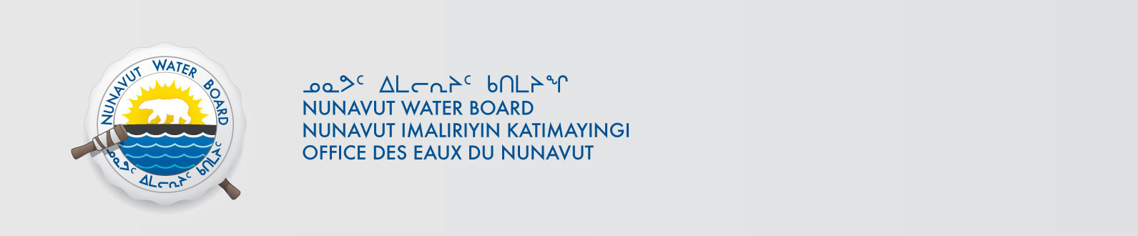

March 20, 2014 File No: NWB2ATU9899 3BM-PEL0712

To: Hamlet, CLARC, HTO, RIA, Coop, and NorthernLocal Organizations – Request to Post Notices

The Nunavut Water Board requests that you post on a bulletin board, until April 10, 2000April 20, 2014, the attached notices (in English and Inuktitut), where they can be viewed by the public. The attached letter is for your information only and does not require posting.

Your time and effort is greatly appreciated.

Sincerely,

Original signed by:

Megan Porter
Licensing Administrator Assistant

Cc:
Hamlet of Kugaaruk 867-769-6069
HTO 867-769-6713
Koomiut Co-op 867-769-6098

