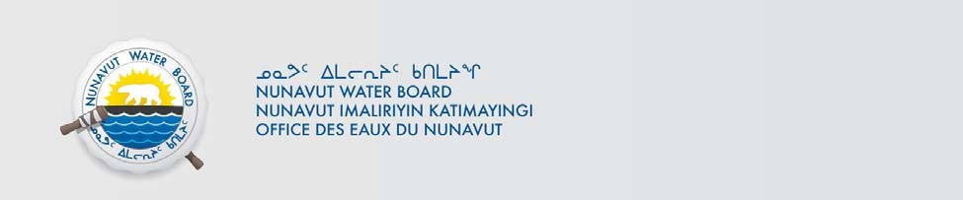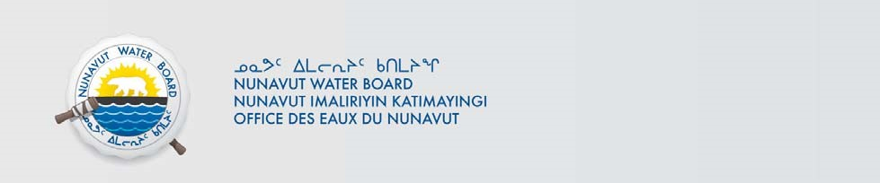

NWB File No: 3BM-PON1520
April 21, 2020

Bhabesh Roy
Municipal Planning Engineer
Community Government Services
Government of Nunavut
Baffin Region, Pond Inlet Box-379; X0A 0S0, Nuanvut
e-mail: BRoy@gov.nu.ca

Subject: Applications for Renewal of Water Licence 3BM-PON1520; Municipality of
Pond Inlet; Technical Review

Dear Mr. Roy,

The Nunavut Water Board (NWB or Board) has completed its technical review of the Renewal Application submitted to the Board for the municipality of Pond Inlet Water Licence 3BMPON1520.

Comments and recommendations have been provided pursuant to the NWB’s mandated responsibilities under the Agreement between the Inuit of the Nunavut Settlement Area and Her Majesty the Queen in Right of Canada and the Nunavut Waters and Nunavut Surface Rights Tribunal Act.

The NWB would like to provide the following comments:

Management Plans

Comment: Management Plans for Pond Inlet facilities are generally out of date and lacking in key information such as the current state of respective facilities. Management Plans to be updated, as per Part F, Item 2 of Licence 3BM-PON1520, include:

- Spill Contingency Plan;
- Sewage Treatment Facility Operations and Maintenance Plan;
- Sludge Management Plan;
- Solid Waste Management Facility Operations and Maintenance Plan;
- Landfarm Operations and Maintenance Plan; and
- Water Supply Facility Operations and Maintenance Plan.
1

Recommendation: The NWB recommends that the Licensee commit to providing updated management plans for all facilities, including a timeline to do so.

Ans. I am currently working from Ottawa Home and I have no access to the GN Office computer. Soon after the COVID 19 Pandemic is back to normal and Nunavut travel restriction is withdrawn, the updated versions of the management Plans of all the Facilities will be made available. I suggest renewing the licence with the conditions for late submission of the requested documents due to this current situation.

Status of All Facilities

Comment: From the information provided in the Application and that contained in the out of date Management Plans (see comment 1), it is unclear what the exact status of each facility is, if it is operating/performing as expected, and if there are plans for any upgrades or modifications. For example, Part F Item 1, of Licence 3BM-PON1520, requires “within Ninety (90) days from issuance of the Licence, submit to the Board for review, a Solid Waste Disposal Facility Update Report including photographic record, which demonstrates the implementation of the commitments and measures to clean-up existing facilities,” however this was never submitted and it is unclear if the commitments were implemented.

Recommendation: The NWB recommends that the Licensee briefly outline and confirm the status of each of the following facilities in accordance with Licence terms and conditions:
- Water Uptake and Treatment Facility;
- Sewage Disposal Facility; • Solid Waste Disposal Facility; • Landfarm Facility.

Ans. Water Uptake and Treatment Facility: Right now, the water truck fill station is shut down. Water is extracted directly from the lake, manually chlorinated and then sent for distribution following the GN-Health directive. At the same time, a consultant is working on the detailed design to repair the intake this summer.
The second consultant is working on the standardization of the new 9 Water Treatment Plants including the Pond Inlet one. The new facility is expected to be built and operational in 3 to 4 yrs.

Sewage Disposal Facility: This lagoon is being used as it is condition right now. No plan to update in the immediate future.

Solid wastes Disposal facility: This is a non -Engineered facility. A Feasibility study including the site selection is anticipated in next 1 to 2 yrs. in order to build a new facility.

Land farm: This facility is there but no use right now. The contaminated soil inside was already remediated.

If you have any questions or require clarification on the above, please contact Derek Donald, Technical Advisor, at (867) 360-6338 or by email at derek.donald@nwb-oen.ca, for any technical inquiries, or Richard Dwyer, Licensing Manager (867) 360-6338, by email licensing@nwb-oen.ca for any procedural or administrative inquiries.

Sincerely,
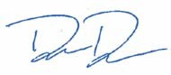
Derek Donald
Technical Advisor
Nunavut Water Board

cc. Distribution List – Qikiqtani
2

