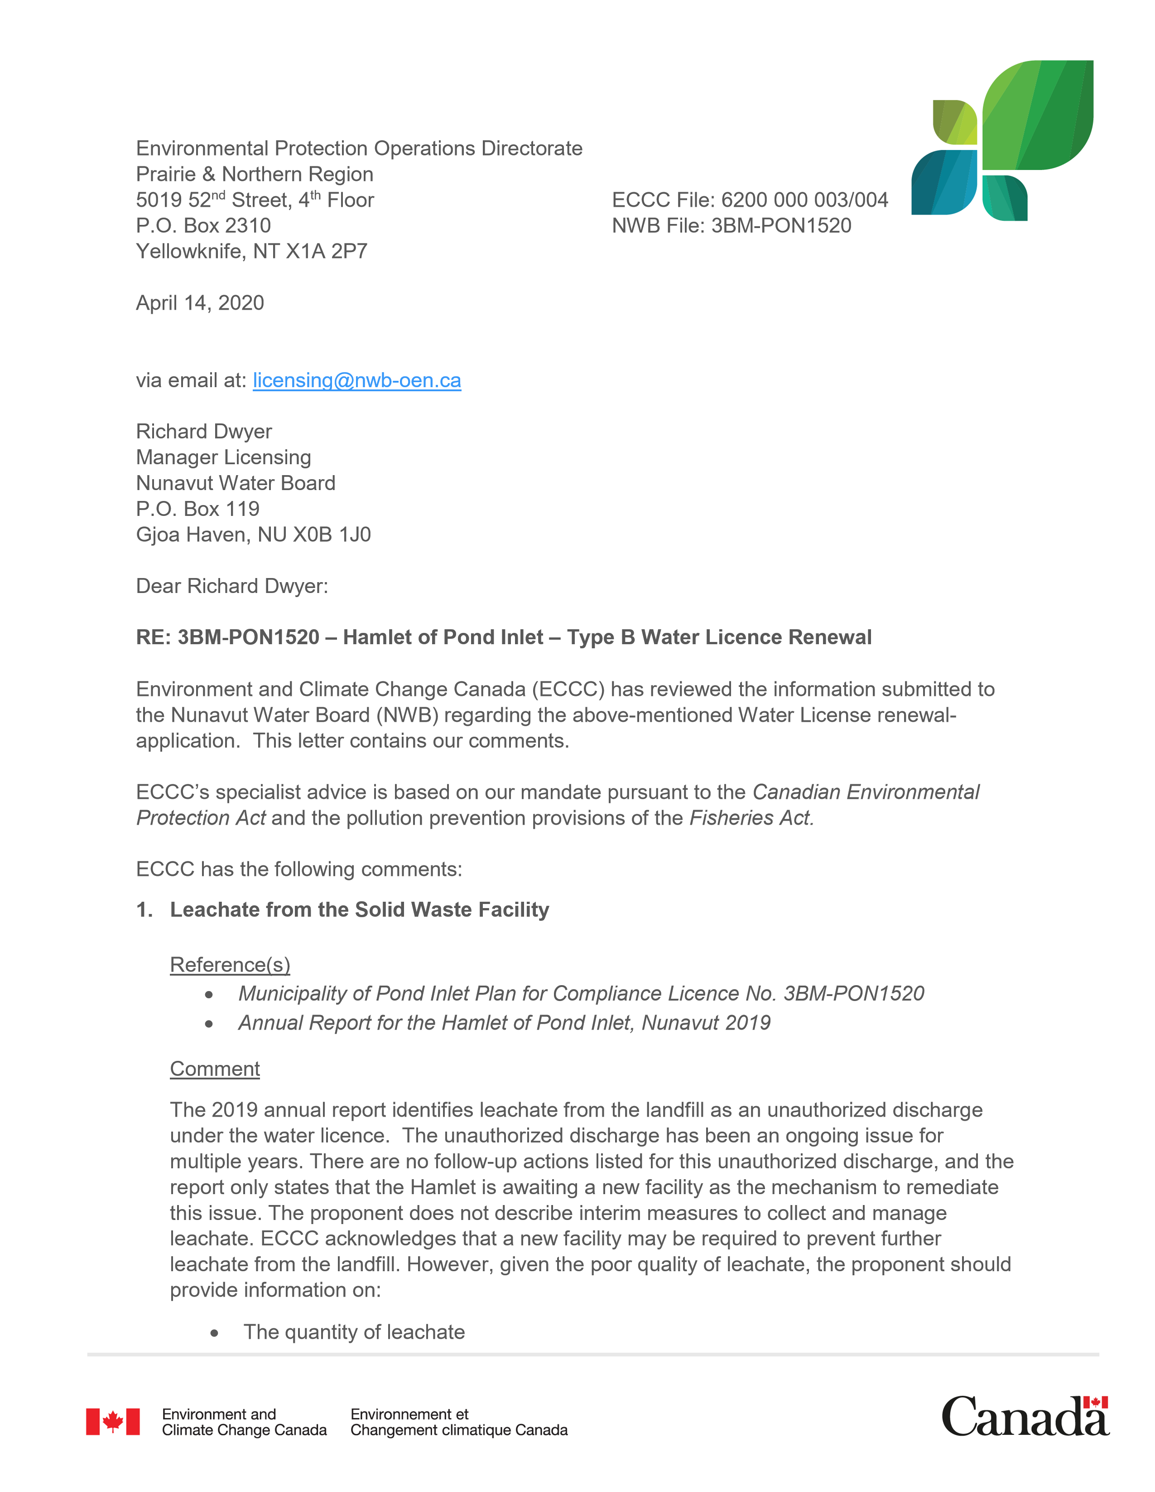
- where the leachate is occurring and reporting to; and
- what measures are being undertaken to collect all leachate such that it is not discharge to the receiving environment.
ECCC Recommendation(s)
ECCC recommends that the proponent take measures to attempt to capture all leachate from the landfill site, for appropriate management such that the leachate does not discharge to the receiving environment. In addition, the proponent should provide information on the quantity, and locations of leaching, as well as overall leachate management.
Ans. The existing Landfill is a non engineered facility and the leachate is uncontrolled. The leachate will be tested 3 to 4 times in summer as long as the flow is seen and sampling station will be established with GPS coordinates. The leachate flows into the nearby natural ditch and highly diluted there prior to meeting the receiving body.
However, the new facility is anticipated to be built to control the leachate and treated inside the facility before discharging to the land. This facility is under planning stage at this moment and expected to be built in next 3 to 4 years.

- Monitoring Results

Reference(s)
  - Hamlet of Pond Inlet 2019 Monitoring Results.
Comment
The Proponent has included monitoring data for five different monitoring stations. However, it is not clear to ECCC where this sampling occurred, because the proponent did not provide a figure that indicated sampling locations or the effluent flow path. In addition, although the proponent did include sampling data, they did not include associated QA/QC results (i.e., trip blank, field blank, duplicates) with the submission.
ECCC Recommendation(s)
ECCC recommends that the proponent:
  - provide a figure depicting monitoring locations and general site layout
  - provide QA/QC data associated with the 2019 monitoring results.

Ans. Hamlet will be using a GPS set to establish the monitoring station with Coordinates and name the monitoring station which correspond to the sampling and testing results. The Hamlet foreman has been trained to follow the conditions of the Monitoring Program of the Hamlet water licence.

I am currently working from Ottawa home and have no access to my office computer. Therefore, the updated QA/QC Plan will be made available soon after COVID 19 Pandemic situation is back to normal and travel restriction is withdrawn.

- Effluent Quality

Reference(s)
  - Municipality of Pond Inlet Plan for Compliance Licence No. 3BM-PON1520
Comment
As per the ‘Plan for Compliance’, the Proponent indicates that all wastewater discharges associated with PON-4 comply with the licence limits, and refers the reviewer to the 2019 monitoring results. Upon review of these results (October 2019 wastewater), ECCC notes that the following parameters exceed relevant effluent quality criteria:
  - TSS – 680 mg/L (EQC = 180 mg/L)
  - BOD5 – 245 mg/L (EQC = 120 mg/L)
In addition to this, the concentrations of ammonia as nitrogen (86 mg/L) and iron (24.3 mg/L) are elevated, and may cause impacts to aquatic life. The proponent has not provided any mitigation measures to address these exceedances in effluent quality criteria, or indicated what are the potential impacts to aquatic life. ECCC notes that work is underway to finalize development of the Northern Wastewater Regulations, and that upon enactment of those regulations it will be necessary to meet standards that are below current discharge quality achieved by the Pond Inlet treatment system.
ECCC Recommendation(s)
The Proponent should identify measures to optimize current treatment, and to improve effluent quality for the long term.
Ans. This Lagoon was built and commissioned in around 2004/5 and very close to its life expectancy. The future facility will address this requirement and definitely satisfy the new regulations of the Northern Wastewater Regulations.
Also, Hamlet has been advised to be very careful for sampling, preservation of samples and shipping the samples to the Ottawa Lab for testing to have better results.
- Updates to Plan for Compliance

Reference(s)
  - Municipality of Pond Inlet Plan for Compliance Licence No. 3BM-PON1520
Comment
ECCC notes that not all sections of the Plan for Compliance have been updated with information relevant to the 2020 renewal process, and that several sections still contain references to planned activities in 2014 (i.e., from during the previous renewal process).
ECCC Recommendation(s)
ECCC recommends the Proponent revise the Plan for Compliance in order to ensure that all information provided is updated and relevant to the current water licence renewal process.
Ans. The Updated Plan for Compliance is attached.

If you need more information, please contact Eva Walker at (867) 669-4744 or Eva.Walker@Canada.ca.

Sincerely,

[Original signed by]

Eva Walker
Environmental Assessment Coordinator

Attachment(s):

cc: John Olyslager, Acting Head, Environmental Assessment North (NT and NU)

