Quality Assurance / Quality Control Plan
(QA & QC PLAN)

Updated October 2024

Municipality of Qikiqtarjuaq

.
Hamlet of Pond Inlet Quality Assurance / Quality Control Plan Oct. 2024

Table of Contents page
1.0 Introduction 3

Monitoring and Regulatory Requirement Program ------------------------------------------------------------------------- 4
  - Objectives 4
  - Scope of Work 4
  - Definitions 4

Field Sampling --------5
  - Sampling Procedures 6
  - Sampling Collection 6
    - 1 Sampling Equipment 7
    - Sampling Methods 7
      - 1 Wastewater sampling 7
      - 2 Landfill runoff sampling 7
      - Groundwater sampling 7
  - Sample Handling 8

Quality Assurance and Quality Control Program 8
  - Laboratory Accreditation 8
  - Method detection Limits 8

5.0 Annual Reporting Requirements 9

Annual Water Consumption and Sewage Report for Municipality of Qikiqtarjuaq ……………………….……10

References …………………………………………………………………………………………………………………….11

Figure -1: Water Licensed Facilities 10
Table -1: Monitoring Stations 6
Appendix-A: Summary of sample bottle Requirements ………………………………………………………………11
Appendix-B: Environmental Monitoring Program check list…………………………………………………………………………14
Appendix-C: Completed example of chain of custody documentation …………………………………………………………….16
Appendix-D: Environmental Monitoring Program guidelines…………………………………………………………………………18
Appendix-E: Letter of Support by CADUCEON lab -------------------------------------------------------------------------------------------------21
Appendix-F: CALA Certification to CADUCEON Lab-----------------------------------------------------------------------------------------------23

Municipality of Pangnirtung Quality Assurance / Quality Control Plan, Oct. 2024

  - Introduction

The Municipality of Qikiqtarjuaq is located at Latitude 67⁰ 33’N and Longitude 64⁰ 02’W on Broughton Island, off the eastern coast of Baffin Island, adjacent to Auyuittuq approximately 470km NE of Iqaluit, in the Qikiqtani Region of Nunavut. The population of the Community in 2024 is 657. Currently they have four facilities under the Water Licence # 3-BM-QIK1924,Type B. The 4th facility is a Land farm. This facility has been redesigned and attached. This is expected to be built in 2025.

The current licensed four facilities are:

    - Water Supply

    - Sewage Lagoon

    - Municipal Dump sites;

      - Domestic waste

      - Metal waste

    - Land Farm

Item 3 is a non-engineered facility. No design and drawings is available. The O&M manual did not exist at the past. Therefore, Hamlet is not following any regulatory protocol managing the community wastes. The metal wastes site has no fencing.

Both sites 3(a) and 3 (b) are full. Community is expecting a new engineered facility to accommodate all the wastes satisfying the regulatory requirements.

Hamlet has installed all the Monitoring signs at the waste sites. They have been doing extensive sampling program following GN-CGS sampling guidelines.

Hamlet has started segregation of hazardous waste and they like to continue each year following the guidelines of GN-DOE.

Nunavut Water Board (NWB) issued a Class B Water Licence (3BM-QIK 1924, Type B the Hamlet on September 20 2019. The water licence governs water use and waste disposal within the Hamlet.

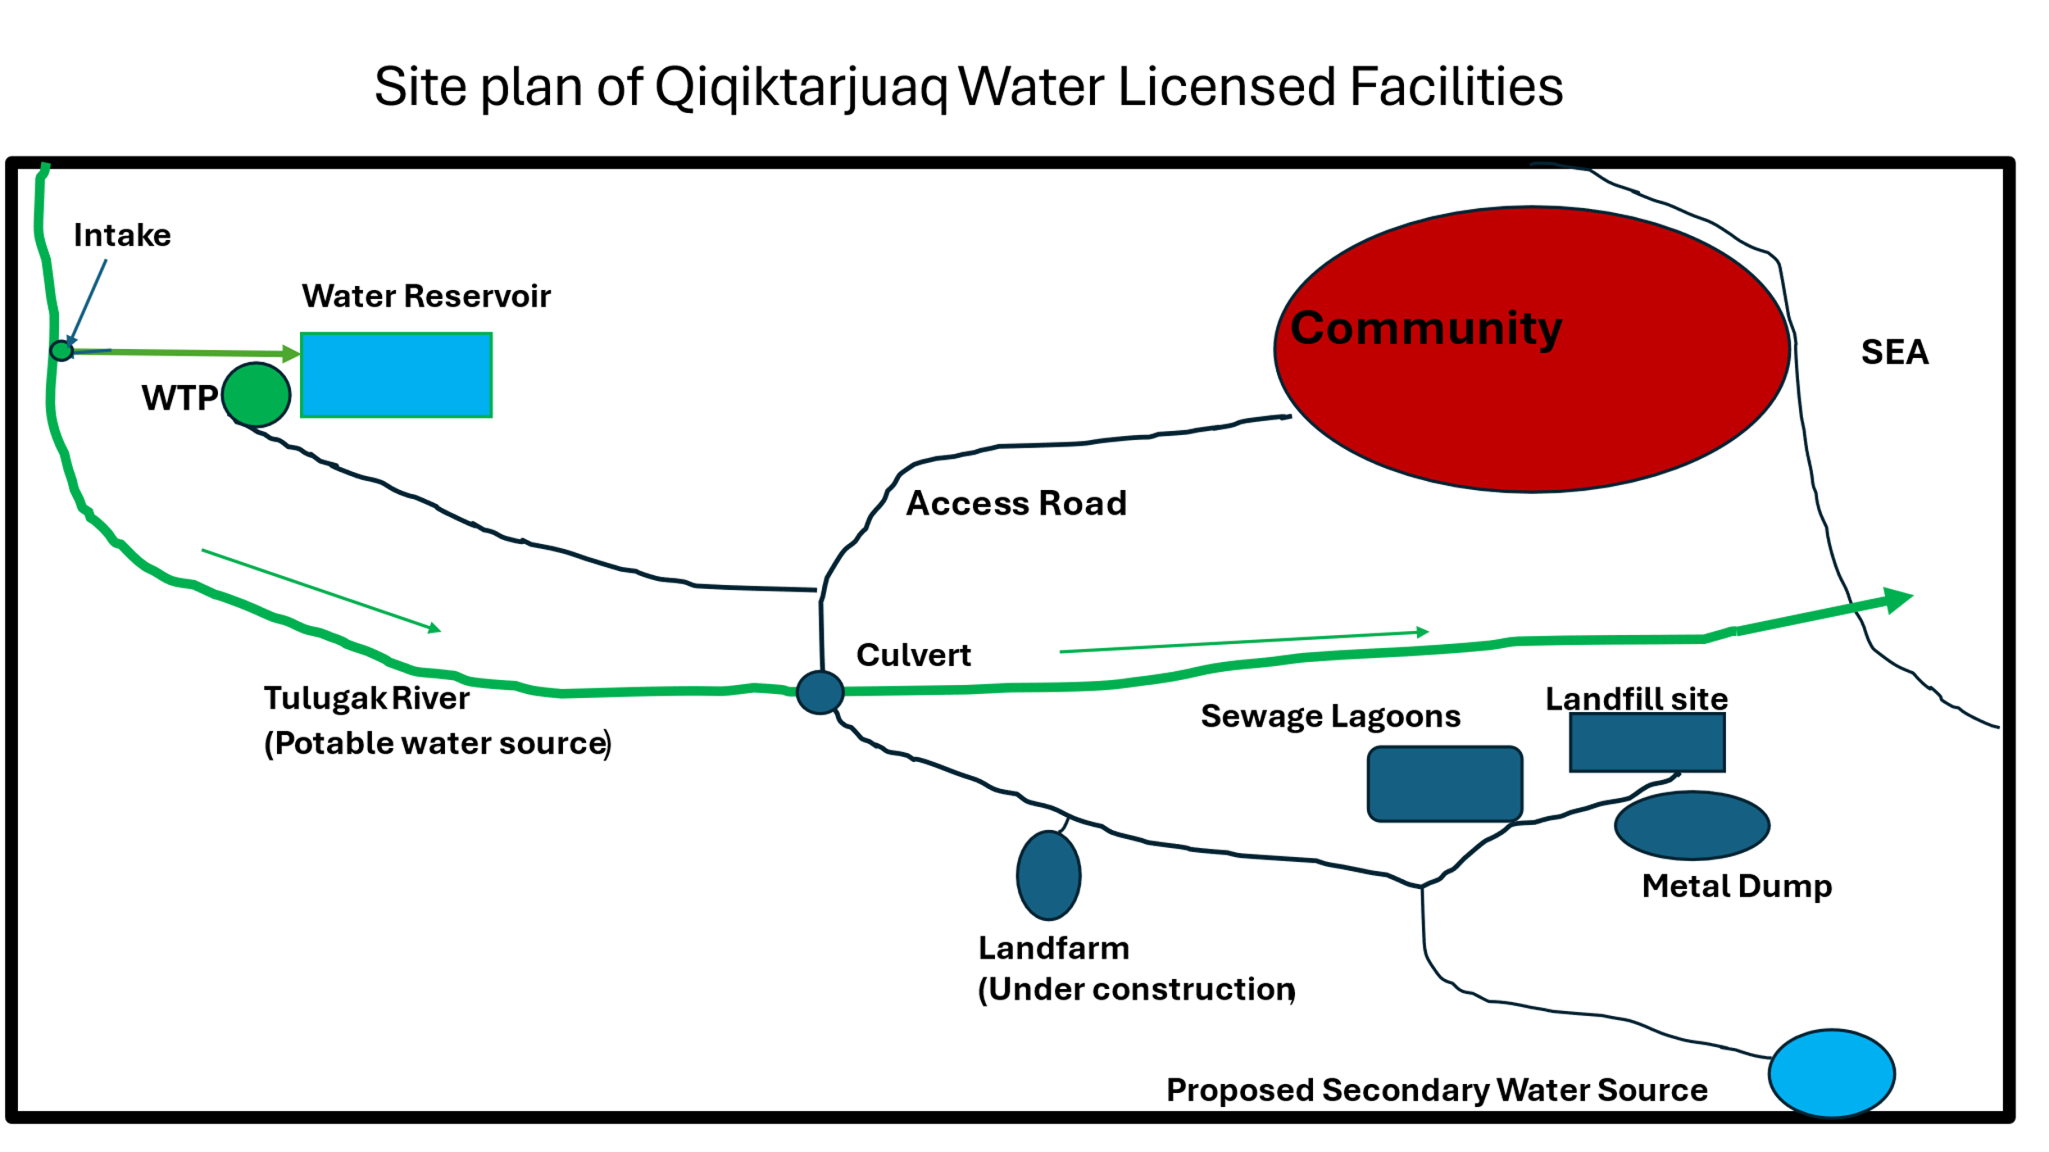
  - Monitoring and Regulatory Requirement Program

Item 2(g) of Part F and item 13 of Part H of the water licence issued to the Hamlet requires that the Hamlet submit to the NWB for approval, a Quality Assurance / Quality Control (QA/QC) and Monitoring Program Plan that conforms to the guidance document QA/QC guidelines for use by class “B” Licensees in collecting representative water samples in the field and for submission of a QAQC Plan INAC (1996). The Plan shall be acceptable to an accredited laboratory and include a covering letter from the accredited Laboratory confirming acceptance of the Plan for analysis to be performed under the Licence.

Objectives
The objectives of this QA/QC plan are to: i) to ensure the reliability of the data collected during monitoring activities at the locations specified in the Hamlet’s water licence, and ii) satisfy the requirement of the water licence.

Scope of Work
This QA/QC Plan covers the environmental monitoring undertaken at the Hamlet’s truck fill station, solid waste disposal site, and Sewage Disposal Facility and Land farm.

Definitions
The following definitions that are relevant to this plan include:
Quality Assurance is a system that ensures that quality control procedures are correctly performed and documented.
Quality Control refers to the established procedures observed both in the field and in the laboratory, designed to ensure that the resulting end data meet intended quality objectives.
Trip Blank is a sample of clean water that was prepared by the analytical laboratory and shipped to the sample site in the cooler along with the empty sample bottles. This trip blank sample remains unopened and is transported back to the laboratory with the monitoring program samples. The trip blanks is analyzed by the laboratory along with the monitoring program samples. The purpose of the trip blank is the assess contamination introduced during shipping and field handling procedures.
CALA refers to the Canadian Association for Laboratory Accreditation, formally known as the Canadian Association for Environmental Analytical Laboratories (CAEAL).
Chain of Custody Documentation refers to the documentation that accompanies samples sent to an analytical laboratory. It is a legal document which ensures that the sample taken at a specific site is the same sample received in the laboratory. It also provides information on the sample condition and integrity as received by the laboratory.

2

.
Hamlet of Pond Inlet Quality Assurance / Quality Control Plan Oct. 2024

Field Sampling

  - Sampling Procedures
All sampling, sample preservation and analyses is to be conducted in accordance with methods described in the current edition of Standard Methods for the Examination of Water and Wastewater (American Public Health Association, American Water Works Association, and Water Environment Federation, most current edition).
To obtain meaningful results from the analyses, the following six factors are of particular importance:
- Sample collection as per schedule and location.
- Correct usage of container/sample bottle for parameter being tested.
- Correct labeling of sample bottles and filling out record/field sheet.
- Correct procedure for field sampling.
- Proper and timely shipment of samples to the laboratory.
- Timely delivery of samples to the laboratory from the air cargo facility.

  - Sampling Collection
Refer to the Environmental Monitoring Program Checklist, found in Appendix C for specific details on the sampling locations, equipment and sampling methods.

Monitoring and Sampling

Table-1: Monitoring Stations

Monitoring Station | description | Program station
Qik-1 | Raw Water Supply intake at Tulugak River (Volume) | 0640-1
Qik-2 | Raw water supply intake at the Reservoir Truck Fill Station (Volume) | 0640-2
QIK-3 | Raw sewage from pump out Truck | 0640-3
QIK-6 | Discharge from the Sewage Disposal Facilities before, during and at the completion of discharge | 0640-6
QIK-8 | Run-off from the Solid waste disposal Facilities that has collected within the constructed collection pond. | 0640-8
QIK-12 | The Final Discharge Point of the Wetland Treatment Area | 0640-11
Qik-13 | Monitoring well located up gradient of the solid waste disposal facilities | 0640-12
QIK-14 | Monitoring Well located down gradient of the Solid waste disposal facilities | 0640-13
QIK-15 | Monitoring well located down gradient of the Waste Metals Area | 0640-14
QIK-16 | Monitoring well located up gradient of the Land farm Facility | After this facility is built ,  0640-15
QIK-17 | Monitoring well located down gradient of the Land farm Facility | After this facility is built,  0640-16
QIK-18 | Discharge from the Land farm Facility at the controlled point of release | After this facility is built,  0640-17

Hamlet of Cape Dorset Quality Assurance / Quality Control Plan, Oct. 2024

Sampling Equipment
Dedicated latex or nitrile gloves (i.e., one pair per sample) are to be used during sample handling.
Dedicated sampling equipment such as sampling poles (see photo below for an example) are to be cleaned with
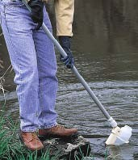
soap and water after each sample is collected to prevent cross-contamination.
Environmental monitoring samples collected for analysis of selected chemical parameters are to be placed directly into new pre-cleaned, laboratory-supplied sample bottles. All monitoring samples are to be placed in clean coolers for transportation to the subcontract laboratory. The samples are transported/submitted under Chain of Custody documentation. Included on a Chain of Custody form is the client information, the sample information, the analyses requested, the relevant regulations, the turnaround time for the analytical results, comments, and temperature of the samples at the time they arrived in the laboratory. An example of a completed Chain of Custody form is included in Appendix D.

Sampling Methods
Please see Appendix D for the Environmental Monitoring Program Schedule. As a general recommendation, please refrain from using insect repellant, disinfection hand gel or other chemical products before and during sample collection. Also, please refrain from smoking during sample collection.

Wastewater Sampling
Sewage Lagoon and Wetland:
        - Collect raw sewage sample directly from the truck once in summer every year to establish the base line data.
        - Collect effluent samples from QIK-6 three times, at the beginning of decanting, at the middle of decanting and at the end of decanting.PON-6 is the compliance point.

Landfill Runoff Sampling
Landfill runoff is collected once monthly during periods of observed flow from Station Qik-8. Runoff samples are collected from the receiving water body by immersing the sample bottle into the runoff stream neck first to a depth of 5 to 10 cm (if possible). The sampling container is filled with runoff and the sample bottle is raised neck first to prevent sample spillage.

7

.
Hamlet of Pond Inlet Quality Assurance / Quality Control Plan, Oct. 2024

Sample Handling
All water samples are to be collected in laboratory-supplied containers with the proper preservative, where applicable. A complete list of parameter handling and preservatives can be found in Appendix -B.
All sample containers are to be tightly sealed and properly labeled with the sample ID, date and time of sample collection, location of sample collection and parameters to be analyzed. The outside of the bottles are to be cleaned with soap and water after sampling and dried off prior to placing the samples in the cooler. The samples are to be stored on ice in a cooler until delivery to the laboratory. A chain of custody form is to be filled out completely and is used to track the samples and placed in the cooler with the samples, in a zip lock bag. Keep the last page of the Chain of Custody and give it to the Hamlet Foreman for their records.
The following checks are generally performed by the laboratory upon receipt:
- Verification of the integrity and condition of all sample coolers.
- Verification of the integrity and condition of all sample containers.
- Checks for leakage, cracked or broken closures or containers, evidence of grossly contaminated container exteriors or shipping cooler interiors, and obvious odours, etc.
- Verification of receipt of complete documentation for each container.
- Verification that sample identification numbers on sample transmittal forms corresponds to sample identification numbers on the sample containers.
- Verifications that holding times were met and samples were kept cool during transit.

Quality Assurance and Quality Control Program
Cross contamination is a common source of error in sampling procedures. QC samples help identify when and how contamination might occur. There are various types of QC samples. For the purposes of the Hamlet’s environmental monitoring, we recommend the use of trip blanks. It is essential to request a trip blank sample to be prepared when placing the bottle order with the contract Laboratory.
  - Laboratory Accreditation As indicated in the Guidelines, the Hamlet should use an analytical laboratory accredited by the Canadian Association for Laboratory Accreditation (CALA); formally known as the Canadian Association for Environmental Analytical Laboratories (CAEAL) for the monitoring program for NWB Licence 3BM-
-QIK 1924.. Appendix F includes a copy of the laboratory’s CALA accreditation certificate and a list of the parameters for which they are certified.

  - Method Detection Limits: The method detection limits (MDLs) are provided on the contract laboratory’s Certificates of Analysis. Hamlet of Pond Inlet is using Caduceon Environmental Lab in Ottawa and following their lab procedure.

5.0 Annual Reporting: As a condition of Part B: General conditions of Municipality of Qikiqtarjuaq water licence #:
3BM-QIK 1924 , the Hamlet is required to submit an Annual Report to the NWB, no later than March 31 of the year
following the calendar year reported. Among other requirements, the annual report is required to include tabular summaries of all analytical data generated under the Monitoring Program (compared to the Maximum Average Concentrations – provided in Part D of the NWB Licence 3BM-QIK 1924 where applicable).

Annual Water Consumption and Sewage disposal Report for the Municipality of Qikiqtarjuaq
(Template)

YEAR BEING REPORTED:

The following information is compiled pursuant to the requirements of Part B, Item 1 of Water Licence # 3BM-QIK 1924 issued to the Hamlet of Pond Inlet.

    - - iii) tabular summaries of all data generated under the “Monitoring Program”; monthly and annual quantities in cubic metres of freshwater obtained from all sources; monthly and annual quantities in cubic metres of each and all wastes discharged;

Attached are quantities of water used as reported in our On Tap Water Delivery System and the estimated discharge of sewage waste based on quantities used.

Month Reported | Quantity of Water Obtained from all sources (litres) | Quantity of Sewage Waste Discharged  (Estimated)
January
February
March
April
May
June
July
August
September
October
November
December
ANNUAL TOTAL
Note: Consumption volume of water is considered as equal to discharge volume.

References:
exp’s QA/QC Plan for the Hamlet of Cape Dorset, 2011

Quality Assurance (QA) and Quality Control (QC) Guidelines for use by Class “B” Licensees in Collecting Representative Water Samples in the Field and for Submission of a QA/QC Plan, Department of Indian and Northern Affairs Canada, July 1996.
Standard Methods for the Examination of Water and Wastewater, American Public Health Association, American Water Works Association, and Water Environment Federation, 22nd Edition, 2012.

Appendix A: Summary of Sample Bottle Requirements

Sample Bottle Requirements for Parameters Listed in Conditions 4 & 6 of Part H of Water Licence No. 3BM‐QIK1924.

 | Recommended  Sample Container | Preservative | Hold Time, days
Alkalinity | 250 mL Plastic | None | 14
Anions (Br, Cl, F, NO3, NO2, PO4, SO4) | 250 mL plastic | None | 5/28
Biochemical Oxygen Demand (BOD5) | 250 mL plastic | None | 4
Carbonaceous Biochemical Oxygen Demand (CBOD5) | 500 mL plastic | None | 4
Carbon, Total Organic (TOC) | 500 mL plastic | H2SO4 (pH<2) | 10
Conductivity | 250 mL plastic | None | 28
Dissolved ICPMS, ICP Metals | 250 mL plastic | Nine-if not field filtering | 60
Total ICPMS, ICP Metals ‐ NOT FILTERED | 250 mL plastic | HNO3 ) (pH<2) | 30
Nitrogen ‐ Ammonia ( NH3 ‐ N ) /  Total Kjeldahl Nitrogen ( TKN ) | 250 mL plastic | H2SO4 (pH<2) | 10
Solids ‐ ( TS, TSS, TDS ) | 250 mL plastic | None | 7
Microbiological (incl. faecal coliforms) | 250 mL plastic | Na2S2O3 | 48
Total Hardness | 250 mL plastic |  | 28
Phenols‐Total | 120 mL amber glass | H2SO4 (PH<2) | 30

APPENDIX-B: Environmental Monitoring program Checklist

Environmental Monitoring program Checklist Hamlet of Qikiqtarjuaq
Pre-sampling Activities
Bottle order | At least two weeks before upcoming environmental sampling, send a request to the contact laboratory for the appropriate sample sets for the required sampling test groups. | o
Personnel protective equipment | Ensure that the required personal protective equipment (PPE), such a latex gloves, is on hand before commencing the environmental monitoring program, | o
Bottle shipment | Ensure that the bottle shipment has arrived from the contract laboratory in time for the sampling program and verify the integrity of all sampling containers. | o
Sampling location Inspection | Perform an initial inspection of all routinely-monitored sampling locations before the commencement of the monitoring program. Make note of any equipment damage or conditions that may prevent the collection of the environmental  monitoring program samples. | o
General sampling instruction
Prevention Case Contamination | Ensure that any laboratory provided sampling instructions as strictly followed. Latex or nitrite gloves should be worn during sampling and should be replaced with fresh gloves after all sample containers are filled at each sampling location. Dedicated sampling equipment such as sampling poles should be cleaned with soap and water after each sample is collected to prevent cross-contamination. As a general recommendation, please refrain from using insect repellant,  disinfection hand get gel or other chemical products before and during sample collection. Also, please refrain from smoking during sample collection. | o
Sample care(including packing of cooler) | All sample containers should be tightly sealed and properly labeled with the sample ID, date and time of sample collection. Location of sample collection and parameters to be analyzed. The outside of the bottles should be cleaned with soap and water and dried prior to placing the samples in the cooler. The samples should be stored on ice in a cooler until delivery to the laboratory. A chain of custody form should be filled out completely and be used to track the samples and placed in the cooler with samples, in a Ziploc bag. Keep the last  page of the chain of custody and give it to the Hamlet Foreman for their records. | o
Raw water supply
Sampling Station QIK-1 | Volume is being calculated daily, monthly and annually. | o
Sewage disposal facility
QIK-6 | Discharge from the Sewage disposal Facilities before, during and a completion of discharge | o
 | Solid waste facility
Qik-8 | Land fill runoff (leachate) is collected once monthly during periods of observed flow .Runoff samples are collected from the receiving water body by immersing the sample bottle into the runoff stream neck first to a depth of 5 to 10cm if possible. The sample container is filled with runoff and the sample bottle is raised neck first to prevent sample spillage

Appendix C: Completed Example of Chain of Custody Documentation (Template and an example)

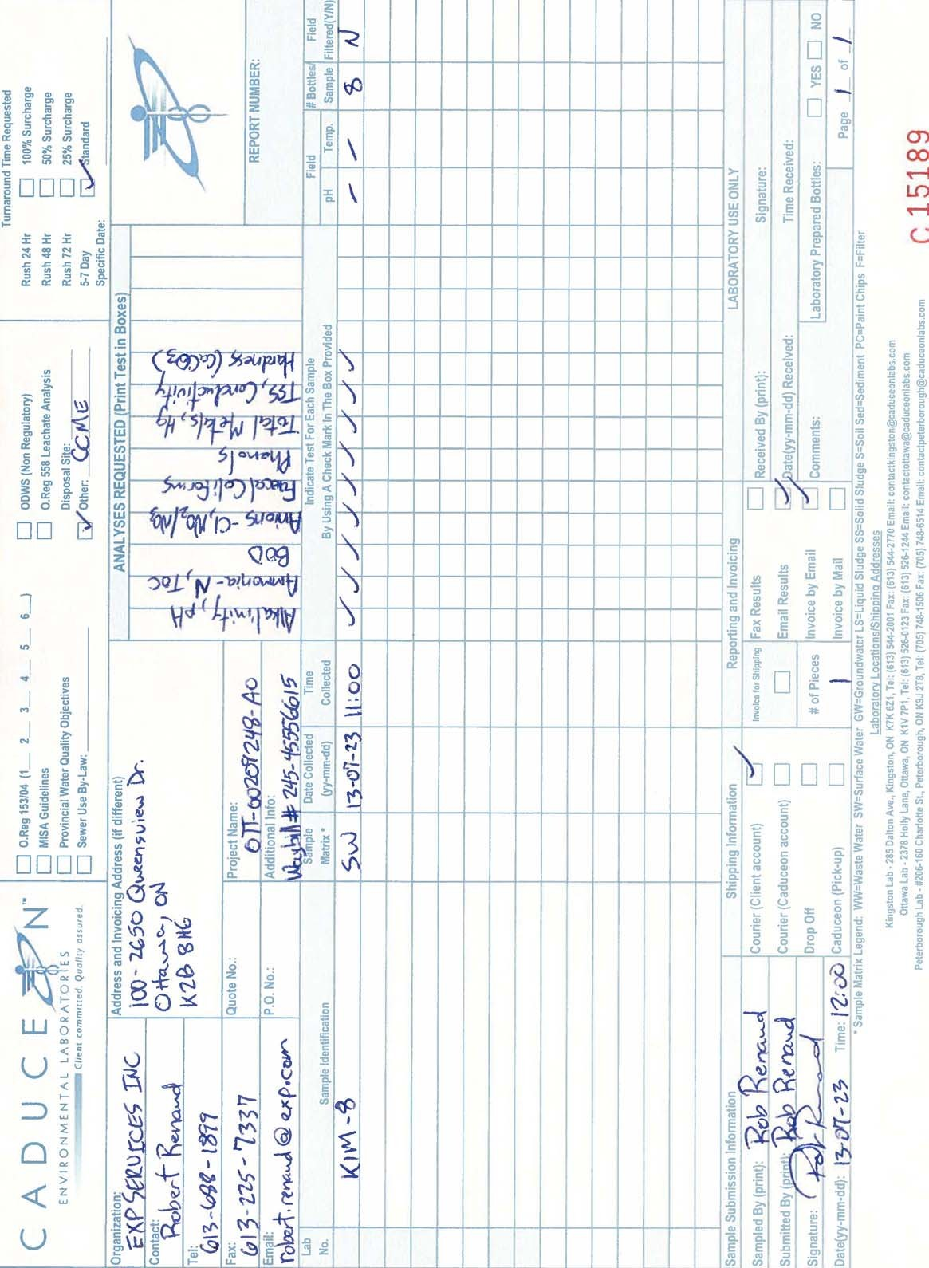

Appendix D: Environmental Monitoring Program guidelines and Schedule

Guidelines for Water, Wastewater and Leachate Sampling Baffin Communities
Drinking water:

Monthly Sampling: (Bacteria analysis)

      - Collect five samples (200 ml each) from five different locations and send to Iqaluit Health Lab though your local health center. One of the five samples should be raw water sample.
Once in month if population is less than 1000.

Twice in a month if population is in between 1000 to 2000

Iqaluit Lab for all Baffin Communities. This Lab is now closed,

Environmental Health Department Health and Social Services, Baffin P.O.Box 1000, Station 1046
Iqaluit, NU, X0A 0HO
Note: All the bacteria samples from the Baffin Communities are tested by Caduceon Lab in Ottawa.

Annual Sampling: (Chemical Analysis)
      - Send samples to Ottawa Lab (All Baffin Communities) once a year for Chemical Analysis.
Caduceon Environmental Laboratories

Manager
2378 Holly Lane
Ottawa Ontario K1V 7P1 Tel: 613-526-0123
Fax: 613 526 1244

Precautions of Sampling:

- Be careful not to let the mouth of the bottle or lid touch anything including sampler’s fingers.
- Do not overfill the bottle or rinse out
- Fill the bottle to the 200ml line from water tap, valve or water truck delivery hose nozzle. When sampling from a water tap, remove screen, aerator or other attachment from tap and allow the cold water to run for 2‐3 minutes before collecting. Do not dip into the filled water truck tank to take a sample.
- Ensure each bottle label information is filled for:
‐ Date and time sample was taken
‐ Sample point location
‐ Sampler’s name
- Persons’ name and contact address where to send sample Test results and invoice.
- Samples must arrive at the Labs either Iqaluit or Ottawa within 24 hrs. from the time of sampling.

Wastewater:

- Collect treated samples from the first point of discharge of Sewage (end of pipe).
- Collect raw samples directly from the truck discharge

Leachate:

- Collect five leachate samples from the land fill site

Sample bottles specifications for Wastewater and leachate:
Five samples should be taken from a point in five different bottles:
Bottle 1: 500 ml
Bottle 2: 100 ml
Bottle3: 1000 ml
Bottle 4: 250 ml
All the wastewater and Leachate samples will be sent to Ottawa Lab.
Manager
Caduceon Environmental Laboratories
2378 Holly Lane
Ottawa Ontario K1V 7P1 Tel: 613-526-0123
Fax: 613 526 1244

Precautions of sampling:

  - Use hand gloves
  - Ensure each bottle level information is filled:
- ‐Date and time sample taken
- ‐Location with GPS coordinates
- ‐Sampler’s name
  - Person’s name and contact information where to send sample Test Results and invoice.

  - Samples must be arrived Ottawa Lab within 24 hours from the time of sampling.

APPENDIX-E: SUPPORT LETTER BY CADUCEON LAB, OTTAWA

APPENDIX-F: CALA CERTIFICATION TO CADUCEON LAB., OTTAWA

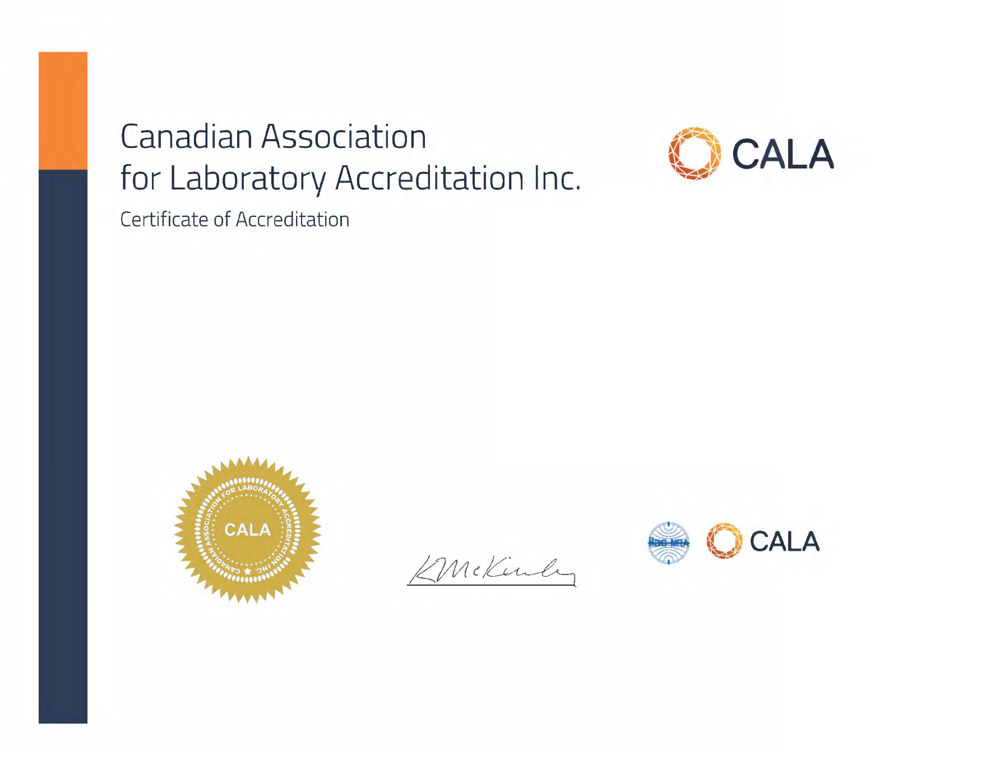

Caduceon Environmental Laboratories (Ottawa) Caduceon Enterprises Inc.
2378 Holly Lane Ottawa, Ontario

This laboratory is accredited in accordance with the recognized International Standard ISO/IEC 17025:2017.
This accreditation demonstrates technical competence for a defined scope and the operation of a laboratory quality management system (refer to joint ISO-ILAC-IAF Communiqué dated April 2017).

Accreditation No.: 1002644 Issued On: 1/13/2023
Accreditation Date: 1/3/2005 Expiry Date: 7/13/2025

President and CEO

This certificate is the property of the Canadian Association for Laboratory Accreditation Inc. and must be returned on request; reproduction must follow policy in place at date of issue. For the specific tests to which this accreditation applies, please refer to the laboratory’s scope of accreditation at www.cala.ca.

