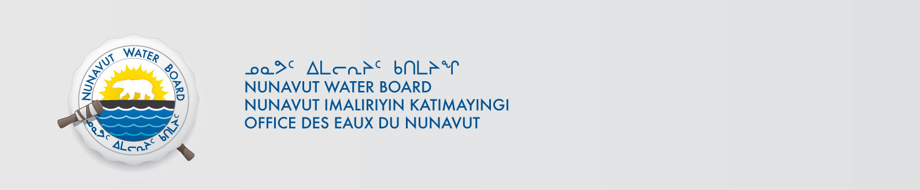

July 2, 2019 NWB File No: 3BM-QIK1419

Geela Kooneelusie, Senior Administrative | Bhabesh Roy, Municipal Planning Engineer
Hamlet of Qikiqtarjuaq | Community & Government Services
PO Box 4 | PO Box 379
Qikiqtarjuaq X0A 0B0 | Pond Inlet X0A 0S0
munqik@qiniq.com | broy@gov.nu.ca

Subject: Application Acknowledgement for Hamlet of Qikiqtarjuaq Water Licence Renewal

Dear Ms. Kooneelusie:

The Nunavut Water Board (“NWB”) acknowledges receipt on June 17, 2019 of your renewal water licence application, for Hamlet of Qikiqtarjuaq. This application has been assigned file number 3BM-QIK1419. Please refer to this number on future submissions. Application documents received are as follows:

- 190617 3BM-QIK1419 2019-04-29 NPC letter re 149074
- 190617 3BM-QIK1419 Application Renewal
- 190617 3BM-QIK1419 Cover Letter
- 190617 3BM-QIK1419 Executive Summary English
- 190617 3BM-QIK1419 Executive Summary Inukitut
- 190617 3BM-QIK1419 Hazardous Waste Segregation , Storage and Transportation June , 2019
- 190617 3BM-QIK1419 Letter of Authorization
- 190617 3BM-QIK1419- Plan for Compliance Qik-June ,2019
- 190701 3BM-QIK1419 2016 Annual Report
- 190701 3BM-QIK1419 2018 Annual Report B18-28049_R
- 190701 3BM-QIK1419 2018 Annual Report B18-28050_R
- 190701 3BM-QIK1419 2018 Annual Report B18-28051_R
- 190701 3BM-QIK1419 2018 Annual Report B18-28052_R.pdf
- 190701 3BM-QIK1419 2018 Annual Report B18-32499_R
- 190701 3BM-QIK1419 2018 Annual Report B18-32501_R
- 190701 3BM-QIK1419 2018 Annual Report Certificate of Analysis
- 190701 3BM-QIK1419 2018 Annual Report
- 190701 3BM-QIK1419 Executive Summary of the Municipality of Qikiqtarjuaq
- 190701 3BM-QIK1419 Response to NWB
- 190702 3BM-QIK1419 131001 Updated O and M water sewage and solid waste
- 190702 3BM-QIK1419 NWB Tech Advisor Comments

Please be advised that under the Agreement Between the Inuit of the Nunavut Settlement Area and Her Majesty the Queen in Right of Canada (Nunavut Agreement) Article 11, Section 11.5.9 and s. 76 (1) of Nunavut Planning and Project Assessment Act (NuPPAA), the proponent of a project governed by NuPPAA is also required to submit a project proposal document directly to the Nunavut Planning Commission (NPC or Commission) for the NPC’s determination regarding the applicable land use planning requirements and/or directions regarding whether the project is subject to screening by the Nunavut Impact Review Board. In particular, please note that as established under Articles 11, 12 and 13 of the Nunavut Agreement, NuPPAA and Part 3 of the Nunavut Waters and Nunavut Surface Rights Tribunal Act, until the project has completed the applicable land use planning and assessment process required by the NPC and the NIRB, the NWB cannot issue a water licence/approval.

The NWB confirms receipt of NPC conformity under NuPPAA on April 29, 2019 and NIRB determination through NPC under NuPPAA on April 29, 2019. This application is now ready for review and comments. Deadline for submissions is August 2, 2019.

Please call the undersigned at (867) 360-6338 or email to licensing@nwb-oen.ca if you have any questions.

Sincerely,

Richard Dwyer
Manager Licensing

