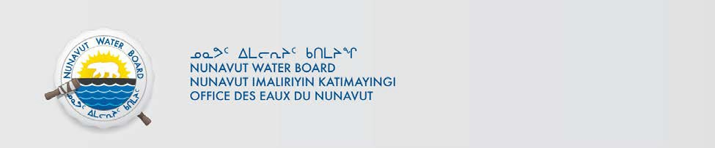

July 3, 2019

To: Local Organizations – Request to Post Notices

The Nunavut Water Board requests that you post, on a bulletin board, until August 2, 2019, the attached notices (in Inuktitut & English), where they can be viewed by the public.

Your time and effort is greatly appreciated.
Sincerely,

Richard Dwyer
Manager Licensing

Cc: | Hamlet of Qikiqtarjuaq | (867) 927-8120
 | Qikiqtani-IA | (867) 927-8196
 | Nattivak HTO | (867) 927-8525
 | Northern Store | (867) 927-8070

