YEAR BEING REPORTED: 2023

The following information is compiled pursuant to the requirements of Part B, Item 1 of Water Licence No. 3BM-WHA1520 issued to the Hamlet of Whale Cove.

Below are tabular summaries of all data generated under the “Monitoring Program”.

- Monthly and annual quantities of freshwater obtained by daily logs for all freshwater sources and estimated sewage waste discharged.

Table 1: Summary of water obtained from ls combined and estimated sewage water discharge in m³
Month Reported | Quantity of Water Obtained from all sources (m³) | Quantity of Sewage Waste Discharged  (m³)
January | 1,395.4104 | Same
February | 1,114.93311 | Same
March | 1,208.9198 | Same
April | 1,568.60455 | Same
May | 1,571.8372 | Same
June | 1,583.1379 | Same
July | 1,595.3477 | Same
August | 1,685.0595 | Same
September | 1,618.0539 | Same
October | 1,693.0319 | Same
November | 1,466.1629 | Same
December | 1,416.3081 | Same
ANNUAL TOTAL | 17,916.80696 | Same

Note: No meter exists to measure the sewage discharge volumes, therefore Sewage discharge volumes are considered equal to the water consumption volumes.

- A summary of modifications and/or major maintenance work carried out on the Water Supply and Waste Disposal Facilities, including all associated structures and facilities:

- Sewage decant permission was granted by Atuat Shouldice (Inspector- CIRNAC) on August 27, 2024

- A list of unauthorized discharges and summary of follow-up action taken:

Spills:

Table 5: List of spills reported to the NT-NU Spill Report Line and are listed on the Hazardous Materials Spills Database of Whale Cove in 2023

Spill | Occurrence Date | Location Description | Product Spilled | Quantity
20233023 | 17-July-2023 | Whale Cove | Petroleum – Fuel oil (Jet A, diesel, turbo A, heat) | 200.00L

- A summary of any abandonment and restoration work completed during the year and an outline of any work anticipated for the next year:
- None

- A summary of any studies requested by the Board that relate to waste disposal, water use or reclamation, and a brief description of any future studies planned:

- Community Government and Services and the Hamlet plan to undertake planning study in 2025, to develop a work plan for improvement to the land fill site.
Total funds allocated for the project is 10 million dollars

- Any other details on water use or waste disposal requested by the Board by November 1st of the year being reported; and
- None

- updates or revisions to the approved Operation and Maintenance Plans:
- None
ADDITIONAL INFORMATION THAT THE LICENSEE DEEMS USEFUL:

Water Licensing Sampling Points:
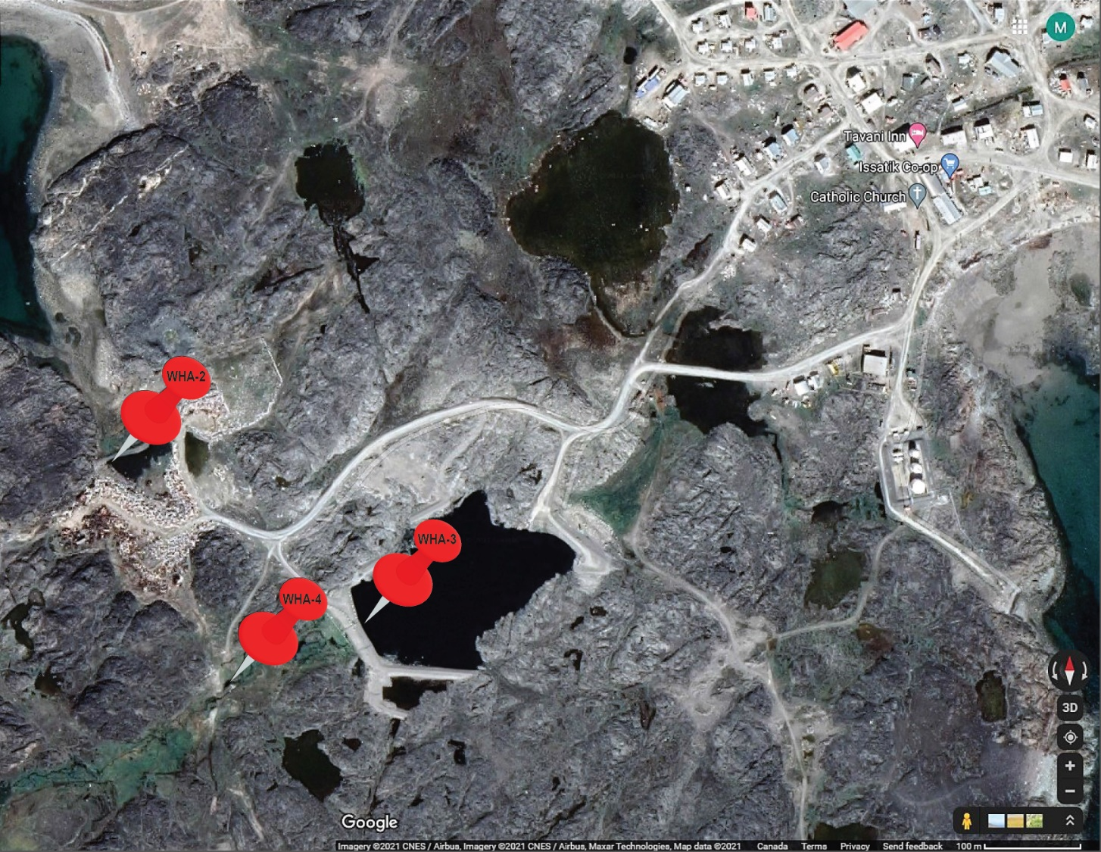
WHA-2: Runoff from Solid Waste Disposal Facilities
WHA-3: Final Discharge Point for effluent from the Sewage Disposal Facility prior to the wetland
WHA-4: Effluent outfall area from the wetland area

FOLLOW-UP REGARDING INSPECTION/COMPLIANCE CONCERNS:
- None

Appendix A: WHA-3 Effluent Quality Limits

Appendix B: Weekly Inspections at Monitoring Program Station

Appendix C: Certificate of Analysis July 22, 2024
Certificate of Analysis November 2, 2024

Appendix D: Hazardous Materials Spill Database, Whale Cove 2023

Appendix E: Whale Cove 2023 Sampling Summary

Appendix A

3BM-WHA1520 Whale Cove Monitoring Program Results 2023
WHA-3 Effluent Quality limits

Appendix B

Appendix C

Appendix D

Appendix E

