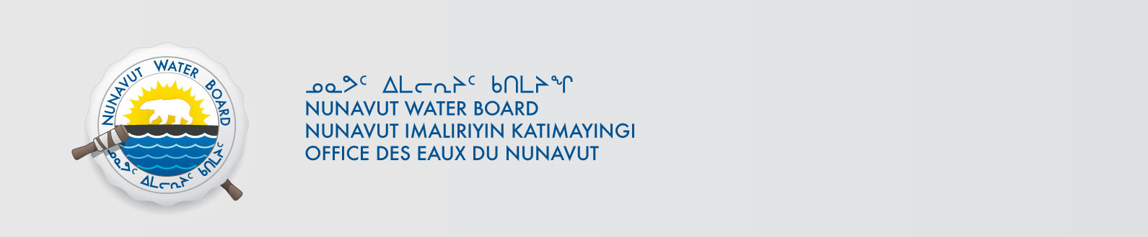

May 13, 2015 NWB File No: 7BL-AWL1015

Mr. Richard Weber
Canadian Arctic Holidays Limited
North Country Gold Corp.
369 Pritchard Road
Alcove, Quebec J0X 1A0
E-mail: Richard@arcticwatch.ca

Re: Acknowledgement and Receipt of Water Use Fees for Water Licence 7BL-AWL1015

Dear Mr. Weber:

The Nunavut Water Board acknowledges receipt on April 21, 2015 of your water use fees, cheque number 000620, for the above project. Your payment has been forwarded to Aboriginal Affairs and Northern Development Canada in Iqaluit for processing. A receipt will be issued through their office for fees totaling $30.00 for water use fees.

Please refer to the calculation for water use fees, in the Nunavut Waters Regulations, Section 12, to ensure that the correct fee has been submitted. A copy of this regulation is available from our ftp site or by contacting this office. This is an annual fee which is required to be submitted yearly on the anniversary of the issuance of your water licence.

Please call the undersigned at (867) 360-6338 or e-mail licensing@nwb-oen.ca if you have any questions.

Sincerely,

Phyllis Beaulieu
Manager Licensing

Cc: Jean Allen, AANDC

Melanie Netser, AANDC

