August 14, 2013 File No: NWB2NAN97027BL-EDE0611/TR/A

Christine Wilson
Resource Management Officer, Fields Operations Unit
Aboriginal Affairs
Nunavut Regional Office
P.O. 100
Iqaluit, NU X0A 0H0
Email: Christine.Wilson@aandc.gc.ca

Subject: Submission of Water License and Land use Permit Introduction letter for Inspection at Henik Lake Adventures Ltd. Drawings - Part G, Item 12

Dear Mr. Ledrew,Dear Ms. Wilson:

The Nunavut Water Board (“NWB”) acknowledges receipt, on July 04, 2013, of a submission from Aboriginal Affairs and Northern Development Canada, dated July 04, 2013, entitled Water Licence and Land use permit Inspection 2013. This submission has been placed on the NWB public registry and is available from the NWB ftp site, username public, and password: registry.
Received January 26, 2000
Notice of this report is forwarded to the distribution list for information only. Anyone wishing to provide comments may do so by return email to the Manager of Licensing at licensing@nunavutwaterboard.org.

Please note contact information as follows for the AANDC Inspectors:
Qikiqtani Region – Andrew Keim Andrew.Keim@aandc-aadnc.gc.ca
Kivalliq Region – Christine Wilson – Christine.Wilson@aandc-aadnc.gc.ca
Kitikmeot Region – Eva Paul - Eva.Paul@aandc-aadnc.gc.ca

Sincerely,

Original signed by:

Megan Porter
Licence Administrator Assistant

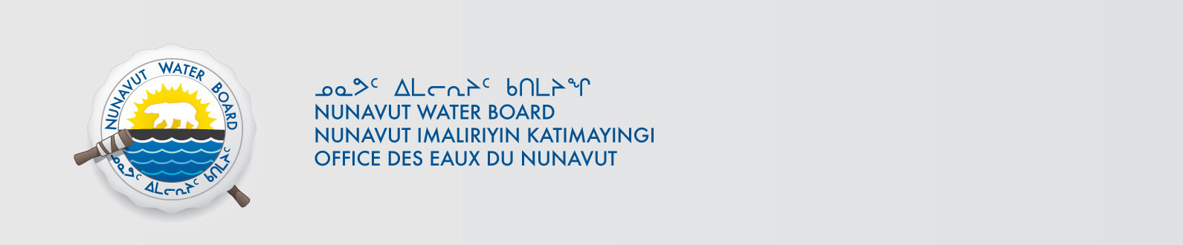
cc. Kivalliq Paula Pacholek, EC
Chris Nichols, DSD
Gladys Joudrey, NIRB
Jordan Degroot, DFO
Roxanne Beavers, DIAND (YK)
Paul Smith, DIAND (Iqaluit)Distribution List

