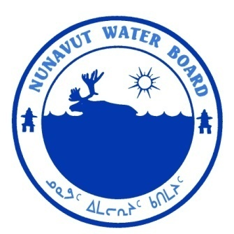  P.O. Box 119 | kNK5 wmoEp5 vtmp5
Gjoa Haven, NU X0B 1J0 | NUNAVUT WATER BOARD
Tel: (867) 360-6338 | NUNAVUT IMALIRIYIN KATIMAYIT
Fax: (867) 360-6369 | OFFICE DES EAUX DU NUNAVUT

File: 7BL-ENN0914/TR/B2

July 14, 2011

Tom Young, President
Cawker & Young Outfitting Ltd.
4904 Tenth Line, R.R. #1,
Terra Cotta, ON L0P 1N0

Email: info@cawkeryoung.com

Subject: Licence No. 7BL-ENN0914, “Ennadai Lake Lodge”, Kivalliq, Nunavut;
Submission of 2010 Annual Report

Dear Mr. Young:

The Nunavut Water Board (“NWB”) has completed a technical review of the 2010 Annual Report for the above-mentioned project, which was received on March 27, 2011. The annual report was distributed for information.

The NWB would like to remind you that standardized forms should be used for annual reporting. These forms are available at the NWB ftp site at the following link: ftp://nunavutwaterboard.org/ADMINISTRATION/ (User: public; Password: registry).

Should you have any questions, please feel free to contact the undersigned at (867) 360-6338 Ext. 30 or k.kharatyan@nunavutwaterboard.org, at your earliest convenience.

Yours truly,

Karén Kharatyan
Technical Advisor

cc: Distribution List – Kivalliq

