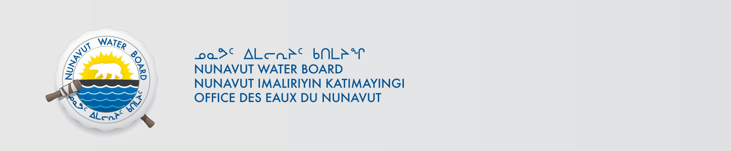

February 18, 2014 NWB File No: 7BL-NNL1115

Ryan St. John
Henik Lake Adventures Ltd
P.O Box 420
Arviat, Nunavut X0C 0E0
E-mail: ryan@eskimopointlumber.com

Re: Acknowledgement and Receipt of Water Use Fees for Water Licence Application –7BL-NNL1115

Dear Mr. St. John:

The Nunavut Water Board acknowledges receipt on January 16, 2014 of your water use fees, cheque number 1153, for the above project. Your payment has been forwarded to Aboriginal Affairs and Northern Development Canada in Iqaluit for processing. A receipt will be issued through their office for fees totaling $90.00 for water use fees.

Please note the total amount of Water Use fees covers the years 2011, 2012 & 2013.

Please refer to the calculation for water use fees, in the Nunavut Waters Regulations, Section 12, to ensure that the correct fee has been submitted. A copy of this regulation is available from our ftp site or by contacting this office. This is an annual fee which is required to be submitted yearly on the anniversary of the issuance of your water licence.

Please call the undersigned at (867) 360-6338 or e-mail licensing@nwb-oen.ca if you have any questions.

Sincerely,

Original signed by:

Megan Porter
Licensing Administrator Assistant

Cc: Jean Allen, AANDC
Leetia Angoyuak, AANDC

